
Assignment Cover Sheet

Student Name: | Omnia Rafiq
Student Number: | 1343
Course: | Diploma in interior Design
Assignment NO: | 7

Student Statement:

By submitting this assignment, I confirm that this is my own work.

Student Signature | Omnia Rafiq | Date | 7-1-2015

For Tutor / Assessor Use Only
Total Marks
Marks Obtained
Percentage / Grade

Q.1.i. How important it is to consider the function of a room when planning a color scheme
For it? And why?
Color is one of the most uplifting and practical ingredients you can bring Into a scheme. Almost all designers have a magic wand in their tool box. It is called color and it can:
- evoke a particular period
- change the proportions of the room
- make a small room look larger
- lighten a dark room
- help to create a certain mood
- make a room feel ’cool’ or ‘warm’
- link different objects and areas in a house
A good color scheme adds value to everything present in the room whereas a bad one
Loses every charm altogether.Colors behave in three basic ways: active, passive, and neutral. You can easily match every room’s colors to your personal desires, to your taste and to the room’s purpose. Light colors are expansive and airy, making rooms seem larger and brighter. Dark colors are sophisticated and warm; they give large rooms a more intimate appearance. If you like the idea of using colour to create an emotionally healthy home, colour consultants say you should first consider the primary function of each room. Next, pick a predominant colour. Although it can't be proven scientifically, colour consultants say some hues work better than others at encouraging certain activities.
For example: Living room and foyer paint colors. Warm tones like reds, yellows, and oranges, and earth tones like brown and beige often work well in both the living room and foyer, because they're though to stimulate conversation. "These are colors that encourage people to sit around and talk, As You feel the warmth, the connection with other people." In a bedroom you may find pastel colors more acceptable, while in a Child’s playroom primary bright might be more appreciated.

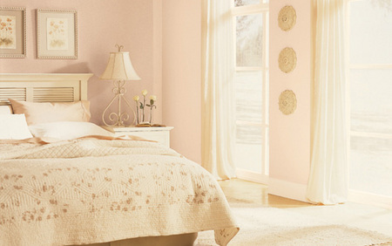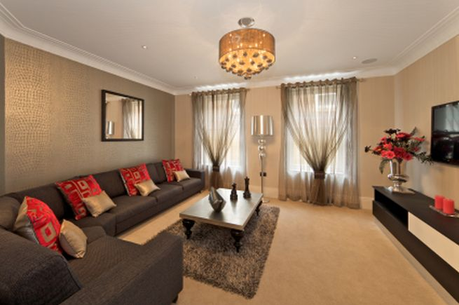

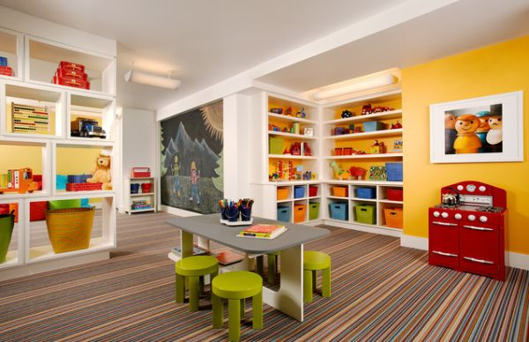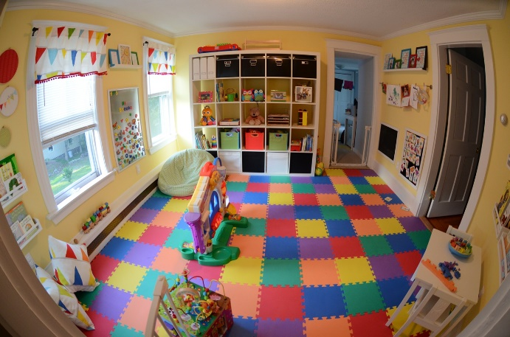

Q.1.ii. Which colour scheme would you suggest for a room facing south?
The south-facing room is the sunniest spot in the house because windows that face south receive the most direct sunlight throughout the year. These sun-drenched spaces are warm and well-lit during the day which can be a blessing in the winter, but it can also be too much of good thing. South-facing rooms sometimes benefit from a drop in visual temperature. The best way to accomplish this is by using cool colours.
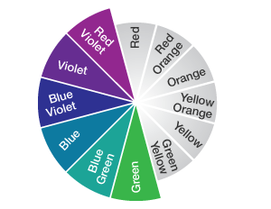
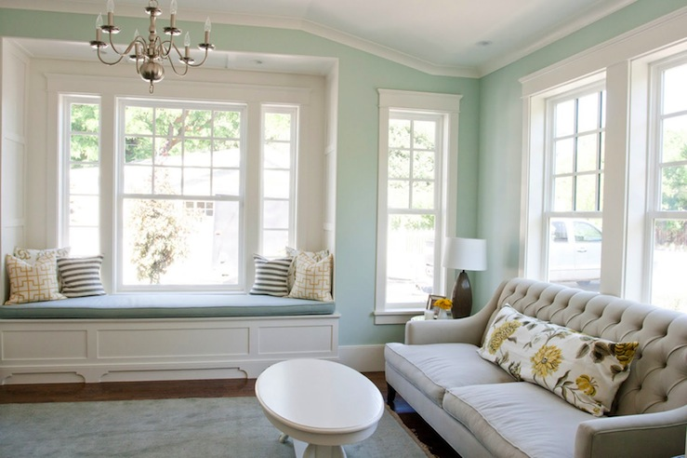

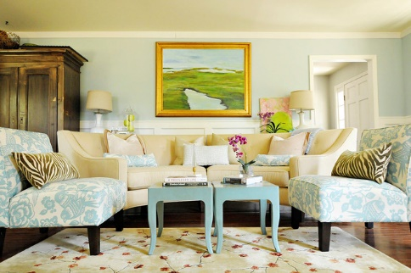

Q.1.iii. Which type of colors in your opinion would be appropriate for a room which faces
North?
North-facing rooms receive very little direct sunlight, if any. Also, the natural light that does stream into the space is often a cool, bluer light — not the warm sunny type. This can have a huge impact on colour and literally leave your paint job in the shadows. With all of that, north-facing rooms can still be warm and inviting, if you're willing to use colours that are more saturated and vibrant.
We may counteract the coldness of the light byintroducing a colour from the warm side of the wheel.
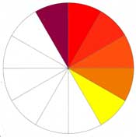
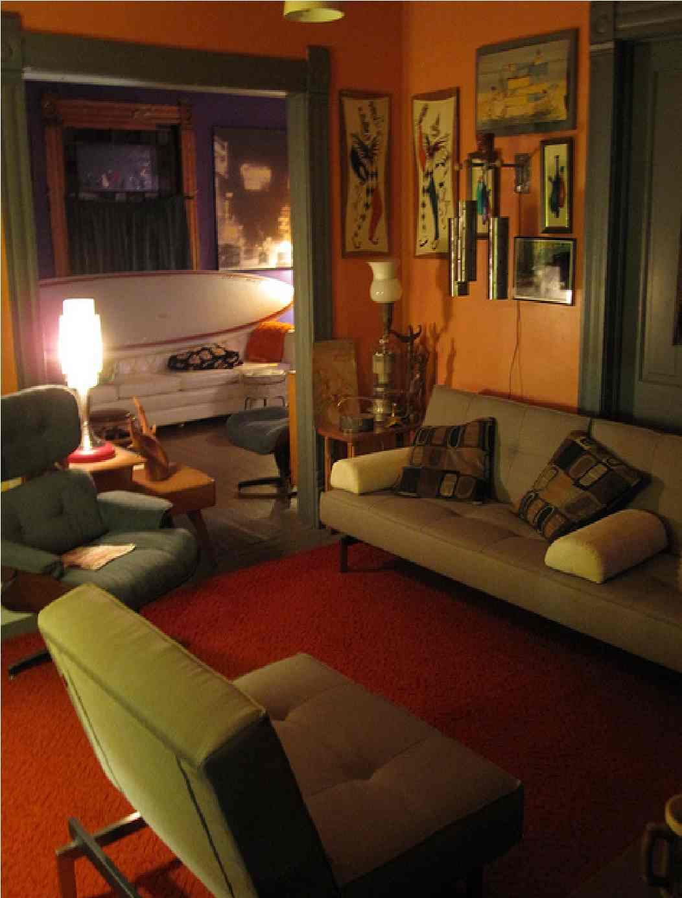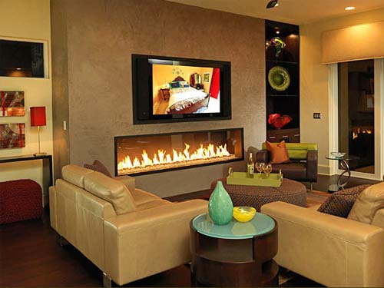

Q.1.iv. How can we make adjustment of the size of the room by colour?
A large space can be reduced by walls in warm, dark and strong colours. A long room we virtually cut so that we paint the most remote walls in a dark shade or a warm colour, which brings the walls optically near. We can equip walls in different colours (we combine complementary colours or use a harmonic colour scheme); with large patterns on the wall or wall papers or the combination of different materials and patterns. A carpet also decreases the room optically. If a ceiling is high, we paint it with dark warm colour, then the optical effect is larger. While we can get larger room size by applying cold very bright colour shades. Such as light blue, light green, light yellow colour, etc. Also having a white ceiling leaves us the impression of space, another tip is using monochrome panels or small patterns on the walls.

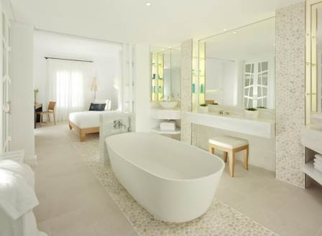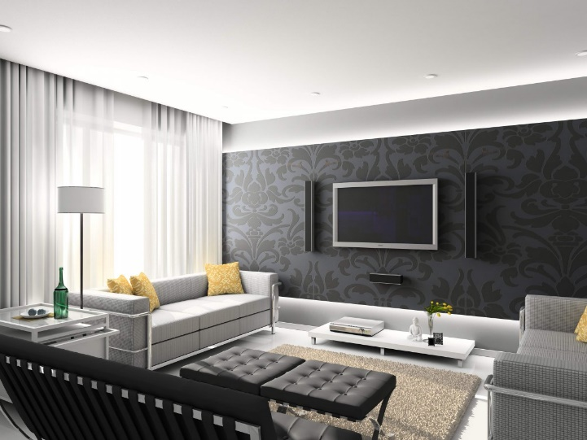

Q.1.v. Why it is important to consider natural light which a room receives when planning
Colour scheme for it?
It is very important to consider the natural light when choosing color because light can either bring a color to life or deaden it. First we should beware of the type of natural light coming into the room. The colder the light the better suited it is to use warmer colors - cream as opposed to brilliant white; terracotta rather than orange, aquamarine instead of turquoise.
Secondly observe how the external factors affect the light in the room. The light in the built up area is filtered and flattened and is quite different to that found in the open spaces. Light is considered to be a factor that influences the use of colour. Since colour is a reflection of light, it depends on the amount of light in a room and a significant impact on your colour scheme. Experiment with how natural light or light from lamps or recessed fixtures affects colour in our wallpaper, fabrics, furniture, and other surfaces. Daylight is considered the perfect light because it has nearly uniform intensity over the entire spectrum of colours. Natural light changes from sunrise to sunset as the sun’s ray’s travel through varying amounts of your home. When considering a colour scheme for a particular room, spend some time in the space throughout the day, taking note of how the light is shifting and the effect on your room. A warm color palette would be effective there to soften any darkness and shadows and it would react well to more hours of artificial light.
Incandescent lighting emits a redder and warmer light than sunlight. Fluorescent lamps generally create a bluer, cooler light. When selecting colors for a room that is used primarily before sunrise or after sunset, choose the colors only under the lighting used in the room. Keep in mind that any color with white in it will reflect the colors that surround it. A white wall, for example, will take on the reflections from carpeting, ceiling color, and even furnishings.
Consider the effect of artificial light on color. In rooms with only one overhead lighting source the light becomes diffused and the colors become dull. It is therefore best to create a layered scheme, including up lighters that can be used to wash a wall or spotlights that highlight key features. The choice of bulb and shade is also important. Halogen bulbs produce a clear white light that has the least discernible effect on color. However it is diffused or reflected. The halogen light is too bright for room intended relaxing. Here the warmer glow of the tungsten bulbs is more
Comfortable.

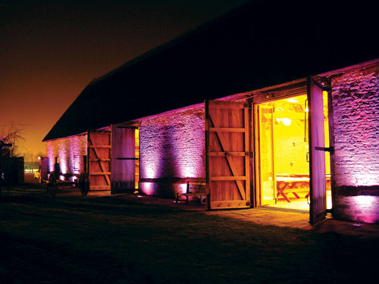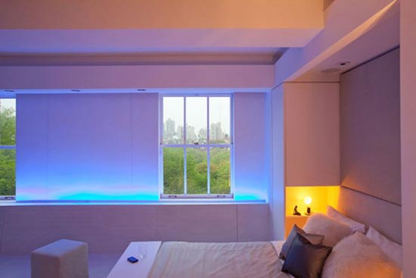

Q.1.vi. Before completely painting a room with a chosen color, why is it recommended to
Paint a sizeable area on the wall of the room?
Before completely painting a room with a chosen color, It’s recommended to paint a sizeable area on one wall of the room to observe how the color looks at different times of the day and evening. To see the amount of natural light entering the room and its effect. Also to check the artificial lights required, Their types and if the color would change when reflecting lights falling on it. If you decide that it is not quite the right hue that is finally required, you can fine tune it by trying a shade or two lighter or darker. The process will help you get the right color scheme actually required and will save time and money.
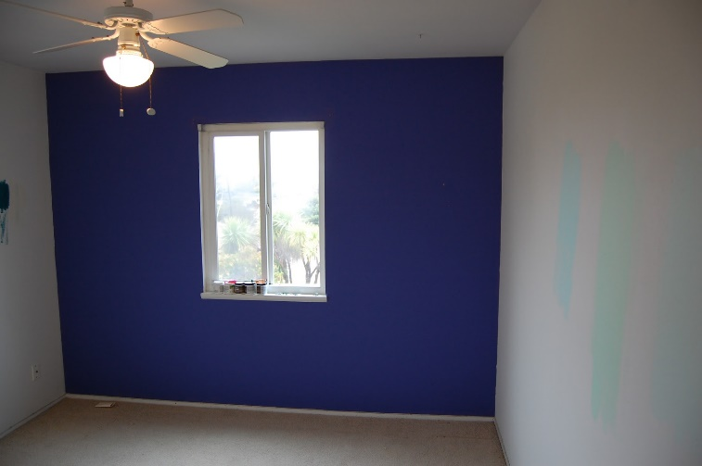

Q.1.vii. Reds, oranges and yellows are known as warm advancing colors. What are the colors on
The opposite side of the colour wheel known as i.e. violets, blues and greens?
Colors can be perceived as warm or as cool depending on where they lie on the color wheel. In interior design color psychology, the yellow, red and orange region is considered as warm color zone. Whereas the purple, blue and green area is considered to give a cool feeling. There are beiges and muted greys that don’t really have a warm or cool projection in interior color psychology. These are referred to as temperature neutrals. The colors on the warm side of the wheel are advancing colors and give a closer and cozier feel. If we have to decorate a large space that lacks intimate appeal, we should consider using colors from this part of the spectrum. On the other hand hues from the cool side tend to recede visually, suggesting an open space. These are therefore good to use in small spaces.

Q.2. What is the importance of colour when planning a space?
Colour is an important aspect of the design of interior spaces. We know that a well-planned space can be enhanced by using ‘appropriate’ colours. An appropriate colour for a space is relative and cannot be prescribed. The use of colours in interior spaces as the translation of abstract colour schemes, theories and meanings into real materials, surfaces, experience and use in a space is a complex matter requiring creativity, judgment and often comes with experience. However, organized methodology and advance planning of colours can lead to successful use of colours.
- It Brings in harmony :
One of the most harmonious color schemes is made by working with different values of one color, to create monochromatic or single color Scheme. Such a scheme is calming and relaxing and when blues or greens Are used, it suggests space and elegance. Colors that are next or adjacent to each other on the color wheel, naturally harmonize each Other.
- It Bring in contrast:
Contrasting and complementary color schemes are most stimulating and therefore should not be used for areas used for relaxing. We can create contrasting schemes by using two dynamic opposites: blue/ orange, Yellow/ violet, red/ green but also think about the tonal contrast and the Use of a neutral as a link. In a scheme if pale primrose is combined with Rich plum- purple, cream can be used as the neutral. A simple way of creating a contrasting scheme is to combine a warm with a cooler color,
Which needs not necessarily be the complete opposite, blue can be used For instance with yellow.
- Create the feeling of warmth:
All the warm colors - in their various tints, shades and tones, work well in cold, dark and north – or west facing rooms. The warm colors can be used to create cozy atmosphere. The warm, long wavelength colors include red, red/ orange, yellow/ orange, yellow and some yellow/ greens. You can also use their various tones, tints and shades such as pink, rose, wine red, gold, apricot, yellow and terracotta to create the same results.
For added interest you can use strong cool accents into mainly warm scheme.
- Create excitement :
The way you put colors together is called creating color harmonies, Although sometimes you may create excitement rather than harmony. For instance, a stimulating affect can be created in the children’s playroom by using contrasting or complementary colors. Try combining a warm with a
Cool, such as red with green, blue with orange, purple and yellow. All these colors are direct opposite on the color wheel, and can be very strong and dominant. A softer and still stimulating scheme can be created by using pale and subtle values of the complementary colors, or by pairing yellow and blue, grey and pink. It is also a good idea to add plenty of textural contrast to exciting stimulating schemes. To do this shiny and light reflecting surfaces can be combined with rough rustic and matt light absorbing Ones.
- Creates Calm and relaxation:
There are the adjacent or neighborly colors, which are found next to each other on the color wheel. When creating a relaxing scheme, work with color from the same family. You can try yellow/ green and blue/ green. Calm schemes can include mainly warm or mainly cool colors. For
An even more relaxing scheme, you can work with monochromatic color scheme where different values of one basic hue are used.
Harmony Calm
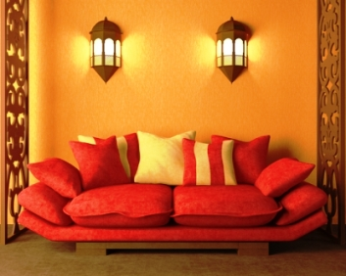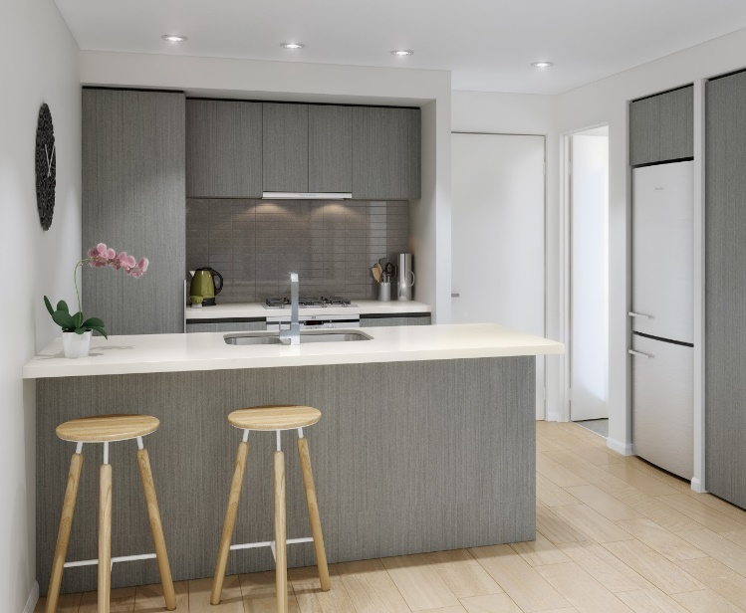

Contrast Exciting
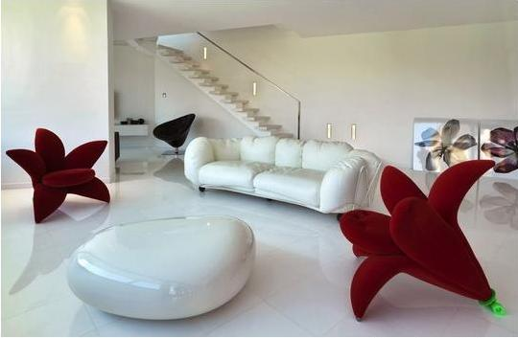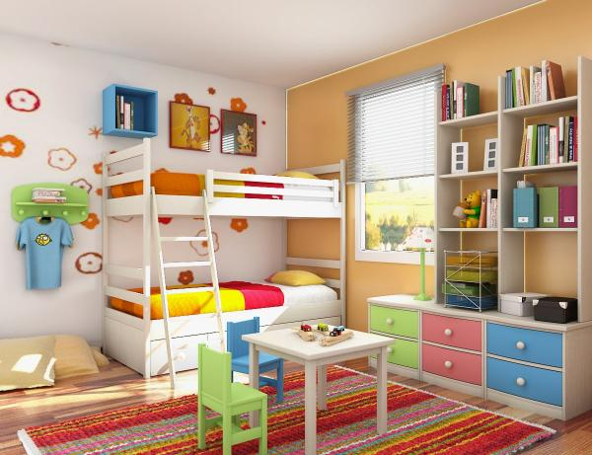

Q.3. Which colors would you choose to give an impression of a cozy atmosphere in an interior
Space?
There are the adjacent or neighborly colors, which are found next to each other on the color wheel. When creating a relaxing scheme, we should work with color from the same family. We can try yellow/ green and blue/green. Calm schemes can include mainly warm or mainly cool colors. For
An even more relaxing scheme, you can work with monochromatic color scheme where different values of one basic hue are used.
Also by Using Neutrals since natural and neutral textures can also be used to create a relaxing area, but they should come from the same family. The only true neutrals are black, white and greyhen these three non-colors are used together, they can be highly stimulating, especially if combined with bold patterns and lots of different textures. These days other accepted neutrals(although some may include different color bias) include cream, beige, off white, mushroom, brown and the colors of natural untreated materials,such as wood sea grass, jute, slate.
