
Assignment Cover Sheet

Student Name: | Saleema Choudrey
Student Number: | 1240
Course: | Fashion Designing
Assignment NO: | Unit 8

Unit 8

- What is meant by “Binary Colours”?

Binary colour is made up of two primary colours. That’s called secondary color. Binary scheme shows us the difference with 2 colors in lighter and darker shades.
. 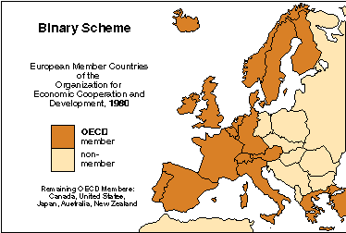
(sample Binary colour scheme)

- Grey colour is formed when black is mixed with white.is it a warm or cool colour what do you think and how best it can be used in creating an attractive colour scheme?

Black is a warm color, white is a cool color. Grey is considered to be a Neutral color. Adding dark colors as an opposite color to enhance grey would be an attractive color scheme. Using colors like red, yellow, blue, green.

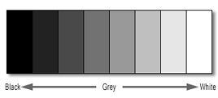
(Sample: achromatic colour scheme)

- Which of the following colours should a stout person wear? Dark or light. And why?

A stout person should wear dark colours to create slimness. Because cool colours reduce sizes.

- If you want to create an illusion of height and slimness using colour. How would you do it?

To create an illusion of height and slimness using colour I would recommend dark and dull colours to wear. An outfit that’s one piece creates slimness and height aswell.

- Wearing black for a grey haired lady is the most suitable choice. But how should she wear this in the best possible way.
The best way to stand out for a grey haired to wear black is to wear something with a white touch in her clothes close to her neckline. Like a white color, or rouches, white buttons etc

- For a person of sallow complexion which type of colours is best choice? And why?
A sallow complexion person should avoid colors like yellow, browns, tan. To enhance the yellow complexion the person should wear warm tints colors like, red, rose,grey.these colour would make the person less yellowish.

- Which types of colours would be more suitable for a blonde persons dress?

Suitable colours for blonde persons are blue,greens,violets.the blonde suits light pastel colours too. She should not be wearing heavy jewelery. Instead light pearls jewelery should be looking good on a blonde person.

Activity
Collect fabric swatches for different colour harmonies. Also name the colour scheme. Create a contrasting colour scheme using atleast three colours of your choice. Design a fabric using at least three colours.
Fabric swatches
- complementary harmony
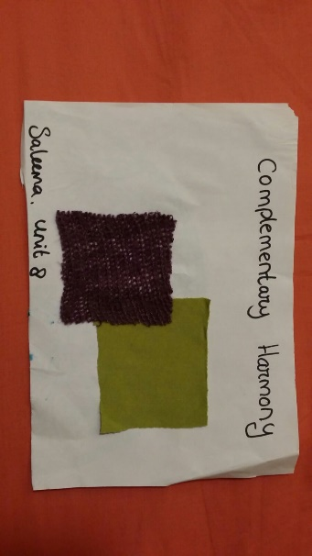
- triad harmony
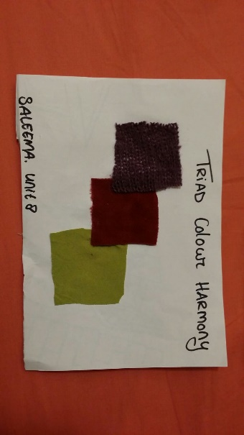
- analogous harmony
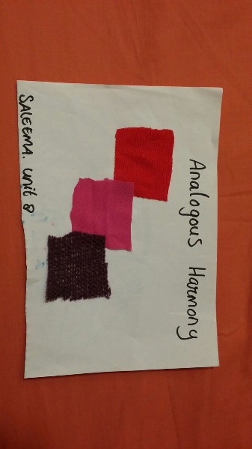
- Achromatic harmony
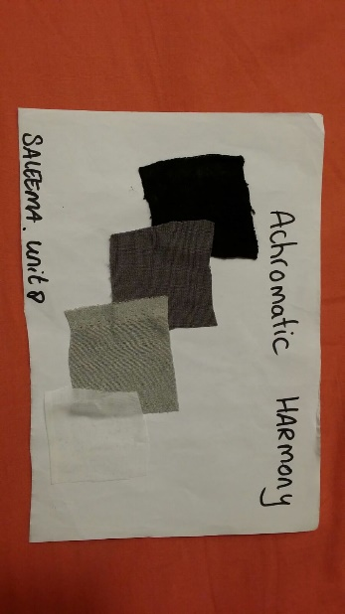

- Contrasting color scheme by own choice
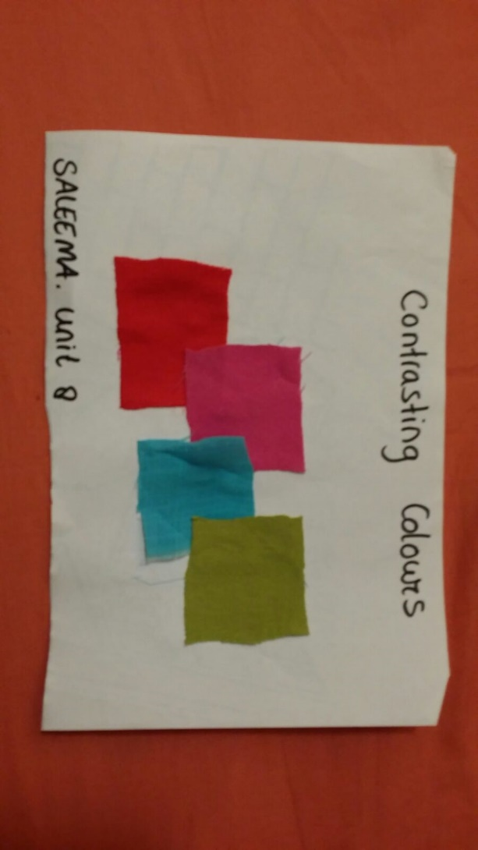

Fabric design
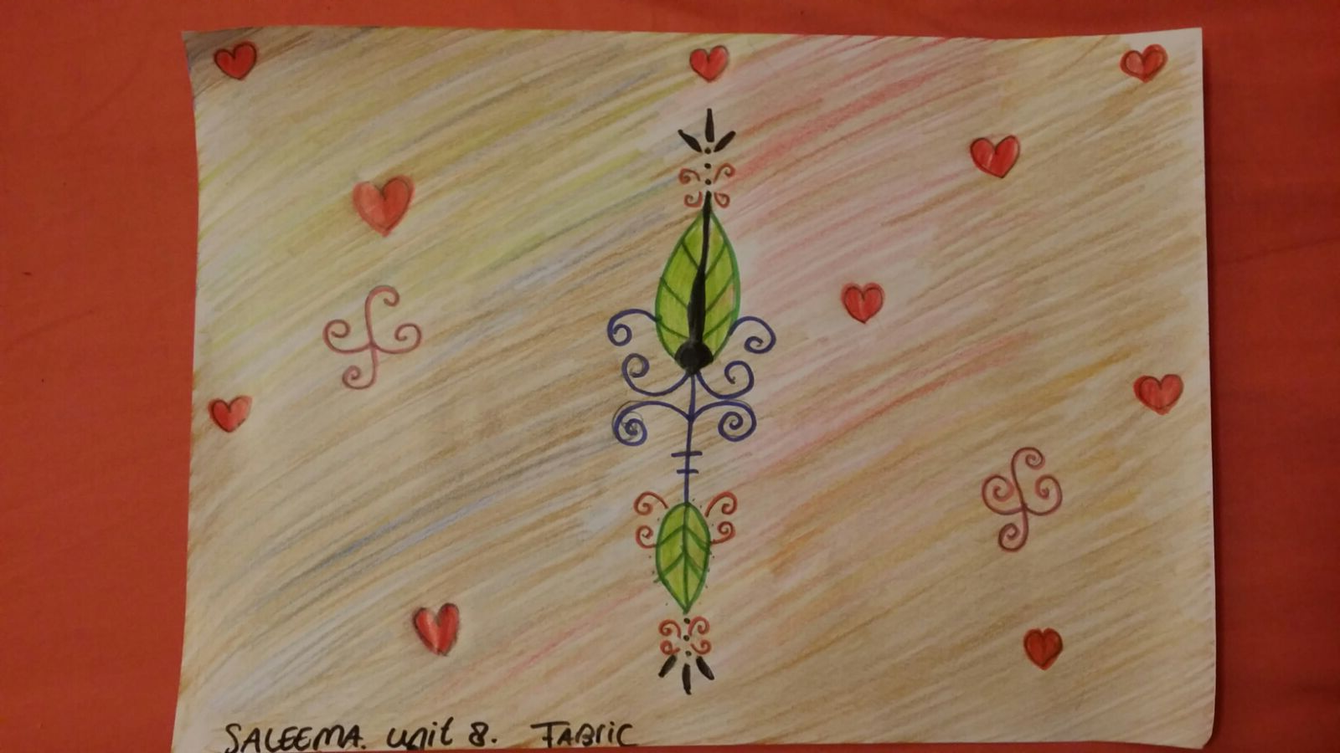

Student Statement:

By submitting this assignment, I confirm that this is my own work.

Student Signature | S.Choudrey | Date | 11/03/2016

For Tutor / Assessor Use Only
Total Marks
Marks Obtained
Percentage / Grade

