
Catherine Richardson
1427
Diploma in Public Relations
Corporate Public Relations
Assessment 7
Page 1
Assignment Cover Sheet

Student Name: | Catherine Jane Richardson
Student Number: | 1427
Course: | Diploma in Public Relations
Assignment NO: | Corporate Public Relations - Assessment 7

Marking Criteria:
We expect the learners to write minimum one well expressed point in three lines against each allocated mark. This means one needs to write 15 lines with 5 well expressed points to get high grades for a 5 marks question.
For high grades use examples and illustrations where appropriate.
Please insert your completed assignment (in word format) here:
- Give short answers to the following questions:

i. Distinguish between corporate mission, corporate objectives, and corporate goals.

The corporate mission is used to communicate the purpose and main principles of an organization. Corporate objectives are defined as realistic goal setting with internal strategic decisions and anticipated time frames of achievement. Corporate goals are targets set by an organisation (Gollwitzer 1990). They are quantifiable outcomes that commit attaining to achieve its corporate mission and objectives (Fawcett 2012). Goals are means of translating the mission and objectives of an organisation into specific, quantifiable terms that results can be measured (Hill & Jones 2008). The main purpose of an organisation is having defined corporate goals, objectives and a mission statement to adhere the primary purpose of the organisation. Collective organizational ideology within an organisation entwines its publics using motivation and solidarity to meet such targets.

ii. What are the different categories of corporate planning?
Catherine Richardson
1427
Diploma in Public Relations
Corporate Public Relations
Assessment 7
Page 2
Corporate planning defines the strategies that the employees will take to meet the business' goals and missions (Smith 2016). This type of planning can be categorized into three areas: project planning; operational planning and strategic planning.
Project Planning oversees the overall capital investment, production and the marketing operation (Kerner 2003). Operational planning focuses on staff responsibilities and procedures specific to that established and required area of expertise. Strategic planning identifies the progressional process of the business, such as the actual stages the staff will take to stabilize challenges, train employees and achieves their accomplishments and objectives (Olsen 2012).

iii. How is the progress of an organisation measured?
Key performance indicators help businesses to measure and manage the most important processes in an organisation, which in turn offers a measure of organizational advancement against goals (Bryant 2015). Each organisation could select specific key performance indicators that are relevant to them. Some examples are turnover generated, new customer's acquisition, sales forecasts, employee turnover, and employee performance indicators. Key performance indicators can be defined as either be visible results or financial results. Visible results are the manufactured products or services produced. Financial results are the figures relating to costs, profits, turnover and assets. Most corporate businesses tend to focus their key performance indicators primarily on the financial outcomes. Financial outcomes will identify clearly any advances or limitations of the current state of an organisation.

iv. What is meant by corporate image? What does the image of an organisation depend upon?
Corporate image is the public perception of an organisation rather than a reflection of its actual state or position (Gray 2000). Unlike corporate identity, corporate image is malleable and can change overnight (Wheeler 2006) from encouraging to damaging to neutral. Large firms use numerous corporate advertising techniques to enhance their image to improve their desirability as a supplier, employer, customer or borrower (Olins 1995).
Corporate image is also based on corporate communication and behavior displayed and then translated by the audience. If the image is positive or negative, this is based from the whole perspective of the audience. Reputations are the outcomes corporate image (Schindler 2000). Feedback is the impression of the overall organisation and how it is perceived by outsiders. Specifically with corporate organisations, corporate image is of paramount importance to stakeholders; internal and external publics. Importantly, stakeholder groups are likely to have a relatively different perception of an organisation because each is concerned primarily with a different aspect of its operation (Davis 1996). Therefore, the image is different depending on the stance of the stakeholder.
Catherine Richardson
1427
Diploma in Public Relations
Corporate Public Relations
Assessment 7
Page 3

v. Describe briefly the steps in Corporate Public Relations activity.
Defining corporate objectives employing setting guidelines of what needs to be achieved for an organisation. The corporate objectives set the effectiveness of a strategy unique to the planned performance or method of delivery.
Planning Process to decide the appropriate strategies and implementing the programme of what needs to be done. Planning is crucial to plan for the eventuality which may arise due to unavoidable situations such as crisis control.
Communication elements from who send what message and what is understood by the intended message. The emphasis of how the message is conveyed is also applicable to an organisation. Communication sources may be with the uses of newsletters, memos, house journals, leaflets, etc. This applies to all audiences and recipients internal and external to the organisation.
Evaluation is the final stage that allows reflection. The organisation can review the activities to ascertain if there are any concerns regarding the planning and the execution of the planned activity and the desired outcome.

vi. List the aspects that are considered in the evaluation of a Public Relations programme.
The evaluation of a public relations programme consists of:
The methodology which was adopted by the public relations spokesman, to project the image of the organisation. Defining the methods used to enhance the image of an organisation (Smith 2002).
The adequacy of message content and structure to ensure that the message is delivered in a manner with the planned intention.
Catherine Richardson
1427
Diploma in Public Relations
Corporate Public Relations
Assessment 7
Page 4
The extent of media application, its nature and suitability – the purpose of media application and whether it is a suitable method to portray the intended message (Lister 2009).
The target audience; and the effect the message has on the target audience. – Communication if considered appropriately (Maines 2000), the intended message would reach the desired audiences and as a result be persuaded to act accordingly.
This step of evaluation is also essential to review and modify (if necessary) the Public Relations' activity oriented towards image building (Krazit 2001). The evaluation also helps to find out any discrepancies between programme planning and execution. Furthermore, the evaluation process guides the public relations practitioner to identify whether all the planned objectives were attained according to the expectations of the planned campaign (Miyamoto 1995).

vii. Briefly explain the following terms.
- Social Audit b. Corporate Accountability c) Corporate Culture

Social Audit is an assessment of the organisation performance regarding the corporate social responsibility objectives. It evaluates measurable goals intended to help a business meet the expectations of stakeholder groups regarding the company's social and environmental responsibilities (Kokemuller, 2015). Balancing social responsibility with business performance is imperative in our current business arena (Shamir 2004). Current trends of corporate social responsibilities are areas of environmental sustainability, and charitable or aid influenced sectors.
Corporate Accountability can be defined as the act of being accountable (answerable) to the stakeholders of an organization. This includes all stakeholders, internal, external publics and communities within the countries operations (Utting 2008). A corporate organisation would have responsibilities and be conscious of environmental and social duties within a community. If these corporate organisations engage in a malpractice and as a consequence the communities suffer, the corporate organisation could be held liable for not upholding such duties. (Friends of the Earth 2005).
Catherine Richardson
1427
Diploma in Public Relations
Corporate Public Relations
Assessment 7
Page 5

Corporate Culture can also be identified as an organizational culture (Parker 2000). Needle (2004) suggests that corporate culture is the universal values, beliefs and attitudes that portray an organisation and guide its practices. For some, a company's internal culture may be translated in its mission statement or vision statement ensuring that the message engages all publics with consistency (Denison 1990).

Activity
Yours is a pharmaceutical firm engaged in the manufacture of a wide range of antibiotics and Lifesaving drugs. An epidemic hits the community leading to a severe shortage of drugs in the market. What steps would you take to discharge your social responsibility and maintain goodwill of the community?

Organisations whether non-profits to large multi-nationals demand for an increased stakeholder engagement (Jeffery 2009). Stakeholders request for transparency (Tomlinson 2014) has an impact on the business’ Corporate Social Responsibility strategies. According to Porter (2013) successful CSR public relations requires an orientation with the organization’s business goals and involves everything from charitable donations and fundraisers, to human resources and investor relations.
The aim is to engage people and communities whilst advocating the organisations’ story and history (Skau 1992). This promotes shared values based on actual business practices. This type of communication opens opportunities for collaboration and shared power for both the organisation and the community, and also results in a trustworthy relationship (McLean 2015).
The objectives for a pharmaceutical firm would be to maintain their reputation and relationships in a trustworthy and positive light within the community (Googins 1997). The aim is to create a CRS plan to mitigate risks and enhance relationships (Jones 2007).
For the purpose of this activity, the pharmaceutical company Johnson & Johnson will be the centre point of discussion.
Johnson & Johnson is a multi-national company specializing in consumer healthcare; household named medications, first aid, baby products, skin & beauty products and contact lenses, pharmaceutical medications; Janssen pharmaceuticals, diagnostics, therapeutics and healthcare innovation and medical devices.
Catherine Richardson
1427
Diploma in Public Relations
Corporate Public Relations
Assessment 7
Page 6
Johnson & Johnson have a statement of beliefs and aims which guides their organisation: “Our Credo challenges us to put the needs and well-being of the people we serve first”…”our ability to make positive, life-saving and life-improving differences.”
Their strategic framework:
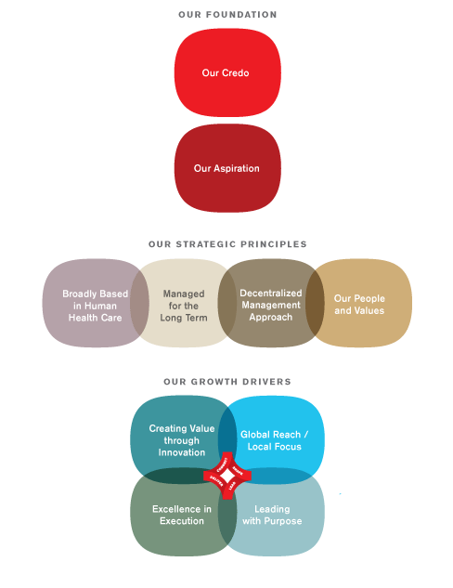

The initial step is for an organisation to define clearly their roles and missions (Graves 2007). Johnson & Johnson clearly define their roles and missions within the global community. They have a social responsibility to their stakeholders and community to ensure that risk is managed to keep in line with their credo.
Given the example of an epidemic, the campaign would involve the next stage of planning and implementing by selecting appropriate objectives. Pharmaceutical companies have moral guidelines (Cohen 2005) to ensure that communities can function in a healthy manner.
Catherine Richardson
1427
Diploma in Public Relations
Corporate Public Relations
Assessment 7
Page 7

According to Johnson & Johnson objectives to consider are to maintain their reputation and relationships in a trustworthy and positive light within the community.
A pharmaceutical company could set up a community-related committee (McLean 2012) to offer support about the epidemic, prevention guidelines, and cure strategies where possible and applicable.
The above goal would also have an impact regarding the corporate social responsibility to the community while upholding the organisation credibility and reputation (Lantos 2001).
The scope of work would determine and detail the project throughout its developmental phases (Trek 2006). The scope of work would highlight the deliverables, resources, projections, manpower, cost and schedule.
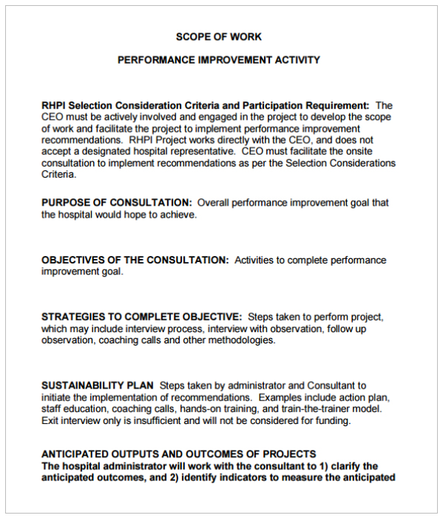

Alongside the scope of work, action plans (Kotler 1967) would also help to achieve the objectives in a timely and realistic manner. Addressing the purpose of the campaign, identifying the key objectives, what initiatives or activities are required, who is responsible and when the activities are expected to be completed.

Budgeting and implementing the programme draws up budgets, highlights the role of budgets in controlling expenditure and the extent to which budgets can be used in creating a sense of responsibility. Johnson & Johnson’s cyanide crisis cost the multi-national company over 100 million US dollars to recall the contaminated product. Their idea was to act quickly, accept responsibility while to preserve their ideology of trust and putting the needs of people and health first.
Catherine Richardson
1427
Diploma in Public Relations
Corporate Public Relations
Assessment 7
Page 8

Evaluating results from feedback, research and analysis, this allows for an analysis with what is planned and what is expected to be executed. Johnson & Johnson evaluated the crisis and were prepared to accept the short-term costs and losses and not sacrifice their consumer reputation and trusting relationship with their customers.

Communication
In 1982, Johnson & Johnson’s Tylenol suffered a crisis when an individual tampered with the drug by spiking it with cyanide. As a result, seven people died and panic spread regarding the contamination. Through this crisis management, Johnson & Johnson acted quickly to address this issue by recalling every outlet and by not re-establishing the drug until the product processing methods were tamperproof.
Communication was effective and open offering transparency about this blunder. Public announcements were made regarding the warning, and product advertisements were placed on hold. Regarding the message, Johnson & Johnson state in their credo that the company‘s responsibilities were to the consumers and medical professionals using its products, employees, the communities where its people work and live, and its stockholders. Therefore, it was essential to maintain the safety of its publics to maintain the company alive. Johnson & Johnson’s responsibility to its publics first proved to be its most efficient public relations tool. (Mitchell 1989).

Taking into consideration Johnson& Johnson’s ethos, and given the example of a local epidemic, a large pharmaceutical company could build strong community relationships by offering a community relations committee (Rutzou 2016) by offering support regarding prevention, awareness and intervention regarding the epidemic crisis.
Support could be provided with leaflets in local supermarkets, medical practices, etc., telephone hotlines (Johnson 2009), social media blogs (Wright 2008) and sites to inform and communicate the latest information regarding the epidemic.
Naturally, a corporation would have to invest resources from staffing and training to offer such services.
The social responsibility for an organisation such as Johnson & Johnson is to uphold their mission statement about “putting the needs and well-being of the people they serve first” by offering such support.
Vaccinations or supplies of medication would most probably have political and financial implications regarding distribution and numbers manufactured. From a corporate standpoint distribution of such products may have ethical implications (Herbert 2015). Therefore, a corporate organisation may not want to provide giveaways but within their expertise, they may offer alternatives (Nadler & Schulman 2015). By offering such supportive services, a pharmaceutical company gains credibility (Mills 2007) and social acceptance (Macris 2015) regarding a specific crisis and what they can offer realistically to a community. One of the main aims of a large corporate organisation is that a strong reputation can help an organisation differentiate its products and services, attract talent, and even mitigate risk (Crenshaw 2014). The return of investment by partaking in the “morally” minded social responsibility is an enhanced goodwill of the community embracing the social ideology of public welfare. CSR can give a business a competitive advantage while also making positive changes to the community and the environment (Gilman 2014)
Catherine Richardson
1427
Diploma in Public Relations
Corporate Public Relations
Assessment 7
Page 9
Student Statement:
By submitting this assignment, I confirm that this is my own work.

Student Signature | Catherine Jane Richardson | Date | 23rd Feb 2016

For Tutor / Assessor Use Only
Total Marks
Marks Obtained
Percentage / Grade

