
Assignment Cover Sheet

Student Name: | Ray Wilson
Student Number: | 1390
Course: | Environmental Management
Assignment No: | 8

Assignment8 Total Marks 30

1. Outline the benefits of EMS. What are some key elements of an EMS? 6

Over the decade, there has been increasing evidence that organizations that implement environmental management systems (EMS) for their operations can realize significant benefits in terms of improved environmental performance, including;

- improved environmental performance and compliance,
- systematic method of managing organizations environmental matters
- prevention of pollution,
- increased operational efficiency, products, services and processes
- cost savings
- improved relations with regulatory agencies
- allows continuous improvement of system adopted

Originally adopted in the private sector, EMSs are now proving to be a powerful tool that can also help public agencies. EMSs do not impose new technical requirements, nor do they act as a substitute for existing regulatory requirements. EMSs provide an authoritative and replicable method for an organization to more effectively manage its environmental obligations and, as a result, improve its overall environmental performance, including areas not subject to legal requirements. EMSs can also help organizations reduce unnecessary costs.

Other benefits also include;

- Reduced operating costs. In nearly every case, an EMS reduces operating costs through waste reduction, energy conservation, and other savings. The typical payback period for an EMS is typically 9 months to 2 years.

- Reduced legal risk and potential liabilities. An EMS provides a structured framework for identifying and meeting regulatory requirements. This results in fewer fines and other regulatory complications over time.

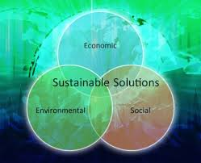

- Improved bond ratings. A formal EMS can demonstrate to the lenders a reduced risk that results in lower interest rates

- Recognition as a progressive leader. A registered EMS demonstrates leadership to managers, local governments and also the public in general, especially to the businesses in the area. Managers of ISO 14001 certified agencies are regularly asked to speak at conferences

- Demonstration of competitiveness with private industry

The Key Elements of an EMS include;

- Environmental policy - Develop a statement of your organization’s commitment to the environment. Use this policy as a framework for planning and action.
- Environmental aspects - Identify environmental attributes of your products, activities and services. Determine those that could have significant impacts on the environment.
- Legal and other requirements - Identify and ensure access to relevant laws and regulations, as well as other requirements to which your organization adheres.
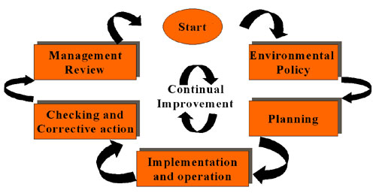
- Objectives and targets - Establish environmental goals for your organization, in line with your policy, environmental impacts, the views of interested parties and other factors.
- Environmental management program - Plan actions necessary to achieve your objectives and targets.
- Structure and responsibility - Establish roles and responsibilities for environmental management and provide appropriate resources.
- Training, awareness and competence - Ensure that your employees are trained and capable of carrying out their environmental responsibilities.
- Communication - Establish processes for internal and external communications on environmental management issues.
- EMS documentation - Maintain information on your EMS and related documents.
- Document control - Ensure effective management of procedures and other system documents.
- Operational control - Identify, plan and manage your operations and activities in line with your policy, objectives and targets.
- Emergency preparedness and response - Identify potential emergencies and develop procedures for preventing and responding to them.
- Monitoring and measurement - Monitor key activities and track performance. Conduct periodic assessments of compliance with legal requirements.
- Nonconformance and corrective and preventive action - Identify and correct problems and prevent their recurrence.
- Records - Maintain and manage records of EMS performance.
- EMS audit - Periodically verify that your EMS is operating as intended.
- Management review - Periodically review your EMS with an eye to continual improvement.

2. What does PDCA stand for? Explain the PDCA cycle. 12
It’s a dilemma faced by many this day and age. You've worked hard to create a credible vision of where you want it to be in future but something needs to change: something's wrong, and needs to be fixed, But are you 100% sure that you're right? And are you absolutely certain that your solution will work perfectly, in every way?
Where the consequences of getting things wrong are significant, it often makes sense to run a well-crafted pilot project. That way if the pilot doesn't deliver the results you expected, you get the chance to fix and improve things before you fully commit your reputation and resources. So how do you make sure that you get this right, not just this time but every time? The solution is to have a process that you follow when you need to make a change or solve a problem; A process that will ensure you plan, test and incorporate feedback before you commit to implementation.
A popular tool for doing just this is the Plan-Do-Check-Act Cycle (PDCA). This is often referred to as the Deming Cycle or the Deming Wheel after its proponent, W Edwards Deming. It is also sometimes called the Shewhart Cycle.
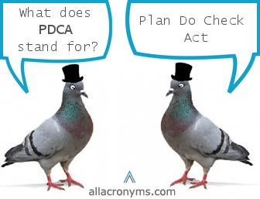
Deming is best known as a pioneer of the quality management approach and for introducing statistical process control techniques for manufacturing to the Japanese, who used them with great success. He believed that a key source of production quality lay in having clearly defined, repeatable processes. And so the PDCA Cycle as an approach to change and problem solving is very much at the heart of Deming's quality-driven philosophy. Of course it’s not just quality that this approach is used for and it works equally as well when utilized for Environmental management systems.
The four phases in the Plan-Do-Check-Act Cycle involve;
- Plan: Identifying and analyzing the problem.
- Do: Developing and testing a potential solution.
- Check: Measuring how effective the test solution was, and analyzing whether it could be improved in any way.
- Act: Implementing the improved solution fully.

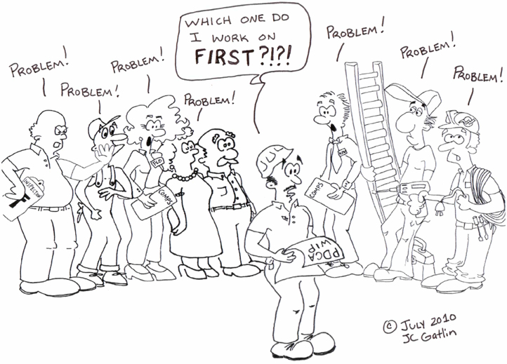
The PDCA Cycle encourages you to be methodical in your approach to problem solving and implementing solutions. Follow the more detailed steps below every time to ensure you get the highest quality solution possible.
1. Plan: Locate what can be improved, fix an objective and think about how this objective can be archived. You can create working groups to search potential improvements in the processes and products of your company. It can help to listen to the ideas of the employees, and find better and new technologies that the company has not used yet.
2. Do: We made the required changes to implement the proposed improvement in our processes. In general, it is recommended to do a pilot project to test the operation before making large-scale changes.
3. Check: Once the changes are implemented, we establish a trial period to verify the developing of the new process. If the improvement does not achieve the initial expectations we will have to modify the process again to obtain the desired objectives.
4. Act: Finally, when the trial period ends, we have to study the results and compare the performance of our processes and activities before and after the improvement. If the results are satisfactory the improvements will be implemented permanently. However, if they are not satisfactory we will have to decide whether to make more changes to adjust the results or to discard them and return to the start point.
Once completed, you have to return to the first step periodically to implement more new enhancements and continual improvement.
Several ISO standards talk about the concept of Continuous Improvement. For example ISO 9001 talks about the continuous improvement in the quality management system, explicitly naming the PDCA Cycle (Plan, Do, Check and Act). According to ISO 9001:2008, all Quality Management Systems certified with this standard must apply the methodology of continuous improvement in a systematic way. Another widespread standard that refers to continuous improvement is of course ISO 14001 “environmental management systems”. It also refers to the PDCA cycle again as the basis for the implementation of an environmental management system.

3. What is environmental auditing? Explain the Methods used for valuing the Environment. 12

Environmental audits are tools which can quantify an organizational environmental performance and position. There are three main types of audits which are environmental compliance audits, environmental management audits to verify whether an organization meets its stated objectives, and, functional environmental audits such as for water and electricity.
Environmental auditing aims to evaluate environment management systems systematically and objectively. It has the following objectives;
- Waste prevention and reduction
- Assessing compliance with regulatory requirements
- Placing environmental information in the public domain
The benefits vary depending on the objectives and scope of the audit. Environmental auditing benefits include;
- Organizations understand how to meet their legal requirements;
- Meeting specific statutory reporting requirements;
- Organizations can demonstrate they are environmentally responsible;
- Organizations can demonstrate their environmental policy is implemented;
- Understanding environmental interactions of products, services & activities;
- Knowing their environmental risks are managed appropriately;
- Understanding how to develop and implement an ISO 14001 EMS;
- Improving environmental performance and saving money.
The Eco-Management and Audit Scheme (EMAS) is the EU voluntary instrument, which acknowledge organizations that improve their environmental performance on a continuous basis.
ISO 19011:2012 Guidelines for auditing management systems provides information regarding the choice of Environmental Auditor. Environmental Auditors should have personal attributes, such as ethics, open-mindedness, perceptiveness and tact. They should understand audit principles, procedures and techniques, as well as having gained experience through conducting audits. They should know the subject matter they are auditing against and how this applies to different organizations.
Audit Team Leaders should be able to plan and resource effectively, have good communication and leadership skills. Preferably Environmental Auditors should complete training and have attained an appropriate level of education and normally be accredited to an established society such as IRCA. A good Auditor should have adequate skills and experience.
When seeking an external Auditor consideration could be given to the skills outlined above. Ideal Global Environmental Auditors have completed training (5 days) and have met a minimum certification standard. Depending on the auditing requirements consideration could be given to determining whether the Auditor needs to be certified by additional organizations (e.g. EPA appointed Environmental Auditors).

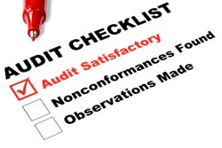Ecosystem or Environmental valuation can be a problematic and controversial task, and economists have often been criticized for trying to put a “price tag” on nature. However, agencies in charge of protecting and managing natural resources must often make difficult spending decisions that involve tradeoffs in allocating resources. These types of decisions are economic decisions, and thus are based, either explicitly or implicitly, on society’s values. Therefore, economic valuation can be useful, by providing a way to justify and set priorities for programs, policies, or actions that protect or restore ecosystems and their services.
There are a number of market-based methods of environmental valuation. There are three market-based techniques;
  - factor of production approach,
  - change in producer/consumer surplus and
  - examination of defensive expenditures
In order to understand how economists approach ecosystem valuation, it is useful to review some important definitions and concepts of Environmental functions and services.
Ecosystem functions are the physical, chemical, and biological processes or attributes that contribute to the self-maintenance of an ecosystem; in other words, what the ecosystem does. Some examples of ecosystem functions are provision of wildlife habitat, carbon cycling, or the trapping of nutrients. Thus, ecosystems, such as wetlands, forests, or estuaries, can be characterized by the processes, or functions, that occur within them.
Ecosystem services are the beneficial outcomes, for the natural environment or society that result from ecosystem functions. Some examples of ecosystem services are support of the food chain, harvesting of animals or plants, and the provision of clean water or scenic views. In order for an ecosystem to provide services to humans, some interaction with, or at least some appreciation by, humans is required. Thus, functions of ecosystems are value-neutral, while their services have value to society.
Decisions about ecosystem management are complicated by the fact that various types of market failure are associated with natural resources and the environment. Market failures occur when markets do not reflect the full social costs or benefits of a good. For example, the price of gasoline does not fully reflect the costs, in terms of pollution, that are imposed on society by burning gasoline. Market failures related to ecosystems include the facts that;
(i) many ecosystems provide services that are public goods;
(ii) many ecosystem services are affected by externalities;
(iii) property rights related to ecosystems and their services are often not clearly defined
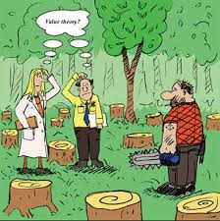
Ecosystem services are often public goods, which means that they may be enjoyed by any number of people without affecting other peoples’ enjoyment. For example, an aesthetic view is a wholesome public good. No matter how many people enjoy the view, others can also enjoy it. Other services may be pseudo-public goods, where at a certain level of use, others’ enjoyment may be diminished. For example, a public recreation area may be open to everyone. However, crowding can decrease peoples’ enjoyment of the area. The problem with public goods is that, although people value them, no one person has an incentive to pay to maintain the good. Thus, collective action is required in order to produce the most beneficial quantity.
Ecosystem services may also be affected by externalities, or uncompensated side effects of human actions. For example, if a stream is polluted by runoff from agricultural land, the people downstream experience a negative externality. The problem with negative externalities is that the people (or ecosystems) they are imposed upon are generally not compensated for the damages they suffer.
Finally, if property rights for natural resources are not clearly defined, they may be overused, because there is no incentive to conserve them. For example, unregulated fisheries are an open-access resource – anyone who wants to harvest fish can do so. Because no one person or group “owns” the resource, open access can lead to severe over-harvesting and potentially severe declines in fish abundance over time.
Ecosystem valuation can help resource manager’s deal with the effects of market failures, by measuring their costs to society, in terms of lost economic benefits. The costs to society can then be imposed, in various ways, on those who are responsible, or can be used to determine the value of actions to reduce or eliminate environmental impacts. For example, in the case of the crowded public recreation area, benefits to the public could be increased by reducing the crowding. This might be done by expanding the area or by limiting the number of visitors. The costs of implementing different options can be compared to the increased economic benefits of reduced crowding.
In the case of a stream polluted by agricultural runoff, the benefits from eliminating the pollution can be compared to costs of actions to reduce the runoff, or can be used to determine the appropriate fines or taxes to be levied on those who are responsible. In the case of open-access fisheries, the benefits from reducing overfishing can be compared to regulatory costs or costs to the commercial fishing industry if access is restricted.
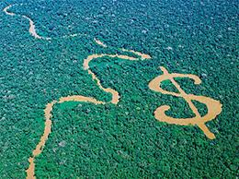
Ecosystem values are measures of how important ecosystem services are to people – what they are worth. Economists measure the value of ecosystem services to people by estimating the amount people are willing to pay to preserve or enhance the services. However, this is not always straightforward, for a variety of reasons.
Most importantly, while some services of ecosystems, like fish or timber, are bought and sold in markets, many ecosystem services, like a day of wildlife viewing or a view of the ocean, are not traded in markets. Thus, people do not pay directly for many ecosystem services. Additionally, because people are not familiar with purchasing such goods, their willingness to pay may not be clearly defined. However, this does not mean that ecosystems or their services have no value, or cannot be valued in monetary terms.
It is not necessary for ecosystem services to be bought and sold in markets in order to measure their value in currency. What is required is a measure of how much purchasing power (dollars, pounds, yen etc.) people are willing to give up to get the service of the ecosystem, or how much people would need to be paid in order to give it up, if they were asked to make a choice similar to one they would make in a market.
Economists classify environmental values into several types. The two main categories are use values and non-use, or “passive use” values. Whereas use values are based on actual use of the environment, non-use values are values that are not associated with actual use, or even an option to use, an ecosystem or its services.
Thus, use value is defined as the value derived from the actual use of a good or service, such as hunting, fishing, birdwatching, or hiking. Use values may also include indirect uses. For example, an Alaskan wilderness area provides direct use values to the people who visit the area. Other people might enjoy watching a television show about the area and its wildlife, thus receiving indirect use values. People may also receive indirect use values from an input that helps to produce something else that people use directly. For example, the lower organisms on the aquatic food chain provide indirect use values to recreational anglers who catch the fish that eat them and so on.
Option value is the value that people place on having the option to enjoy something in the future, although they may not currently use it. Thus, it is a type of use value. For example, a person may hope to visit the Great Barrier reef in Australia sometime in the future, and thus would be willing to pay something to preserve the area in order to maintain that option.
Similarly, bequest value is the value that people place on knowing that future generations will have the option to enjoy something. Thus, bequest value is measured by peoples’ willingness to pay to preserve the natural environment for future generations. For example, a person may be willing to pay to protect the Norfolk Broads area (photo below taken in the UK) so that future generations will have the opportunity to enjoy it.
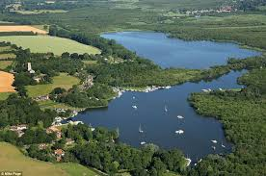
Non-use values, also referred to as “passive use” values, are values that are not associated with actual use, or even the option to use a good or service. Existence value is the non-use value that people place on simply knowing that something exists, even if they will never see it or use it. For example, a person might be willing to pay to protect the Amazon rainforests, even though he or she never expects or even wants to go there, but simply because he or she values the fact that it exists.
It is clear that a single person may benefit in more than one way from the same ecosystem. Thus, total economic value is the sum of all the relevant use and non-use values for a good or service.

Student Statement:

By submitting this assignment, I confirm that this is my own work.

Student Signature | Raymond Wilson | Date | 29th May 2015

For Tutor / Assessor Use Only
Total Marks
Marks Obtained
Percentage / Grade

