
Assignment Cover Sheet

Student Name: | Omnia Rafiq
Student Number: | 1343
Course: | Diploma in interior Design
Assignment NO: | 17

Student Statement:

By submitting this assignment, I confirm that this is my own work.

Student Signature | Omnia Rafiq | Date | 31-5-2015

For Tutor / Assessor Use Only
Total Marks
Marks Obtained
Percentage / Grade

Q.1 Multiple Choice Questions:

I. How many stages are there in a design project?
c) four

ii. The second stage of a design project involves;
a) the designer’s proposal and the client’s agreement

iii. The initial meetings with the client not only establish the brief but also helps the client to understand;
b) the whole process

iv. At which stage of a project survey takes place?
b) stage two

Q.2 Short Questions:

I. What is the importance of design analysis? How does it help the design process?
The initial meetings with the client not only establish the brief, but also help the designer to
‘Educate’ the clients so that they fully understand how the whole process works. If the designer writes a design analysis after the briefing session, it not only acts as the confirmation of the brief but also creates a memory bank. This might seem an unnecessary measure for just one room but since most projects involve several rooms its value can be clearly understood. The information collected here should help define the brief, give the client confidence and set out the fee structure.

ii. What are the important points to consider for the delivery of a successful presentation?
Before presenting the concept to the client, spending a little time anticipating questions that might come up can also pay dividends. It is important to pitch the presentation correctly. The designer must show respect for the audience and should retain the right degree of formality and professionalism for the occasion. Audibility, voice, projection, enthusiasm and pace all contribute to a successful delivery, as does the appropriate body language, posture and the use of eye contact.

iii. What is meant by ‘specifications’?
Specification is the stage that requires a great deal of time. This is a process where all the
Details in a scheme are pinned down. This process sometimes is as long as the original
Planning and design. If, for example, a designer specifies a lamp, consideration needs to be
given not only to the lamp itself but to the type, size, colour and wattage of the bulb; the
Size, shape, material and colour of the lampshade and the colour of the flex.

iv. Why is the procurement schedule prepared?
A procurement schedule is prepared to ensure that materials, finishes, fittings, equipment
And furniture are all available for installation. The designer must work hard to establish
Good working relationships with the suppliers to get the best possible service and help. If for
example, something is damaged on delivery, the designer should be confident that the
Suppliers will provide a replacement quickly.

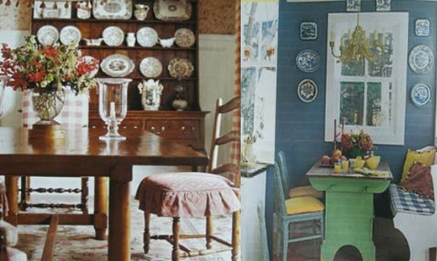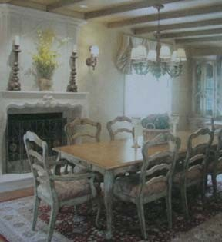FRENCH COUNTRY:

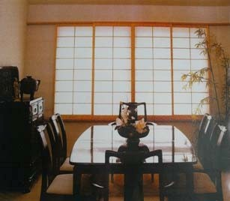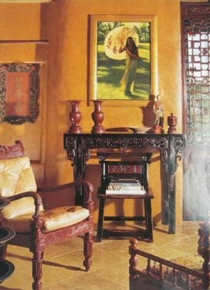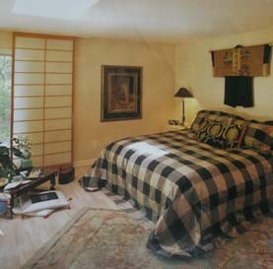ASIAN:

EARLY AMERICAN:

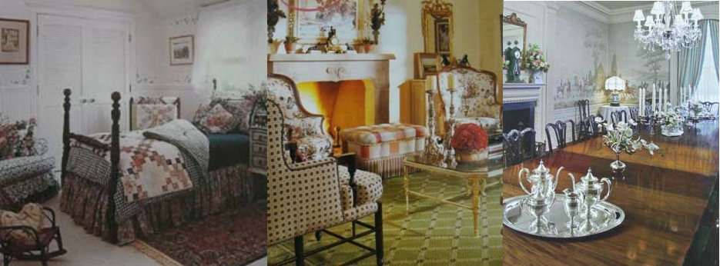
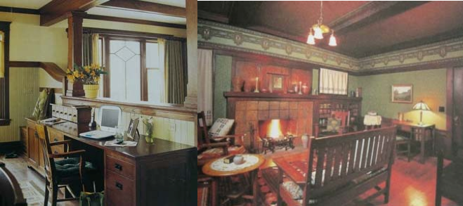MISSION:

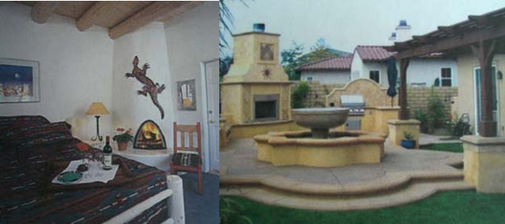SOUTHWESTERN:

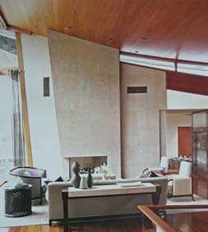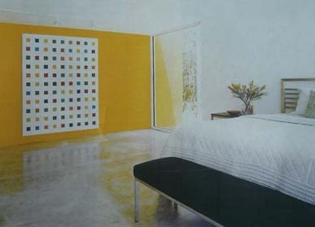INDUSTRIAL:

