Assignment 1

Q1 The definition of tourism and how it is different from Travel
Tourism is a leisure activity that is organised work. Tourism is the activity of a person travelling and staying in places that are different to their everyday life or a normal environment for no more than a year. There are three different types of tourism which are leisure, business and visiting friends and family. When a person travels they usually travel alone whereas if they travel for leisure they are often with others. People wanting to travel take part in activities because they choose to, there may be a certain event they wish to attend such as a wedding, or a hike.
Q2 What is the difference between inbound and outbound tourism?
Inbound tourism is where the tourist enters a country for example someone from England wants to go on holiday and they are not a resident in another country and outbound tourism is where the person leaves their country and travels to another for example someone from france may decide to go to Austria for a business trip or the holidays .

Q3 What is business tourism? Discuss its main types
Business tourism is where people have travel during their business life to somewhere they wouldn’t normally travel to this may mean travelling to a meeting or a conference in another country. Some travel and tourism business rely on the income made from the workers that travel to other countries.
Main types of Business Tourism
- Business Meetings
Business meetings may mean people have to stay away from home in hotels next to motorways or near rail stations.
- Trade Fairs
Trade fairs attract thousands of visitors, companies have the chance to pay for a display at the fair to promote or show their products and business to their customers. It also gives businesses a chance to have a conversation possibly regarding feedback or ideas on how else they can promote the business.
- Conferences and Conventions
A wide variety of businesses/ companies hold yearly conferences and conventions which hundreds attend will mean that people need to travel or stay away from home for the duration of the conference/ conventions.
- Corporate hospitality
Companies usually entertain their guests whilst they visit on business terms for example providing tickets for an event for example a ball or a sporting event.
Activity My chosen country is India
“The Lake Palace in Lake Pichola in the city of Udaipur was built as a royal summer palace in the 18th century. Today it is a luxury 5 Star hotel, operating under the “Taj Hotels Resorts and Palaces”. The Lake Palace hotel operates a boat which transports guests to the hotel from a jetty at the City Palace on the east bank of Lake Pichola.”. This is a natural attraction that would appeal to visitors from the UK because its in the middle of a lake and its not everyday you see a hotel in a lake, it also has an outstanding view and provides people with historic knowledge as well, this would also be good for tourists from the UK to visit because of the scenery people may to want to go here to take pictures and have good memories and to see the amazing scenery.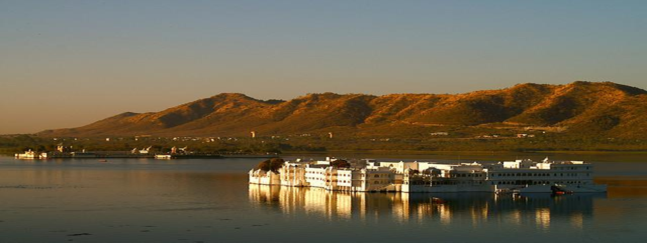
The next place I have decided to choose is the Virupaksha Temple. “The Virupaksha Temple in the city of Hampi started out as a small shrine and grew into a large complex under the Vijayanagara rulers. It is believed that this temple has been functioning uninterruptedly ever since the small shrine was built in the 7th century AD which makes it one of the oldest functioning Hindu temples in India.” This would be good for UK tourists to see because it’s a mixture of a natural and cultural attraction, it also has a lot of history behind it as it was built in “7 th century AD.” This makes it cultural as because “it’s one of the oldest temples in India” and it helps to represent the indian culture. 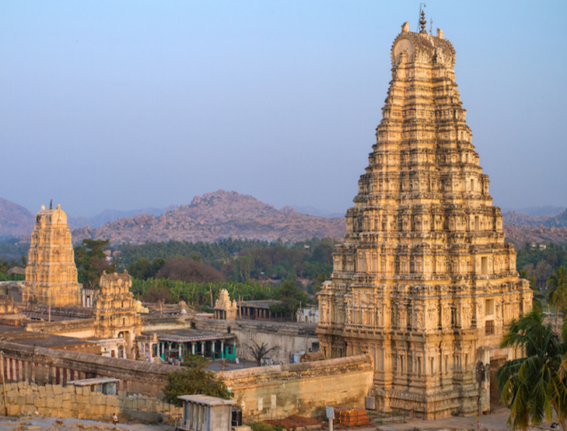
The next natural attraction is Palolem. “Palolem is the most southerly of Goa’s developed beaches and also one of the most beautiful. It is a natural bay surrounded by lofty headlands on either sides, resulting in a calm, idyllic sea with a gently sloping bed. For those who believe a beach cannot be paradise without a decent selection of cheap restaurants and good hotels, a dose of nightlife and plenty of like-minded people Palolem is the place to be.” This would be good for the tourists to see as it shows off the beautiful scenery and is very different from a UK beach and it would provide tourists with amazing memories, pictures and a very pleasurable experience.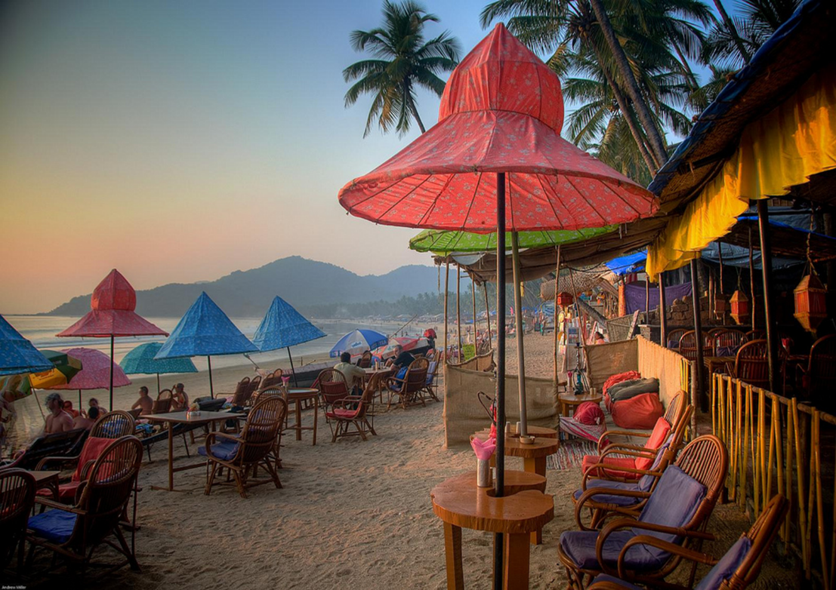
The next natural attraction is Kanha National Park this is a natural attraction and also includes media influences in to it, it provides beautiful wildlife, amazing memories, mesmorising scenery and very good oppurtunities that will stick with the UK tourist forever. “Kanha National Park is among the most beautiful wildlife reserves in Asia and one of best places to catch a glimpse of a tiger in India. The lush sal and bamboo forests, grassy meadows and ravines of Kanha provided inspiration to Rudyard Kipling for his famous novel “Jungle Book” and make this one of the top attractions in India.”

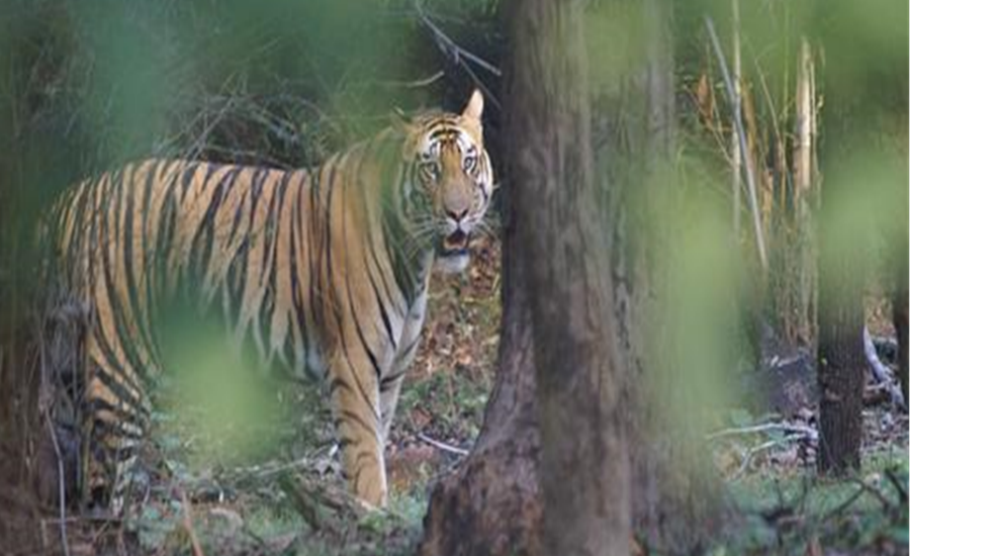
A cultural attraction in India is Diwali “Celebrated by Hindus, Sikhs and Jains worldwide, Diwali is not only one of the most popular festivals of India, but also one of the most vibrant among all festivals of the world. Diwali – the festival of light is celebrated every year on 15th day of Ashwin month (October/November). Representing the victory of goodness over evil, the festival of Diwali is indeed an inseparable part of rich culture of India dating several thousands years back.
The 5-days long festival of Diwali (which means a row of lamps) is celebration of lights, fireworks and puddings. Many of the widely known mythologies have it that celebration dates many thousands years back. As Dussehra (one of another most popular festival of Hindus) marks the victory of Hindu God, lord Rama, over the demon king Ravana, the festival of Diwali marks the arrival of lord Rama to his home, Ayodhya. Not only Hindus, but also Sikhs and Jains all over the world celebrate the spirited fest by lightening candles and diyas (earthen lamps) to welcome the goddess of wealth, Lakshmi.
The festival of Diwali is not only about lightening diyas and enjoying fireworks. The 5-days festival is full of religious and traditional activities taking place everyday. First day of the festival is Dhan Teras (an auspicious day for shopping) and second day is Naraka Chaturdashi. The actual Diwali is on third day, when the moon in the sky is totally nil, and light of diyas and candles makes the night gleaming and full of revelry. The 4th and 5th day of the celebration mark Padwa and Bhayiduj.” This is very cultural and good for UK tourists to go and see it brings lots of communities together and helps people understand the culture of India, it also makes citizens of the UK realise how the indian culture is different to ours.
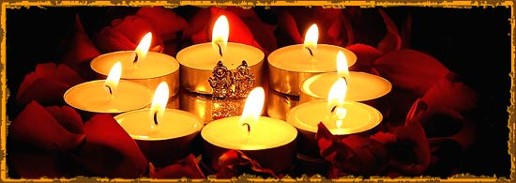
The next is a cultural attraction called Onam. “Celebrated with great pomp and show in Kerala, Onam is the annual festival of the state. The biggest and most popular festival of Malayalee (inhabitants of Kerala), Onam is harvest festival of the state. Significant among all cast, creed and faith, the festival of Onam with its rich customs and tradition is a great cultural fiesta.
The 10-days running festival takes part in the month of Chingam (August-September), the first month of the Malayalam year. Onam is basically a harvest festival, which also finds deeper association with several of Hindu mythologies and folklore. As the widespread mythologies says, the festival marks the homecoming of demon king Mahabali. The jubilation of Onam is greatly celebrated with much of its extravagance at places like Trichur, Tiruvantapuram and Kottayam. Enjoying the cultural and religious magnificence of the festival is a wonderful joy.
Rich in its rituals, the carnival of Onam brings the affluent culture and tradition at its best. The floral arrangement (Onapookalam), the grand lunch (Payasam) which includes 21 kinds of curries and 3 types of sweets, and songs and dance are arranged to welcome the king Mahabali, as it is said that it is the one day the king visits his kingdom. The large cultural procession at Trichur and snake boat race at the Pampa river are the two most remarkable attraction of the festival, for which the festival is widely known.” This would be a great attraction for UK tourists because it gives them a chance to join in with the activities, see different communities come together and try indian cusine.
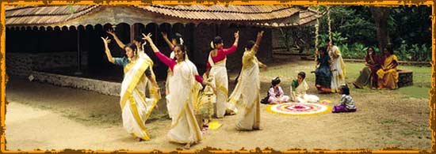
“The final cultural attraction is performing arts, “Multifaceted culture and heritage of India, in true way, is the biggest asset of the country which dates thousands years back to period of earliest civilization. Blissfully, the country still preserves its rich culture and heritage in various of its forms like arts, crafts, religion, philosophy and tradition.
Performing arts, being the innate form of Indian culture and heritage, has been celebrated in the country for thousands years. Be it music, dance or theater, every form of performing art of India is known for its uniqueness and symbolise its age-old rich culture and tradition.” This would be good for UK tourists to go and see because it explores the indian culture from a different perspective and gets everyone together it also provides history.
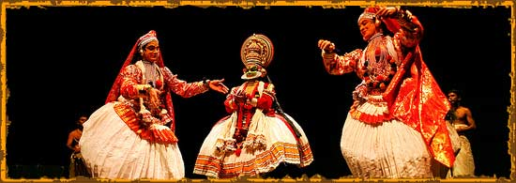

Weblinks I have used
Travel and tourism study guide
http://www.cultural-heritage-india.com

