
Assignment Cover Sheet

Student Name: | Sumbal Jamil
Student Number: | 1149
Course: | Fashion Design
Assignment NO: | 7

Student Statement:

By submitting this assignment, I confirm that this is my own work.

Student Signature | Sumbal jamil | Date | 14-1-2014

For Tutor / Assessor Use Only
Total Marks
Marks Obtained
Percentage / Grade

2. Which type of materials should be chosen for the dress of a thin person? And when choosing a stripy print which type of stripes would you recommend for the dress of a thin person?
Answer: The rectangle body shape is defined generally as a woman with a body shape that features similar or identical waist, hip and shoulder widths, similar to a tower or building. The rectangle body doesn’t feature curves.
- Material for the dress of a thin person:
1. Material which do not cling to the figure.
2. Lustrous material.
3. Materials that stand out somewhat from the figure.
4. Clothes with frills, fluted edges and ruffles will create volume which will give feminine curves.
5. Light fabrics give the illusion of curves.
- Stripes for the dress of thin person: Vertical and horizontal stripes both looks great on a thin person.
1. Vertical stripes (running up and down the length of the body) make the look sexier and slimmer as well as it adds height.

2. Horizontal stripes, on the other hand, often look unflattering on many body types because they’ll make the widest part of your body look even wider. This is true even on slender body types.

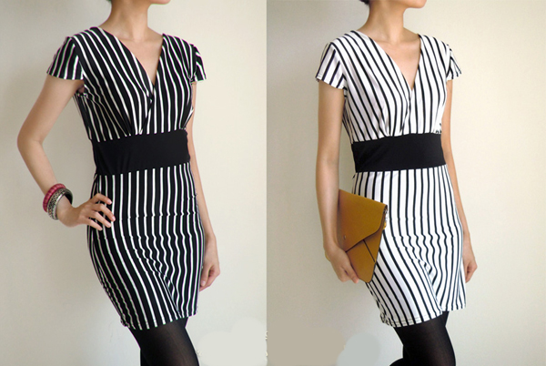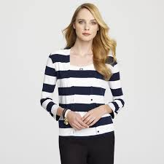
Vertical stripes horizontal stripes

3. How would you design a dress for a person with large waist and hips? Which designing techniques would you apply?
Answer:
- First of all, since a lot of attention is going to be drawn to the top part of the body, so get a good fitting bra.
- Tops that highlight body at the slimmest point which is often just underneath bust. They should have enough space for belly but not be too wide.
- T-shirts that is rushed in the middle. This will confuse the eye and can’t tell that there’s a big tummy underneath.
- Tops with a V-neck to break up the size of chest and create a lean line.
- Tops with a thicker texture that don’t cling so much. Woven tops can be great.
- Patterns tend to look very good on a apple shape body as they flatter and camouflage.
- Tops should cover the whole belly area and end just below the hip bone.
- Shirts look nicest when they are tight just underneath the boobs and then go out.
- Tailored jackets have a nice v shape at the top.
- Having a tie at the waist is great as it highlights the waist and hides the belly.
- A straight duster coat that ends just above the knee will create a nice long silhouette.
- Make sure that the jacket fits the shoulder perfectly, so choose the size for shoulders, not belly. If can’t close the jacket, then use a scarf to fill the gap if you like.
- Dresses should have their waistline just below the bust.
- It’s always good to have some detailing on the tummy area for camouflage.

Bottoms
- Trousers that have zippers at the side to avoid adding extra bumps on the front.
- Trousers should be wide or straight and not cling to tummy or thighs.
- Jeans that is tailored and wide legged.
- It’s best to get trousers with some stretch for extra comfort and a good fit.
- Skirts that have their zippers at the side.
- It is important that any pleats of skirts start below the belly to avoid adding extra volume.
- From under the belly skirts should hang straight.

4. A person with stout figure must never try wearing a dress which is too tight for her. Discuss.
Answer: A person with stout figure must never try wearing a dress which is too tight for her because this merely emphasizes the figure. Just as the thin person must create a horizontal movement of line, the stout person must obtain a vertical movement by the use of devices which will cause the eye to travel up and down rather than across the dress. The stout should avoid extremes in dress, as, for example-very short or very long skirts, very tight sleeves, or the flowing variety. A long V line to the neck is always desirable. When selecting a fur coat for a stout figure, never take a raccoon or any long-haired fur, for it has bulky appearance. Mink, squirrel or seal are much better.

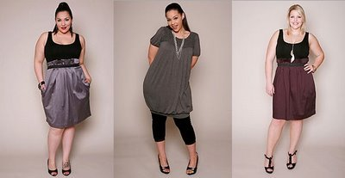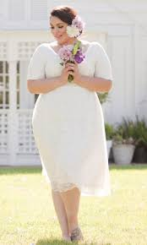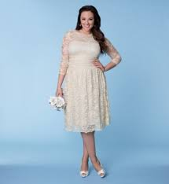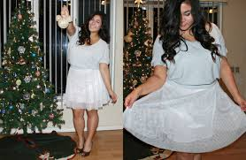
Some suitable dresses for stout person

5. How would you design a dress for a person with round shoulders so this problem is least noticeable?
Answer:
- For rounded or sloped shoulders, adding shoulder pads t square off frame and appear upright. Using them with everyday outfits not just for special occasions will be great.

- When we have round shoulders we want to avoid necklines that are equally wide and thick that add mass to an already full area. Instead, round-shouldered beauties should opt for necklines that contain a deep, plunging V-neck or U-neck design because they cause the eye to travel downwards and inwards, taking the focus off of our shoulders. Also, if the neckline of a top or dress is too wide, it stretches horizontally, which makes everything on our upper body appear larger, including our shoulders.
We should avoid anything with extra detail or anything that cuts off our arm. This means cap sleeves, puffy sleeves, pleats at the shoulders and ruffled detail on the upper part of the arm. Alternatively, look for sleeves that have more fabric and a fuller design, such as kimono or dolman sleeves because the cut of the sleeve softens the severe nature of our shoulders.

- We should let our shoulders be the center of attention -- the best dresses guide people's eyes wherever we want them to go. Color and prints can accomplish this task; a dress that has a print on the lower half guides eyes down. Our other strategy is to guide eyes up from the shoulder. It can be done by going with a dress that has a deep V-neck -- it not only showcases our cleavage, but it pulls the eyes up to our face.
- Blazers look best on people having round shoulders. Blazers are pulled off the best by people who have shoulders to pull it off. And if we leave the blazer open it basically makes slim our body line. Generally darker and neutral toned blazer would probably work best.

Activity
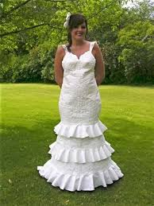
Dress (A): Body shape: Apple
Problems in dress or faults:
1. Stiff fabric
2. Ruffles
3. Extreme long waist makes the lower part too heavy.
4. Tight garment.
5. Poor silhouette according to body shape.

Corrections:
1. Soft yet not cling fabric.
2. Ruffles should avoid.
3. Normal waist line or slightly above or below it.
4. Semi fitted, rather than tight effects in the dress as a whole.
5. Silhoutte should be like empire-waist, A-line dress or ball gown dress. Some examples are given below for the good silhouette on apple shape body.

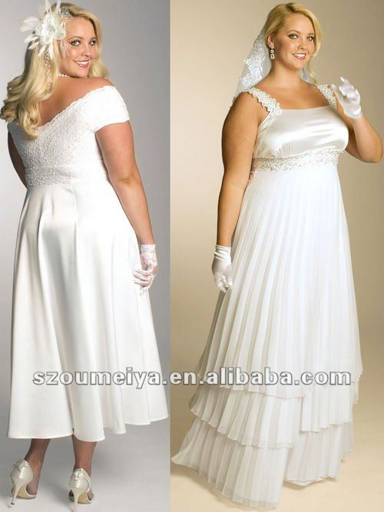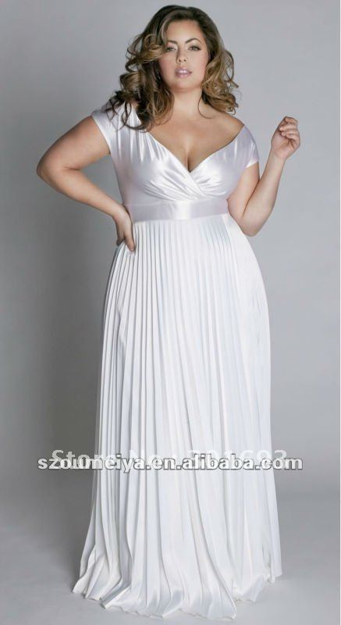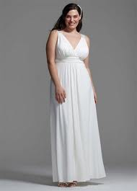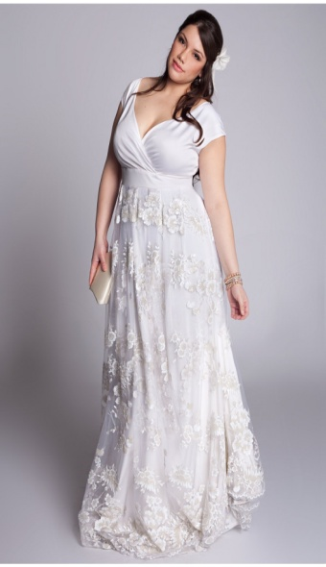

Dress (B)
The rectangle-shaped woman is the body shape we all know well and recognize from the catwalks. It is the body shape of all the models and many celebrities! The rectangle woman is thin and is characterized by waist, hip and shoulder widths that do not differ much from each other.
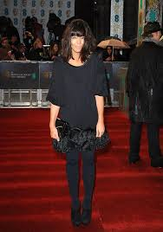
Body Shape: Rectangular
Problems or faults in dress:

1. Same color on top and bottom looks poor and dull.
2. Shapeless top emphasize rectangular body shape and lack of curves.
3. Silhoutte is very poor.
4. Vertical lines making body even more elongated and thinner.
5. Waist is not defined which is the most important outfit goal.
Corrections in dress:

1. Bright, eye catching color helps to give shape to rectangular body shape. Color on top and bottom should be different. It looks great. Bright colors are perfect for this shape.

2. Top should add curves to top half and create a nipped in waist. It is important to make sure the nipped shape is at the waistline.

3. Silhoutte that create curves from waist up and waist down.

4.Belts are best wardrobe that trim waist in flash and are great to create waist. Belts in dark or muted color without any embellishment are best to define waist.

Dress(C)
Body Shape: Diamond
As a Diamond body shape, your hips are wider than your bust and shoulders and you have a full midsection. You tend to gain weight in your stomach and hips and your waist is not very defined, and full. Your upper legs are also a bit full, but your lower legs are well shaped. Your arms are slender.
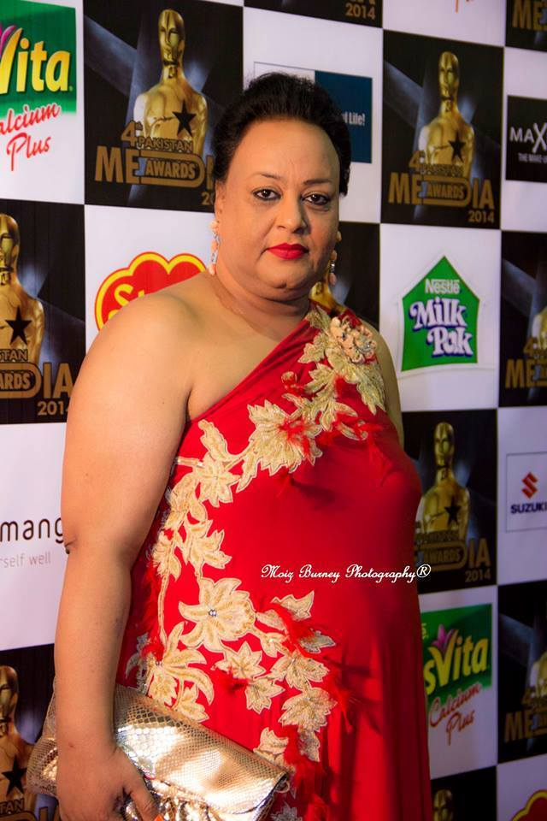
Problems and faults in dress:
1. Bright colour in large area looking bad.
2. Overall fitted, patterned garment.
3. No neckline.
4. No sleeves.
5. No curves.
6.Poor silhouette.
Corrections:
1. Dull colour in large area looks great.
2. The key to dressing a Diamond body is to balance shoulders and bust with hips while creating waist. This is achieved by choosing clothing that adds curves and fullness to upper body with appropriate clothing cuts. Such as empire waist dresses balance the diamond shape body.
3. Asymmetrical cuts or patterns, or patterns with diagonal lines will divert focus from midsection.
4. Necklines that are wide such as boat necks can bring the eye across the shoulder and thus minimize the tummy.
5. Capped sleeves to broaden shoulders or long set-in sleeves.
6. Adding volume to shoulders and fitted clothing at the waste will create the perfect curves. The goal is to take the attention away from the midriff.

