
Assignment Cover Sheet

Student Name: | Annur Zara Liyana Othman
Student Number: | 1227
Course: | Diploma of Fashion Design
Assignment NO: | 04

Student Statement:

By submitting this assignment, I confirm that this is my own work.

Student Signature | 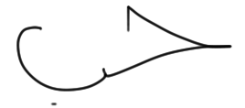 | Date | 2nd June 2014

For Tutor / Assessor Use Only
Total Marks
Marks Obtained
Percentage / Grade

The Process and Structure of Fashion Industry

Q: 1. Give short answers for the following questions:
l. What is meant by market segmentation?
Market Segmentation is one of the processes in fashion industry that involves dividing a broad target market into subsets of consumer who have common and priorities, and then designing and implementing strategies to target them. The segmentation targeting and positioning section of the marketing plan is one of the most important. Usually through research, uncover similarity in the entire buying market and then segregate them accordingly to trends and similarities, the forming segments once the design company have their segments, they will select one or more segments, they will select one or more of the most profitable or appealing segments to target and then find their target market. Research and segmentation is vital because without understanding exactly who the market that they will be aiming their product and all communications in the wrong direction.

II. “Design is a visual thinking, perhaps of a higher order than verbal thinking”. Explain
Season by season, designers try to come out with unique idea to apply in their collection in hope it can be a fashion. There are few factors that influence fashion designer for creating new style. One of them is visual influence. Designer will observe what happen in the surrounding which mean they are inspired from what they see. For example, some garment designer has create a new design of fabric and if its match designer’s want, its going to be chosen for their new design. In other word, designers will always keep their eyes open for interesting garments. Because sometimes, new trend start from consumer and later then, designer will create clothes based on what “in” on that time. Designers tend to watch people on the street or the parties and take inspiration from street fashion. Furthermore, Photographs of the garments, artefact and images natural object are the few sources, which inspired the designer for creating their new design. For example, nature colour like sky blue and green grass always is one of the factor designer’s designs. For verbal factor, which is can be refers as design idea that come from communication also can be inspiration to designers. But since human brain likely to trust and believe soon love something that they see. So, design is a visual thinking, perhaps of a higher order that verbal thinking.

III. Explain briefly the developing of a sample garment.

Sketching
This is one of the step making a new style. Designer will sketch out their ideas on a paper. The designers can see two-dimensional sketch and this can allow them to imagine new garment will look in three dimensional when made up in the fabric. They will make a rough sketch first but still have to accurate for the patternmaker understanding. In the sketching, notes and measurements usually included.

The First Pattern

The next step in the design procedure in development of the first pattern, the pattern used to cut and sew the sample garment. In the sample size, it used for testing and selling purpose. The two method that patternmaker can use draping or flat pattern.

Draping method
Draping method can be refers as the patternmaker will cut a fabric into the dress form. So the designers can see proportions and line of the design cleanly. Then, the design can be form by altering it on the wearer. On this process, every detail will be markdown. Once designer is satisfy with the look it will taking of from the wearer and designer start to drafting curves, angels, and rules later then the pattern will be reduce on heavy paper.

Flat Pattern Method
Flat pattern method is important for areas like sleeves and pant leg side. These areas are difficult to be drape on a figure. Base shapes are drafted out which known for blocking out on pattern and soon, after being tasted for accuracy, it become blocks or slopers that later can be adjust to the new styles by moving the darts and seams.

The Sample Garment
After the pattern being drafted on the hard paper, it’s will be laid out on the fabric then soon being traced and cut by assistance designers. They can create the first sample or prototype. The sample marker who the best sewer in the factory will be the one who make it. The sample markers will always working with design staff in case there is any question about the design in the making process. After that, they will make a model to wear that to make sure it fits well even in the motion. The designers themselves are their own critics. The design must be the same as in the first sketching or else it will be alter.

The Design Work Sheet
The detail records will be keeping on as they develop. Designer’s work sheet containing the guides procreation department in figuring cost and in ordering fabrics and trimmings. When final line is selected, the work sheet becomes an adoption sheet.

Style Board
As known for master the master plan. The development of the whole process of the line is chart in a board on the wall of design room. Styles are being adjusted and alter until the line is established. It’s also help to keep track of production schedules.

Line Selection
Designers create 2 or 3 styles of each line and they will choose the best for that line. Many styles are weeded out, until they found the best combination of the fabric, syle and prize. The line must be well present and able to explain itself to the consumer in the store. The visual impact have to great to impress consumer since designer cant be in the store to explain the design.

Duplicates
Duplicates are copies of the original sample garments. It will send to sale person across the country to show to buyers. Its also use for guides in production at the factory. The quality control and good test in production are offered because they will make in factory.

The Couturier
Based on French word for fine. Couture can be refers as custom dress design. A couturier is a couture designer; a couturiere is his female counterpart. The clothes must be measure for particular costumer.

Houte Couture
Based of French for needlework. Its made for specific costumer and the styles are made from a huge quality; expensive fabric and sewn with extreme attention to detail and finish, often using time consuming, hand-executed techniques.

Prêt-A-Porte
French word for ready-to-wear. Its already famous since 1980. Every houte couture house also has own prêt-a-porte collection. The extreme houte couture’s are rarely sold so by this method, it proved that it could be sold easier. Some houte couture house no longer consider as one because their ready-to-wear are sold well.

Line
After the fabric selection, designer must considering the other elements of good design. It’s closely related to visual interest. Line direction should flow from one part of the garment to another and should not being meaninglessly cut up. Straight line will offer crispness such as tailored garment, curved lines imply fluidity. This two type of lines have to move together to make it look good to human form.

Knockoff
It’s a copy of someone else design. The company who did this particular garment, make a pattern from similar fabric, and manufacture the garment. The cost will be lower since they made in a large quantity.

Avant Grade
The fashion leader can be refers as arrant grade because they usually will combine the unique fashion whether it from the designers, small boutiques, or vintage store. The basically design their own styles.

Bridge
This is the method to allow average consumer buy the designer’s clothes. It made from the cheaper garment and sold in lower price. For example, CK from Calvin Klein and Donna Karan’s DKNY.

IV. What is a CAD system and how it has revolutionised the fashion industry?
CAD is stand for Computer-aided design. This system is use for assist in the creation, modification, analysis, or optimization or the design. CAD software is used to increase the productivity on the designer, improve the quality of the design, improve communications through communication and create database for manufacturing. In fashion industry, CAD is used for showing the designer’s idea in more clearly way. CAD becomes an essential tool for pattern making and related job in garment industry. In fashion industry CAD software is used for pattern making, grading or pattern, marker making and digitizing manual pattern.

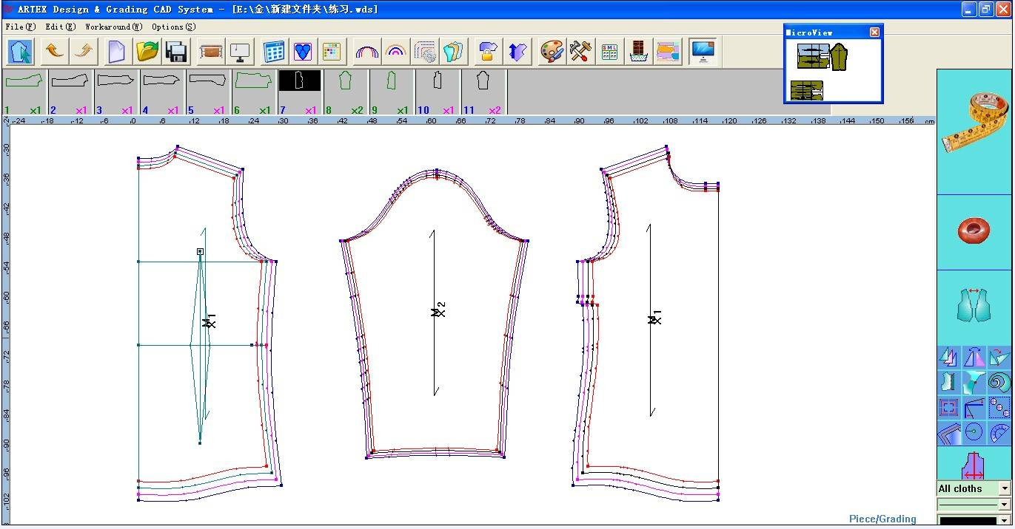

Example of a digital pattern done by CAD software.

Project: Market Research
a) Compare two dresses of similar price by two different designers, try them on. Which one has the best fit? Compare fabric choices in terms of quality and suitability to the design. Compare styling which is more innovative? Which dress is the best buy? Sketch both the garments

VERSACE

Borocco Pop Splash Silk Dress
Prize 1360 £
Review – This silk dress is a lovely foray into feminine effortless dressing. The print and metallic fringe on the neckline illustrate Versace's approach to daywear: relaxed but always remarkable. It is a refreshing alternative to a T-shirt dress. Team it with sandals and a shopper.

Size – Loose fitted and fits true the size
Detail & care – Thin straps, button-fastening keyhole back, metallic fringes on the neckline, belted.
100% silk
Dry clean

Fashion Sketch
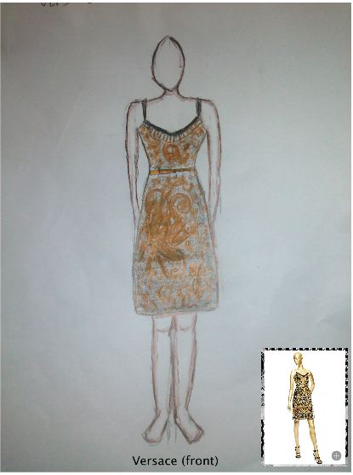

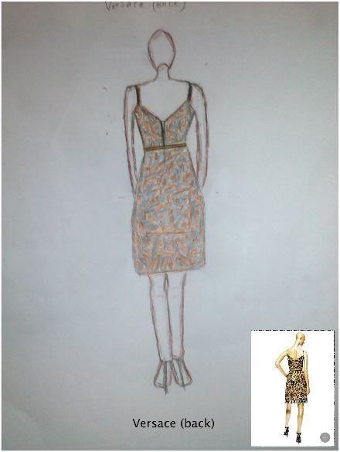

DOLCE&GABBANA

Wheel and Prickly Pear Print Sheath Dress
Review – This dress give a fresh look for spring/summer season. Ruched sundress with wheel and prickly pear print; printed viscose cady, wheel and prickly pear print on a white background. The dress length is below the knee; lined.
Size – Slim fit
Detail, material & care – Lining 100% Viscose
Dry clean

Fashion Sketch

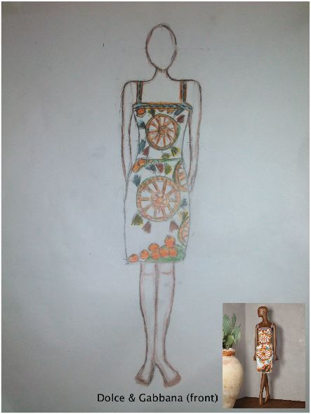

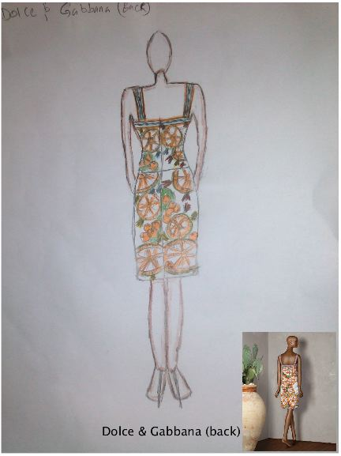

Comparison
Personally, the Dolce&Gabbana dress fitted better and feels so comfortable. The print style really looks lovely and gave a calm mood. The colour is really match the season. Meanwhile, The dress from Versace gave a comfort feel from usage of silk fabric. But, the printing style is a little heavy for this season. However, this dress got the metallic fringe on the neckline, which is gave an expensive and chic mood.

b) In a local department store, compare contemporary and junior departments. List the major manufacturers in each department, and explain the general styling differences.
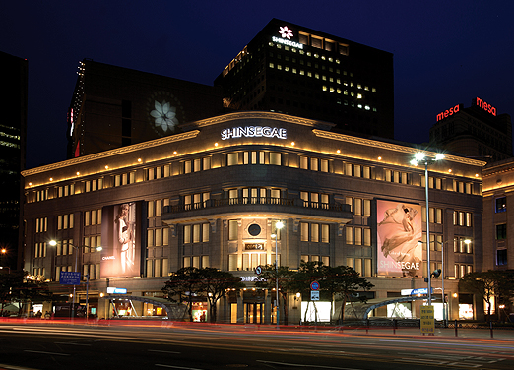

SHINSEGAE DEPARTMENT STORE MYEONGDONG, SEOUL SOUTH KOREA
This is one of the biggest department store in Seoul, South Korea. It has 14 floors starting from cosmetic, imported brands, Designer brands, Designers bridge brands, cotemporary, junior, luxury boutiques and ect.
List of store/brand in Cotemporary department
CALVIN KLEIN PLATINUM LABEL
ELIZABETH & JAMES
IRO
VANESABRUNO
JILL STUART
LOVE MOSHINO
MARC BY MARC JACOBS
VIVIENNE WESTWOOD
KENZO
CLUB MONACO
THEORY LADIES
DKNY WOMEN
JILSANDER NAVY
ZADIG & VOLTAIRE
MAJE
DVF
BEAKER
BLUE FIT
G-CUT
LUCKY CHOUETTE
RAUM
BARBOUR
PAUL &JOE
SONIA BY SONIA RYKIEL
RALPH LAUREN
UGG
SANDRO
DEWL
TOMBOY
STEFANEL

Casual Cotemporary
BOON THE SHOP & COMPANY
HENRY BEGULIN
MCQ
CARVEN
3.1 PHILIP LIM
ACNE STUDIOS
ALEXENDER WANG
ISABEL MARANT
RICK OWENS
NEIL BARRETT
TER ET BANTINE
PAUL SMITH
DOROTHEE SCHUMACHER

The major styling is based on the season. Most of the store has lots of line for spring/summer season. As seen in there, Techno fabric are widely chosen since in in summer it will be rain hard here. Also, the flower printed fabrics are famous now. The colour became so much soft and sweet. Even though the designers have their own style in creating clothes, they always follow the trends and season in order to make people accept that style.

List of store/brand in junior department
KIDS STYLE
BURBERRY
CHILDREN
BAPE KIDS
BONPOINT
MLB KIDS
BENETTON KIDS
BLUEDOG
DAKS KIDS
CAN KIDS
BB HOUSE
ORGANICMOM
ORCITE
GAP KIDS
BEAN POLE KIDS
BOON JR.

MOONYAMOONYA

BLUEDOG BABY
CHOCOLAT
PACO RABANNE BABY
ABSORBA
MINKMUI
ETTOI
BEEN
TIFFANY & CO.

NEW BALANCE

KIDS
FELA KIDS
LEVI’S KIDS
GUESS KIDS

The major styling in junior department is based on the season. As seen in the stores, the spring pattern as almost conquers the whole of this floor. In most of store, they also have a round year collection. Lines are qualified by their size. Techno fabrics are widely chosen and the colours are very bright. Its gave a fresh look.

The general styling different
As soon as we step into cotemporary department, we can see the colours are very nice and sweet. The flower printed styles are widely used. For this department, most of the brand really follow the season and only display the spring/summer season’s collection. For handbags and bags there is no season for that. Probably some brand got that, but most of them just have and display the round year handbags and bags collection.
Meanwhile, the junior department show a bright full look. The colour such as pink, blue, green and yellow are widely used. Flower and nature printed also easy to be seen in this floor. Most of brand try to display more the summer/spring collection, however some are still keep displaying the round year collection. Some even display the clothes that made from thinner fabrics or fresh look fabric from the last autumn/winter collection.
Overall, the cotemporary department and junior department both have the similarity because the commitment with the season. The cotemporary department goes very close to summer/spring collection and for junior department they tend to mix the collection with this season and round year collection. Also, this is the beginning of season off. So, most of the stores give discounts to the summer/spring collection in order to sell it to the very last piece.

