Kyle Pentland
1605
Assignment 2
Diploma in Environmental Management

Page 1

Q.1
I. The earth has three regions, which makes up its atmosphere. These regions are called the troposphere, mesosphere and stratosphere. The stratosphere is between ten and fifty kilometres from the earth’s surface and within this region is the slightly, odourish metallic smelling, bluish gas called ozone. Ozone is made up of molecules each containing three oxygen atoms or O3. Ozone acts as an efficient filter against harmful uv-b rays. It is produced in the atmosphere and also where it is destroyed. The table below illustrates this.
Ozone Production in the Stratosphere
High energy ultraviolet radiation strikes an oxygen molecule | and causes it to split into two free oxygen atoms
The free oxygen atoms collide with molecules of oxygen | to form ozone molecules

Page 2
II. In humans, increased UVB exposure causes non-melanoma skin cancer and malignant melanoma development. It has been linked to cataracts (a clouding of the eye’s lens) and a suppressing of the immune system. In animals, Solar UVB radiation causes damage to early developmental stages of fish, shrimp, crab, amphibians and other animals. The most severe effects are decreased reproductive capacity and impaired larval development. Therefore, less food further up the food chain that feed on these animals.
III. Global warming is an increased level of greenhouse gases (namely carbon dioxide from human industry, land use and deforestation) into the atmosphere, affecting the natural composition of gases and temperature. These greenhouse gases act like a blanket, trapping the sun’s energy. The productivity of crops and livestock decline because of higher temperatures and drought-related conditions. Rainfall patterns and severe precipitation events may delay planting and harvesting. An example of this is rainfall decreasing 20 percent in southern Europe whilst increasing 10 to 40 percent in northern countries in the twentieth century.
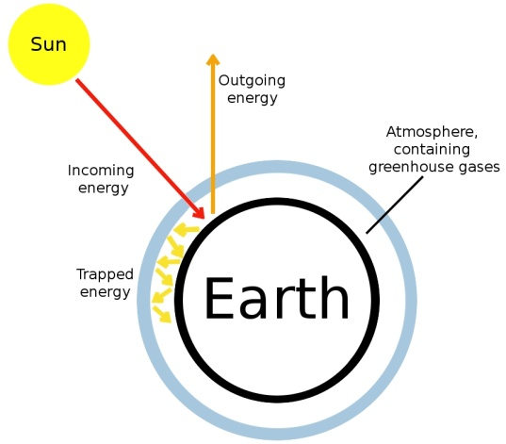
IV. Biodiversity envelopes all living species on Earth and their relationships to each other and the environment in which they live i.e. rainforest, coral reef, savannah, water and the plant animal life contained within them. There is diversity on the genetic level within populations, i.e. micro-organisms; diversity within ecosystems among the species that inhabit them, i.e. plants and animals; and even diversity among ecosystems, i.e. rivers, marshes and forests. Every living thing has a purpose or it would not exist within this biological diversity.

Page 3
V. Climate change and even very slow, gradual climate change is one ingredient that ecosystems need to survive. However, if change is sudden, the plant and animal life does not have time to adapt and die or as a result, as well as any other species that depend on them. Most ecosystems are interconnected, so the chain reaction of effects could be immeasurable. The results could be something like a forests gradually dying off and turning to grassland or entire coral reefs dying. Many species of plants and animals would adapt or move to deal with the shift in climate, but many would become extinct.
Q.2
Deforestation: Fulfilling the resource requirements of a growing population ultimately requires some form of land use change to provide for the expansion of food production through forest clearing. An example of this would be slash and burn tactics used by cattle ranchers for the beef market. This leads to further CO2 being released by the dead trees and methane which is twenty times more potent than CO2 being released by the cattle.

Water pollution: A country like China is one of the fastest growing both economically and by population. As people migrate to the city, waste also increases. A large number of cities/towns either do not have any sewerage system or the sewerage
Page 4
system is overloaded. This means waste products from industry, business and homes gets into the rivers. Widespread consequences of water pollution upon ecosystems include species mortality and biodiversity reduction. An example of this is the extinction of the Yangtze river dolphin.
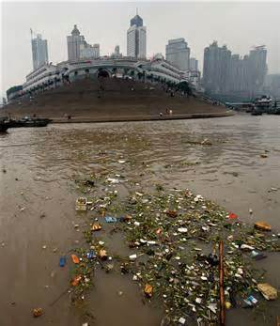
More frequent natural disasters: Hurricanes, floods and other environmental hazards damage and/or destroy agriculture, livestock and fishing infrastructure. An example of this was in 2010, when heavy monsoon rains in north-west Pakistan caused flash flooding. The floods destroyed 3.3 million hectares of crops and 2.4 million hectares of agricultural land, directly affecting 20 million people.

Page 5
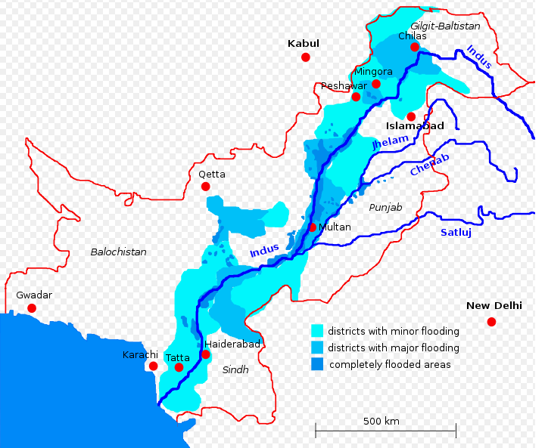
Population distribution: Environmentally, the distribution of people around the globe has three main implications. First, as less-developed regions cope with an increasing share of population, pressure intensifies on an already dwindling amount of resources within these areas. Second, migration shifts relative pressures exerted on local environments, easing the pressures in some areas and increasing it in others. Finally, urbanization, particularly in countries like China and India, frequently outpaces the development of infrastructure and environmental laws, often resulting in high levels of pollution.

Page 6
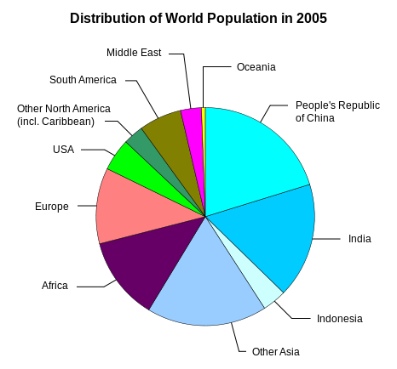
Technology: Current technological usage, policies, and culture are influential in the relationship between human population dynamics (urbanization) and the natural environment. The technological changes that have most affected environmental conditions relate to energy use and their release of carbon dioxide. The consumption of fossil fuels i.e. coal, increased dramatically during the twentieth century. Until about 1960, developed nations were responsible for most of this consumption. Since then, however, industrialization in the newly developing nations has resulted in greater reliance on resource- intensive and highly polluting production processes.

Page 7
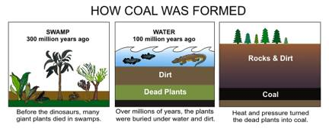
Q3:
Climate change was first recognized as a serious threat in February 1979. It was the first serious meeting held by scientists from around the world. Its purpose was to assess the state of knowledge of climate and the effects of climate variability and how it would affect humans. The second major conference was in Geneva in 1990. It reviewed and reassessed the work done from the conference in 1979. It was a crucial step towards a binding global convention on climate change, which was signed by over 150 nations in June 1992, in Rio. It was the “United Nations framework convention for Climate Change”. It came into force in March 1994. The main goals of UNFCCC were:
1. To commit governments to reducing atmospheric concentrations of greenhouse gases with the goal of "preventing dangerous anthropogenic interference (human) with Earth's climate system";
2. Co-operation between countries on research and technology; and
3. To encourage the protection of carbon sinks.
The ultimate goal for the countries was lowering greenhouse gases (GHG). In this respect, the Convention sets the Parties to three categories.
- Annex 2 countries (green) are developed nations and the largest GHG emitters post industrial revolution. They are required to provide financial and technical support to Economies in Transition (EIT) and developing countries to assist them in reducing their greenhouse gas emissions;
Page 8
- Annex 1 countries (blue) are EITs.
- Annex B (yellow) are mostly low income, developing countries.
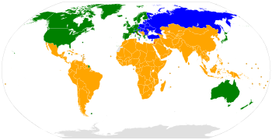
To put teeth into that pledge, a new binding treaty was finalized in Kyoto, Japan, in 1997 after years of negotiations and it went into force in 2005. Under Kyoto, developed countries would have binding commitments to reduce their GHG emissions between 2008 and 2012 to below pre 1990 levels. Developing countries, however, did not have to commit to reductions in this time frame because (a) per head, their emissions are a lot lower and (b) their less developed economies cannot afford the costs of greener technology. The more they develop their industrial infrastructure the more they are brought into the agreement.
Sustainable development is key to all of the above. We must meet our needs of today without compromising the needs of future generations. This is only done through the embracing of social, economic and environmental factors.
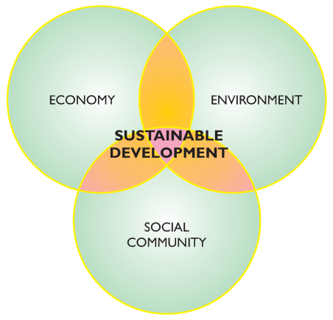

Page 9
These factors cannot contradict one another like they currently do, for example industrial growth might conflict with preserving natural resources. Yet, in the long term, responsible use of natural resources now will help ensure that there are resources available for sustained industrial growth far into the future.

