
Assignment Cover Sheet

Student Name: | Omnia Rafiq
Student Number: | 1343
Course: | Diploma in interior Design
Assignment NO: | 6

Student Statement:

By submitting this assignment, I confirm that this is my own work.

Student Signature | Omnia Rafiq | Date | 22-12-2014

For Tutor / Assessor Use Only
Total Marks
Marks Obtained
Percentage / Grade

Q.1.I. How are light and colour linked to each other?

Light like color, can create both mood and atmosphere in a room, and therefore should be planned very Carefully. It has the ability to dazzle, or enhance, dim or brighten any
Space. Light and color are closely linked; the amount of light a color
receives can change its appearance subtly, so the two should always be
Considered very carefully. Pairing the right paint colour and lighting can have magical results. But finding that perfect combination can be tricky. First of all we should know what the room is made for. For example some people might use a certain room only at night. This makes all the difference in picking the right colour. A warm chocolate brown might be good for this room. Since It looks great with lamplight. In contrast, If the room you’re painting is primarily used in the morning the light is going to be clear and warm, which is why neutrals and whites look freshly relaxing. If the room is cool and dark, add warmth. If it’s bright and illuminated, go neutral or add cool colours with blue undertones.
What else is in the room? If you have a rug—or another large piece—in a dark purple or brown, it will change how every other hue in the room appears. The way light reflects from one colour to the next has a strong impact. The relationship between colours in a room is important. You should consider all the large elements in the room and find a colour that cooperates, something that will make everything look better. The bulbs in your lamps and overhead lighting will also change the way a colour looks on the wall. People nowadays are using more compact fluorescent light bulbs and while CFLs have gotten better, warmer, with better colour rendition, people still see a difference. Sometimes a colour goes redder, other times a colour becomes greener. Your best bet is to upgrade as many bulbs in the house as you can before you choose a new colour. Then, bring in samples of colour and pick out what you think looks best under these conditions. Get a large poster board and paint it the colour you’re considering. Live with it for several days. Literally move it around the room to see how the light affects it. Put it near different light bulbs, close to and far from the windows. If it’s working for you, then that’s all there is to it. If you see it and you like it, you should be fine.

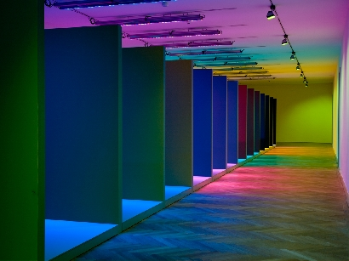

Q.1.ii. If the amount of natural light is not enough for a room. How would you solve
The problem?

If the amount of natural light is not enough for how people want to use the room, there will be two options: to explore ways of bringing in more natural light, perhaps by adding another window or by changing the solid doors to glass ones; or to boost the existing day light with artificial light. In that
Case you will have to plan the lighting scheme.

So we can sum up some tips to enhance lights in a specific room which are :

1. Mirrors. Place a mirror on a wall adjacent to a window or opposite a window. When placed adjacent, a mirror will mimic the window and make it seem like you have more windows in the wall. When placed opposite, the mirror will reflect light and views from the window.
2. Reflective surfaces like a back-painted glass backsplash can bounce light around and give the impression of more light when windows are limited.
3. Let the light in. Avoid heavy, light-blocking window treatments. Opt instead for translucent shades that provide privacy while allowing light into the space. This will even give a soft glow to the shade and bounce light into the wall directly adjacent to the shaded window.
4. Ceilings a little lighter than walls. Flat white is best if your walls are white, but if you have dark walls, be sure to go with a slightly lighter color on the ceiling, as in this room from White on the ceiling in an otherwise rich room will only feel oppressive. Matte paint — while not reflective like glossy or semi gloss — is a good choice for reflecting light.
5. Clean! Keeping fixtures, bulbs, and windows clean will let the light you do have shine its brightest!

Using reflective surfaces
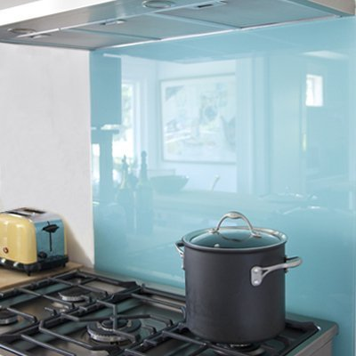

Strategically place mirrors
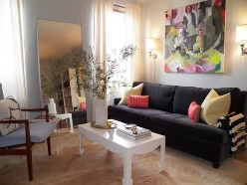

Painting the ceiling in a lighter color
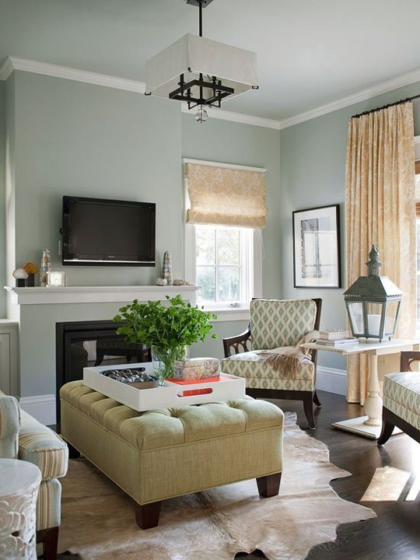

Using translucent window treatment
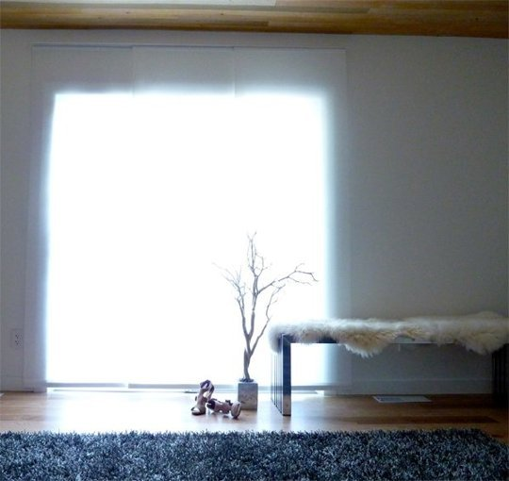

Q.1.iii. What is meant by ‘Light enhancer’ and how they can be used in a room to Maximise the brightness?

They are light reflecting objects such as crystals or mirrors can be strategically placed to enhance light, or even reflective flooring treatments, They all boost energy levels And direct energy around the house. By day mirrors will reflect natural Light and by night they will reflect light from the candles or lamps.
Different light enhancers examples:
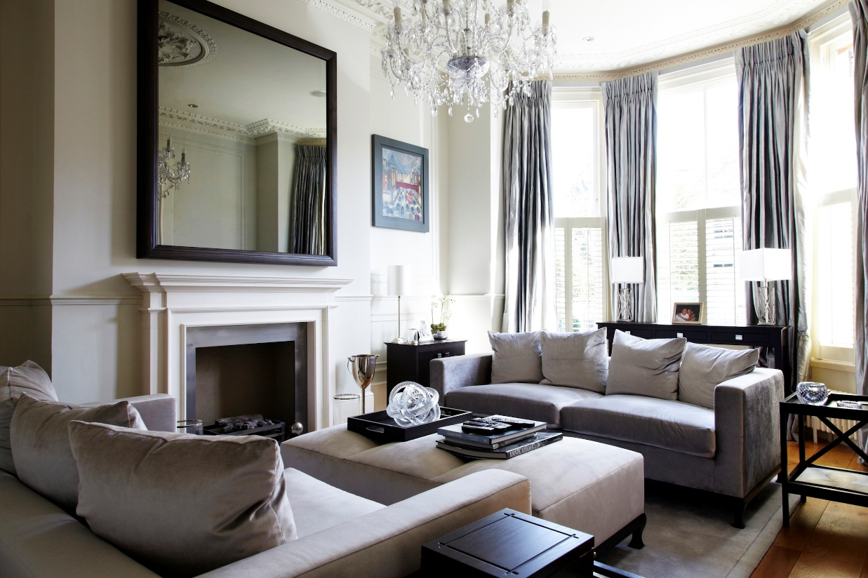

Reflective flooring system
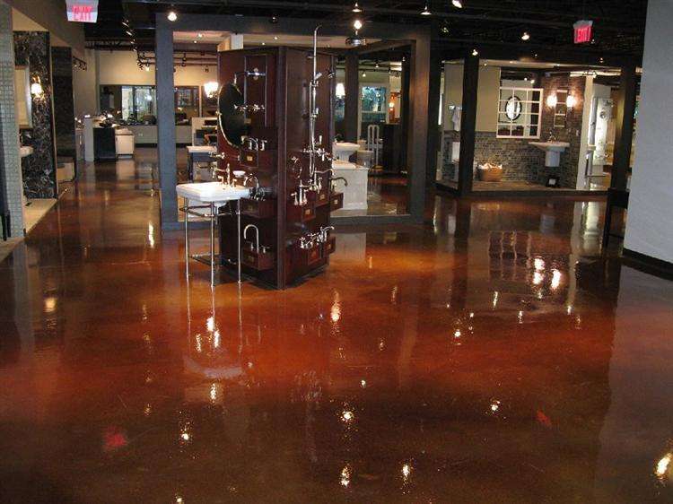

Q.1.iv. How important it is for a designer to know about the function of the room
Before planning a lighting scheme for it?

A well-planned lighting scheme not only makes room more generally pleasing but it is very important whether you write down letters, cook or apply makeup- all these tasks will be helped if under taken in appropriate Lighting conditions. Once the furniture is shown on the plan, we can see how exactly many light points, circuits and sockets will be needed and Their best positions. There are many points to keep in mind when Planning a lighting scheme for a room.
Considering the following points:

- Activities
We should know what will be happening in the room and where? What type of lighting Would be most appropriate?
- Balance of light throughout the day
We must ensure that there will be no dark corners.
- Highlighting of Features
What about the stunning pictures? About the magnificent marble fire
Place, beautifully beamed ceiling- are they all bathed in light and shown Off to their best advantage?
- Flexibility
What of room changes? Do you have enough free-standing light fittings That can be repositioned to provide new functions?
- Decorative Style
Does the selection of fittings compliment the room or they clash the Decorations?
- Ambience
Decorative or reflective? It’s our choice.
- Overall Light Level
How many fittings would be required to achieve a good overall level of Light?
- Variety
A scheme composed of all the same type of fitting can be boring and is Unlikely to satisfy all the room’s requirements. We must be imaginative in our Selection.

Q.1.v. Which features in a room need emphasis? And how?
Emphasis is to draw the eye to that part of the room. For example, using a focal point creates a point of emphasis in the room, serving to anchor the rest of the design, if in fact it is based around the same focal point.
Using emphasis is the difference between good decorators and great ones. The ability to look at a room, and choose which type of emphasis to use, within a client’s budget is the hallmark of a good designer. The room and furniture you have to design decide which type of emphasis to use.
The first type is the Architectural Emphasis:
This concept uses an architectural point in the room as a focal point, and the rest of the room is designed around it. The most obvious example of this is if a room in your house has a fireplace. A fireplace is an architectural feature of your house (it’s built right into the wall, and cannot be moved easily) that will naturally draw your eye toward it. In a room like this, designing the room around the fireplace is an excellent example of architectural emphasis. You can match the colour of furniture to the paint on the mantle, or use the fireplace as a focal point and face most of the furniture towards it.
Piece emphasis is the other option. It is to select an added feature to the room and design around it. This causes the eye to drift to the piece that you want to be the focal point of the room, and accentuates its importance in the overall design. For example, if you found a beautiful dresser that was built a century ago, it would be an effective use of emphasis to put that piece in your creative space. If you design a room around it, then it’s clear that you are striving for classic designs that stand the test of time; which is an awesome mantra for any creative mind. Designing the room around it is how you can get people to look at that piece.

Architectural emphasis examples:
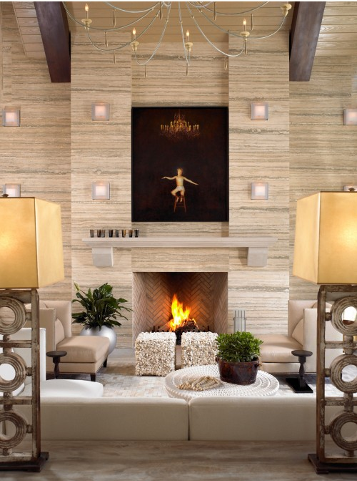

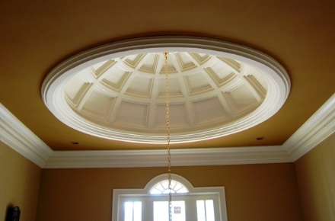

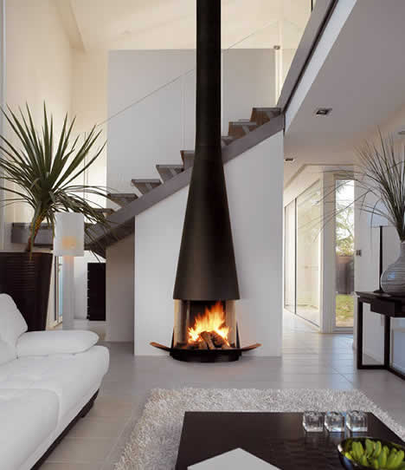

Piece emphasis
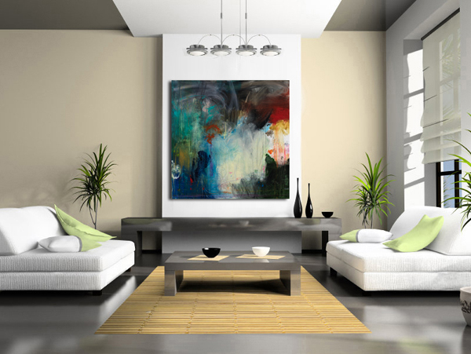

Q.1.vi. What do you think is the main advantage of free standing light fixtures (i.e.
Table lamps)?
Table lamps are considered to be from the Task lighting, Which is used to illuminate a specific area for a more practical reason- reading, for example. A desk lamp is used to light a table, and an under cabinet light used to illuminate a kitchen counter Other examples of task lighting include:

Swing arm lamps
Wall scones
Adjustable floor lamps
Under cabinet Lighting
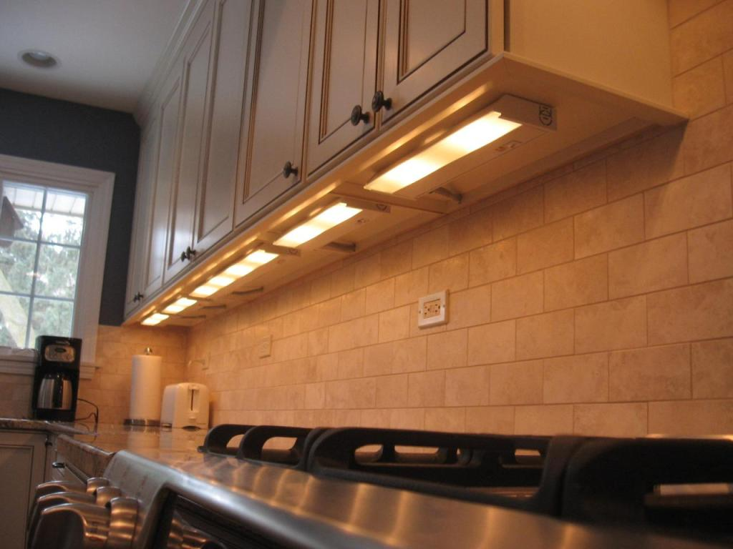

Swing arm lamp
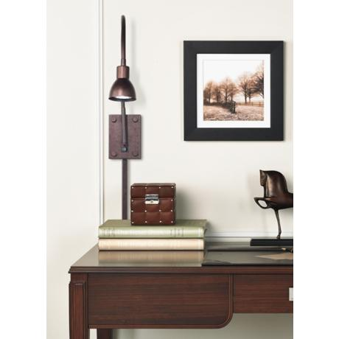

Different Wall Scones
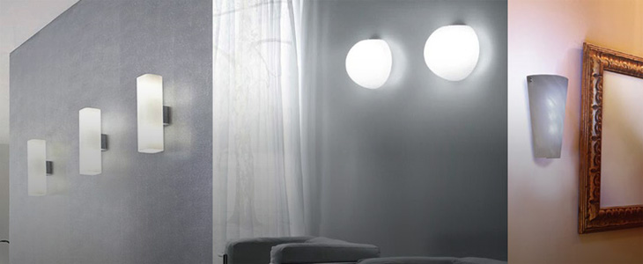

Q.2. Why is the orientation of a room so important to consider when putting a design
Scheme together?

- Knowing that: The Sun rises in the East and sets in the West, no matter where you are in the world.
- The Sun is higher in the summer sky and lower in the winter sky.

The positioning of the home affects the amount of natural light available, south facing rooms receive full light. East facing rooms will face light from the rising sun, west facing rooms light from the setting sun. North or north east facing rooms will not receive much direct light.
The ideal house orientation is that the main long axis of the building runs East-West,When deciding the building orientation also take into account the location of landscape features on your plot , i.e. trees and walls, etc. which will impact on how you harness the Sun. Ideally you do not want them blocking the sun light as the sun tracks across the sky.
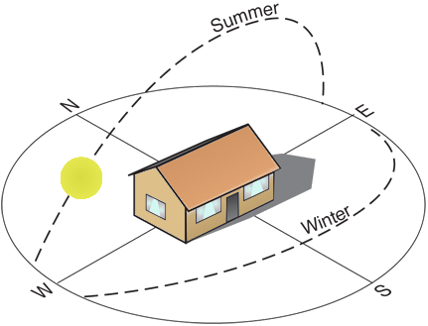
So we must take into consideration, The Orientation of the building or that room we are going to design. As a result we will know if the space will be sunny and bright or dark and dim, and if there will be dark corners or not, Hence decide using more artificial lights, Skylights or even a larger window.

Case Study

Brandon and Alisha want to redecorate their living room. As it is a hub for all the activities in
their house, they want variety of lights in the room so that all the activities of the family can
Continue during the day and in the evening. Brandon works from home and there is no separate
Room in the house which he can use as his office. He has his office desk in one corner of the
Living room. They have two children both are under 10.
If you have to plan the lighting scheme for their living room where the whole family can
perform their activities comfortably:

- Which type of Lighting would you use in different areas of the room?
We can use ambient lighting for the overall lighting of the room, like the pendants lights and suspended uprights. Also some accent lightings like illuminated wall niche or spotlights focused on a painting or on a fireplace can be used to brighten up the interesting architectural features of the room. While, for the corner of the room use the task lighting, where the office desk is placed, we shall use desk lamp or wall scones and swing arm lamps.
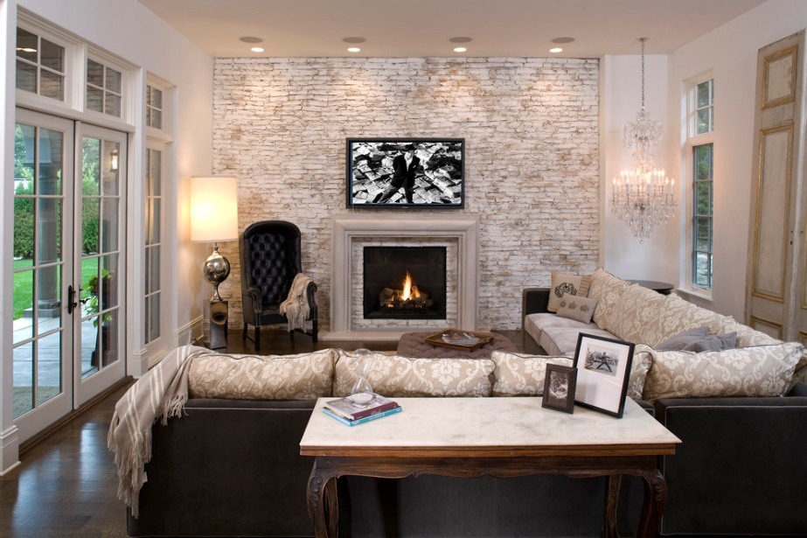

- How would you light the dark corner of the living room?
There can be many ways to light the dark corner of the room, We can use some task lightings like the wall scones, desk lamp and swing arm lamps, Besides using some reflecting surfaces like glass, marble, Reflective flooring treatment, and mirrors.

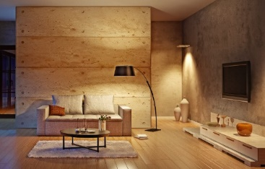

- Will you use some free standing light? If yes why?
Yes, Free standing lights can be used in the dark corner near the office desk, Or even in another area of the room where certain activity may take place. Since it’s considered to be (Task lighting), Which is used to illuminate a specific area in a room for a more practical reason, like reading, writing or any other activity.

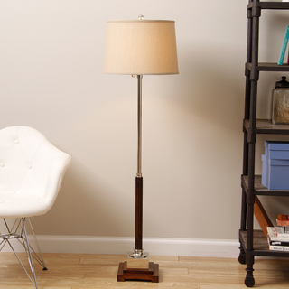
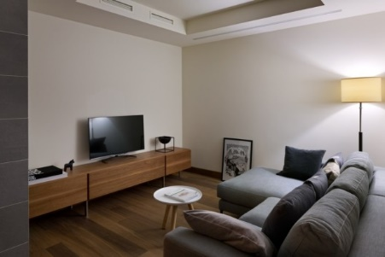

D. How would you enhance the decorative effect of the room?

Accent lighting is always used to enhance the decorative effect of a room. Since it provides a way to focus attention on architectural or decorative aspects of a room. An illuminated wall niche or spotlights focused on a painting draw your eyes to these features. Track lighting or
Recessed ‘eyeball’ style lighting can be used to illuminate interesting wall features or simply provide a wash of light across the painted surface. A wall wash can be very dramatic in itself.

A wall wash
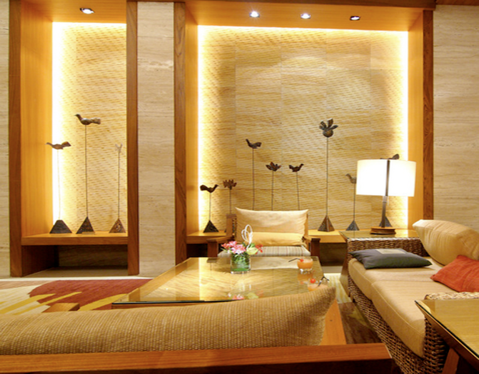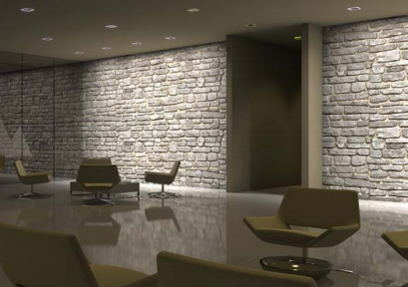

Illuminated wall niches
