
Assignment Cover Sheet

Student Name: | MAJALIWA FREDRICK
Student Number: | 1506
Course: | DIPLOMA IN ACCOUNTING AND FINANCE
Assignment NO: | 2

Marking Criteria:
We expect the learners to write minimum one well expressed point in three lines against each allocated mark. This means one needs to write 15 lines with 5 well expressed points to get high grades for a 5 marks question.
For high grades use examples and illustrations where appropriate.
Role and Activities of an Accountant
Assessment 2 Total Marks: 30

1. Give short answers to the following questions: (16) I. Who is an accountant? Describe various roles and activities which accountants perform.
Answer:
An accountant is the financial adviser of the business organization who take taxes for example. It is the responsibility and Job of accountant to manage the company’s taxes in a way that there is minimum tax liability. The accountant makes sure that tax concessions and tax incentives are utilized by the business.

An accountant plays an important role in an organization. The duties that accountants perform are different in different organizations.

Generally, there are two categories of accountants: The ones who serve in public domain; and the ones who are employed in private sector. The accountants serving in public sector, when conduct financial and cost audits, are known as auditors. Public sector accountants also get membership of professional bodies.

Auditors investigates/audit the account books and balance sheets of a company. While looking at the profits and losses of a company they try to paint an accurate picture of the financial health of a company. Shareholders of a business usually appoint auditors who meet the requirements of the Companies Act in order to conduct financial or cost audits.

An accountant is responsible for account keeping, An accountant is an important instrument for financial control. An accountant is often described as the conscience of an organization and t is involved in managing the information of an organization and providing it internal and external users. An accountant advises the company in fiscal or financial matters while prepares the organization’s financial statements like income statement and balance sheet for a particular period. He/she has the responsibility of maintaining supporting evidence and classified facts related to the financial matters of the organization. An accountant deals with the verification, authentication and certification of the company’s accounts.

Understanding the roles and activities of the accountants, one must answer the following questions:

- An Accountants must Know who really our client is: the company, the management, current shareholders, future shareholders, the public?
- Do I owe primary loyalty to my employer, client, boss, profession, myself, or the public?
- Am I a professional accountant bound by professional standards, or just an employee?
- Is professional accounting a profession or a business - can it be both?
- When should I not offer a service?
- Can I serve two clients with competing interests?
- Is there any occasion when breaking the profession's guideline against revealing confidences is warranted?

II. Explain the various types of accountants.
Answer:
An accountant is an important part of an organisation. He plays an extensive part in all departments of a complex organisation and his role is inescapable. The duties that accountants perform are different in different organizations.
Generally, there are two categories of accountants: The ones who serve in public domain; and the ones who are employed in private sector. The accountants serving in public sector, when conduct financial and cost audits, are known as auditors. Public sector accountants also get membership of professional bodies.
Auditors scrutinize account books and balance sheets of a company. While looking at the profits and losses of a company they try to paint an accurate picture of the financial health of a company. Shareholders of a business usually appoint auditors who meet the requirements of the Companies Act in order to conduct financial or cost audits.
We can summarize three main types of accountants as follows:-
- Finance Accountant
- Management Accountant
- Cost Accountant

III. Which types of duties does a controller perform?
Answer:
Major duties and functions of an Controller/ Chief Accountant:
- Designing a functional accounting system and be able to operate it
- Prepare the company’s financial statements and annual reports
- Be able to establish and maintain the systems and procedures
- Mange the internal and external audit of the organization or business unit
- Be able to use computer financial applications like accounting packages and spread sheet applications
- Exercise cost control of an organization
- Be able to prepare business budgets
- Be able to run forecasting methods and preparing analytical reports
- Supply financial information to management for sound decision making about business and many many more

IV. What is a double entry system? Outline the steps involved in Double entry system.
Answer:
The Double Entry System of accounting was developed in the 15th Century in Italy by Lucas Pacioli. Under the system, every transaction has two aspects-Debit and Credit and at the time of recording a transaction, it is recorded once on the debit side and again on the credit side. The Double Entry System has proved to be a scientific and complete system of accounting followed by every enterprise and organisation.

For example, at the time of cash purchases, goods are acquired and in return cash is paid. In the transaction, above two aspects are involved, i.e., receiving goods and paying cash Under the Double Entry System, both these aspects are recorded.
One part, i.e., the receipt of goods is debited and the second part, i.e., payment of cash is credited. The method of Debit and Credit will be discussed in “Accounting Procedure – Rule of Debit and Credit”

The following are the three different stages of a complete system of a double entry book keeping:
- Recording the transactions in the Journal.
- Classifying the transactions in the Journal by posting them to the appropriate ledger accounts and then preparing the Trial Balance.
- Closing the books and preparing the final accounts.
The main advantages of Double Entry System are:-
- Scientific System
- Complete Record of Transactions
- A Check on the Accuracy of Accounts
- Ascertainment of Profit or Loss
- Knowledge of Financial Position
- Full Details for Purposes of Control
- Comparative Study is Possible
- Helps Management in Decision-Making
- No Scope of Fraud

V. What is the meaning of ‘Debit’ and ‘Credit’?
Answer:
An understanding of debits and credits is essential in the effective usage of any accounting system. Every accounting entry in the general ledger contains both a debit and a credit. Further, all debits must equal all credits. If they don’t, the double-entry system is out of balance. Therefore, the accounting system must have a mechanism to ensure that all entries balance. Indeed, most automated accounting systems won’t let you enter an out-of-balance entry; they will just beep at you until you fix your error. Depending on the type of accounting system, debit or credit will either increase or decrease the account balance. For every increase in one account, there is an opposite (and equal) decrease in another. That’s what keeps the entry in balance.

The terms Debit and Credit have Latin roots. The term ‘Debit’ comes from ‘debt’, which means to owe. The term ‘Credit’ comes from ‘creditable’, which means to entrust. Sometimes Debit is abbreviated as ‘Dr’ and Credit is abbreviated as ‘Cr’. It is important to understand the principles of debit and credit in order to work with financial transactions. Debit and credit can be associated with either increase or decrease in financial amounts; this is determined by the kind of account.

VI. What is meant by ‘Hybrid basis’ accounting? How the entries are recorded using this method?
Answer:
In Hybrid Basis of Accounting, certain entries are made on cash basis accounting and other entries are made on mercantile system of accounting. Many companies practice this hybrid basis of accounting. For instance, a company practices mercantile system of accounting when making entries of its export business but the duties and subsidies offered by the government are recorded on cash basis accounting when the payments are received.

The Hybrid bases of accounting helps in reducing the uncertainty in calculating benefits and losses by making few entering only when cash payments are received. However, practicing this method of accounting can render profits and losses unrealistic. When a company or a professional wants to adopt a conservative approach, they can go for this method of accounting. They only record income when it is received and they record all incurred expenses even if the payments are not made. Hybrid Basis of Accounting is not widely practiced due to its inconsistence in accounting recordings

VII. What is the difference between ‘Real Accounts’ and ‘Personal Accounts’?
Answer:
- Real Accounts
Real accounts record transactions related to property or assets. Each asset has its own separate account. For example; cash, machinery, building, land etc. There are two types of Real accounts which are ‘tangible’ or ‘intangible’ accounts.

- Tangible Real Accounts: Tangible asset or property is that which can be touched, felt, measured, sold or purchased such as machinery, equipment, furniture, cash, inventory etc. The accounts related to tangible assets or properties are known as tangible real accounts.
- Intangible Real Accounts: Intangible asset or property cannot be touched or measured in monetary terms. Goodwill, patents, copyright, trademarks etc. are examples of such intangible assets. Accounts dealing with such assets or properties are called intangible real accounts.
Note:
The basic accounting rule for Real accounts is: Debit what comes in Credit what goes out

- Personal Accounts
Personal accounts record transactions that are carried out with a person or a group of persons. These accounts are usually maintained to record credit transactions and can be classified into the following categories:

- Natural persons: It records transactions with an individual person, male or female. Such accounts are titled as Henry’s Account, Jane’s Account etc.

- Artificial or legal persons: Such an account records financial transactions with an artificial entity or a legally created artificial person. Examples of this kind of account are accounts of business firms, limited companies, educational institutions, cooperative societies etc.

- Groups/Representative personal Accounts: This account indirectly represents a person or a group of persons. This is usually done when a large number of accounts of similar nature are grouped together under one account title. These accounts are said to be representative of a group of personal accounts. For example, outstanding salaries, rent, prepaid insurance, wages etc.
Note:
This is the rule for personal accounts: Debit the receiver and Credit the giver

VIII. How do we record the entries using cash basis accounting method?
Answer:
If an accountant uses the cash method, he/she counts income when it is received and expenses when they are paid. Many small businesses, especially retail businesses, use the cash basis method of accounting, which is based on real-time cash flow. On the day a check is received, it becomes a cash receipt

2. What are the main objectives of book-keeping? How would you distinguish book keeping from accounting?
Answer:
Book Keeping is part of and it is concerned with:
  - Identifying financial transactions and events,
  - Measuring them in terms of money,
  - Recording the financial transactions and events so identified in the books of accounts, and
  - Classifying recorded transactions and events, i.e., posting them into Ledger accounts.
Here below are the list of Definitions of Book Keeping
- "Book Keeping is an art of recording in the books of accounts the monetary aspect of commercial and financial transactions." -Northcott
- "Book Keeping is an art of recording business dealings in a set of books." -J.R. Batliboi
- "Book Keeping is the science and art of recording correctly in the books of accounts all those business transactions that result in the transfer of money or money's worth." -R.N. Carter
- "Bool: Keeping is the art of recording business transactions in a systematic manner." -A.N. Rosen Kampff
A table below summarize briefly the difference between Book keeping and accounting
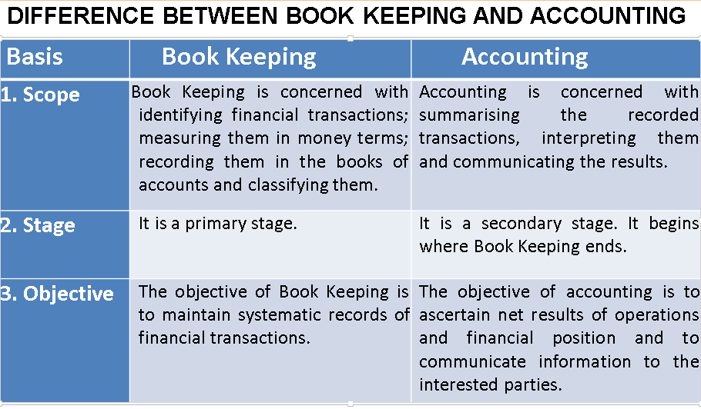

Multiple choice questions
Tick the correct answer. (5)

1. Stock is? Answer (d)
- The quantity of goods at the end of the year

- The total value of all the goods purchased during the year

- Items purchased to sell at a profit

- The value of goods left over at the end of the year

- Fixed assets acquired during the year

2. Which of the following is not an asset? Answer a and d
- Creditors
- Fixed assets
- Cash
- Debtors
- Petty cash

3. Capital is? Answer all mentioned below

- The total amount of cash in the business

- The amount the bank has invested in the business

- Total of the fixed assets and current assets

- The total amount the owner has invested in the business

- The total amount owed by the business to the bank

3. Interest paid to a bank is an example of? Answer b and c
- Income
- Liabilities
- Expenses
- Drawings
- Fixed assets

4. Debtors are? Answer c
- The owner
- The bank
- Suppliers
- Employees
- Customers

5. Purchases are? Answers All except (a)
- Goods bought to give to charity
- Goods bought to sell at a profit
- Fixed assets
- Materials used in production
- Anything the company buys

Activity (9)
Please meet one or more of the following personnel in any organization and talk to them about their respective roles within the organization.

- Accountant
- Ensure all financial transactions of the company are recorded properly in the books of accounts
- To ensure that all books of accounts are up to date and prepare financial reports quarterly to enable Chief Accountant/controller to advise Management for various decision making
- To prepare annual reports and ensure compliance of GAAP
- To Make sure that all financial rules and regulations are observed in all reports be of internal consumption- Management reports or Public reports, Financial reports to stakeholders/business owners
- To ensure the interest of shareholders are secured

- Chief Accountant
- To monitor the financial position of the company
- To advise CEO on matters concerning financial health of the company
- To source for various financing sources of companies activities
- To Ensure that the company is liquidity enough to carry out its operations ( Liabilities)
- To ensure that International and national reporting standards are observed and that no violation of Country Laws is committed in financial reporting
- To control cost of running Business in an organization

- Internal Auditor
- To audit the financial and management reports
- To advise Management on risk management issues
- To monitor the systems and procedures of entity operations
- To Advise Management on compliance of GAAP and other ethical issues in financial reporting

Student Statement:

By submitting this assignment, I confirm that this is my own work.

Student Signature | 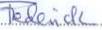 | Date | 21st Sept, 2015

For Tutor / Assessor Use Only
Total Marks
Marks Obtained
Percentage / Grade

