
Assignment Cover Sheet

Student Name: | Anwer Lutfi Mohammad ElSalameh
Student Number: | 1685
Course: | Diploma in Hotel Management
Assignment NO: | 1 - Introduction to Hotel Management

Marking Criteria:
We expect the learners to write minimum one well expressed point in three lines against each allocated mark. This means one needs to write 15 lines with 5 well expressed points to get high grades for a 5 marks question.
For high grades use examples and illustrations where appropriate.
Give short answers for the following questions: (12)

i. What are the convention hotels? Give an example.

These hotels can provide a large quantity of rooms. In addition to
accommodation, they provide extensive meeting and function
space for holding conventions. There are banquet areas within and
around the hotel complex. Most of them provide an in-house
laundry, a business centre, airport shuttle service, and 24-hour
room service. They are often in close proximity to convention
centres and other convention hotels.

ii. What are the basic differences between a hotel and a motel?

Hotels are located within the heart of a city. The type may
vary greatly from business, suites, residential,
economy, mid-scale to luxury.

Motels are designed for overnight stays for car travelers, often with
very basic facilities. The rooms usually have direct access to an
open parking lot. They are often smaller than most hotels. They
are located on the outskirts of towns and cities.

iii. How are extended stay hotels different from Bed and Breakfasts?

Extended stay hotels - or Serviced
Apartments - are cater to customers who stay for an extended
period. They usually offer full kitchen facilities, shopping
services, business services and limited housekeeping services.

While Bed and Breakfasts hotels are usually family-owned. They are private homes whose owner lives on or near the premises and rents out rooms to
overnight customers. The paid accommodation typically includes
breakfast. A popular term is “B&Bs” (i.e. bed and breakfast
provided). The host often provides customers with assistance
regarding directions, and information regarding the local area
including sightseeing suggestions. It is usually located in rural areas
and villages.

iv. What is the relationship between the hospitality industry and tourism?

“Guests” means those who are away from their homes and it therefore, has generated a perception that
the hospitality industry should include or overlap with the tourism industry to a certain extent. Some who considered putting hospitality and tourism into one industry.
There are two main business sectors in the hospitality industry:
Accommodation – To provide accommodation (and usually food and drink) to people who for whatever reason are away from home Food and beverage – To provide food and beverage to local, commuting, transient customers and tourists These two sectors will be covered in more detail in subsequent units.

So, the hospitality industry includes hotels and restaurants, as well as many other types of
organizations or institutions that offer food, drink, shelter and other related services. These products and services are offered not only to people away from home, but also to local customers.

2. Outline the characteristic features of the hospitality industry. (4)

Different from other sectors, the hospitality industry is unique in its nature which tends to be service oriented and has a strong emphasis on human exchange in the service delivery processes. A summary of key characteristics relating to the hospitality industry are :

1) Product-Service Mix
2) Two-way Communication
3) Relationship Building
4) Diversity in Culture
5) Labor Intensive

3. Explain various functions of the major hotel departments. (4)

i. Engineering
The engineering department is responsible for maintaining the physical plant of the hotel such as electricity, plumbing, air conditioning, heating and elevator systems; and for overseeing all mechanical and technical conditions of the hotel.

ii. Security
Security is an important concern in every hotel. The security department is responsible for
implementing procedures which aim at protecting the safety and security of hotel guests, visitors, hotel employees and the hotel itself. Examples include monitoring surveillance equipment, patrolling the hotel premises and maintaining security alarm systems.

iii. Human Resources
The human resources (personnel and training) department is responsible for hiring, orientation, training, wages and benefit administration, labour relations, employee relations, and staff development.

iv. Food and Beverage
The food and beverage (F&B) department provides food and beverage services to the hotel guests and visitors through a variety of outlets and facilities/services. Examples include lounge, bar, coffee shop, restaurants, banquet service, room service (also called in-room dining) and cake shop.

v. Sales and Marketing
The main functions of the sales and marketing department involve generating new businesses for the hotel, coordinating advertising, as well as sales promotions and public relations activities aiming at enhancing the hotel’s image.

vi. Accounts
The accounts department is headed by the financial controller who, as a key member of the
management team, can guide the hotel to an increasing profitability through better control and asset management. In addition, this department is responsible for monitoring all of the financial activities of a hotel. Examples include overseeing accounts receivable, accounts payable, payroll, and cost control systems of the hotel; keeping records of assets, liabilities and financial transaction of the hotel; preparing the monthly profit-and-loss statement, coordinating with purchasing department and information technology department, and handling guests s’ inquiries about billing.

4. Outline the main job responsibilities for the following personnel in a hotel: (4)

a) General Manager

The main responsibilities of the general manager (GM) include:
• Providing leadership to the management team;
• Coordinating the work of all departments;MANAGEMENT
• Participating in the formulation of hotel policies and strategies;
• Leading the hotel staff in meeting the financial, environmental and community responsibilities;
• Assuming full responsibilities for the overall performance of the hotel.

b) Residential Manager

The main responsibilities of the resident manager include:
• Holding a major responsibility in developing and executing plans developed by the owner(s), the general manager and other members of the management team;
• Checking on operations, providing feedback and offering assistance when needed;
• Completing, reviewing and summarizing statistical reports and sharing them with the general manager;
• Assuming responsibilities for the daily operations and management of the hotel.

Activity (6)
1. Investigate the range of hospitality businesses in your area. How many are there? What faction/section of the industry do they cater to the most? Prepare a brief report on what you discover.

Exponential growth ahead for UAE's hospitality sector with more focusing on Dubai

The UAE’s thriving hospitality industry, enjoying an impressive track record for its consistently high occupancy rates and sustained capacity expansion drive, is set for a new phase of exponential growth that is expected to catapult the Emirates to the ranks of the world’s most sought-after destinations for international visitors by 2020, when Dubai will be hosting the World Expo.
The UAE is already among the top five countries in the world for new hotel openings over the past five years. The hospitality industry in the UAE saw positive growth also has the longest pipeline of rooms under construction with an additional 32,107 rooms in the offing while the Middle East/Africa hotel development pipeline comprises 483 hotels totaling 117,450 rooms.
Massive-scale expansion of international airports in the UAE, including what promises to be world’s largest — Al Maktoum International with a capacity for 160 million annual passengers — and the fast pace of growth being recorded by the country’s three industry-leading airlines have already been driving a relentless surge in the number of international visitors and holidaymakers to the UAE. As a result, almost all hotels across the UAE have been reporting impressive occupancy rates as well as steady growth in average daily rate, or ADR.
A report by STR Global on hospitality supply growth around the world reveals that only the US, China, the UK and India are ahead of the UAE. According to a forecast by Alpen Capital, hotel room supply in the UAE from 2012-2016 has been increased by 5.3 per cent annually, taking the number from the current 96,992 hotel rooms to 125,383 rooms by 2016 in tandem with a surge in the influx of tourists.
Dubai, the regional hub for hospitality, tourism and shopping, is the world’s biggest growing market outside of China since 2008 in terms of new hotel openings. The city has been named a top 10 global destination for business, leisure and shopping tourists, in a research exercise by Genesis Consulting ME. Hotels in Dubai exceeded the regional and national average and recorded a 9.9 per cent growth in ADR to $290.68.
According to a report by STR Global, in November 2013, hotels in the region recorded an average 64.6 per cent occupancy at $180.88 ADR, resulting in $116.78 revenue per available room (RevPAR). These represented a dip in occupancy of 1.7 per cent, an increase of 6.8 per cent in ADR and an overall 4.9 per cent rise in RevPAR. During the first nine months, Dubai hotels witnessed significant growth in revenues, with total revenues up by 17.1 per cent, reaching Dh15.33 billion. Total guest nights also recorded similarly impressive rises, up 13.7 per cent to 30,874,916 from 27,163,974 in the first nine months of 2012.
EC Harris, the global consultancy, said that more than 10,000 five-star hotel rooms in Dubai are now in need of refurbishment. It estimates that there were 23,500 five star rooms in Dubai in 2012. However, this number has grown significantly throughout the last years as operators launch new properties to meet growing demand and cash in on lucrative room rates.
The Construction Pipeline Report released by STR Global predicts that Dubai’s hotel room capacity will grow 28.6 per cent in 2013 with 17,409 rooms in the pipeline. Dubai has also been named a top 10 global destination for business, leisure and shopping tourists in a research exercise by Genesis Consulting ME. Alpen Capital said with tourist arrivals in the UAE likely to grow at a compound annual growth rate of 5.3 per cent between 2012 and 2022, hotel supply is expected to increase at 5.3 per cent from 96,992 hotels in Dubai and Abu Dhabi to 125,383 hotels in 2016.
Dubai’s hospitality industry has received a new fillip with a move to license holiday homes. His Highness Shaikh Mohammed bin Rashid Al Maktoum, Vice-President and Prime Minister of the UAE and Ruler of Dubai, issued a decree to help develop the tourism industry by increasing the range of accommodation available to visitors — with the sector currently bursting at the seams. There are currently 100 per cent occupancy rates at hotels during the peak season. The decree states that the Dubai Department of Tourism and Commerce Marketing (DTCM) will have the authority to grant licences to those wishing to rent out furnished residential properties on a daily, weekly or monthly basis, according to the Dubai Media Office.
Standard and Chartered said the Expo 2020 would have positive implications on three key parts of the economy: housing, infrastructure and hospitality. On the hospitality front, the authorities estimate that 25 million people are likely to visit the Expo, of which 70 per cent will come from outside the UAE. However, one key challenge for Dubai is to maintain tourist inflows afterwards to prevent an oversupplied hospitality sector.
“We see the hotel sector as one of the main beneficiaries of growth generated by the event. To accommodate the significant inflow of tourists, the hotel stock will have to expand. Since 70 per cent of the 25 million visitors are expected to come from outside the UAE, Dubai will need to accommodate 17.5 million tourists in the months around the Expo,” it said.
Dubai will require around $43 billion to significantly upgrade its infrastructure for Expo 2020 that may generate additional revenues in the range of $25-35 billion, studies show.
Deutsche Bank said a bulk of the $43 billion spending would go into expanding the hotel and leisure industry, while around $10 billion will be spent to improve transportation infrastructure. The Al Maktoum International Airport, the newly developed airport near the Expo site, when fully completed will be able to handle 12 million tonnes of cargo and 160 million passengers annually, making it the largest international airport by some margin. Dubai has also initiated an expansion plan for its existing Dubai International Airport to increase its existing capacity from 60 million to 90 million passengers per year by 2018.
Finally, given the challenges in the international market – such as the Chinese economic slowdown and decreased spending by Russian tourists due to the rouble’s decline – UAE's hospitality sector is looking towards tourists from GCC states to bolster the hospitality market.

Student Statement:

By submitting this assignment, I confirm that this is my own work.

Student Signature | 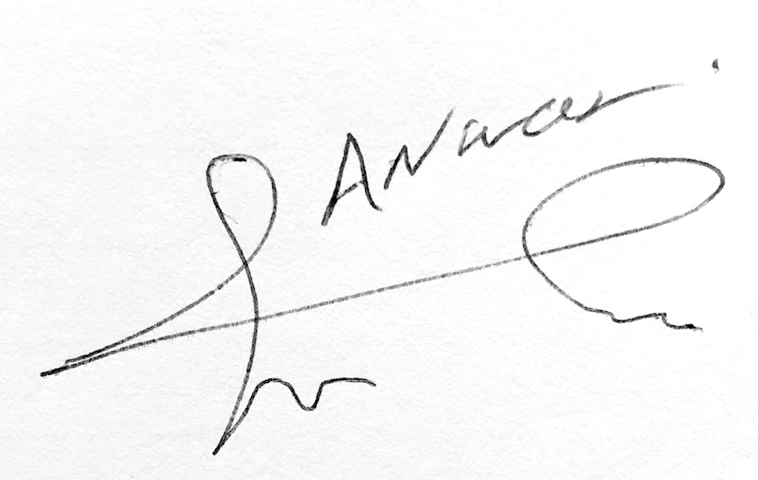 | Date | 11-March-2016

For Tutor / Assessor Use Only
Total Marks
Marks Obtained
Percentage / Grade

