

Assignment Cover Sheet

Student Name: | Saul Christopher Denby
Student Number: | 1498
Course: | Diploma in Fashion Design (Level 4)
Assignment NO: | 1

Marking Criteria:
We expect the learners to write minimum one well expressed point in three lines against each allocated mark. This means one needs to write 15 lines with 5 well expressed points to get high grades for a 5 marks question.
For high grades use examples and illustrations where appropriate.

- I. How did the First World War influence fashion?

The First World War influenced womenswear far more than it did menswear.
For the vast majority of men the expectation was to be wearing a military uniform of some
description, therefore not a great deal of emphasis was made on the changing of mens civilian
fashions during this time.
For women however it was quite different, materials were not so easy to come by so the designs
and lengths of garments had to change.
During the war women had to take over many jobs traditionally done by men in order to keep the
country running while the men were at war. Because of this women began wearing men’s clothes
for more comfort and flexibility. After the war women continued to wear more manly clothes because of their practicality, one of the biggest changes for women during the war, and ever after,
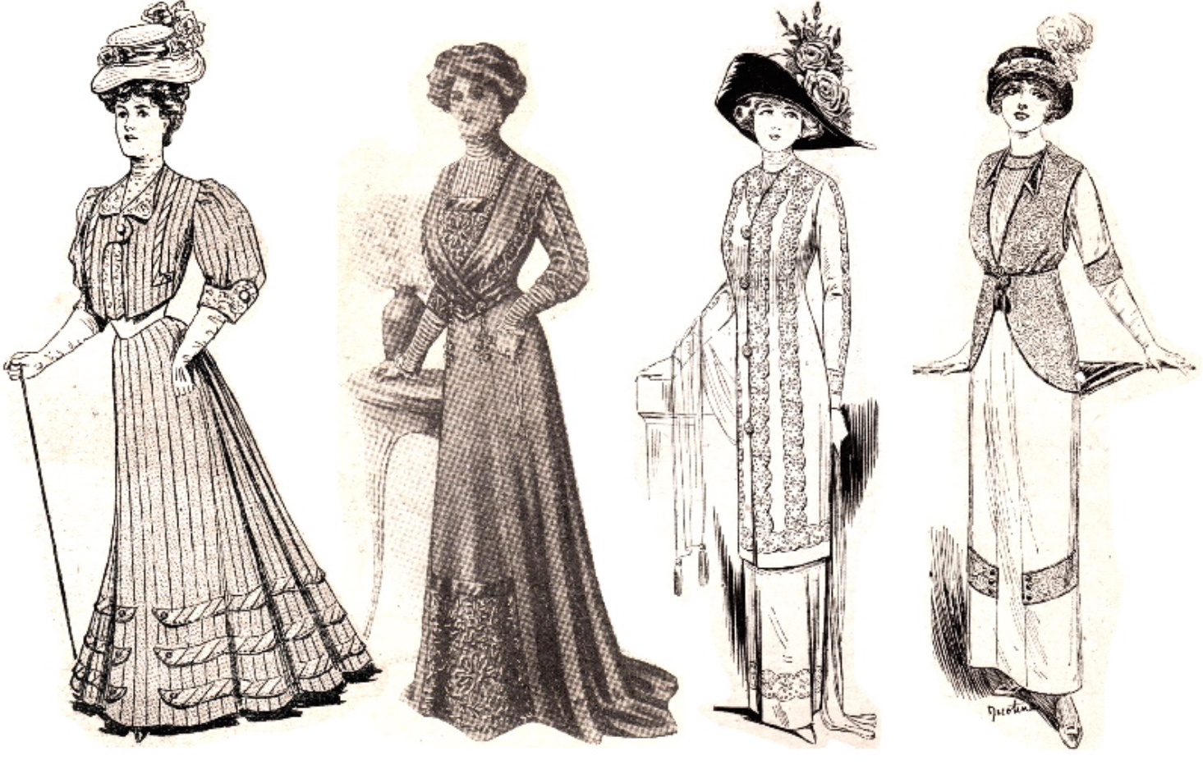

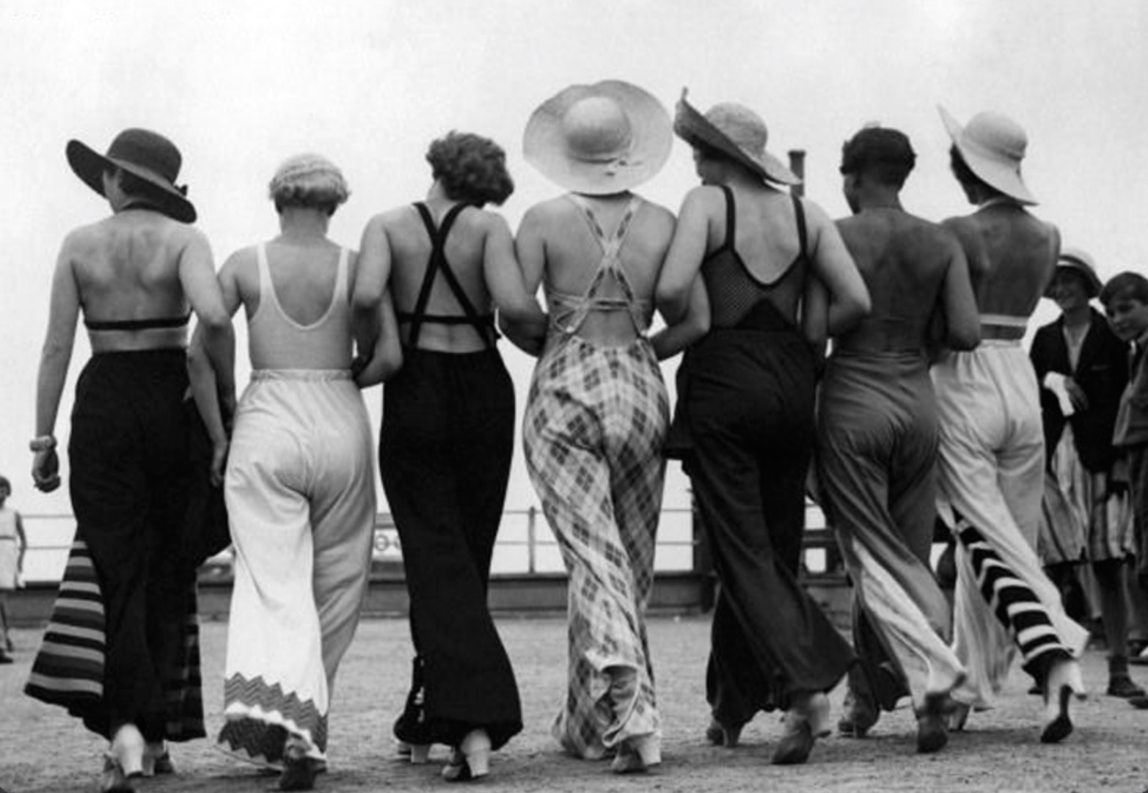

could be the adoption of trousers.

Pre-war womens wear. Post-war womens wear.

II. Describe the characteristic features of the twentieth century’s fashion.

One of the main characteristics of the 1900s must be the concept of ever more freedom
and practicality of women’s and menswear.
The two world wars vastly influenced the practicality of fashion, and the freedom of movement
offered by practicality was very popular and remains strong to this day.

2. Brief notes on the works of main fashion designers of 1970s

Sonia Rykiel - During the 1970s she is perhaps most well known for her knitwear, using fine
wool to make ladies suits, jumpers, short coats and hats amongst other items. Her clothes often
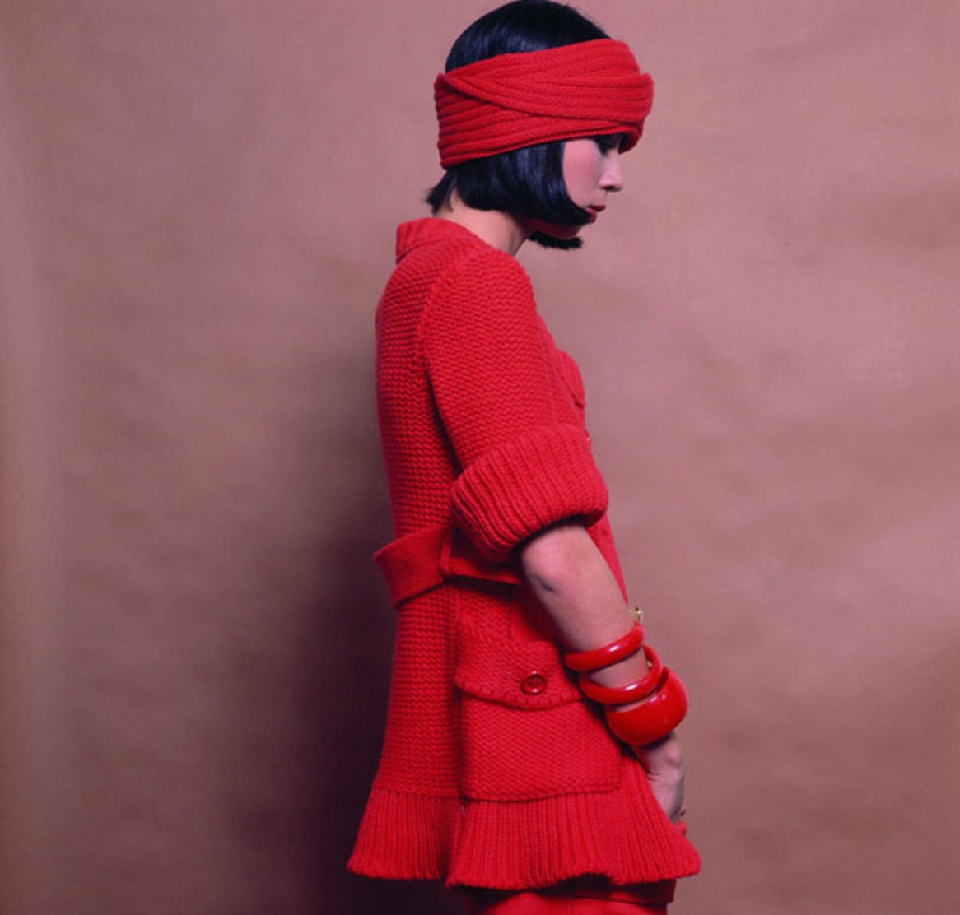

had not lining, and the seams were on the outside of the garments.
Laura Ashley - Long skirts and dresses made from very colourful floral themed materials
were popular designs by Laura Ashley in the 1970s. The cut of her dresses gave them a somewhat
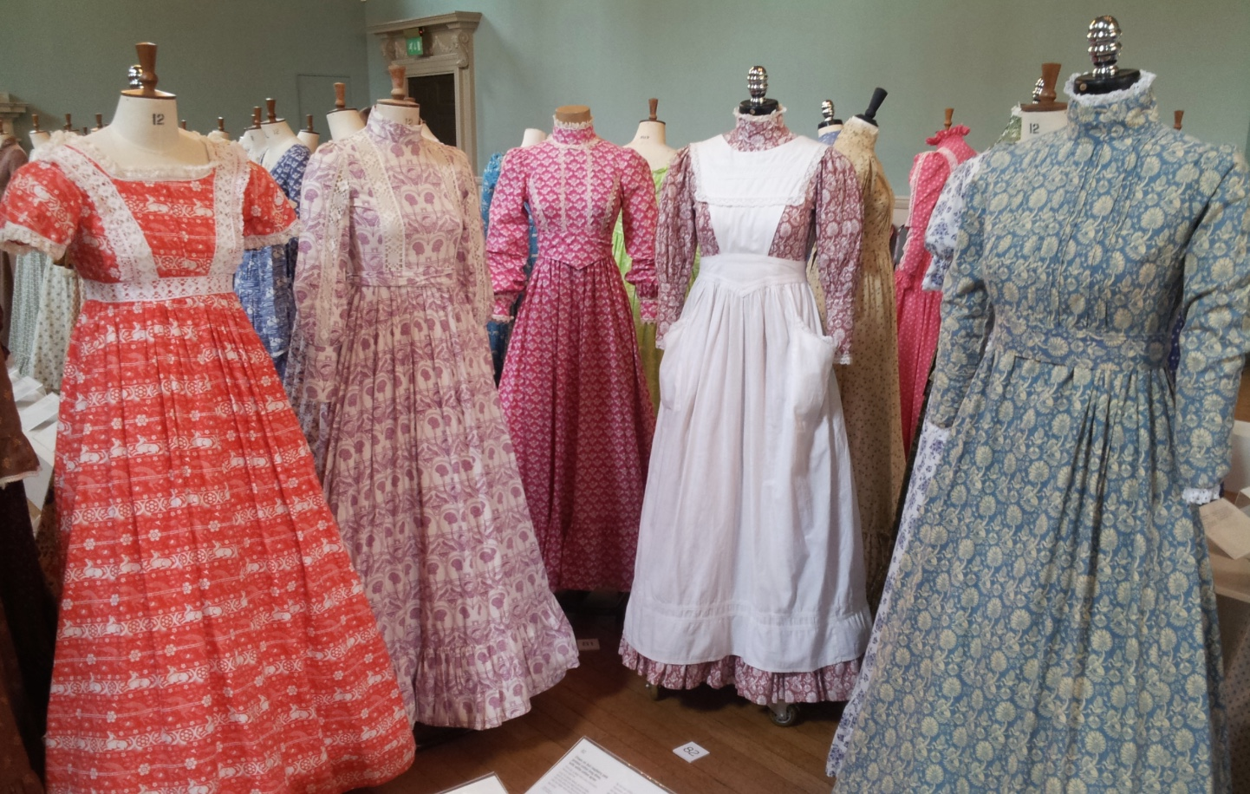

Victorian look. In the late 1970s she began applying her floral materials to home furnishings.

Giorgio Armani - In the mid 1970s Giorgio Armani successfully launched his mens and
womenswear collections, they incorporated a more natural fit using more mellow colours.
His designs for ladies business suits became very popular because of their ready-to-wear and
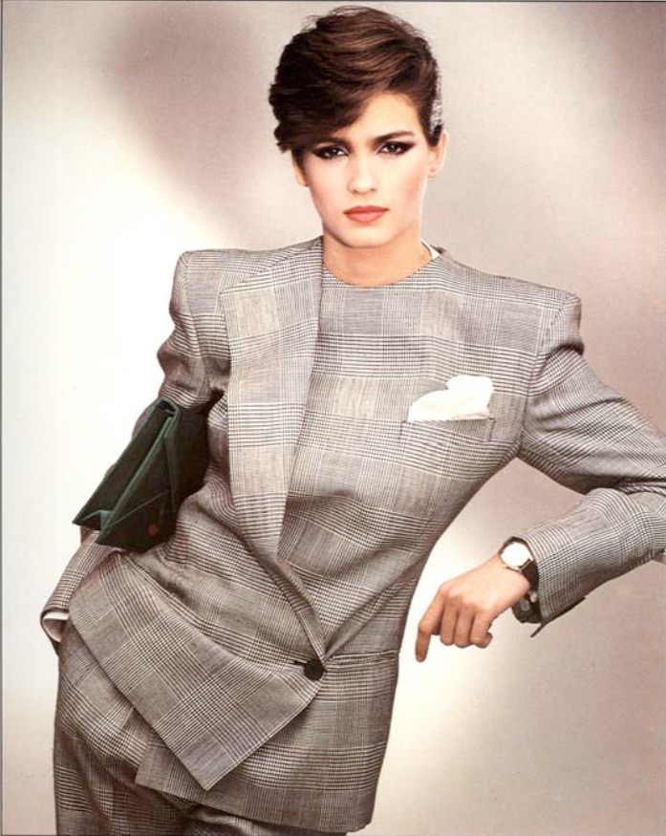

relaxed nature, and were made from sophisticated mens wear materials.

3. What major changes came about in the fashion industry in the early 19th century and why?

At the turn of the 19th Century the “Empire style” was still very much in fashion, its main
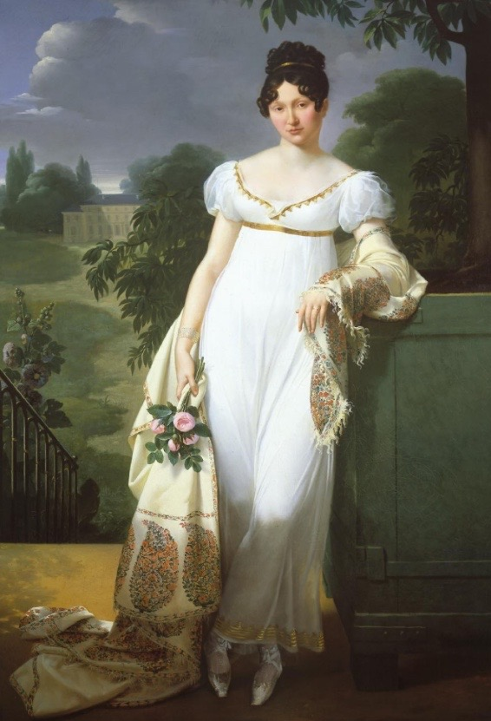

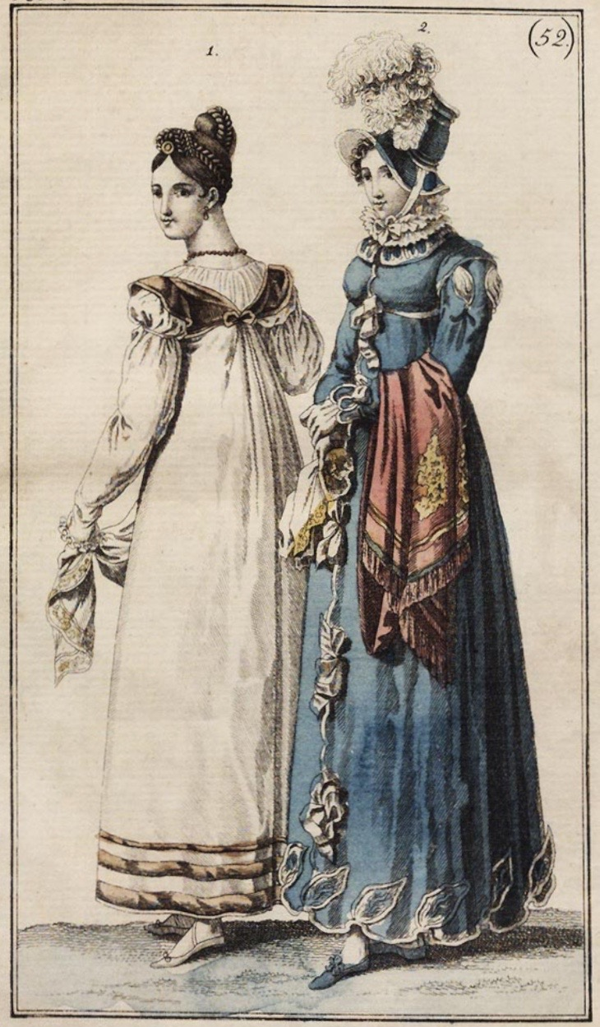

features being a high waist line, skirts with a lot of volume and low necklines.

During the Regency period extravagant fashions began to fade away in favour of more
simplistic Grecian inspired gowns made of thinner cottons which were able to drape and
flow allowing the body to keep its natural form. During this period corsets began loosing
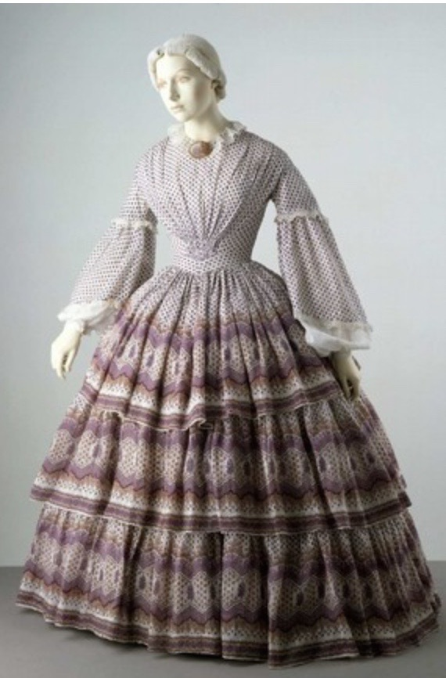

their appeal and waist lines were lowered ever encouraging the more natural look.

For men during the Regency period it was also a time of change.
Breeches, which had been worn for centuries, slowly started to be replaced by pantaloon
or trousers, embroidery and lace began to be faded out of mens wear, and overcoats
began to be much more preferred to capes.
Also the rise of “dandyism” was gaining popularity in the early 1800s.
It was an attempt to move away from the extravagant styles of the decades before,
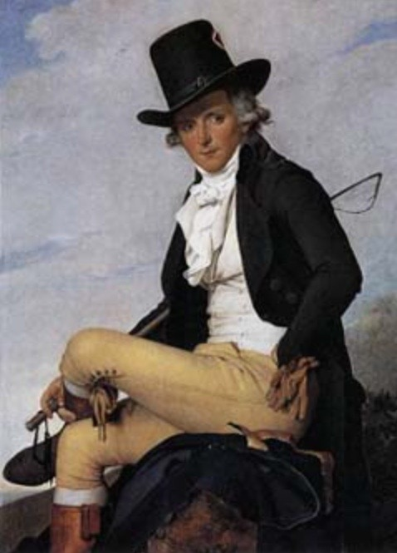

and to adopt a simpler dress code, however still immaculately presented.

One of the first fashion designers of the time was Charles Frederick Worth, and he revolutionised
the fashion industry’s thinking. Prior to him dressmakers would visit the clients’ houses to discuss
their clothing, but Worth invited clients to visit his workroom to view his collections, and this was the beginning of fashion houses, and he was the first to sew his branded labels onto his clothes.
Also at this time designers began to draw their designs for new clothing rather than making the
entire outfit. This became a much cheaper and convenient method of showcasing their new designs to potential buyers.

Activity - Compare fashion of the last two decades with current fashion.

In the late 1990s the fashion trends of both women and men tended to be that of
simplicity. During the 90s people were not so interested anymore in following and keeping
up with all the new fashion designs as they were in previous decades, so eventually the
simplistic and minimalist look itself began to influence fashion designers, and it became
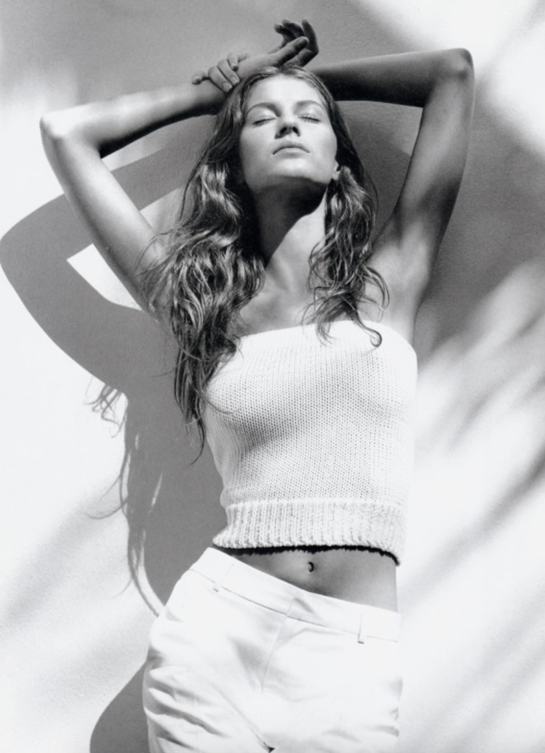

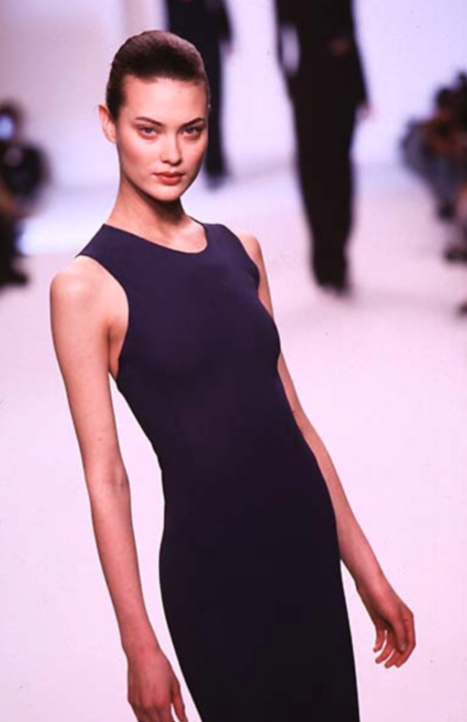

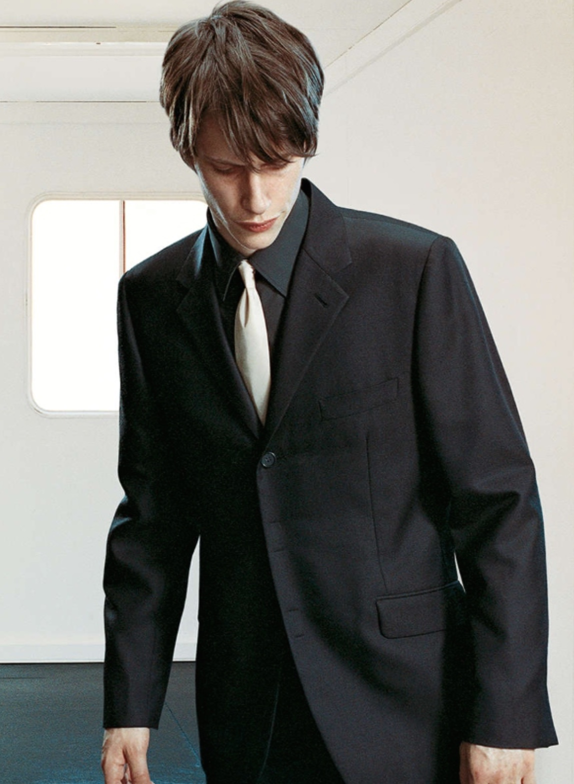

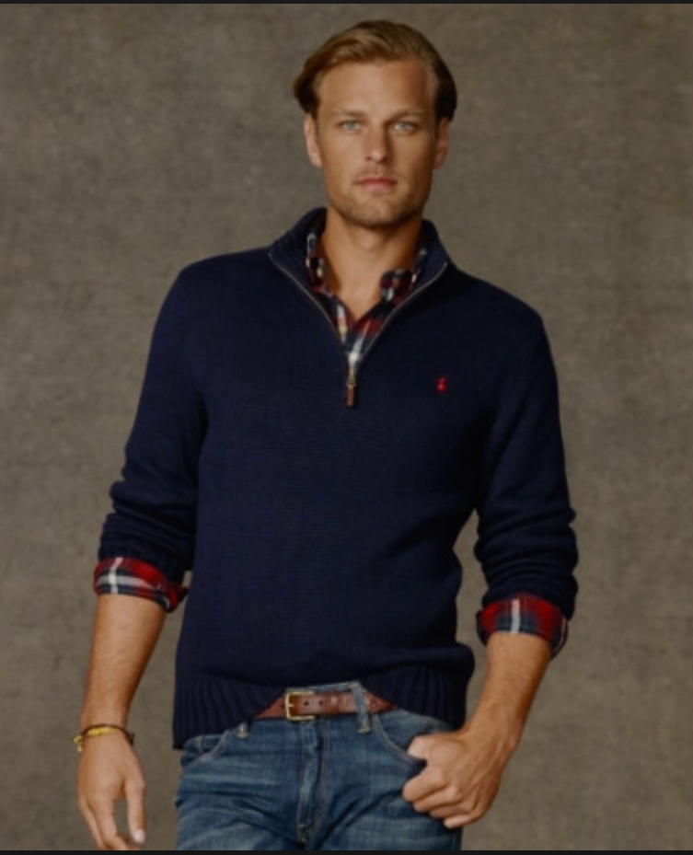

the high fashion of the late 90s.

In the early 00s the minimalistic look was still very popular, however the idea of looking to
the past, such as the 1960s, 70s and 80s for style inspiration started to influence the fashion
industry.
Also at this time mainstream styled clothes started to become more tighter, however at the
same time rap music was gaining in popularity and therefore influenced young peoples fashion
with its baggy and oversized styles.
The early 21st Century was the time of diversity becoming evermore widespread due to the
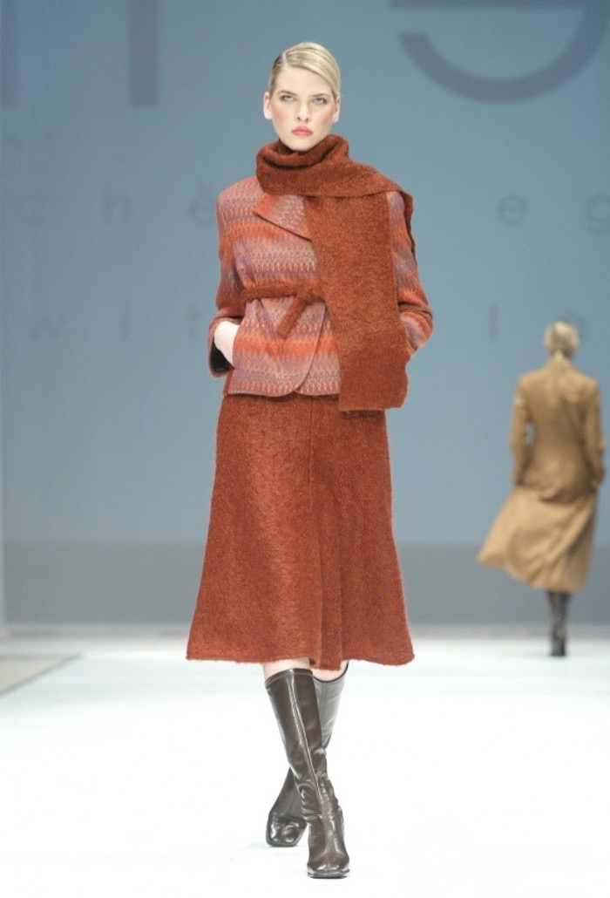

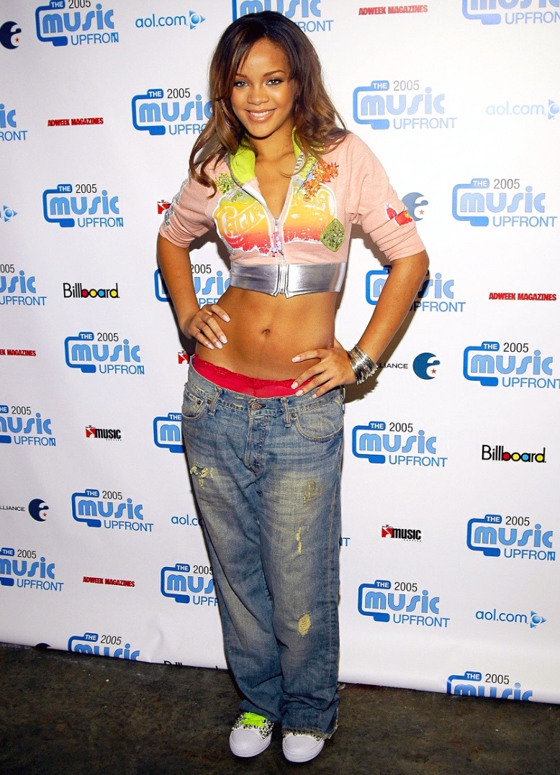

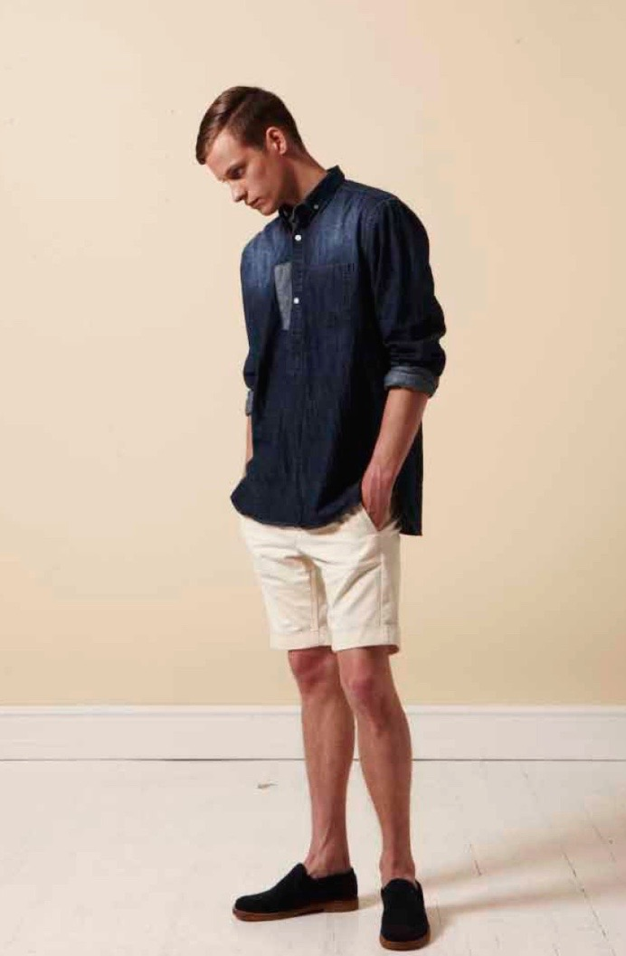

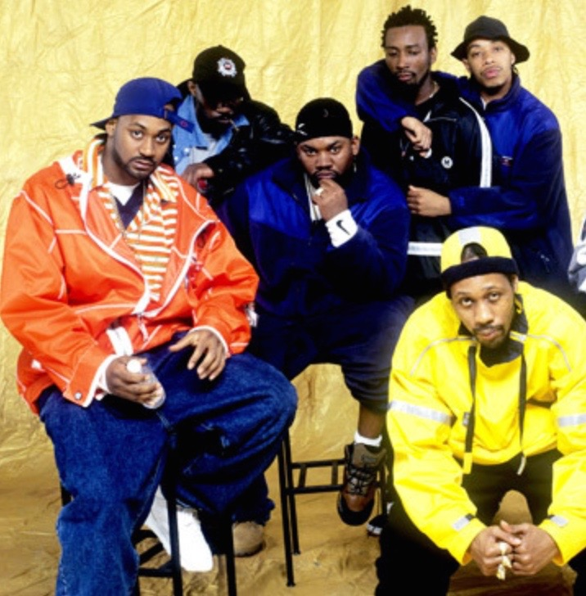

stronger influences of world cinema, tv and music being more readily accessible.

The fashions of today are more diverse than they ever have been, drawing inspiration from
every corner of the globe, with music, films, art, history, geography, religion and many others
playing a huge role in influencing today’s fashion trends.
The mainstream of fashion has also become very diverse and creatively colourful and imaginative,
however if I were to choose a recurring theme of today’s fashion it would be that of a casual
formal style. For women and men it is fashionable to wear formal styled clothes but to wear them
in a casual manor, such as formal shirts and jackets worn with casual trousers and hair styles
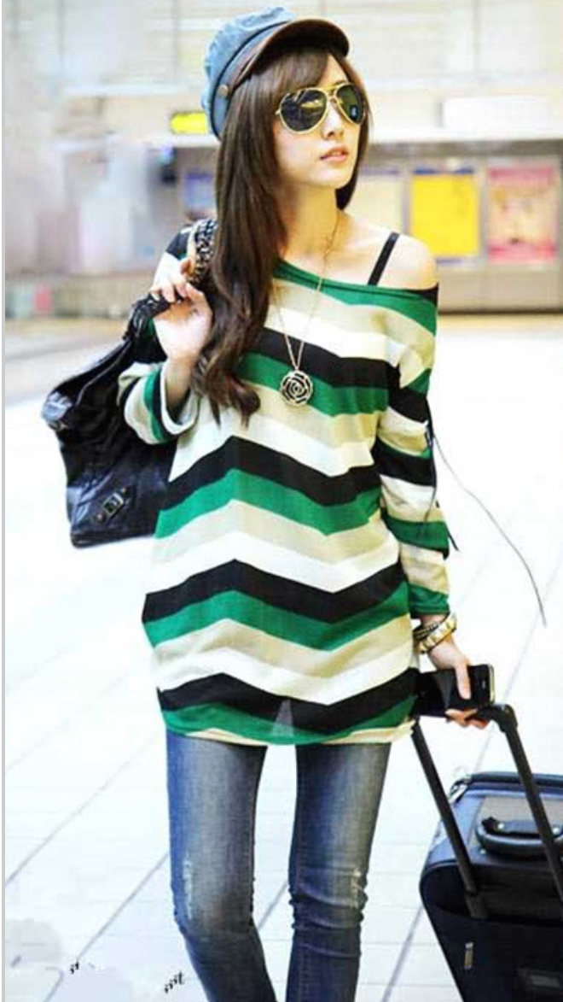

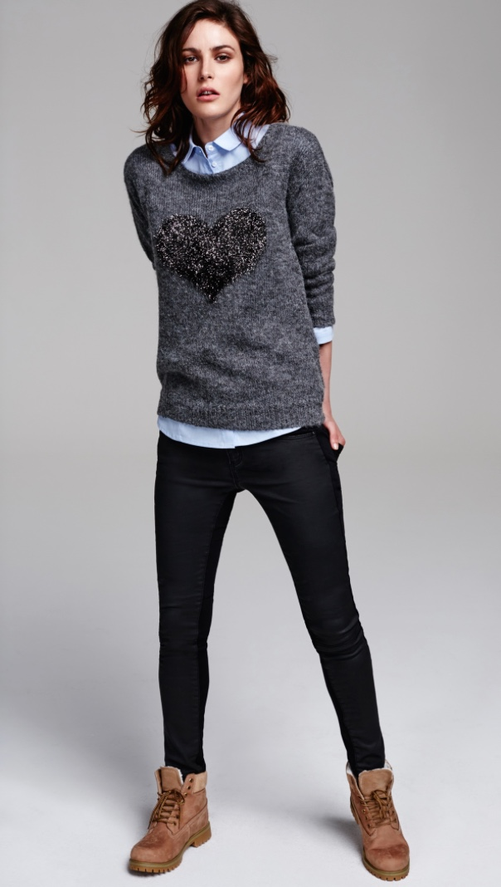

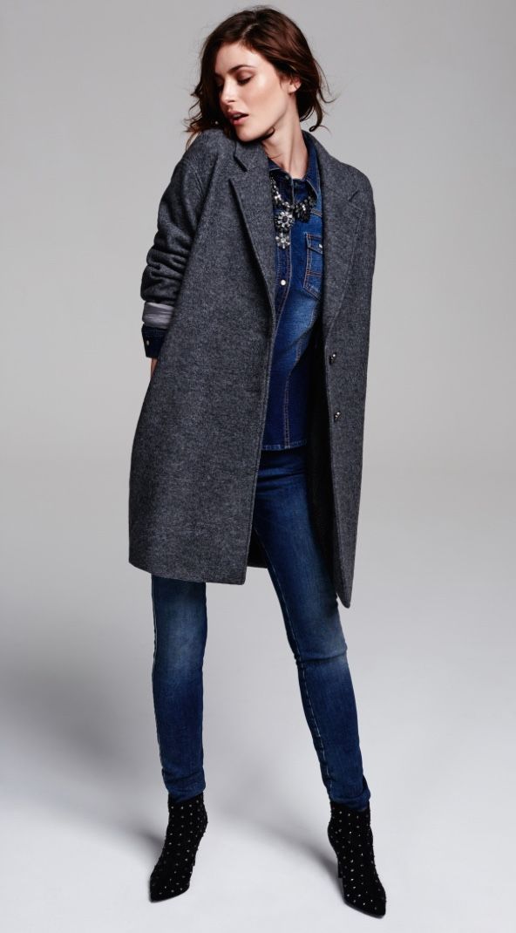

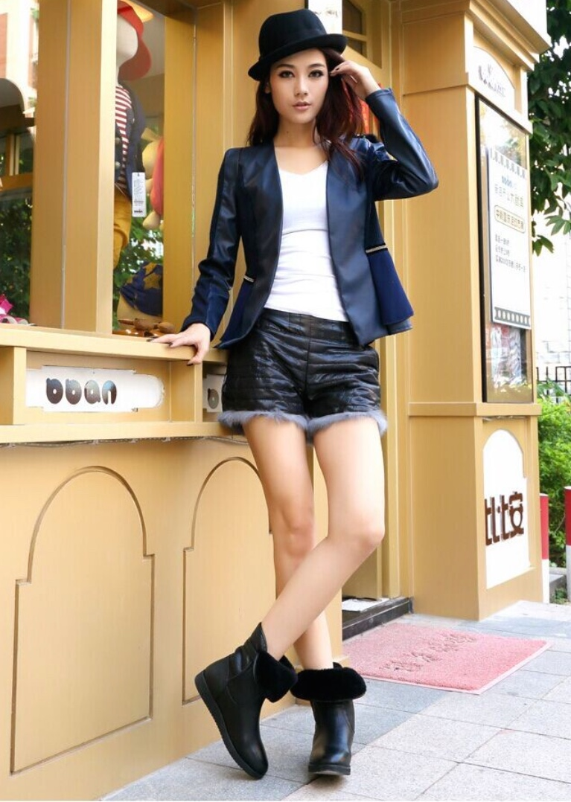

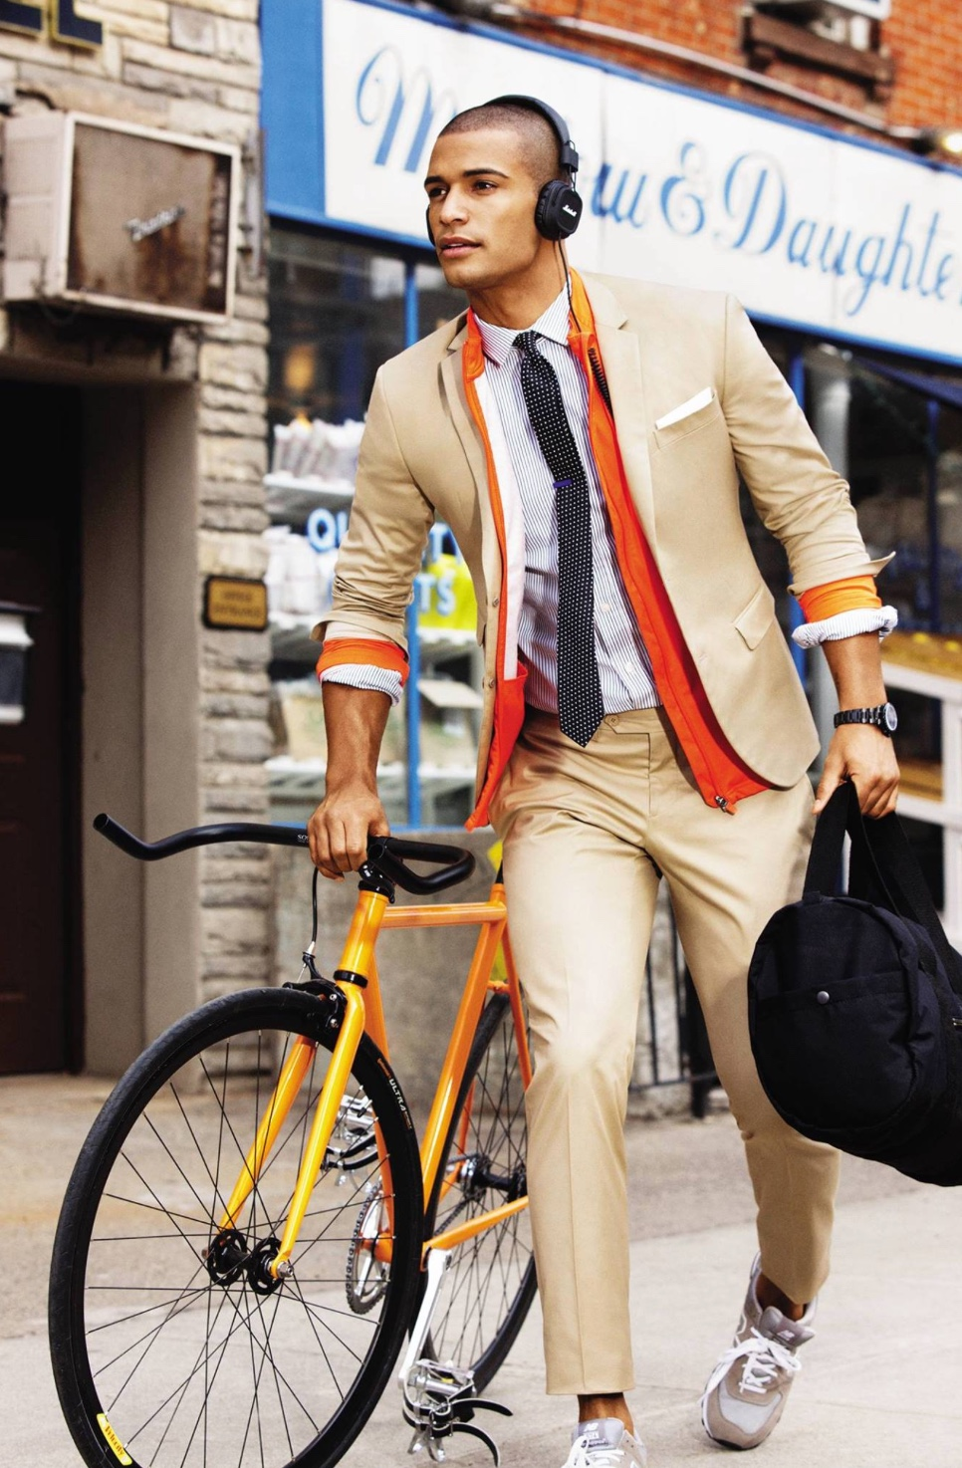

being of a more natural look.

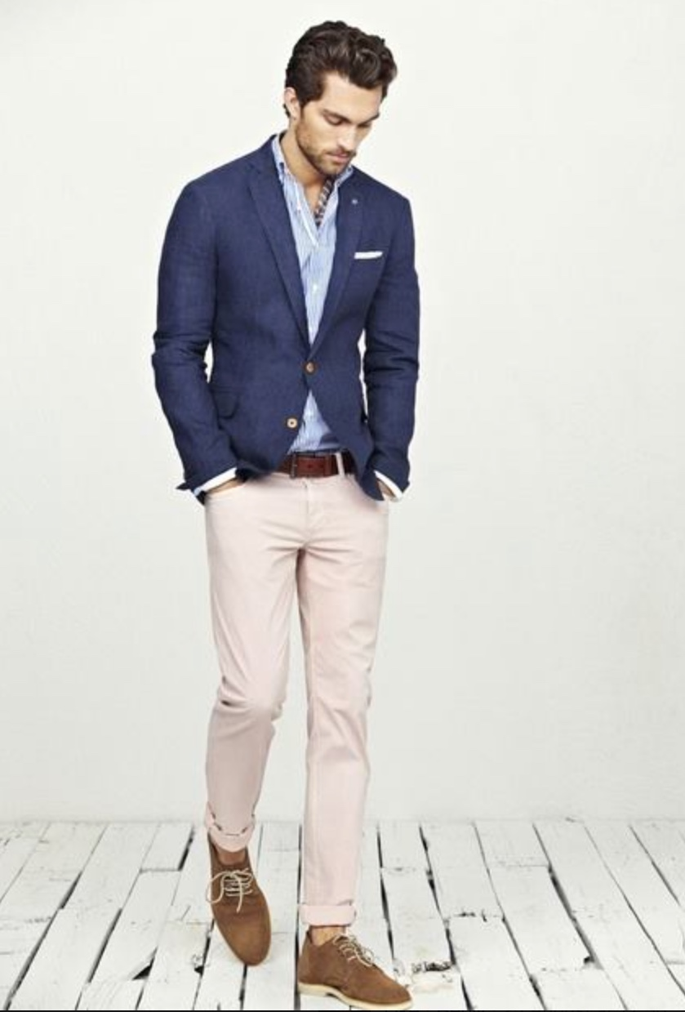

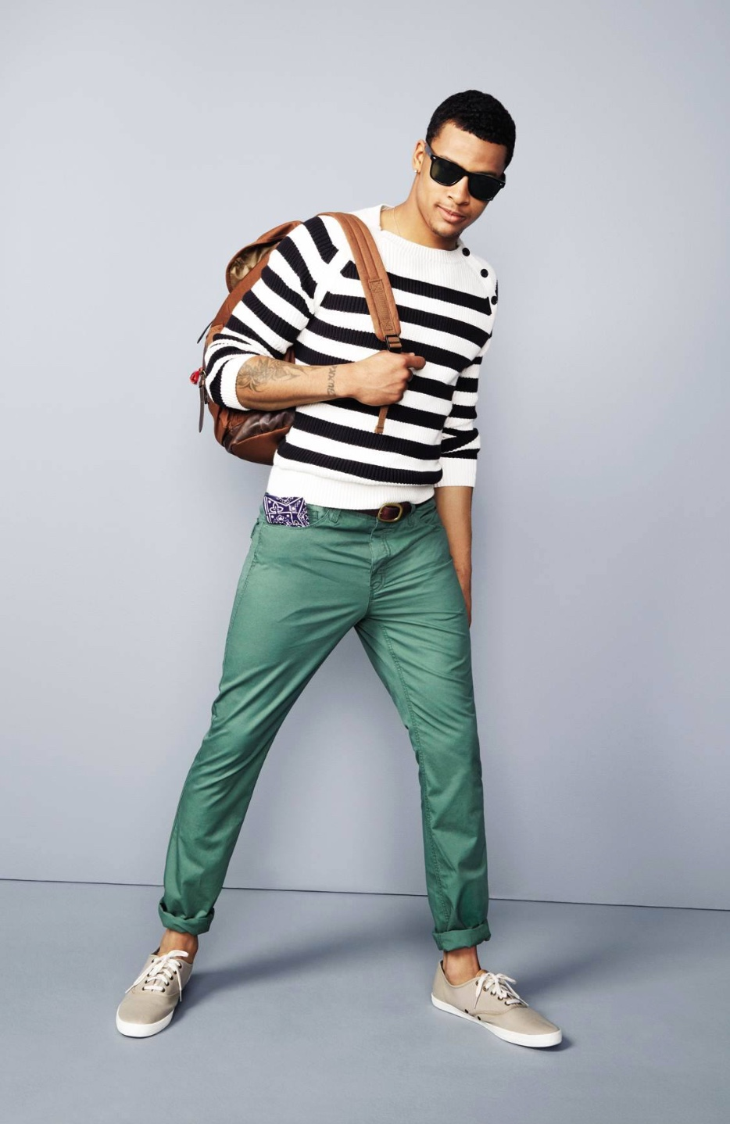

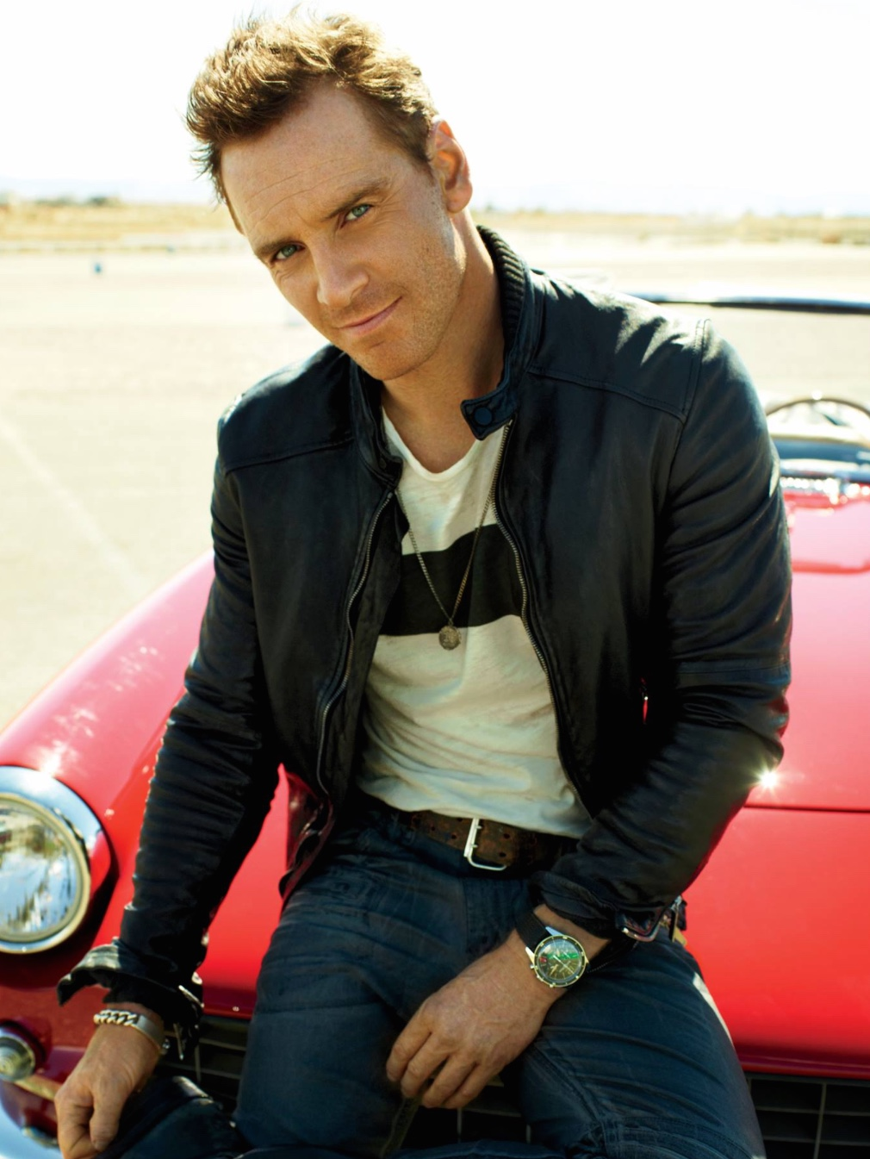


Compared with the previous two decades, today’s fashion has not drastically changed,
it has more so refined the style ideas of previous decades, and continues to refine and gradually
evolve to incorporated more multi-national inspirations.
It could be said that compared with two decades ago the fit of clothing has now become quite a
bit tighter, especially with trousers, and menswear has perhaps become more colourful.
People are now very comfortable and daring to experiment with various different styles and to
combine them in different and original ways.
However it can still be said that every generation through the past decades has in some way
or form had the same inspiration to experiment with styles, so it is by no means unique to the
present day, however due to the diversity of styles now, more and more people have the
confidence to brake any moulds that still exist.

Student Statement:

By submitting this assignment, I confirm that this is my own work.

Student Signature | CHRISTOPHER DENBY | Date | 08/09/2015

