
Assignment Cover Sheet

Student Name: | MAJALIWA FREDRICK
Student Number: | 1506
Course: | DIPLOMA IN ACCOUNTING AND FINANCE
Assignment NO: | 5

Marking Criteria:
We expect the learners to write minimum one well expressed point in three lines against each allocated mark. This means one needs to write 15 lines with 5 well expressed points to get high grades for a 5 marks question.
For high grades use examples and illustrations where appropriate.
Understanding Profit or Loss Statement

Assignment 5

Total Marks: 30

Q1: Explain the contents of statement of Profit or Loss. 10
Answer:

A profit and loss account is a summary of business transactions for a given period - normally 12 months. By deducting total expenditure from total income, it shows on the "bottom line" whether your business made a profit or loss at the end of that period.
A profit and loss account is produced primarily for business purposes – to show owners, shareholders or potential investors how the business is performing. But most of the information is also used by the Inland Revenue to work out your tax bill.

The profit and loss statement shows the trading performance of the business and the distribution of profit. Profit is not equivalent to cash in bank

Income
Customer sales, profit/loss from sale of tangible fixed assets, “non-operating” income, investment income

Expenses
Variable (direct) costs, Fixed (overhead) costs, interest paid, depreciation allowance on tangible fixed assets

Distribution
Drawings/dividends, retained profit

The diagram below illustrates P/L account statement measuring Profit

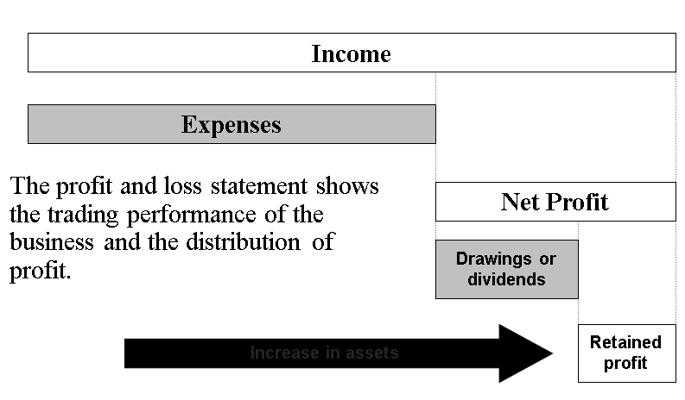
And this diagram below is when Profit or Loss account statement is measuring Loss

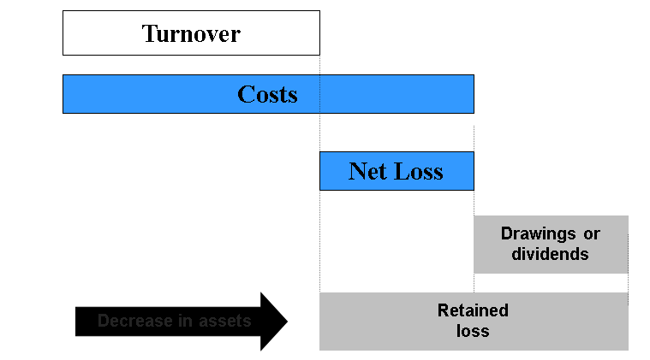

Where Income statement can be represented by the following equation:-

Income Statement = Trading Account, Profit & Loss Account and Appropriation a/c
So, P/L account is the second part of the Income Statement. The difference between gross Profit and Operating Expenses equals Net Profit (NP)

I.e to say,
- Sales
  - Minus Cost of Goods Sold
- = Gross Profit
- Minus Operating Expenses
  - Selling expenses
  - General and Administrative expenses
  - Depreciation and Amortization Expense
- = Operating income (EBIT)
- Minus Interest Expense
- = Earnings before taxes (EBT)
- Minus Income taxes
- = Net income (EAT)

The following is the sample of income statement

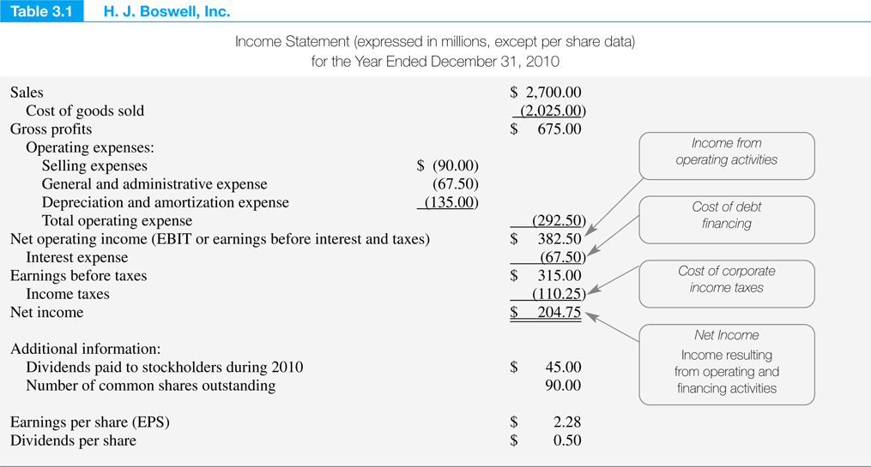

Q2: Explain the following equation in detail 10

Assets = Liabilities + Capital

Answer:
(asset) = (sources of funding)
Assets represents the resources owned by the firm, whereas liabilities represent the total amount of money the firm owes its creditors. Liabilities otherwise known as claims, normally arise on behalf of suppliers of goods, services and loans, but they may include an obligation to provide a service that has been paid for in advance.

Capital sometimes called shareholders equity or owners’ equity refers to the difference in the value of the firm’s total assets and the firm’s total liabilities.

So Capital includes the owner’s equity and retained earnings, where retained earnings is a profit obtained from business operations. Profit is a results of subtracting expanses from revenues earned.

Profit = Revenue - Expenses

Now the revised equation can be rewritten as

Assets = Liabilities + Shareholders equity +( Revenues- Expenses)

Or

Assets + Expenses = Liabilities + Shareholder’s equity + Revenues

Left hand side of the equations, increases debit side of Assets and Expenses accounts and Right hand of the equation increases the credit side of the Liabilities, equities and Revenues accounts

Q3: Discuss the following concepts 10

- Realization concept
Answer:
Realisation concept specifies the point of time at which revenue should be recognised and recorded in the book. It usually refers to the point of time when:
- Goods or services are passed to the customers, and
- The customers incur liability to pay

OR

Realization concept in accounting by definition, also known as revenue recognition principle, refers to the application of accruals concept towards the recognition of revenue (income). Under this principle, revenue is recognized by the seller when it is earned irrespective of whether cash from the transaction has been received or not.
This concept can be explained as follows:

In case of sale of goods, revenue must be recognized when the seller transfers the risks and rewards associated with the ownership of the goods to the buyer. This is generally deemed to occur when the goods are actually transferred to the buyer. Where goods are sold on credit terms, revenue is recognized along with a corresponding receivable which is subsequently settled upon the receipt of the due amount from the customer.
In case of the rendering of services, revenue is recognized on the basis of stage of completion of the services specified in the contract. Any receipts from the customer in excess or short of the revenue recognized in accordance with the stage of completion are accounted for as prepaid income or accrued income as appropriate.

For example, Motors PLC is a car dealer. It receives orders from customers in advance against 20% down payment. Motors PLC delivers the cars to the respective customers within 30 days upon which it receives the remaining 80% of the list price.
In accordance with the revenue realization principle, Motors PLC must not recognize any revenue until the cars are delivered to the respective customers as that is the point when the risks and rewards incidental to the ownership of the cars are transferred to the buyers.

The importance of this concept is explained as

Application of the realization principle ensures that the reported performance of an entity, as evidenced from the income statement, reflects the true extent of revenue earned during a period rather than the cash inflows generated during a period which can otherwise be gauged from the cash flow statement. Recognition of revenue on cash basis may not present a consistent basis for evaluating the performance of a company over several accounting periods due to the potential volatility in cash flows
Source: http://accounting-simplified.com/financial/concepts-and-principles/realization.html#sthash.ZyCMBMEy.dpuf

- Matching concept

Answer:
Matching concept sates that revenue should be linked with its relevant expense or cost in the same period. Commission is the relevant expenses of Sales. (Commission is matched with Sales.) Depreciation of motor vehicle is matched with the time.

Or
The matching principle refers to the accounting principle which realizes the expenses must match with the revenues they helped produce. For example, employees’ salaries are recognized when the product produced as a result of that work is sold, and not when the wages were paid

Or
Matching Principle by definition requires that expenses incurred by an organization must be charged to the income statement in the accounting period in which the revenue, to which those expenses relate, is earned.
This concept can be explained as follows:-
Prior to the application of the matching principle, expenses were charged to the income statement in the accounting period in which they were paid irrespective of whether they relate to the revenue earned during that period. This resulted in non-recognition of expenses incurred but not paid for during an accounting period (i.e. accrued expenses) and the charge to income statement of expenses paid in respect of future periods (i.e. prepaid expenses). Application of matching principle results in the deferral of prepaid expenses in order to match them with the revenue earned in future periods. Similarly, accrued expenses are charged in the income statement in which they are incurred to match them with the current period's revenue.

A major development from the application of matching principle is the use of depreciation in the accounting for non-current assets. Depreciation results in a systematic charge of the cost of a fixed asset to the income statement over several accounting periods spanning the asset's useful life during which it is expected to generate economic benefits for the entity. Depreciation ensures that the cost of fixed assets is not charged to the profit & loss at once but is 'matched' against economic benefits (revenue or cost savings) earned from the asset's use over several accounting periods.

Matching principle therefore results in the presentation of a more balanced and consistent view of the financial performance of an organization than would result from the use of cash basis of accounting.

The following are three examples of the use of matching principle in IFRS and GAAP include the following:
- Deferred Taxation
IAS 12 Income Taxes and FAS 109 Accounting for Income Taxes require the accounting for taxable and deductible temporary differences arising in the calculation of income tax in a manner that results in the matching of tax expense with the accounting profit earned during a period.
- Cost of Goods sold
The cost incurred in the manufacture or procurement of inventory is charged to the income statement of the accounting period in which the inventory is sold. Therefore, any inventory remaining unsold at the end of an accounting period is excluded from the computation of cost of goods sold.
- Government Grants
IAS 20 Accounting for Government Grants and Disclosure of Government Assistance requires the recognition of grants as income over the accounting periods in which the related costs (that were intended to be compensated by the grant) are incurred by the entity

Source http://accounting-simplified.com/financial/concepts-and-principles/matching.html#sthash.VevqZzrV.dpuf

Student Statement:
By submitting this assignment, I confirm that this is my own work.

Student Signature |  | Date | 9 October, 2015

For Tutor / Assessor Use Only
Total Marks
Marks Obtained
Percentage / Grade

