
Assignment Cover Sheet

Student Name: | Sukhwinder kaur
Student Number: | 1282
Course: | Fashion design
Assignment NO: | 12

Answer a)
The flat pattern method is necessary for areas like sleeves and pant legs, which would be difficult to drape on a figure. Basic shapes, such as bodices, pants, or skirts, are draped or drafted. The draping method is like fabric sculpture, it is ideal for soft, flowing designs. The patternmarker cuts and shapes the fabric to a dress form. This enables the designer to see the proportions and lines of the design exactly as they will look three-dimensionally, on the wearer. The design is often altered as it develops on the form. Everything must be carefully marked; centre front, shoulder line, seams, armholes, buttonholes, and so on. When the designer is satisfied with the look and fit, the toil is taken off the form and trued up; the sketched lines are corrected with drafting curves, angles, and rulers; and the pattern is redrawn on heavy papers.

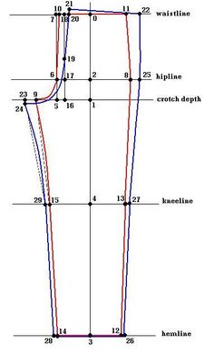
Drafting is blocking out on pattern paper a set of prescribed measurements for each piece. These patterns, after being tested for accuracy, become that can be changed or adapted to each new style by moving darts and seams. Most pattern makers combine the two methods, depending on the dictates of the design, as well as on their technical training and preference.
Answer b)
A custom dressmaker frequently employs one of three pattern creation methods. The flat-pattern method begins with the creation of a sloper or block, a basic pattern for a filled, jewel-neck bodice and narrow skirt, made to the wearer`s measurements. The sloper is usually made of lightweight cardboard or tag board, without seam allowances or style details. Once the shape of the sloper has been refined by making a series of mock-up garments called toiles or muslins the final sloper can be used in turn to create patterns for many styles of garments with varying necklines, sleeves, dart placements, and so on . although it is also used for women`s clothing, the drafting method is more commonly employed in men`s garments and involves drafting a pattern directly onto pattern paper using a variety of straightedges and curves. The pattern draping method is used for more elaborate and unique designs that are hard to obtain through the flat pattern method. This is because it is nearly impossible to account for the way a fabric will drape or hang on the body without an actual 3-dimensional test run. It involves creating a toile mock-up pattern by pinning fabric directly on a dress form, then transferring the toile outline and markings onto a paper pattern or using the toile as the pattern itself. 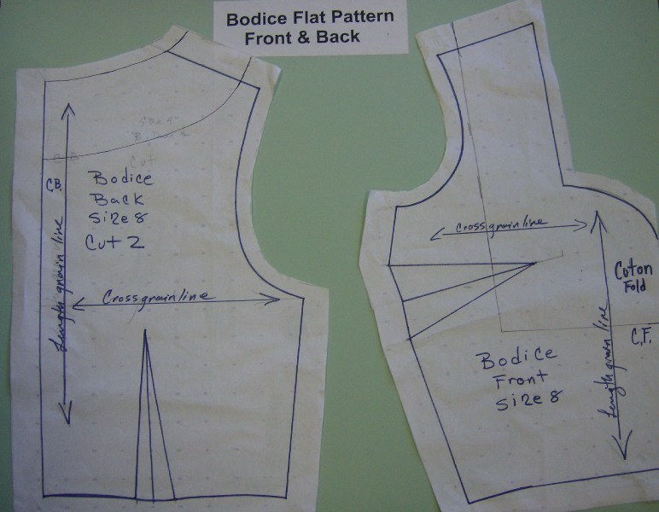
Answer c)
The pattern grading is an essentai part of pattern making. It decides how patterns increase or decrease sizes. According to countries, pattern grading includes Usa`s Eur``s generally, pattern grading adjusts for people of different ages and genders. The fabric type also influences the pattern grading standards. home sewing pattern are generally printed on tissue paper and sold in packets containing sewing instructions and suggestions for fabric and trim. Modern patterns are available in a wide range of prices, sizes, styles, and sewing skill levels, to meet the needs of consumers. Home sewing patterns are graded, that is, redrawn to fit larger and smaller sizes than the original design.
The making of industrial patterns begins with an existing block pattern that most closely resembles the designer`s vision. Patterns are cut of oak-tag with a hole and stored by hanging with a special hook. The pattern is first checked for accuracy, then it is cut out of sample fabrics and the resulting garment is fit tested. Once the style has demonstrated sales potential, the pattern is graded for sizes, usually by computer with an apparel industry specific cad programme. When the manufacturing company is ready to manufacture the style, all of the sizes of each given pattern piece are arranged in to a marker, usually by computers.
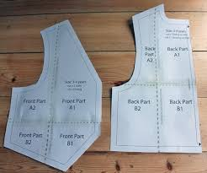
Answer 2.
The darts help shape the flat piece of fabric into a form fitting one that fits the curves of the human body. Broken stitching lines meet at a point to create the dart. These lines show where to fold the fabric to create dart.

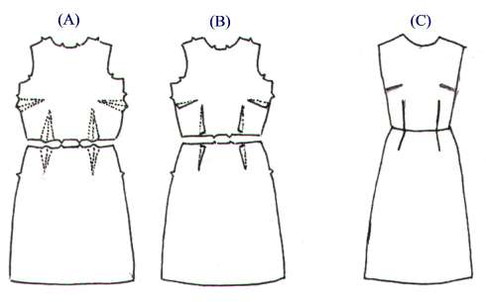

Zipper position this symbol shows the zipper placement. The top bottom markings show you the length of the marking.
Grain line the most important pattern marking, the grain line symbol is a straight line that may or may not have arrows head at each end.
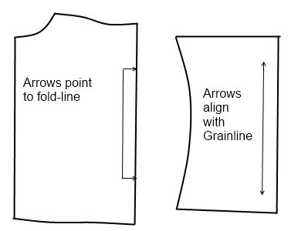
The hemline direction on the pattern shows the recommended finished length of the project, which varies from person to person.

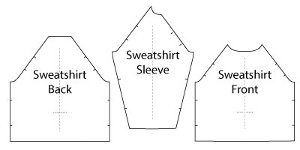
Answer 3.
Getting to know the fabric selvages the finished edges where the fabric comes off the looms, the selvages are parallel to the lengthwise grain.

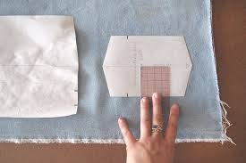
Lengthwise grain or grain line the grain line runs the length of fabric, parallel to the selvages. On knit fabrics, the lengthwise grain is usually more stable and less stretchy than the crosswise grain.

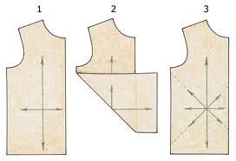
Crorrwise grain this grain runs across the width of the fabric, from selvage to the lengthwise grain. On knit fabrics, most of the stretch is usually across the grain.
Bias 45 degrees between the lengthwise and crosswise grains. When you pull a woven fabric on the bias it stretches and is very malleable. This is why bias tape and trims that are cut on the bias can be easily shaped to follow a curver edge.
Answer 4.
The placing the pattern pieces on grain each pattern piece shows a grain line. Which is also the length wise grain. The grain line allows you to cut the piece on grain meaning that pattern lines up with the lengthwise grain of the fabric.

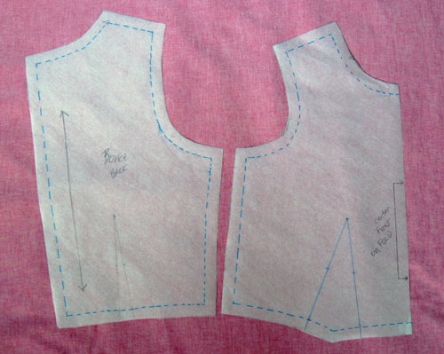
Find and cut apart the paper pattern pieces you need to make your project view; set them aside. If you`re using a multi sized master pattern and want to preserve the option of making the project in a different size in the future, trace the pattern size you need on pattern tracing paper, remembering to transfer all the pattern markings from the master pattern.
Locate the lengthwise grain or place-on-old symbols on the paper pattern pieces. On a flat tabletop, before laying the pattern tissue on the fabric, mark over these symbols using a highlighter for easy reference.
fold and then lay the fabric on a table or cutting board as shown in the pattern guide sheet instructions. If the fabric is longer than your table or cutting board prevent the excess fabric weight from stretching and pulling on your fabric by folding it and laying it on the end of the table.

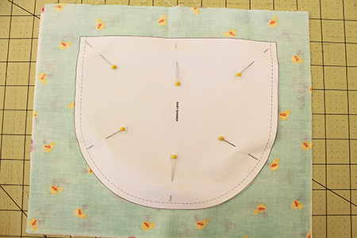
Pinning and cutting out the pieces pin the pattern piece to the doubled layer of fabric so that the pins go through both fabric layers and are perpendicular to and inside of the cutting line. This prevents the fabric from shifting during the cutting process. when you begin constructing a project, you transfer the pattern marks indicating darts, tucks, pleats, and the other symbols to your fabric pattern pieces for a very good reason. for specific instructions on marking and sewing darts, tucks, and pleats, see your pattern guide sheet instructions.

Student Statement:

By submitting this assignment, I confirm that this is my own work.

Student Signature | Sukhwinder kaur | Date

For Tutor / Assessor Use Only
Total Marks
Marks Obtained
Percentage / Grade

