
Assignment Cover Sheet

Student Name: | Rachael Boon
Student Number: | 1501
Course: | Diploma in Fashion Design
Assignment NO: | 4

Marking Criteria:
We expect the learners to write minimum one well expressed point in three lines against each allocated mark. This means one needs to write 15 lines with 5 well expressed points to get high grades for a 5 marks question.
For high grades use examples and illustrations where appropriate.
I.
Market segmentation relates to the brackets in which researchers refer to in order to know which consumers they will be aiming their collection towards. For example the customers income bracket, social class, occupation or even their place in family life cycle. There are then more precise segments that look closer into what decisions the buyer may need to make before purchase, these include; if the garment is for multiple use or a specific occasion, the loyalty of the buyer to the retailer, what the garment will be used for in terms of how they would like to be perceived or for practical use. If the buyer has a somewhat disposable income they will usually dress to suit their lifestyle, an example of this is sportswear that requires specialised clothing; swimming, running, golf etc. Buyers who work with the media also experience other categories such as photographers and their models expressing individuality and actors having many different stage costumes. The number of occupations that require a uniform has increased through the years, creating another segment in the market for fashion to be involved in their work dress, these include; the military and public services but also fast food chains, salons and even retail shops themselves.
II.
Visual thinking is thinking using images and colours that are essential for designers as they need to have a good idea of what they want their finished product to look like in their heads in order to achieve it in real life. For example a graphic designer would have an image of the design they would like to create in their mind before anything has gone into production. It is portraying an idea using textures, colours and shapes in a much more complex way than using language as it is universally appealing and cannot be misconstrued. Verbal thinking is used most effectively by writers, mathematicians, etc. as it is a form of thinking using words and numbers rather than imagery. From a designer’s point of view, visual thinking is seen as more important than thinking verbally as it can be quite difficult to put across an image to others verbally as everyone pictures words differently in their heads, such as a fashion designer would have a rough idea of what they’re aiming their collection to look like. It helps when the designer can transfer their visual thoughts onto paper or in 3D, so as the rest of the product creation team can see exactly what the designer has envisaged.
III.
Most of the time garments are originally designed on the drawing board by sketching the silhouette alternate ways to experiment with their ideas and work out which elements work well with each other. Although the first sketch is simple, it must also be accurate and in proportion with the body, with detailed annotations dictating to the pattern maker where seams and trimmings will be on the final product. This is becoming easier for designers as computers can now sketch designs, automatically creating a pattern from the original sketch. Patterns are made in a sample size so that the designer can show potential buyers and see how the dress looks in 3D. Two techniques are used when pattern making; draping or flat pattern. Draping cuts of soft fabrics such as muslin onto a mannequin, allows the designer to gage the proportions and lines of the garment in a three-dimensional form were markings can be made to show were seams, armholes, buttonholes etc. will go. The flat pattern method is usually used for sleeves and pant legs and they are blocked out on a pattern paper using a set of unique measurements for each piece. They can then be changed or adapted to new styles by altering the pattern. These methods are usually combined when creating different garments.
IV.
Computer aided design or drafting (CAD) is the use of computer technology for the process of design and design-documentation. It allows designers to envisage their final product in three dimensions without having to manually create a prototype. Designers can use CAD software to adapt their designs accurately by changing colours, shapes and fabrics etc. saving time and expenses. Fashion designers use CAD to produce precise patterns of their designs much faster than by hand. Computer technology allows designers who are not as confident or experienced in sketching and illustrations to create detailed and intricate drawings using different fabrics and textiles. Although traditional ways of designing and pattern making manually are still very popular within the fashion industry, CAD has created new levels of design, producing collections much faster than in the past.

Project: Market Research
a)
The first dress I tried on was a Jenny Packham evening dress which was 97% polyester and 3% elastane, the design was simple and elegant. Very diverse in terms of the type of customer they were selling to as I felt different age groups could wear it, however I did feel slightly older when trying the dress on. The fabric was a good choice for the price range and was flattering to the body with the way it draped. The fit was nice and I did feel feminine in the dress, but I think looking at the design it could have been from any designer and it wasn’t distinctive to other dresses by the designer. The Giles Deacon was 100% polyester with a cream bodice embellished with beading and a flowy skirt which made the dress stand out a lot more than the first. Like the first dress I feel the fabric choices complimented the design as the top section was stiffer cinching you in at the waist and then flowing towards the bottom. The target audience was very obvious to me in terms of the silhouette and embellishments. I definitely felt my age trying this dress on, as a younger buyer who goes to more casual events I would feel more comfortable in this dress than the first. Overall I think the Giles Deacon dress would be a better buy for a one off party however as my personal taste played a big part in my decision, I feel the silhouette could date very easily. If I was a person that went to many events, such as cocktail parties, I would purchase the Jenny Packham dress as I felt very elegant when trying on and the fabric was suitable for the type of dress it was, the V-neck neckline is also timeless that wouldn’t go out of date.
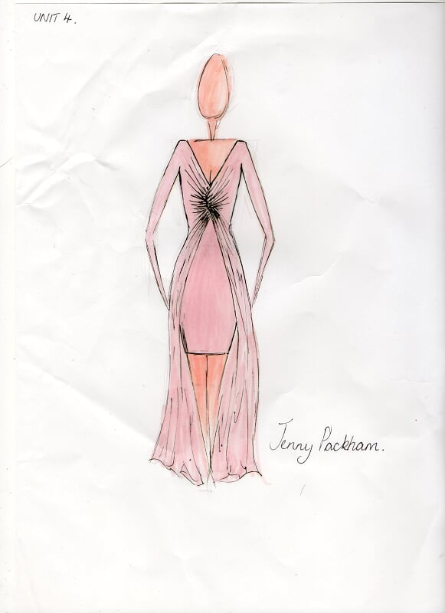

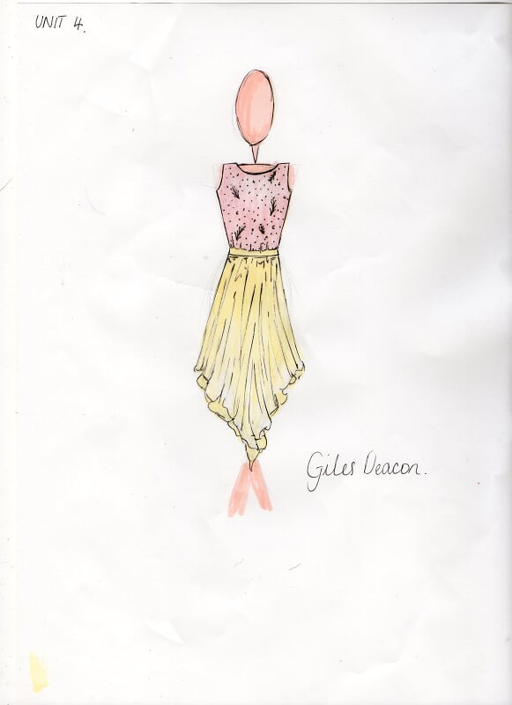

b)
Contemporary | Junior
AX Paris had quite a large range in the store I looked at. The majority of the designs were party dresses at a reasonable high street price. There were also some limited edition items which were slightly more expensive, in between general high street designs and high end designer garments.  River Island was similar to AZ Paris in terms of styling and price, however River Island had more basic every day products in the store as well as a limited edition range, reaching a wider range of customers.  French Connection designs were much more high end than River Island and AX Paris as the majority of their clothing was for evening occasions. The pricing mark-up was quite significant, however some of the designs didn’t differ a great deal from the limited edition ranges of River Island and AX Paris’s designs.  Ted Baker showed a broad range similar to River Island, however there was a significant difference in terms of design as Ted Baker tend to stick to a few fabrics and base their whole collection around the fabric so there wasn’t much range in style. | Bluezoo’s designs were practical junior clothes, using typical colours and designs.  J by Jasper Conran were more designer items but still had some practical items for younger children.  Monsoon’s junior range was quite reasonable in terms of price considering most of their line was party clothing. The clothes looked a lot more designer than ‘child-friendly’, as if they were originally designed for women and then transferred to a junior pattern.

Student Statement:

By submitting this assignment, I confirm that this is my own work.

Student Signature | RACHAEL BOON | Date | 27/11/2015

For Tutor / Assessor Use Only
Total Marks
Marks Obtained
Percentage / Grade

