
Assignment Cover Sheet

Student Name: | Kyle Pentland
Student Number: | 1605
Course: | Diploma in Environmental Management (Level 4)
Assignment NO: | 7

Marking Criteria:
We expect the learners to write minimum one well expressed point in three lines against each allocated mark. This means one needs to write 15 lines with 5 well expressed points to get high grades for a 5 marks question.
For high grades use examples and illustrations where appropriate.

Page 1
Q1:
Environmental management is a process that organisations undertake to regulate and protect the health of the natural world. In most cases, it doesn’t involve managing the environment itself, but rather is the process of taking steps that will have a positive impact on how environmental resources are used and protected.

History has shown us that environmental planning, whilst sounding progressive, does not necessarily produce sustainable development. When the earth had a population a fraction of what it is today, vegetation change and mass extinctions occurred due to human activity.
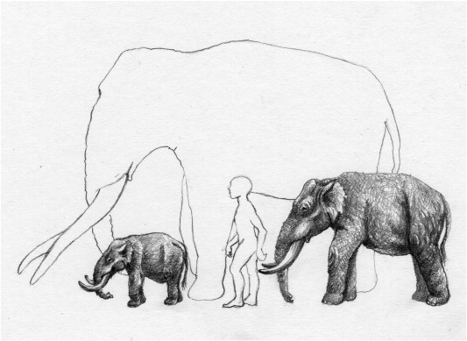
Cyprus Dwarf Elephant (on left) Extinct 7470 B.C.

Page 2
Today, what might be sustainable concepts and practices by one company could be unsustainable to another. An example would be a Hydro-Electric Dam.
Pros:
- It is renewable energy
- It is clean energy
- It is low cost to run
Cons:
- Environmentally damaging downstream
- Droughts
- Impacts fish migration.

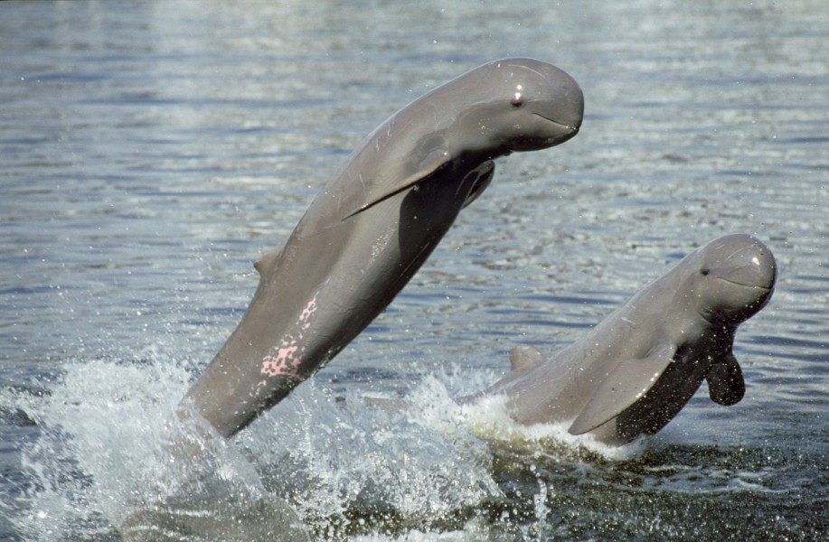
Mekong Irrawady river dolphins cannot migrate on dammed rivers
Another short sighted environmental management concept is Palm Oil Plantation.
Pros:
- It produces 10 times the energy it consumes
- It is a bio-fuel

Page 3
Cons:
- Rain forest destruction
- Loss of wildlife
- Green house gas emissions.

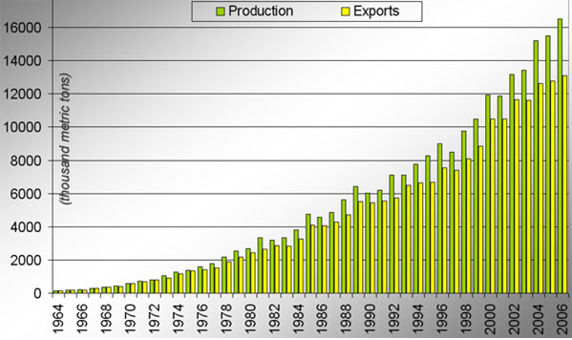
Production and exportation of Palm oil, Malaysia 1964-2004
Also, the sheer number of Environmental Agencies, whilst welcomed, involved in management can end up missing the common goal. Instead rivalries develop, information can be hard to access, whom is in charge of what area, etc, can occur.
With proper understanding and promotion of Environmental Management, macro-business and employment opportunities would be increased (especially in developing countries) in pollution control, recycling and energy supply. However, this has to have political will and finance to do so.

Page 4
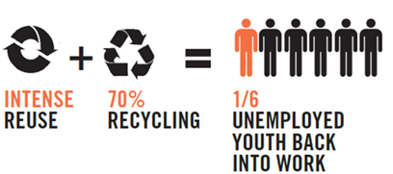
Reuse and Recycling of waste would create 360,000 in Nigeria
Q2:
An Environment Management System (EMS) is a continuous tool for managing the impacts of an organisation's activities environmentally. It provides a structured approach to planning, implementing and review on environmental protection measures. It monitors environmental performance and incorporates environmental management into a company's daily operations and long term planning.
Its key elements would be:-
Environmental Policy: this is a statement of what an organisation has set out and aspires to achieve from an EMS. It makes certain all environmental activities are in accordance with the organisation's objectives.
Environmental Impact Identification: recognition and written documentation of the current and future environmental impacts of an organisation's operations need to be carried out. This can be recognised through undertaking an environmental audit.
Objectives and Targets: an environmental audit forms the basis of an organisation's environmental goals. It benefits by embracing stricter, long term objectives to stimulate/enhance its performance. To improve, targets should be regularly scrutinized.

Page 5
Training: staff undergo environmental awareness training to acquaint themselves with their duties for implementing the EMS and with the overall environmental policy and objectives of the organisation. This provides staff with the necessary attributes for the effective implementation of the EMS.
Management review: Did the policies implemented at the beginning achieve the end goal? If not, review where mistakes were made, alter and start the improved cycle all over again.

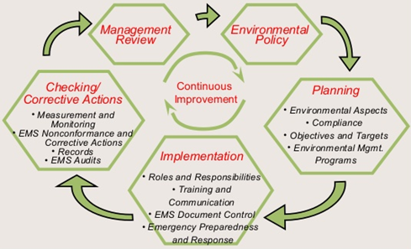
The EMS Plan, Do, Act Cycle
Q3:
Sustainable development allows growth to benefit humanity while encouraging a balanced approach that creates a minimal amount of harm. All development has to take into account its impact on the opportunities for future generations. It can be broken down into 3 main sub points, which are:-
Many areas of economic growth are reliant on natural resources and land development. Economic sustainability places monetary value on these limited resources in an effort to use them fairly among the people of the world.

Page 6
However, can the long term economic objective of sustained agricultural growth be met if, for example, the ecological objective of preserving biodiversity is not?
Environmental sustainability seeks the use of sustainable natural resources over fossil fuels. It also encourages people to make changes in their personal lives to create a smaller carbon footprint, reducing impact on the planet. Common environmental initiatives such as recycling are also included under the heading of environmental sustainability. However, what happens to the environment in the long term if a large number of people cannot afford to meet their basic household needs today? 0.7 billion people live in extreme poverty.
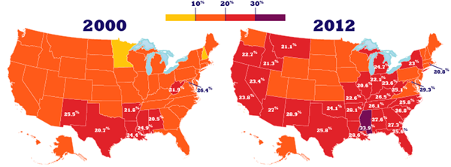
Percentage of American children in Poverty
Social sustainability concerns itself with factors that affect the well being of people and their governments, including food production, food security and poverty. It also is concerned heavily with education and working with groups and individuals to provide information that encourages sustainable development. However, in a rapidly growing population, how do we meet their need for food without increasing agricultural land at the expense of forest degradation and increased Green House gases?

Page 7


Activity:
Mentex Computer Systems is a computer manufacturing company, based in Belfast.
Mentex operations could conceivably influence the environment in a number of ways. Chemicals needed for research, growth, manufacturing processes and services must be properly controlled, from purchase through to storage, use and disposal. Certain processes are energy and/or water-intensive. In addition, Mentex’s products should be designed so that they can be reused, recycled or disposed of properly at the end of their useful lives.
Mentex has a range of mechanisms to observe and measure the functional implementation of its EMS requirements. These include:
Environmental training
Environmental training is provided in line with employees' job responsibilities. There may be several types of training required, with depth of content and amount of topics varying depending on the work location activities, products and services, and on the duties undertaken by employees. Consequently, environmental training can range from general environmental awareness to more complicated, professional training such as hazardous waste management training and certification, training for treatment plant operations etc.
Page 8
Professional Self-Assessment Program
The self-assessment program consists of a series of Mentex unique environmental checklists that are used to equip Mentex with the ability to assess its overall environmental performance nationally and within Europe on a consistent basis. The checklists include both manufacturing and hardware development locations and nonmanufacturing locations at a geographic level around Northern Ireland, product groups and service activities.
Corporate internal audits
Mentex has built an environmental audit program which is implemented by the corporate internal audit organisation. This is an all inclusive audit program which is separate from the Corporate Environmental Affairs staff. Each year, randomly selected sites are audited for environmental, health and safety compliance by Mentex’s Corporate Internal Audit staff.
Environmental Performance Database (EPD)
The EPD functions as one of Mentex’s internal measurement and monitoring systems. The database gauges environmental performance in areas like recycling, water effluents, chemical use and emissions, hazardous and nonhazardous waste management, energy conservation, environmental expenditures and progress toward meeting their objectives. The EPD provides the data used in Mentex’s annual environmental and corporate responsibility reports.
As with any system there are hurdles to overcome. One of the greatest disadvantages of designing and implementing environmental management plans for small businesses is that these companies may not have enough resources, especially financial resources. As a business owner, you need to evaluate the costs associated with training your personnel, any potential consulting assistance and environmental impact analyses or other studies that might be needed. Furthermore, your employees will spend time and effort on learning about and implementing the new environmental management system.

Student Statement:

By submitting this assignment, I confirm that this is my own work.

Student Signature | Kyle Pentland | Date | 28/02/2016

For Tutor / Assessor Use Only
Total Marks
Marks Obtained
Percentage / Grade

