Fashion Forecasting
Assessment 3
- Give short answers for the following questions:

I.How the income groups influence fashion?
The financial capacity is evidently a factor that influences the purchasing process, as the higher it is the higher the acquisition power and garment consumption. Sources of influence and methods of adaptation vary with the consumers' age range, income level, lifestyle, and fashion preferences.
II. Why is awareness of fashion forecasting important for the designer and the buyer?
Forecasting the future demand for particular styles, fabrics and colours is an important aspect of the fashion industry. Can bridge the gap between ambiguous, conflicting signs and the action taken by the design team. Long term forecasting is used by executives for corporate planning purposes. It is also used for marketing managers to position products in the marketplace in relationship to competition. Short term forecasting is used by product developers, merchandisers and production managers to give style direction and shape collections
If a fashion look is promoted by the media and manufactured rapidly enough, the look can trickle across all levels of the market.

III.What is meant by fashion trend?
Fashion trends are the styling ideas that major collections have in common. They indicate the direction in which the fashion is moving. When a Clothing Designer introduces a new fashion, it may be accepted or rejected by the buying public.
A "Trend" occurs when a new design is accepted and sells in sufficient quantity in some test markets, and then creates a demand from consumers across a broader market. Fashion Trends are governed or dictated by the catwalks by major designers.
IV. What are the different factors that affect fashion trend?
The adaptation of a trend depends on the particular group of people who are potential consumers. Sources of influence and methods of adaptation vary with the consumers' age range, income level, lifestyle, and fashion preferences ,social norm, fashion education, mass media, peer groups, social criticism, environment, customs, traditions, religion, leisure activities, inspiration by friends, changing trends and values, influence by family members, education,

Define the following terms;
Classics. They never goes out of fashion.Some styles remain more or less accepted for an extended period. A classic is characterised by simplicity of design
Fads. A thing that becomes very popular in a short amount of time, and then is forgotten at about the same speed
Interrupted cycles. Is when the normal progress of a fashion cycle is interrupted or prolonged by social upheaval, economic depression, or war.
Recurring cycles, Sometimes Designers borrow ideas from the past, but it is interpreted with a change in fabric and detail.
Fashion adaptation is when the manufacturers produce less expensive versions or adaptations of high fashion.
Traditional fashion adoption Couture designer fashion is expensive and it is affordable by only a few people. Those designs are copied again and again at lower prices until they have been seen often by the conservative buyers.It starts from to high fashion to the common people.
Reverse adoption, It starts from street fashion to high fashion. They watch people on street to find ideas. The “gypsy” look is a good example of a street look which reached the runway.

Dissemination. Modern communications bring fashion from around the world into our homes .Mass production means that many different styles can be accepted at a same time.

Activity
Look into some old and new fashion magazines, read fashion columns in the daily newspaper. Compare contents with fashion looks six months ago. From the information you find, try to analyse the fashion directions for the future. Organise your ideas for few basic trend forecasts for colour, fabric, silhouette and line.
From current fashion magazines, collect five examples of each of the following types of fashion: (a) high fashion; (b) mass fashion; (c) classic; (d) fad.

After the research I made in magazines, books and online I can analyse my ideas for the basic trend forecasts for ss 2016.
The colours for ss2015 was the pallete of pastels, red orange and turquoise I believe the ss 2016 the pastel pallete remains but in a more earthy neutral tone like desert orange and pink, khaki, dark roast and olive.
The sports look of aw2015 remains with a combination of leisure and sporty but with more luxurious materials. The silhouettes become less tailored and more casual, simple lines and loose fits like ss2015 and aw2015. Layered silhouettes continue to be influenced by menswear tailoring androgynous style. Florals and daring shoulder revealing styling emphasized with big ruffles.
Sun-bleached pastels and feminine fabrics to contemporary silhouettes. Layered lace, precise pleats and sheer materials add delicate details in washed-out tones, creating a fresh aesthetic. The femininity will be emphasized with a soft focus in dusted pales.
COLOURS.
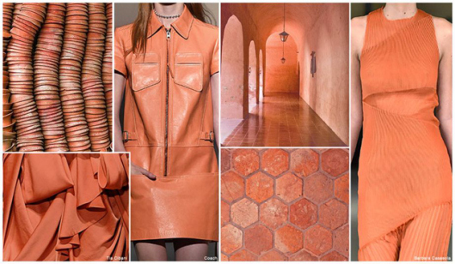
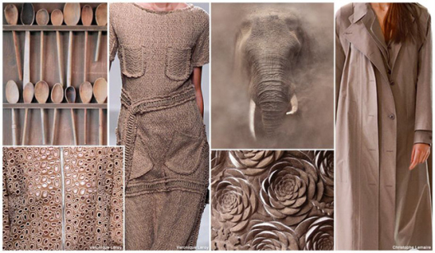

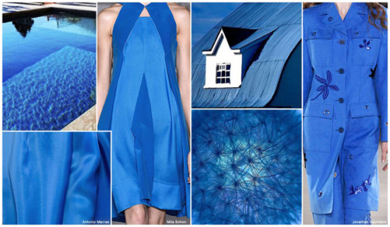

High fashion
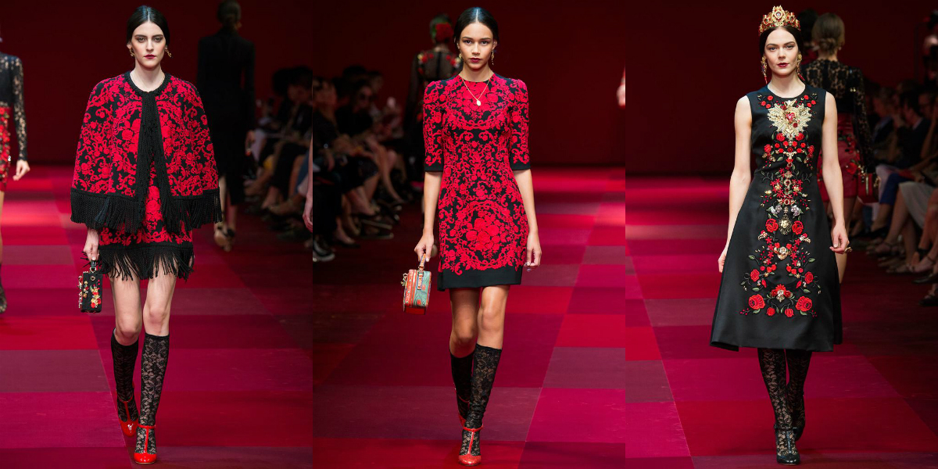
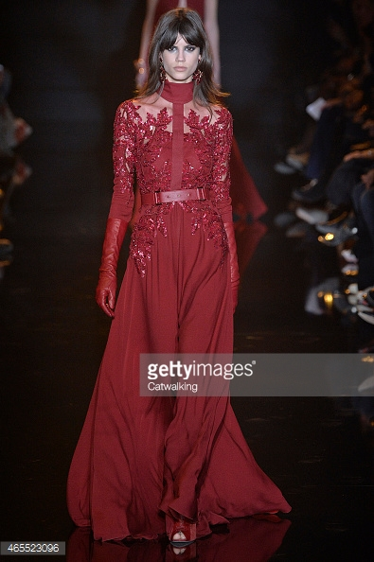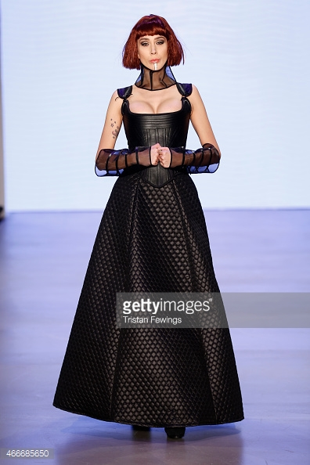
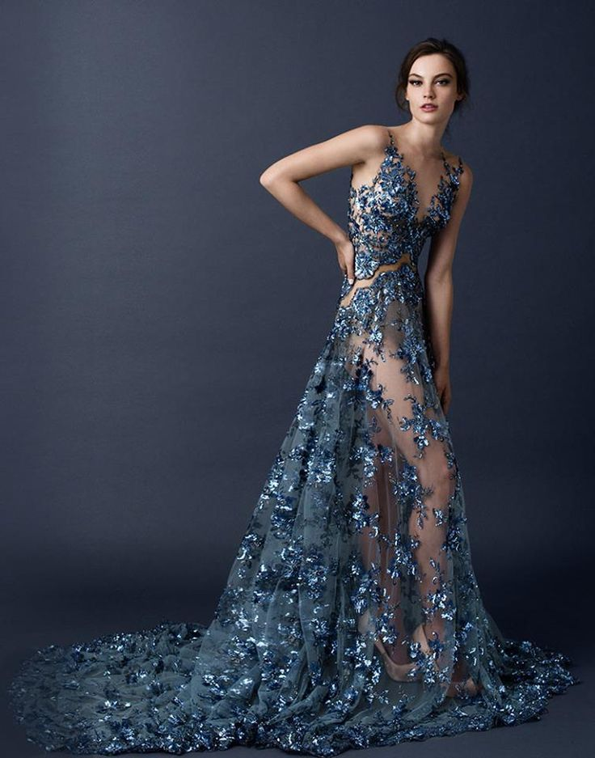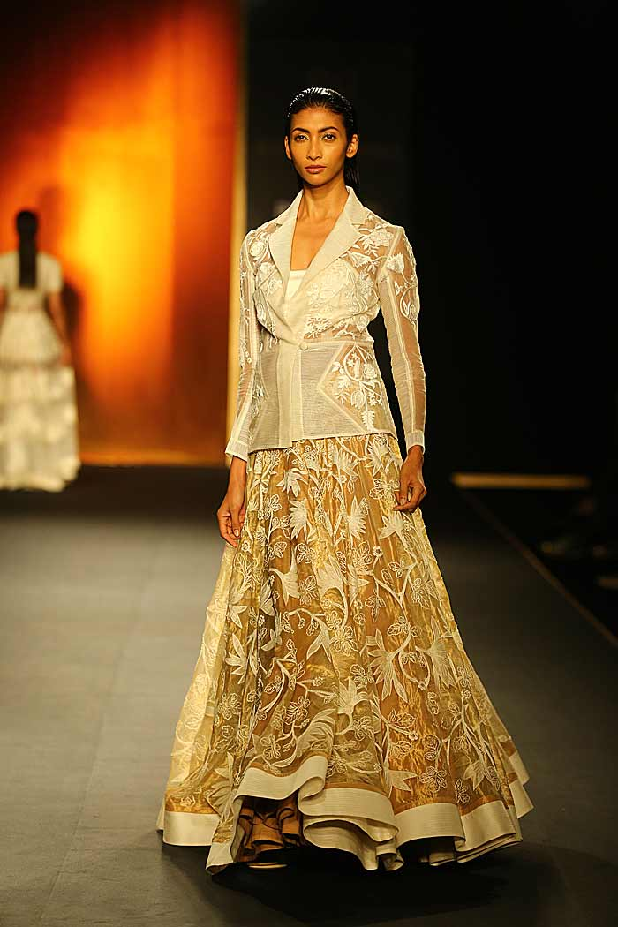

Classic fashion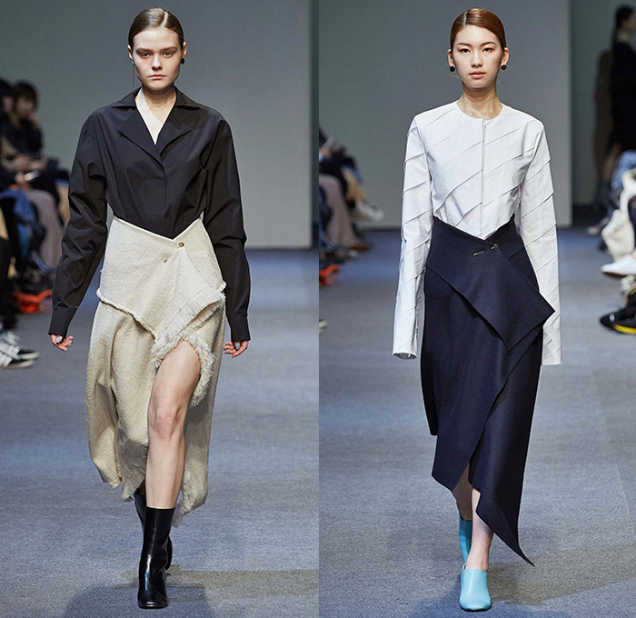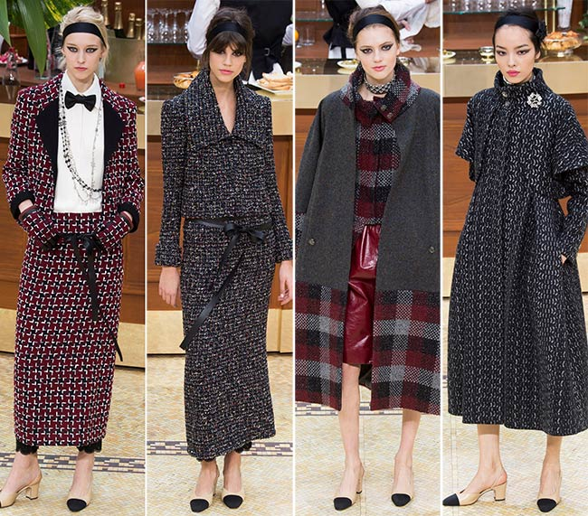

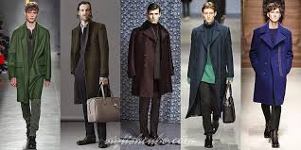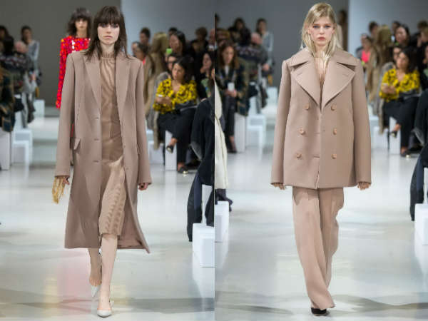
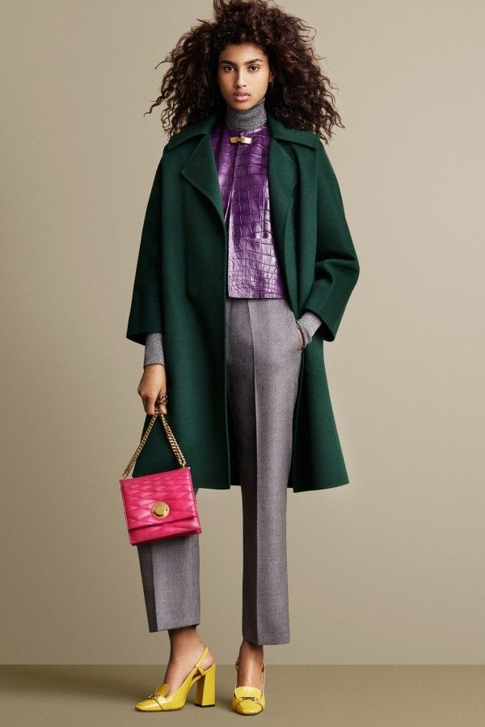

Mass fashion
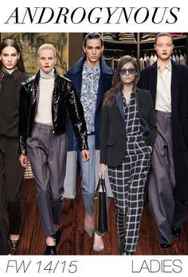

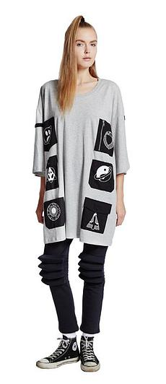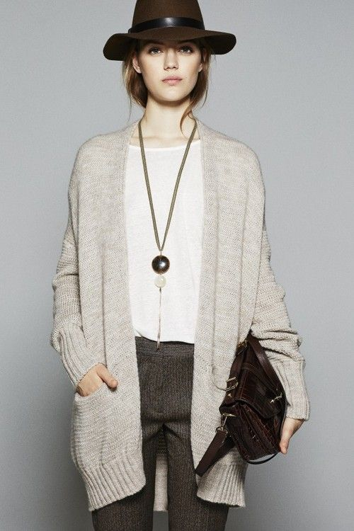

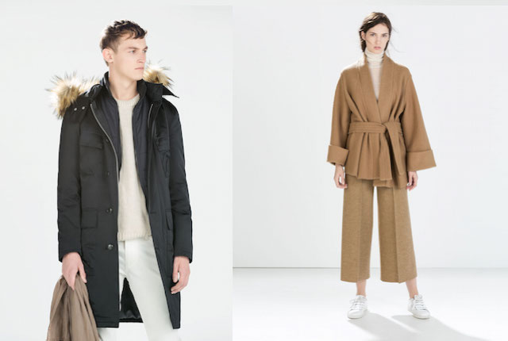

Fad fashion