
Assignment Cover Sheet

Student Name: | Sara Spiers
Student Number: | 1486
Course: | Diploma in Wedding Planning (Level 4)
Assignment NO: | 06

Marking Criteria:
We expect the learners to write minimum one well expressed point in three lines against each allocated mark. This means one needs to write 15 lines with 5 well expressed points to get high grades for a 5 marks question.
For high grades use examples and illustrations where appropriate.
Please insert your completed assignment ( in word format) here:

- i. Which questions should be asked from the venue manager when selecting a wedding venue?
The first question that should always be asked is what the capacity is for the venue. Establishing this early on will decide whether the venue is suitable for the wedding, based on their expected numbers. Following on from this, the couple should ask what packages the venue offers, how much each package costs and whether this changes on certain days or times of year, and what each package includes. They should find out if the package guarantees exclusive use of the venue, if there is food included and what types of food are available (buffets, sit down meal, canapés etc), if there are any drinks included such as a glass of champagne or half bottle of wine per person, what decorations are included, entertainment, master of ceremonies, and the timings the venue are restricted to. They must also ask whether the venue allows them to bring in their own vendors if the venue can’t provide something and whether there are any restrictions in them doing so.

Once these areas have been discussed, will then allow the couple to ask logistical and finer detail questions such as if gluten free/allergen alternatives are available, if they can add on extras at a cost such as soup course or additional drinks per person, payment requirements including deposits, and whether there are cancellation charges.

The couple also needs to ask what the venue’s capabilities and restrictions are in terms of the finer details. They should ask what the venue is capable of providing such as the furniture, a dance floor, cake stand and knife, air conditioning, AV equipment for entertainment and table service. Restrictions can include bringing in external caterers, last orders and closing time to avoid noise complaints and using pins for wall decorations.

ii. If the ceremony is to be conducted outdoors, what important measures should a wedding planner take in advance?
The most important measures to consider when planning an outdoor ceremony is the positioning of ceremony, where bridal party will enter from and where the signing of the register will take place. Also, they must discuss with the couple to establish whether there will be any speeches and where these will take place. Once this has been decided, the planner can consider hire of items such as seating, table for signing register, decorations and wedding arch. The planner must also consider where bathrooms and washroom facilities should be placed and ensure there are enough facilities available for the number of guests attending.

The planner must also ensure alternative measures are in place for bad weather conditions including a marquee or indoor venue. There could be an indoor area for a holding area or short drinks reception before the ceremony which can also be used for the ceremony if weather is too wet. If the weather allows for the couple to have their ceremony outdoors, they should ensure there is protection from wind to avoid decorations being blown away, a suitable pathway across soft ground to site of ceremony, position the ceremony in a way to avoid direct sunlight in eyes and also consider time of ceremony before the midday sun to avoid guests suffering sun stroke or sunburn. Insects can also be an issue and measures to prevent being bitten or spoiling food should be in place including sprays (to be kept away from food) and food coverings.

iii. Keeping a copy of the floor plan or sketch is important for a wedding planner. Why?
Keeping a floor plan is vital as it helps to keep both the planner and vendors right on where they should set up to avoid any confusion and waste valuable setting up time, particularly if this time is limited. Also, the plan is useful if there are any last minute changes to the set-up. If the planner is not at the venue, they can see from it where things can be moved and where there is available space.

It is also vital to keep a copy for health and safety purposes. The planner can see from the floor plan where fire exits are in cases of emergency and assist with the evacuation process. The plan can also be used in the risk assessment to show where any hazards are such as cables, uneven floor (particularly for older buildings), raised steps at an altar and burning candles.

iv. When selecting equipment for the ceremony, what are the important considerations that a wedding planner should take into account?
When selecting equipment for the ceremony, the planner must take into consideration the space available within venue for these items to be set-up, ensuring that fire exits and toilets aren’t blocked. This can be seen through visits to the venue or the floor plan. At this time, they can also determine where the power outlets are in the venue as some equipment may require them.

If the venue is outdoors, the planner must consider the weather and the effect this can have on the equipment. They must have suitable cover on hand should it rain and similarly, they should have precautions incase equipment overheats from direct sunlight.

Vendors often provide much of the equipment they need but some may require tables or chairs which they are unable to source themselves. The planner must ensure the venue or an external company can provide these items for them. Similarly with electrical equipment, most vendors provide their own, however, if a venue is outdoors, the planner may have to source generators and extension cabling.

v. Produce a list of the site layout essentials for a wedding.
The site layout essentials for a wedding are as follows:
- Dimensions the venue(s)
- Entrances and exits, including fire exits
- Lifts and accessible ramps
- Bathrooms
- Cloakroom
- Ceremony layout
  - Seating
  - Altar positioning
  - Décor positioning
- Bride holding area
- Drinks reception layout
  - Furniture
  - Décor positioning
  - Drinks station and/or bar area
- Evening reception layout
  - Table plan and seating
  - Top table
  - Band/DJ Set-Up
  - Dance floor
  - Gift table
  - Cake set-up
  - Lighting set-up
  - Food station for buffet
  - Bar area
- Area for photographs

vi. ‘Tents’ are one of the most important rental items. Discuss.
Tents are one of the most important rental items as it can be the wedding venue itself or a back-up venue for adverse weather, it requires a lot of time to organise and it also costs a lot of money. They are a new, different venue to hold wedding and come in styles and sizes to choose from for any budget, ground used and set-up. They are also highly flexible spaces which you can adapt to suit your theme and have a unique feel of being close to the outdoors.

There are many more decisions to be made with using a tent as a venue as opposed to any other venue. Firstly, the couple must decide whether they are willing to spend more money on a tent and the additional costs associated with an outdoor wedding rather than an indoor venue. For example, as well as hiring a tent, they would have to hire an external caterer and waiting staff, AV company, bar, furniture, generators and portable bathroom facilities for guests. Furthermore, if the couple decides to have a bar, they may require an alcohol license. Having a tent as a venue would take more time to set-up as the structure has to be built before any of the interior items as mentioned above can be set up.

Tents do have important benefits in the sense that they offer a new, unique way to celebrate a wedding and they are a blank canvas with less restrictions than other venues.

vii. What are the guidelines for selecting correct tents?
There are two types of tent to choose from. These are pole tents and frame tents. Pole tents have exterior and interior poles to hold up which are anchored into ground, whereas frame tents have piping around top and sides and aren’t anchored into ground.

The type of tent needed depends on the ground being used. For example, concrete cannot allow for anchoring so a frame tent must be used. Soft ground also may not be able to securely anchor so frame tent might also be used. The couple must consider the ground they are using before selecting a tent and understand that they are both costly and time consuming. Furthermore, frame tents take longer to set up so suitable time for set-up must be factored into the planning.

The size of the tent needed depends on the number of guests attending, whether a dancefloor is needed and also the type of catering on offer. If the couple chooses to have a dancefloor, a larger tent is required. Similarly, if the couple chooses to have a seated meal, they will require a larger tent. Tent sizes increase by 10ft and more staff are then required to set up.

It’s better to have more space than not enough, therefore, couples should overestimate their numbers slightly to ensure there is plenty of space, but not too much to make the event look lost in the tent.

- a. Tables
Tables are an important piece of equipment for a wedding. They are required for the signing of register, holding gifts, favours, the cake, evening buffet, the top table and for guests at the sit-down meal. They come in a variety of sizes and shapes, depending on the couple’s preference. Typically, trestle tables are used for all of the above, with the exception of the guests’ tables which are usually round. If a venue is short on space, trestle tables can be used for the guest meal and also makes the meal appear slightly more informal.

b. Chairs
Chairs are used in every aspect of a wedding, from the ceremony through to the evening reception. Chairs are usually in a theatre style layout for the ceremony, unless the couple chooses to get married in a place of worship such as a Church which has pews already in place. There are also sometimes two chairs at a table at the front of the ceremony for the signing of the register.

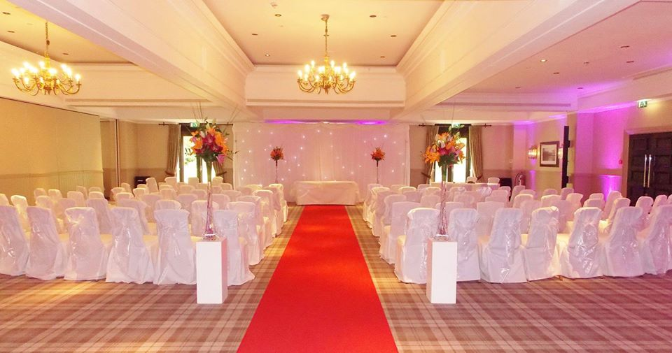(Happy Talk, 2015. a)

For the wedding breakfast, chairs are set up around tables, circular or rectangular for guests to sit and eat their meal. This is usually ten to a table. It is often kept for the evening reception with potential for more chairs to be added, up to 12 to a table, to accommodate more evening guests. It is considered satisfactory for 12 to a table for the reception as guests don’t require the extra room needed for a meal.

Many couples choose to have chair covers as additional decoration. They are usually white in colour with a chair tie which comes in a variety of colours and patterns.

c. Linens
There are a wide variety of uses of linen in weddings. They are most commonly used for covering tables including the altar, register signing table, top table, guest tables, buffet table and gift. Other tables that are often covered with linen can be poser tables for the drinks reception.

A new way of using linen can be to create drapes on the ceiling as shown below. This is another way of hiding features of a room you may not like, adding something to a room which is a blank canvas or to make the room appear more intimate. It also accents any chandeliers which you can hang the drapes from.

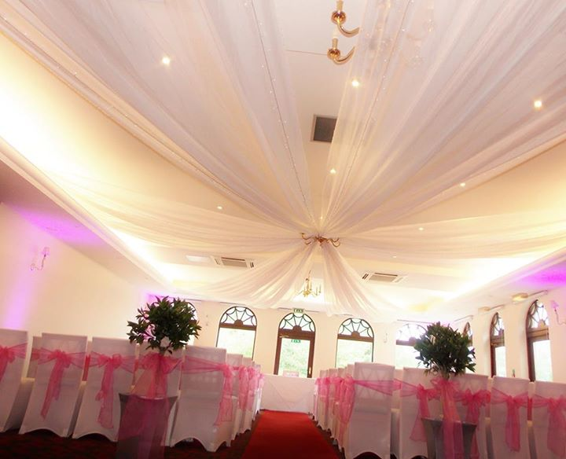 (Happy Talk, 2015. b)

Linen can also be used for backdrops or ‘starcloths’ for around the walls of the room or behind the top table. This becomes the focal point of the room and draws attention to the couple.

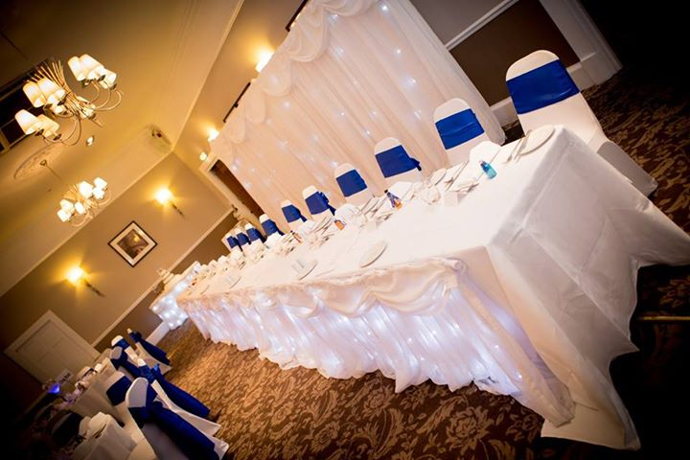 (Happy Talk. 2015. c)

d. Table wares
It is very easy to assume that table wares will be provided for weddings. In some cases, venues may not provide this, for example, if a couple are having a marquee wedding. Therefore, the couple must be aware of this and incorporate the hire or purchase of table wares for the day. These include crockery, cutlery and glassware. Most traditional venues will supply these items but it’s vital to check this with them and the amount of each they have, incase more needs to be hired at the couple’s expense.

Other tablewares include decorative items such as centerpieces such as candelabras, hurricane vases, fishbowl vases and flowers, and other small items including bubbles and favours.

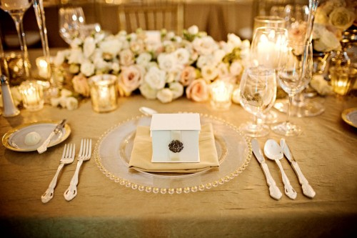 (Bellissimo, n.d.)

Activity

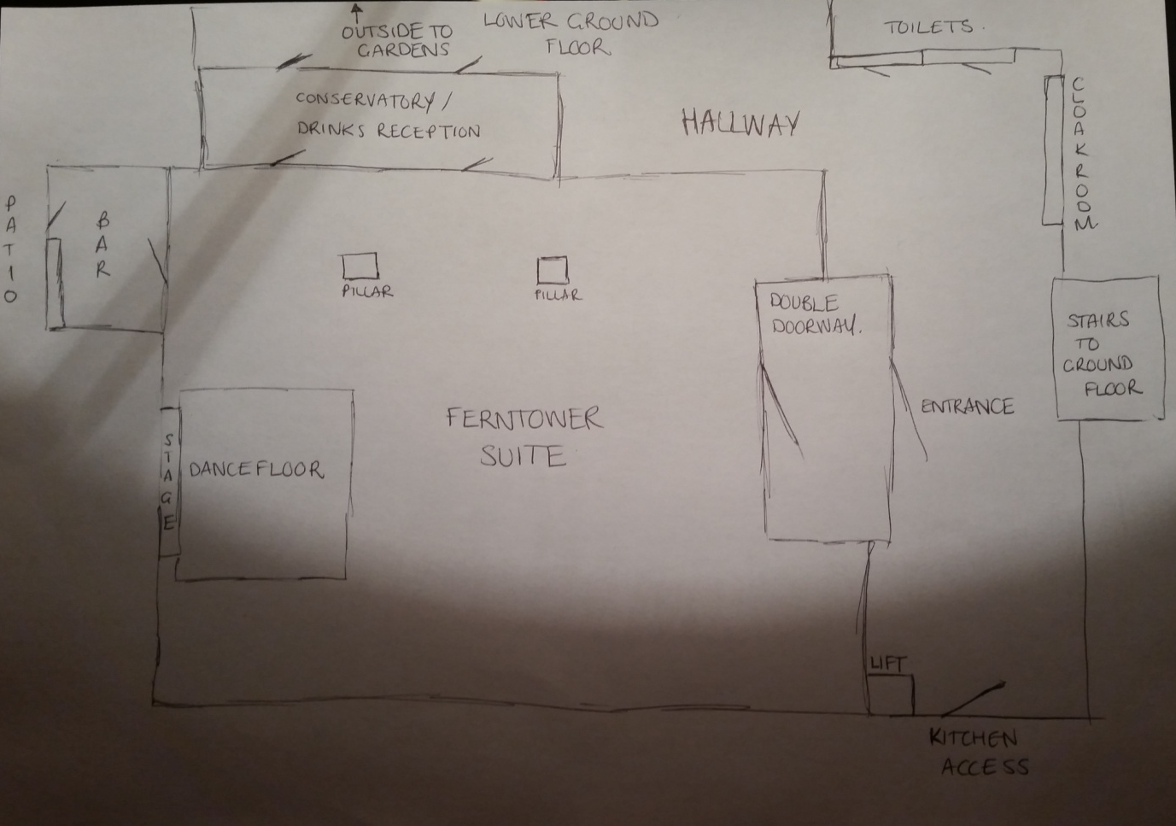

References

Bellissimo. (n.d.) Julia’s Wedding. Available: http://bellissimo-weddings.co.uk/wedding-blog/page/2. Last accessed 22 Oct 2015.

Happy Talk. (2015. a). Good Morning and Happy Sunday Guys! Available: https://www.facebook.com/happytalkevents/photos/a.461367657208005.112414.430482266963211/1087081804636584/?type=3&theater. Last accessed 22 Oct 2015.

Happy Talk. (2015. b). Remember here at Happy Talk Events… Available: https://www.facebook.com/happytalkevents/photos/a.461367657208005.112414.430482266963211/1089415844403180/?type=3. Last accessed 22 Oct 2015.

Happy Talk. 2015. c). We can’t help but share another fab picture… Available: https://www.facebook.com/happytalkevents/photos/a.461367657208005.112414.430482266963211/1092019057476192/?type=3. Last accessed 22 Oct 2015.

Student Statement:

By submitting this assignment, I confirm that this is my own work.

Student Signature |  | Date

For Tutor / Assessor Use Only
Total Marks
Marks Obtained
Percentage / Grade

