
Assignment Cover Sheet

Student Name: | MAJALIWA FREDRICK
Student Number: | 1506
Course: | DIPLOMA IN ACCOUNTING AND FINANCE
Assignment NO: | 4

Marking Criteria:
We expect the learners to write minimum one well expressed point in three lines against each allocated mark. This means one needs to write 15 lines with 5 well expressed points to get high grades for a 5 marks question.
For high grades use examples and illustrations where appropriate.
JOURNAL AND SUBSIDIARY BOOKS

Assessment 4 Total Marks: 30
1. Give short answers for the following questions: (20)
a) What do you understand by Subsidiary books?
Answer:
Generally, transactions are of two types:- :Cash and Credit where Cash transactions can be grouped in one category whereas credit transactions can be grouped in another category. Thus, in practice, the main journal is sub-divided in such a way that a separate book is used for each category or group of transactions which are repetitive and sufficiently large in number. Each one of the subsidiary books is a special journal and a book of original or prime entry. Though the usual type of journal entries are not passed in these sub-divided journals, the double entry principles of accounting are strictly followed.

The number of subsidiary books may vary according to the requirements of each business. The following are the special purpose subsidiary books summarized in the diagram below

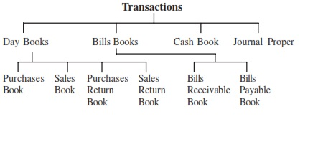

b) What are the advantages of Subsidiary books?
Answer:
The advantages of maintaining subsidiary books can be summarized as under :
- Division of Labour: The division of journal, resulting in division of work, ensures more clerks working independently in recording original entries in the subsidiary books.
- Efficiency: The division of labour also helps the reduction in work load, saving in time and stationery. It also gives advantages of specialization leading to efficiency.
- Prevents Errors and Frauds: The accounting work can be divided in such a manner that the work of one person is automatically checked by another person. With the use of internal check, the possibility of occurrence of errors and frauds may be avoided.
- Easy Reference: It facilitates easy references to any particular item. For instance total credit sales for a month can be easily obtained from the Sales Book.
- Easy Postings: Posting from the subsidiary books are made at convenient intervals depending upon the nature of the business.
c) Define purchase and sale book.
Answer:
Purchases book also known as Bought Day Book is used to record all credit purchases of goods which are meant for resale in the business.
Cash purchases of goods, cash and credit purchases of assets are not entered in this book. The sales book is used to record all credit sales of goods dealt with by the trader in his business. Cash sales, cash and credit sales of assets are not entered in this book. The entries in the sales book are on the basis of the invoices issued to the customers with the net amount of sale. The format of sales book is shown below:-

d) What is journal?
Answer:
A Journal is a book of original entry where all business transactions are recorded in a chronological order. Whenever a business commits a transaction, the record must be entered into a journal which becomes a source documents which assists accountants to check correctness of the financial statements and balance sheets. Transactions recorded are only money transactions and notes or descriptions accompanying each transactions

e) What is petty cash book?
Answer:
A petty cash book is a subsidiary journal used by petty cashier to record financial transactions of various office use like entertainment, teas, office stationaries, etc. Petty word is derived from a French word ‘petit” means small that is why petty cash books keeps records of small amount of money for office u se. Petty cashier is give some amount of money called petty cash and at end of the period he/she is supposed to make disbursement of the money used

f) What are the different kinds of Subsidiary books?
Answer:
A Subsidiary book is a sub division of Journals since a single journal can no be able to handle records of all sorts of transactions of a business. So each account will be categorized as a separate book of records. The following is a list of subsidiary books:-
- Purchases Book
- Purchase returns Book
- Sales Book
- Sales Return Book
- Bills Receivable Book
- Bills Payable Book
- Cash Book and
- Journal Proper
g) What do you mean by Cash book?
Answer:
A cash Book is a sub-division of a journal which keeps records of transactions related to receipts and payments made in cash. Cash receipts are recorded on debit side and payments on credit side. Entries in a cash book are made in a chronological order and should always balance on debit side, as payments will never exceed the receipts.

h) What are the kinds of Cash books?
Answer:
Cash Books are of different kinds as listed below:
- Single column cash Book
- Two column cash Book
- Three column cash Book
- Bank Balance Cash Book and
- Petty Cash Book
i) Define trade discount and cash discounts.
Answer:
Usually in business terms, big buyers of goods and services are offered a discount on the normal prices. This is what we call ‘economies of scale’ effect on a business. A trade discount can either be in percentage wise of the quantity purchased on reduction of prices without regarding volume purchased. Or it can be in terms of transportation discount as if you purchase large volume of goods, delivery costs is incurred by service provider.

On the other hand cash discount is kind of incentive given to buyer who pays the purchase bill in good time without any delay. It is usually given in some percentage of the total amount of bill.

j) Distinguish between trade discount and cash discount
Answer:
A table below provides a summary point on the differences between trade discoint and cash discount
S/N | TRADE DISCOUNT | CASH DISCOUNT
1 | Trade discount cause reduction of item price | Cash discount effects the amount purchased
2 | Trade discount is based on quantity purchased | Cash discount is based on timely settlement of purchase bill
3 | Trade discount is given by whole seller/manufacturer to buyer/retailer | Cash discount is given by seller to byer/debtor
4 | Trade discount is not recorded in journals because net amount is recorded | Cash discount has to be recorded because it is deduction from gross selling
5 | Usually the offer is given to all buyers | Cash discount varies from customer to customer and time period
6 | It changes with sales policy of the business entity | It depends on the condition of settling the bill in good time

Q: 2: What is ledger account? Explain with illustrations. (5)
Answer:
A ledger account is a tool used for classifying and summarizing information about increases, decreases, and balances of financial statements items. Think of it as a storage container like a bucket. Dollars, which are used to measure economic transactions, are “poured” into and out of the container
There are two ledger account formats namely: Three-Amount Column Format (Debit, Credit, Balance) used in general ledgers in the business world as illustrated below:-
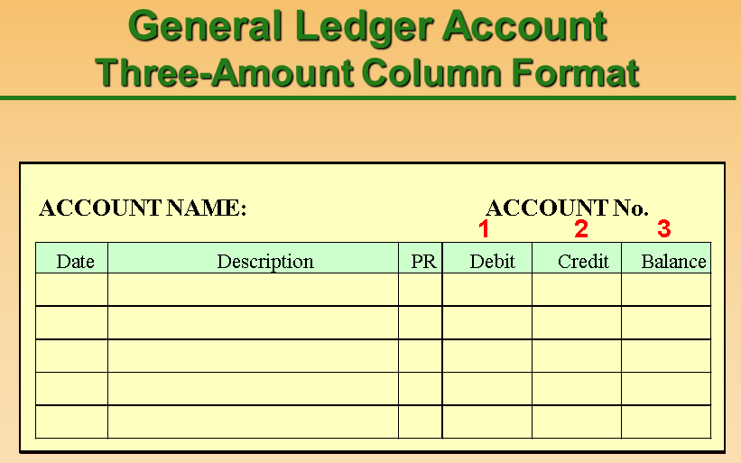

and T-Account Format which is used primarily for teaching and analysis of complex transactions as illustrated below:-
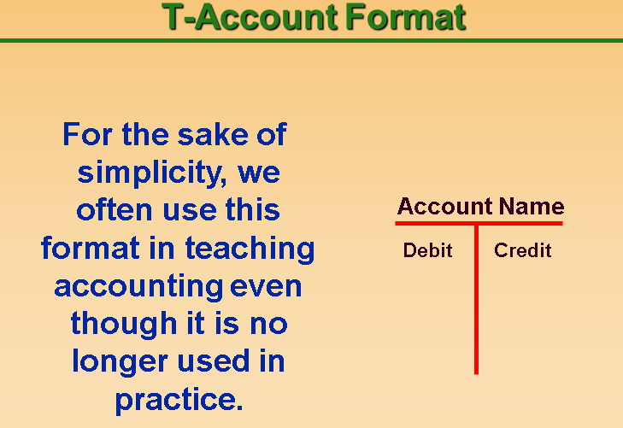

Q: 3: Explain the advantages of subsidiary books (5)
Answer:
The advantages of maintaining subsidiary books can be explained as follows:-
- Division of Labour: The division of journal, resulting in division of work, ensures more clerks working independently in recording original entries in the subsidiary books.
- Efficiency: The division of labour also helps the reduction in work load, saving in time and stationery. It also gives advantages of specialization leading to efficiency.
- Prevents Errors and Frauds: The accounting work can be divided in such a manner that the work of one person is automatically checked by another person. With the use of internal check, the possibility of occurrence of errors and frauds may be avoided.
- Easy Reference: It facilitates easy references to any particular item. For instance total credit sales for a month can be easily obtained from the Sales Book.
- Easy Postings: Posting from the subsidiary books are made at convenient intervals depending upon the nature of the business.

Student Statement:
By submitting this assignment, I confirm that this is my own work.

Student Signature |  | Date | 5 October, 2015

For Tutor / Assessor Use Only
Total Marks
Marks Obtained
Percentage / Grade

