
Assignment Cover Sheet

Student Name: | Elizabeth Abidemi Akinlabi
Student Number: | 1380
Course: | Diploma in Fashion Design
Assignment NO: | 16

Marking Criteria:
We expect the learners to write minimum one well expressed point in three lines against each allocated mark. This means one needs to write 15 lines with 5 well expressed points to get high grades for a 5 marks question.
For high grades use examples and illustrations where appropriate.
Please insert your completed assignment ( in word format) here: 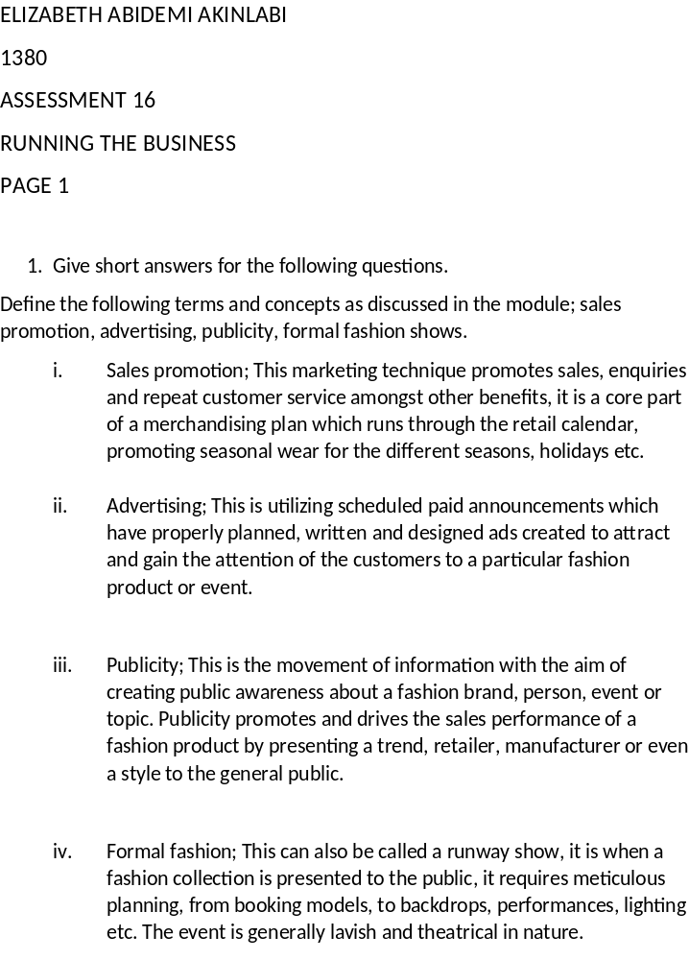

Student Statement:

By submitting this assignment, I confirm that this is my own work.

Student Signature | Elizabeth Abidemi Akinlabi | Date | 08/03/2016

For Tutor / Assessor Use Only
Total Marks
Marks Obtained
Percentage / Grade

