
Assignment Cover Sheet

Student Name: | Martin Selley
Student Number: | 1328
Course: | Safety In The Workplace
Assignment NO: | 5

Marking Criteria:
We expect the learners to write minimum one well expressed point in three lines against each allocated mark. This means one needs to write 15 lines with 5 well expressed points to get high grades for a 5 marks question.
For high grades use examples and illustrations where appropriate.
Question 1 - Discuss the key elements of a safety plan.

Answer - The key elements of a safety plan are:
- Company Policy
This section should set out the Companies vision with regard to safety management. Most companies will have some kind of high level statement(s) advising the key elements of their policy. Included in the policy it may also advise who, within the company, play the key roles. There may also be a statement from the owner on the importance the company places on safety in the workplace.
- Hazard Identification
This is a key element in a safety policy; hazards need to be identified; risks must be assessed, to determine if adequate control measures are in place. Also information must be provided advising on the process for ongoing review of hazards, and how they will be managed.
- Emergency Response Plan
Put simply this element of the safety policy needs to advise the workforce what action to take if/when a safety incident occurs. This can range from a simple evacuation/muster scenario to a full blown Emergency Response Team being put in to action. The drivers for this will primarily be the size of the workforce, nature of the business and the type/severity of the hazards that may be encountered.
- Regulations
This section of the policy must clearly state what legislation, codes and standards the company works to. This will vary from country to country, and regionally. Each business will probably also have industry specific policies that govern the operation, these must also be taken into account.
- Communication Plan
Within this section of the policy it must clearly indicate how employees find out, or will be advised of changes to, and issues relating to, the safety policy. There may be a weekly HSE newsletter; videos may be shown at safety meetings etc. Methods have to be devised to ensure all members of the workforce are kept up to speed.
- Ongoing Process
The policy must address how /when reviews/audits will take place. It is not acceptable just to create a policy to ‘tick a box’ and then walk away from it. Employees need to be assured that regular reviews etc. will be undertaken, and the policy revised if required.
- Employee Participation
Involving the workforce is a fundamental element in any safety program. Employees sometimes see things from a different perspective, and long serving staff can provide key insight into issues that management may not have considered. Without employee buy in to, and participation in the process is a recipe for failure.
- Training
Training, of some kind, will always be required as part of a successful safety policy. Training can take various forms; on the job training from experienced personnel may be enough. Formal classroom training/courses can be utilised as /when appropriate
- Investigation & Documentation process
To be described in this section should be the procedures and methods that the company will use to investigate incidents that occur. This should clearly state how things will be investigated; how the outcomes will be documented, and how employees can access the information.
- Toolbox
Detail here what tools the company has available to the employees to assist with/contribute to the safety process. It is important to advise where the Tools can be found; tools are not necessarily physical and can be processes and procedures. Physical tool tools can include kits to use for first aid, accident investigation, protective equipment etc.
- Appendices
If applicable; refer here to supplementary information, procedures and other sources of information. This will vary from company to company and probably be industry specific.

The diagram below outlines the Plan/Do/Act approach; which shows a sustained and systematic approach typically used when developing/implementing a safety plan.
(Executive, 2013)

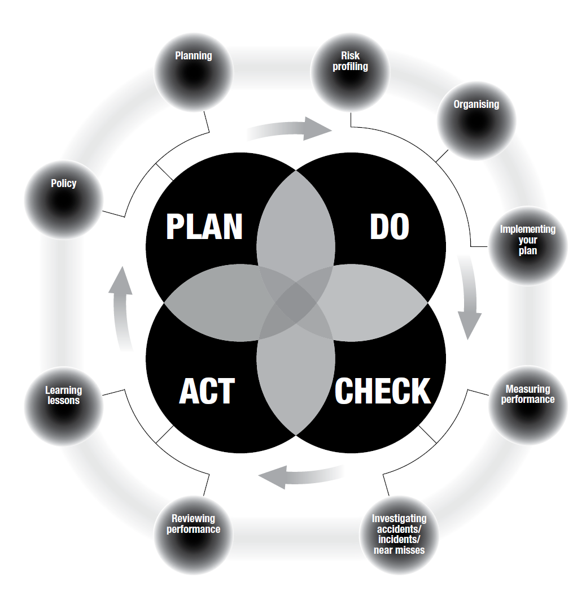

Question 2 - What is the purpose of a safety investigation? Outline the steps involved in this process.

Answer - The purpose of a safety investigation is primarily to determine how / why the incident / event occurred, and to see how it can be prevented from happening again.
The steps involved in this process are:
- Gather data
At this stage it is necessary to gather the basic facts relating to the incident. It may be required to photograph or sketch the scene, and also gather any physical evidence. Ensure that you know where it happened, who was involved, what happened and where it took place.
- Determine probable cause
A review of the initial data gathering phase will hopefully identify the probable cause. Try and be specific and get to the root cause; hopefully then solutions can be designed, to help prevent further incidents of this nature.
- Identify effective solutions
Too come up with an effective solution it must be something that is not beyond the company’s control. It must also comply with the company’s safety policy and values, whilst at the same time help prevent similar incidents happening again.
- Assign responsible parties and reasonable target dates
An action plan needs to be put in place that clearly identifies what will be done, who will undertake the action, and when it must be completed by. The action plan should also how progress will be monitored and reported, and how it can be evaluated.
- Write a final report
A comprehensive report needs to be prepared that provides all the information, from all the preceding steps. This report will help future hazard identification reviews, and provide good historical data as well as assuring employees that actions will be taken.
- Communicate the results
It is vital to communicate the results of the investigation to the entire workforce. This does not need to be comprehensive but should clearly communicate what was found and what will be done to prevent a recurrence of the incident. Means of communicating this information will vary, use emails, safety briefings, posters etc.
- Track solutions
To come up with recommendations/solutions is great but checks must be carried out to ensure that the solutions are being implemented as determined in the action plan. Typically this person is the accident investigator as they are familiar with the incident.
- Evaluate solutions
Continuous monitoring of the workplace for recurrences of the incident is required at a predetermined interval. If there have been no similar incidents then probably the correct root cause and solution were identified. If it has happened again then re-evaluate.

Question 3 Case Study

The goal of a safety culture is for no incidents at all. However, we are dealing with human beings, machinery, and an inability to behave predictably and safely in all instances. Let’s look at how to respond to a mock incident.

Disaster!
Inside a meat packing plant, 20 workers are all performing various tasks involving heavy machinery. Suddenly, a scream echoes through the factory. George, the foreman, has gotten his arm caught in one of the meat packing machines. Panic erupts: one worker turns to stare and gets caught in the conveyor belt; another worker trips and falls as he tries to run from the scene; yet another worker falls into the vat that they have been cleaning out. No one has called for help and the scene is in complete chaos.

What would you do?

Answer – In this specific set of circumstances it is essential not to panic; try to keep calm, try to get things under control, and do not dive in and make the situation worse. I have personal experience of a situation in the 1980’s where confined space entry was not controlled as it is today. When the first worker entered the space and could not be contacted, others then entered the space and subsequently died.
So the following steps are what I would probably do;
- Get the situation under control, take charge
- Do a quick sweep of the immediate area and assess the hazards
- Isolate power to the production line whilst keeping myself safe
- Try to ensure everyone else is safe and get them out of harm’s way
- Call the emergency services; and activate the appropriate emergency response teams as dictated in the company emergency response plan
- If possible help the victims, at all times consider my own safety
- Do another sweep of the area checking that there are no new hazards
- Keep control of the scene/incident area, trying not to disturb the scene as evidence will need to be gathered
- When the emergency response team or emergency services arrive brief them on what I know then get myself out of harm’s way

The only problem with the above is that in real life it is very difficult to keep your emotions in check. Hopefully adequate training has been given and things click into place.

Executive, H. a. (2013). An introduction to managing for health and safety. ISBN 978 0 7176 6604 1. Retrieved August 6, 2015, from hse.gov.uk: http://www.hse.gov.uk/pubns/indg275.htm

Student Statement:

By submitting this assignment, I confirm that this is my own work.

Student Signature | Martin Selley | Date | 07-AUG-2015

For Tutor / Assessor Use Only
Total Marks
Marks Obtained
Percentage / Grade

