
Assignment Cover Sheet

Student Name: | Salma Mohamed Safaa
Student Number: | 1170
Course: | Interior Designing
Assignment NO: | 9

Student Statement:

By submitting this assignment, I confirm that this is my own work.

Student Signature | Salma Mohamed Safaa | Date | 27/10/2015

For Tutor / Assessor Use Only
Total Marks
Marks Obtained
Percentage / Grade

Student Name: | Salma Mohamed Safaa
Student Number: | 1170
Course: | Interior Designing
Assignment NO: | 9
Page NO: | 1

Interior Designing Course
Unit 9: Walls & Ceilings
Q.1. Short Questions:
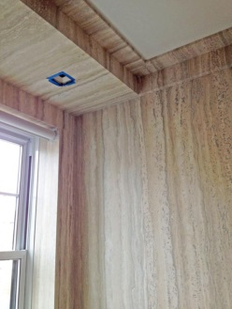
I. If ceilings are of reasonable height:
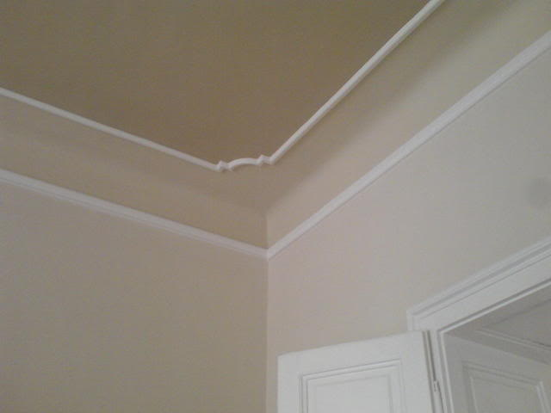
Some treatments can be considered;
- Painting the top stringing of the cornice with a contrasting colour with the ceiling or even cover it with metallic gold or silver leaf.
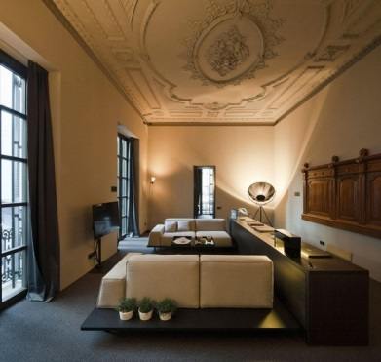
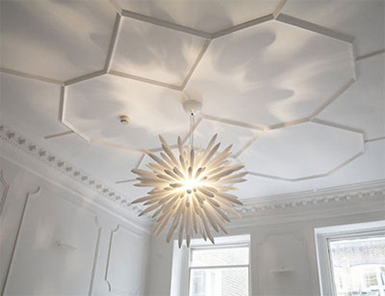
Geometric ceiling Design Plaster Moldings
- Add decorative moldings like cornices or ceiling roses.

Classic Moldings and Ceiling Rose
II. If ceilings are too low:
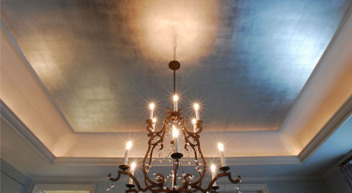
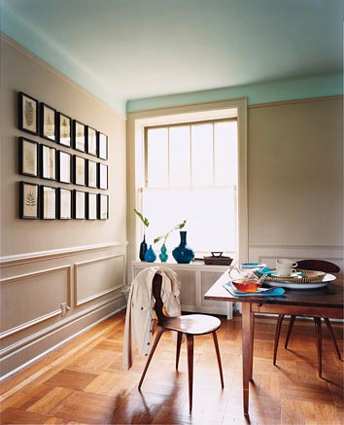
Some treatments should be considered to give the effect of a higher appearance;
Ceiling treatments:
- Using shimmer paint on the ceiling.
- Painting the ceiling paler colours than the walls' colour.
Shimmer silver ceiling
- Installing cool florescent lights.

Student Name: | Salma Mohamed Safaa
Student Number: | 1170
Course: | Interior Designing
Assignment NO: | 9
Page NO: | 2

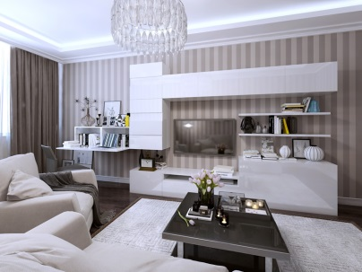
Wall treatments:
- Vertically stripping the walls with paper or painting, tricks the eye giving the illusion of more far appearance than the ceiling is.

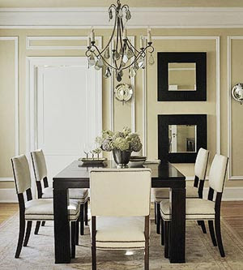
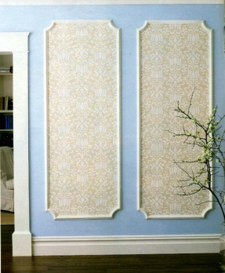
- Designing tall and narrow panels of walls using moldings to give the same illusion of more height.

- Install curtain pelmets just below the ceiling to make the windows seem taller, and therefore exaggerate the ceiling.

III. If ceilings are too high:
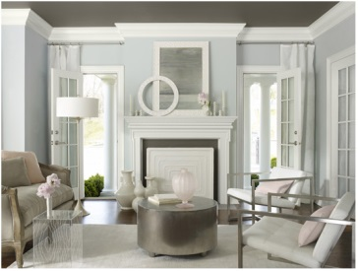
Some treatments could be considered to break up the height and give the effect of a lower appearance;

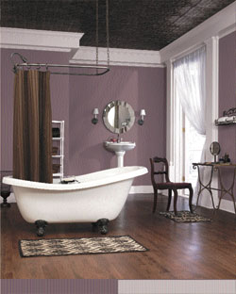
Ceiling treatments:
- Painting the ceiling a darker colour than the walls'.

- Install some recessed lighting, which will draw attention towards the walls instead of the ceilings.

Student Name: | Salma Mohamed Safaa
Student Number: | 1170
Course: | Interior Designing
Assignment NO: | 9
Page NO: | 3

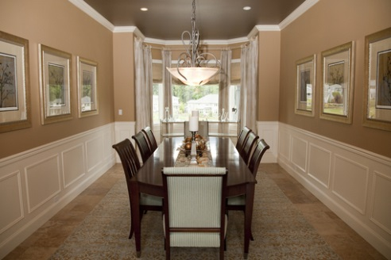
Walls treatments:
- Dividing the walls into portions to break up the height.
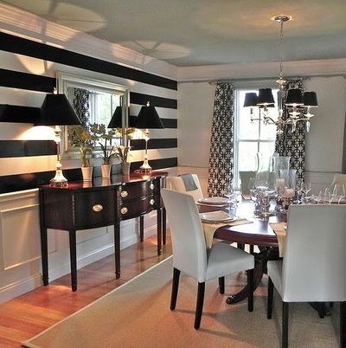
- Horizontally stripping the walls using wallpapers or painting to give the illusion of a lower ceiling.
Dividing the walls in two parts to break the height also painting the ceiling darker
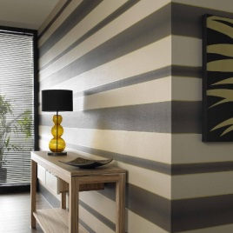

IV. If a room has a beautiful door, it can be further enhanced in a scheme
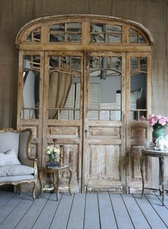
- It can be made into a special feature by adding antique furniture in the room.

- The best way of enhancing a door in a scheme is to paint it contrasting to the colours of the room.
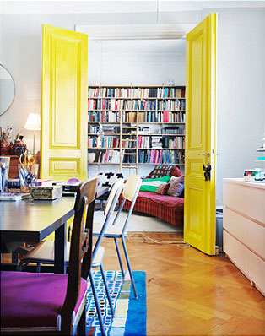
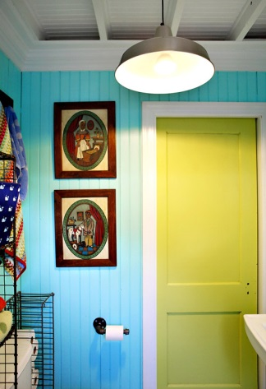
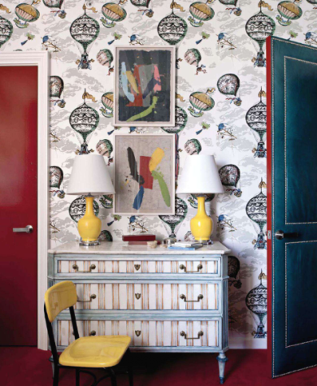

Student Name: | Salma Mohamed Safaa
Student Number: | 1170
Course: | Interior Designing
Assignment NO: | 9
Page NO: | 4

V. To blend a door into a scheme, paint it the same colour as the walls or two shades lighter or darker.
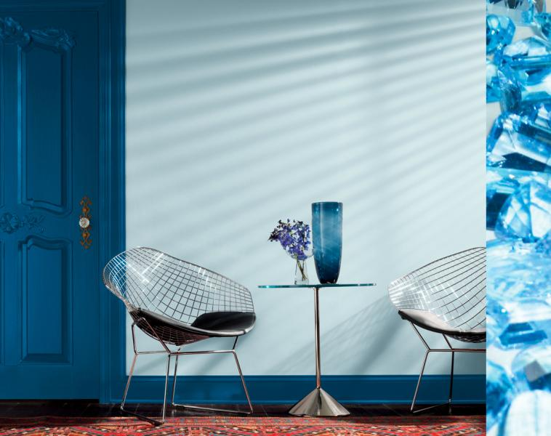
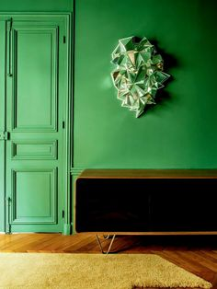
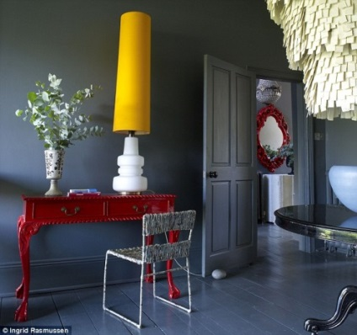

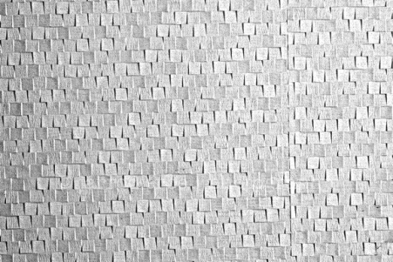
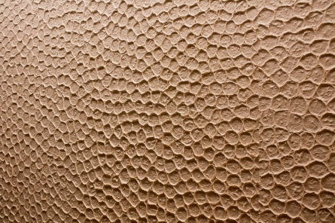
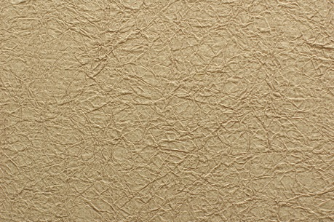
VI. Textured wallpapers are used for: covering irregular surfaces, as they are heavy and very durable.
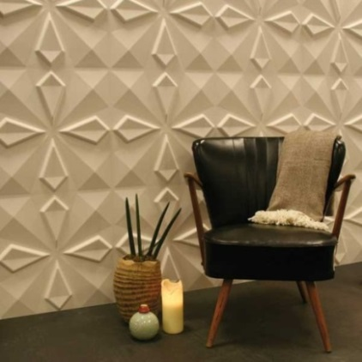
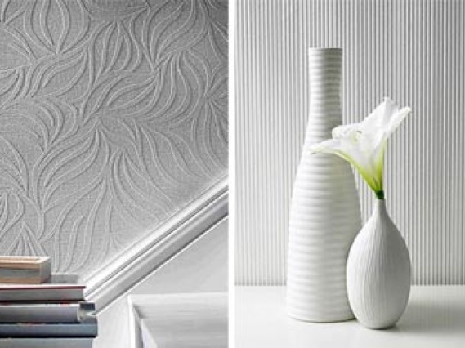
They are usually used in hallways.

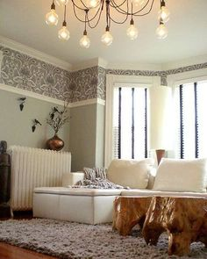
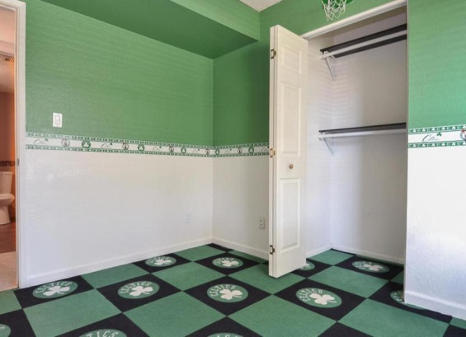
VII. The purpose of using wallpaper borders: is either to define or break up a given space.

Student Name: | Salma Mohamed Safaa
Student Number: | 1170
Course: | Interior Designing
Assignment NO: | 9
Page NO: | 5

VIII. Lining paper is a type of wallpapers that is good to be used as a background for paintings. They are hung horizontally or vertically and stuck
precisely edge to edge so that a neat finish is achieved.
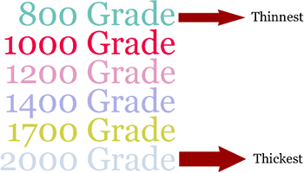
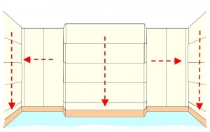
Graphic of room showing lining and cross lining techniques
Lining paper thicknesses grades 800 -2000

Q.2. Upholstered walls look luxurious and provide insulation against cold and noise.

The process involves:
- Fixing a framework of thin batten to the wall
- Lining the walls between with wads of polyester
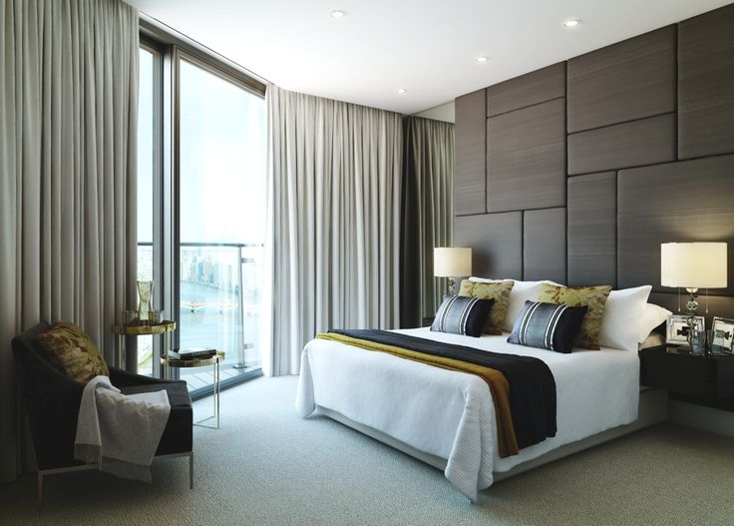
- Finally stretching the fabric over the battens.

The results are often original and usually luxurious.
An upholstered bed can also serve as a headboard, thus becoming a double feature for the bedroom.
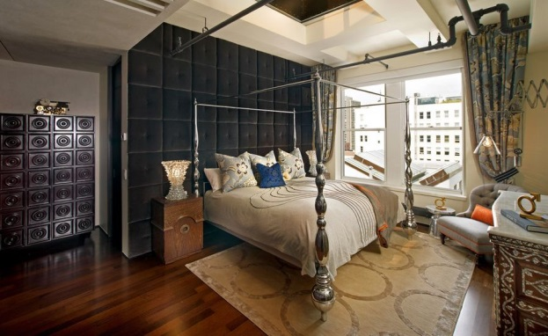

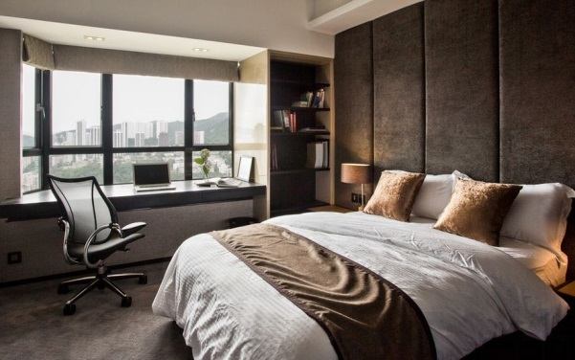

Student Name: | Salma Mohamed Safaa
Student Number: | 1170
Course: | Interior Designing
Assignment NO: | 9
Page NO: | 6

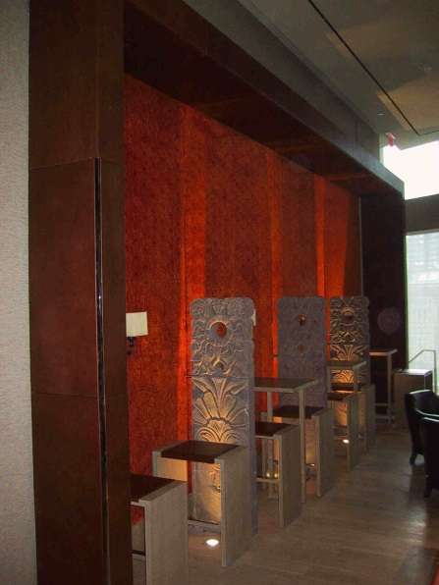
Upholstered walls aren’t just for bedrooms. They’re commonly used in commercial settings such as private offices, open workstations and restaurants.
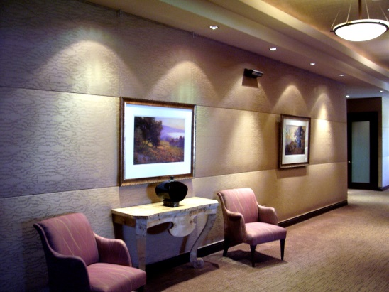

They’re the perfect way to dress up a lobby or reception area, and used in hallways to muffle sound and help keep things quiet.
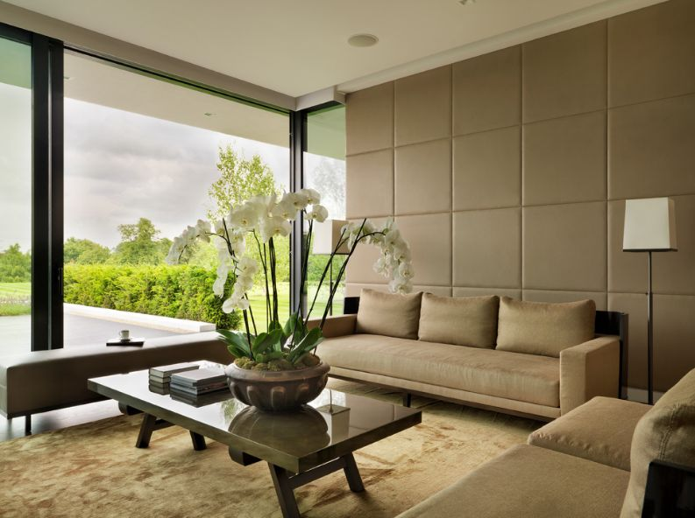
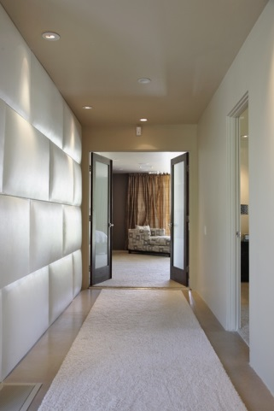
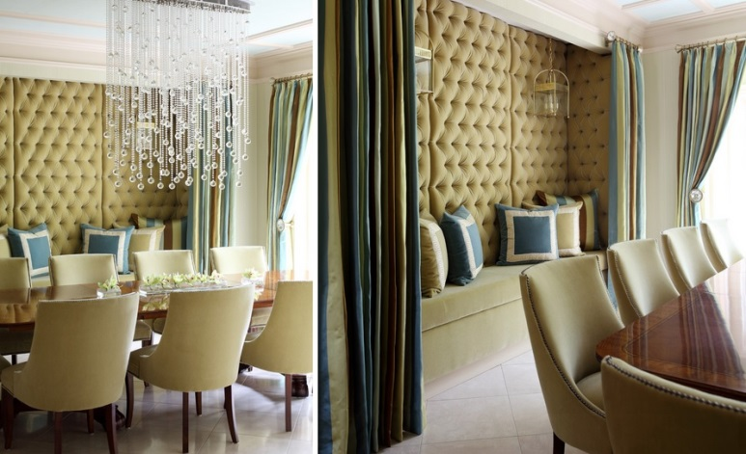
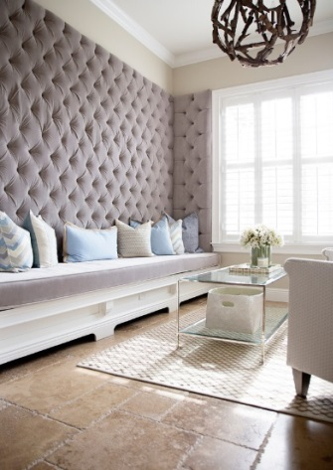
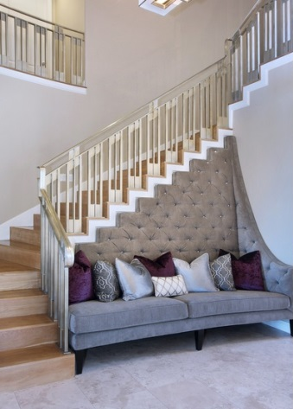
They look as beautiful as wallpaper with greater sound absorption and versatility.

Student Name: | Salma Mohamed Safaa
Student Number: | 1170
Course: | Interior Designing
Assignment NO: | 9
Page NO: | 7

Q.3.There are several decorative details that can appear on the ceilings, three of them:

- Plaster Moldings such: Cornices or Ceiling roses
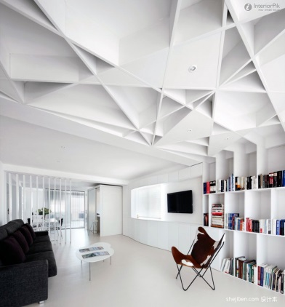
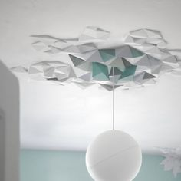
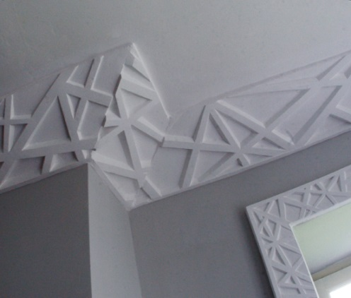
Modern Designs:

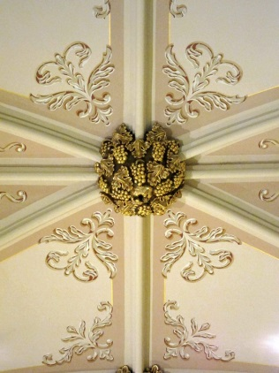
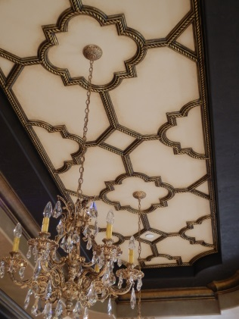
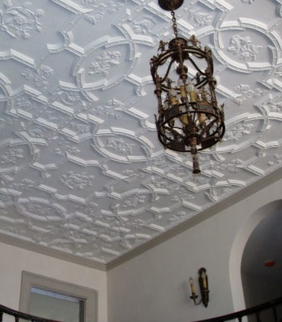
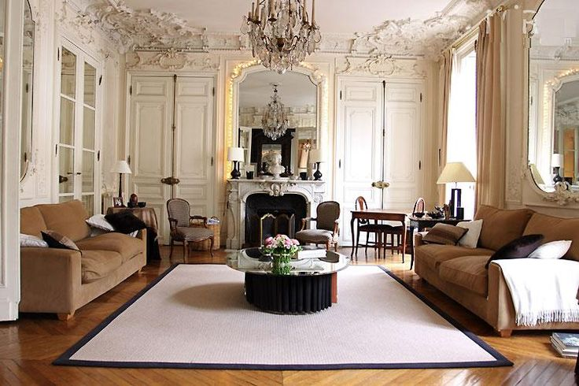
Classic Designs:
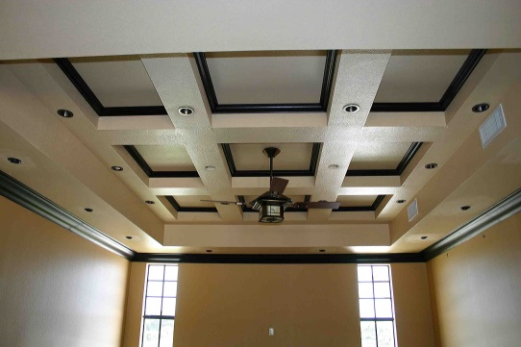
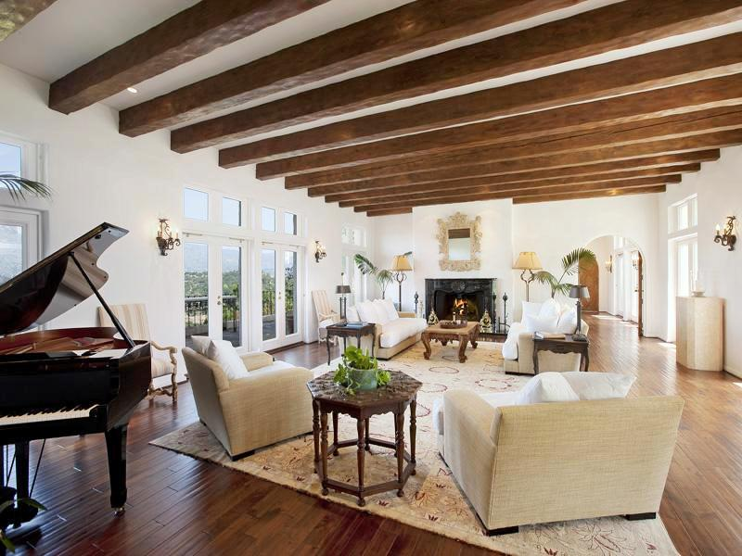
- Beamed ceilings
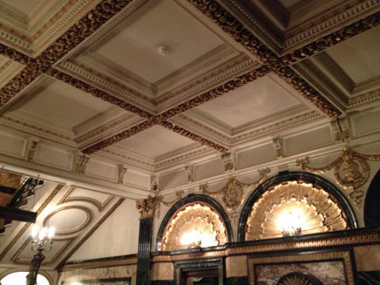
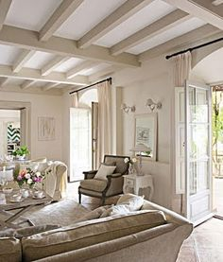

Student Name: | Salma Mohamed Safaa
Student Number: | 1170
Course: | Interior Designing
Assignment NO: | 9
Page NO: | 8

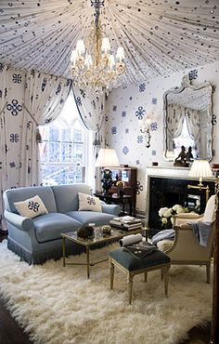

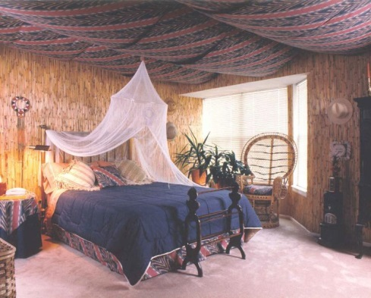
- Covering with Fabrics such as: tenting ceilings
