
Assignment Cover Sheet

Student Name: | Annur Zara Liyana Othman
Student Number: | 1227
Course: | Diploma of Fashion Design
Assignment NO: | 14

Student Statement:

By submitting this assignment, I confirm that this is my own work.

Student Signature | 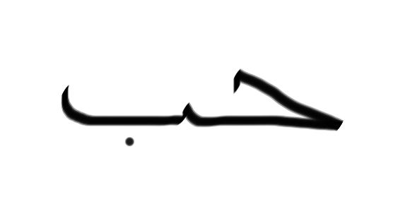 | Date | September 13th 2014

For Tutor / Assessor Use Only
Total Marks
Marks Obtained
Percentage / Grade

Surface Decorations

Assessment 14

1. Multiple Choice Questions:
a) Tucks are folds of fabric, holding fullness and are used for;
i) Shaping

b) Trimmings are the materials needed;
i) To finish and decorate garments

c) Which of the following is correct?
i) Braided trims are made by interfacing three or more yarns to form a flat narrow fabric

d) In interfacing;
i) A layer of garment/ fabric is placed between the garment fabric and its facing

e) Which of the followings is correct?
ii) The interfacing should never be heavier than the actual garment

f) According to the method of insertion pockets are divided into;
a) Three broad classes

2. Write short notes on the followings:
Pockets, belts, care labels
Pockets
Pockets are not an integral part of the construction of a garment, but are additions which allow the wearer to carry coins, wallet, notebook, keys, comb, pens and so on. From the long time ago pockets not only for decoration but its super useful to the wearer of the garment, bag ect. Pockets should e a good addition to the garment withoit byrden it either visually or practically. Pockets may be divided into three broad classes according to the method of insertion: first the pocket which is simply sewn on to the surface of the garment, the patch principle; secondly the pocket which involves cutting through the surface of the fabric in order that the pocket bag may hang on the inside of the garment, the through principle; and thirdly the pocket which forms part of a seam, the inset principle. Pockets should be design match its purpose. The size and where it locate is an important to designers in deciding to add pockets to the garment.
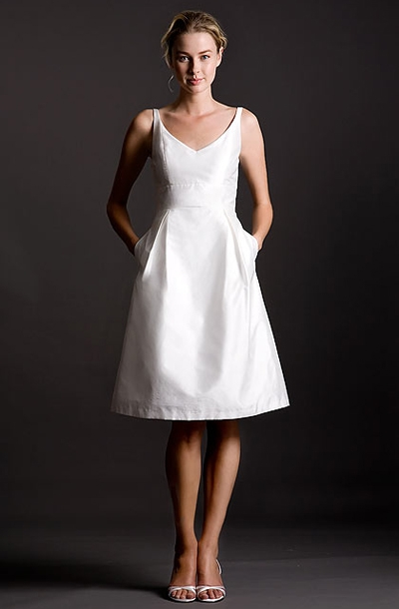
The example of one type of pocket applied to a dress

Belts
Belts can be refer as a strip of leather or other material worn around the waist. There are two types of belt manufacturers. The rack trade sell to retailers, and the cut-up trade sell less expensive belts to apparel manufacturers to be used on dresses, jackets, skirts, or pants. Garment belts normal made from inexpensive material such as bonded leather, vinyl, or ribbon. The belts manufactures of belt always match the fashion requirement. Belts can also be made "in house" by the garment manufacturer with buckles from the button supplier. Most of these belts are made from garment fabrics. Self-belts (made of the manufacturer's fabric) can also be made to order by a contractor.
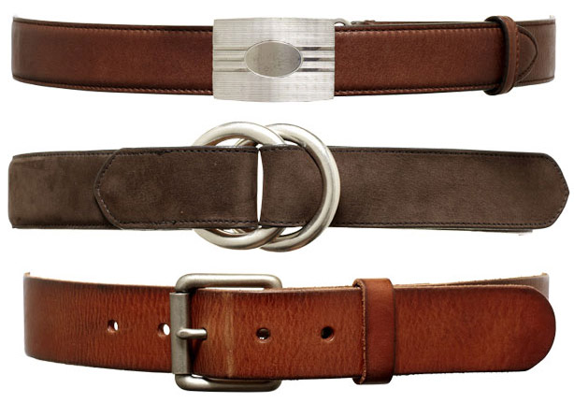
The example of a different look of belts

Care labels
Labels are the sources of identification for garments. They tell the consumer the name of the manufacturer and sometimes the designer. In other words, label is very important thing neither for the business itself or the other purpose. The label can be made by many types of material. Normally the expensive garment’s label always made by a satin or in high quality material matches the garment ad vice versa. Its can help to establish the company name as well as telling the detail about the garment.
Care label showing fibre content, care instructions, and country of origin must also be included in the garment. This information can be part of the primary label but is usually separate, just underneath the manufacturer's or store label. Care labels can be printed, or made in house on a Soabar machine. Hang tags are printed and hung on threads from the side of the garment, so that the customer sees them first when looking at garments sideways on a hanger rack.
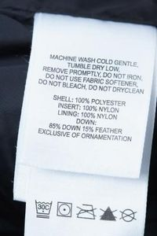
The example of care label on a garment.

4.Explain the following terms as discussed in the module.
Appliqué, banding, beading, galloon, medallions
Appliqué
In its broadest sense, an appliqué is a smaller ornament or device applied to another surface. An appliqué is usually one piece. By the definition, Applique literally means "to put on" in French and is a technique used to decorate the surface of fabric by applying pieces of cut fabric on top of a layer of fabric by sewing or embroidering around the edges. The technique used depends on the textile used and the use of the finished product.

Wool, leather, and other non-raveling materials
Once woven wool is fulled, it usually does not unravel at the cut edge. Like wool felt, the fibers have matted together. This means that you don't have to turn the cut edges under when tacking them down. Likewise with leather.
Since you don't have to worry about the edge, you can simply cut out your shape and tack it to the ground fabric using whatever stitch suits you.

Silks, Linens, Cottons and other raveling materials
Any woven fabric except wool will need to have its edges treated in some fashion when used as appliqué material. You can approach this in one of two ways. First, you can leave the edge raw, tack the shape down and apply cording on top of the edge to hide it and prevent it from further fraying. This is a good method and a period one, provided you make sure your raw edge is tacked very securely down and won't slip out from under the cording applied on top of it.
The other way of approaching the edge is to roll it under as you are tacking it down. This is a good method if the article is going to be washed quite a bit. Depending on how small the appliqué piece is, you might even be able to iron the edges over prior to stitching down, which will make things much easier. One problem you will face with this method is when you come to tight interior corners. You will need to clip your seam allowance to allow the fabric to fold around the curve without too much fuss.
If the fabric chosen wants to unravel the second you cut it, you might consider using an alternative fabric for appliqué. You will have a devil of a time working with it unless you use Fraycheck (a edge bonding agent) or the period equivalent of Fraycheck, Gum Arabic. There is ample evidence in period that Gum Arabic was used not only as a deterrent to ravel prone edges but also as a sizing bath. Fabrics such as velvet, velveteen and other slick or napped fabrics respond very well to Fraycheck. Fraycheck makes it possible to not have to roll the edges under which makes working with velvet/velveteen much easier.
Types of stitches
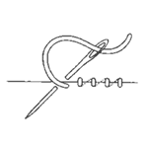 | 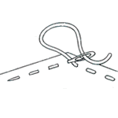 | 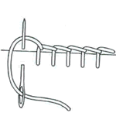
Common tacking stitch | Running stitch | Blanket or Buttonhole stitch
The above three types of stitches are the ones most commonly used in period appliqué. The common tacking stitch is best used on a turned edge rather than a raw edge. The running stitch is good for both raw edges and turned edges. The blanket or button hole stitch, if worked very closely together is great for covering a raw edges. If worked loosely as above, it makes a nice embellishing stitch especially when done in a heavy thread.
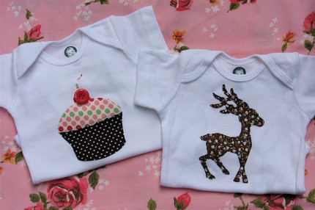
The example on Appliqué on the junior garments

Banding
Banding can be refers as A narrow strip of fabric used to trim, finish, or reinforce articles of clothing. In the other words, Banding is narrow fabric having two straight or decorative edges that make it interchangeable for various top trims such as borders, edging, insertion, or accenting of a design line. It used for the edge finishing. Banding not only for secure the edge seam, but also can be a decoration to the garment or anything else.
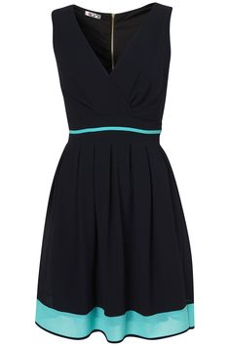
The example of banding trims on the edge on a garment.

Beading
Beading is openwork trimming, usually lace or embroidery, through which a ribbon may be threaded. Beading is one of the decoration for the garment that can make a good visual attraction if it’s done well. Its can be in many pattern. Let say for lace, it can be in many colours and shapes. Its give an effect of grace. Embroidery is a type of beading that usually being sewn directly to the fabric. This type of beading gives the effect of classic. It also can be in many design and colours. Many designers these days using beading in their latest collection.
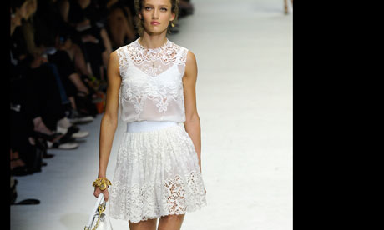
The example of beading(lace) trims on a dress

Galloon
Galloon is lace, embroidery, or braid having two scalloped edges. It can be used as a banding, border, or design-line accent or can be applied just like insertion for a see-through effect. Insertion is a trim with two straight edges. It is also a method of applying trim by inserting and sewing it between two cut edges of fabric. Galloon also can be define as is a decorative woven trim sometimes in the form of a braid and commonly made of metallic gold or silver thread, lace, or embroidery. Galloon is used in the trim of military and police uniforms, ecclesiastical dress, and as trim on textiles, drapery, and upholstery. Galloon widely used in the past fashion and also in the nowadays fashion. In every designers new collection, there are always using galloon perhaps the effect of see-through itself is really good.

The example on Galloon(embroidery) trims on a dress
Medallions
Medallions are a chain of trims with individual motifs that can be used continuously as banding, edging, or galloons, or clipped apart and used as appliqués. Based on its real definition, its refer to a metal chain. But in fashion it can be in many materials. In other words, if some fashion items it’s a combination from a few pieces of things and placed it for banding, edging, or galloon, its is medallions. This is can make a pretty visual decoration effect.

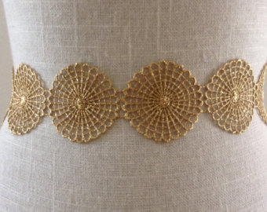
The example of Medallions trims on a lace
Reference
Information: BOLC unit 14 note, Fashion lecturer Hongik University, South Korea, Fashion websites, Fashion magazine (online and offline), Fashion blogs.
Images: Fashion websites, Google images, Online fashion magazine.

