

Student Name: | Vismantas Mikstas
Student Number: | 1181
Course: | Supply Chain Management Diploma
Assignment NO: | 10

Student Statement:

By submitting this assignment, I confirm that this is my own work.

Student Signature | V. Mikstas | Date | 04/09/2014

For Tutor / Assessor Use Only
Total Marks
Marks Obtained
Percentage / Grade

1. Give short answers for the following questions:

- What are the aims and functions of warehouses?

A warehouse is any site where material is stocked on their way to supply chains. In general, the objectives of a warehouse are to sustain the broader logistics function by giving a mixture of high shopper service and low costs. More exact aims include:
  - Providing necessary storage at key points in a supply chain;
  - Giving secure storage of the type needed by materials;
  - Keeping all materials in good condition and with minimal damage;
  - Giving high customer service;
  - Doing all necessary activities efficiently and with low costs;
  - Getting high productivity and utilization of resources;
  - Controlling all movements of materials effectively and without errors;
  - Sorting materials arriving and quickly transferring them into storage;
  - Picking materials departing, quickly transferring them out of storage and consolidating deliveries;
  - Being able to store the whole range of materials needed;
  - Being flexible enough to deal efficiently with variations in stock levels;
  - Allowing for special conditions, rotation of stock , and so on;
  - Giving safe working conditions, and compliance with regulations.

- What is the difference between public and private warehouses?

Private warehouses are owned or leased by a business as part of its own supply chains. The business runs its own warehouses to sustain its major operations. This gives greater control over a middle part of logistics, and allows incorporation of warehousing with the broader activities of logistics.
A public warehouse is run as a self-governing business, which makes money by charging users a fee. There are a lot of types of public warehouse, including bonded warehouses, cold stores, bulk storage, tankers and various specialty stores. The facilities accessible are usually so flexible that an organization can obtain within reason, any facilities that it requires. The main advantage of public warehouses is their flexibility.

- Explain the advantages of public warehouses.

The main advantages of public warehouses include:
- Flexibility to deal with changing demand, possibly due to seasonality;
- Ability to supply skills and knowledge that the business does not have internally;
- Access to the newest equipment and practices;
- Avoiding big capital investment, giving higher return on investment;
- Easy access to a wider geographical regions;
- Allowing immediate tests of working in new areas;
- Use of economies of scale to lessen warehousing costs;
- Consolidating loads with other organizations to decrease transport costs;
- Certain high quality and well-organized service;
- Flexibility to deal with varying conditions, removing risks from dated practices and technology.

The move towards contracting out warehousing means that the most widespread arrangement for warehousing is maybe a combination of private and public. The choice between private and public warehousing is frequently seen as another feature of the ‘make or buy’ decision, and is often presented as a break-even analysis. Private warehouses have elevated fixed costs but lower unit operating costs, while public warehouses have small fixed costs but potentially high variable costs.

- What are the manual warehouses?

Manual warehouses where workers move to a pick location, pick the goods, and then move to the delivery dock. These facilities aren’t necessarily completely manual. They might employ forklifts and conveyors in certain locations in the warehouse. In contrast, automated warehouses use extensive conveyors, sortation equipment, automated storage and retrieval systems and other material handling solutions that move the goods to the workers.
Manual warehouses only work if the items are small and light enough to lift. Shelves must be low enough for them to achieve and close together to decrease the distance walked. Very-high-throughput automated warehouses are not nearly as flexible as manual warehouses. With a manual warehouse, it is not that difficult or expensive to move racking, change warehouse flows, or add new value added services. In a warehouse with miles of conveyors making these types of changes is often very difficult and costly.

- What are the automated warehouses?

Automated warehouses employ automated systems, including conveyor belts, pulleys, and robots to store and move items. An automated system offers several key benefits:
- You will no longer need warehouse workers driving around on forklifts.
- Also, automation creates a more efficient use of space. With less floor space and building height taken up by storage, companies can dedicate the extra space for other functions.
- Because they can operate 24/7 and don’t rely on manpower, automated warehouses are much more efficient. The machines used are designed for safety and will likely result in fewer accidents than a forklift system.
Obviously one of the biggest potential downsides for companies considering an automated warehouse is cost and lack of flexibility.
Automated warehouses include the following components:
  - Storage regions that can be accessed by mechanical equipment; these often make use of narrow aisles up to, say, 40 m tall to get an elevated density of materials and reduce the distances moved.
  - Equipment to shift materials around the warehouse; these are typically automated guided vehicles (AGVs);
  - Equipment to mechanically choose materials and place them into storage, including high speed stacker cranes that can arrive at any point in the thin aisles very fast.
  - Equipment to move materials between the diverse types of equipment; these mechanical loaders and unloaders may include industrial robots.
  - A warehouse administration system to record material locations, and manage all movements.

- What are the main materials used for packaging?

Many items require special protecting packaging during moves, chiefly delicate things like china and electronics. Sometimes the wrapping can defend goods from harsh environments, such as rain or sun; sometimes it is essential to part materials that would pollute each other, such as sugar and petrol; sometimes it keeps the contents clean, such as foodstuffs and medicines.
There are five chief materials for packaging:
- Glass is simple to clean, reuse and reprocess, but is easily broken, comparatively expensive and hard to make;
- Plastic is light, strong and simple to clean, but can be costly and hard to create or reuse;
- Cardboard is light, inexpensive and can be recycled, but has slight strength and poor toughness;
- Wood is strong, tough, easy to use and can be reused, but it is weighty, bulky and tricky to clean;
- Metals strong and tough, but is weighty and can be costly.
The choice of these – or other materials – depends mainly on the kind of products, movement and protection required.

2. Outline the activities that take place in a warehouse.

Basic activities taking place in a warehouse usually are:
- Receiving goods from upstream sellers;
- Identifying the goods, matching them to orders and finding their planned use;
- Unloading materials from delivery vehicles;
- Doing any essential checks on quantity, quality and state;
- Labelling materials (usually with bar codes) so they can be recognized;
- Sporting goods as essential;
- Moving goods to mass storage area;
- Holding them in stock until required;
- When required, moving materials from mass storage to a smaller picking store;
- Picking materials from this store to meet orders;
- Moving the materials to a marshalling area;
- Assembling materials into orders;
- Packing and packaging as necessary;
- Loading delivery vehicles and dispatching the order;
- Controlling all communications and connected systems, such as inventory control and finance.
Some organizations try to shift materials fast through the supply chain; they take more staging points through which materials shift as fast as possible. As warehouses role in long-term storage has decreased, they have turn out to be suitable locations to do a variety of other jobs. They are, for instance, the finest place for sorting materials, packing and consolidating deliveries. A different type of consolidation happens when a manufacturer makes, or buys, parts of a finishing product in diverse locations. Then it can organize for all components to be sent to a warehouse which unites the parts into the final product, and organizes delivery to customers. This sort of consolidation can go further than just bringing together materials from diverse sources. It may add the final packing and packaging to present a single product, or even do an inadequate amount of final manufacturing. This is the root of postponement, where the final steps of construction are left to the last potential moment. This has the benefit of reducing stocks and rising flexibility to meet late changes in consumer demands.

3. Describe in details the general layout of a warehouse. Using examples and illustrations.

One of the most significant decisions when operating a warehouse is its design. This describes the physical plan of storage racks, loading and unloading areas, offices, rooms, equipment, and all other facilities. Layout decisions are imperative for three essential reasons:
- they need substantial investments of both money and effort,
- they involve long-standing commitments,
- they have important impact on the cost and competence of immediate operations.

This suggests that the necessary elements in a warehouse are:
- an arrival bay, or dock, where goods coming from suppliers are delivered, checked and sorted;
- A storage area, where the goods are kept as stock;
- A departure bay, or dock, where customers’ orders are assembled and sent out;
- A material handling scheme, for moving goods around;
- An information system, which records the site of all goods, arrivals from suppliers, departures to consumers, and other applicable information.

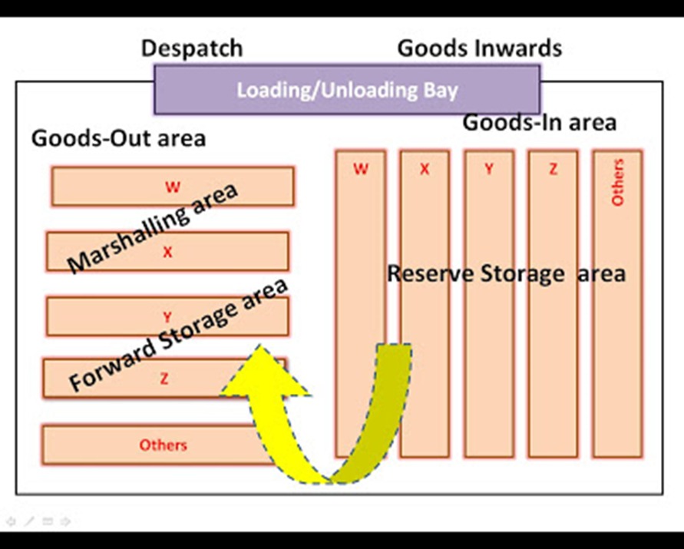
Basic Layout of a warehouse

There are a lot of variations on this fundamental outline. The most general one – which is also used in most supermarkets – in fact, has two storage areas. Goods arrive and are put into a mass store (the backroom in a supermarket) which is the major storage area. The packages in the mass store are wrecked into individual units and shifted to a smaller picking store that is used to collect orders (the shelves in a supermarket). When an order is received, the items required are ‘picked’ from the smaller, picking store and brought jointly in a consolidation area, before moving to the departure bays. When stocks in the picking store run low, they are refilled from the bulk store. This gives the run of materials from arrival bays, bulk store, picking store, consolidation area to departure bays.

There are some suggestions for superior layouts. These include:
- Plan the layout to give a smooth flow of materials into, through and out of the warehouse;
- Simplify movements, eliminating or combining separate movements where possible;
- Use high level storage where possible, as this reduces the overall area;
- Have offices outside the main warehouse area, as space above them is wasted;
- Consider using spare roof space for overhead movement of materials;
- Give appropriate space for aisles – as narrow as possible to reduce non-working space, but wide enough for equipment;
- Consider mezzanine floors for picking and administration;
- Have movements in straight lines on one floor.

