
Youssef
Assignment Cover Sheet

Student Name: | Gehan Aly Youssef
Student Number: | 1092
Course: | Interior Design Diploma
Assignment NO: | Module 14

Student Statement:

By submitting this assignment, I confirm that this is my own work.

Student Signature | Gehan Youssef | Date | 1/12/2015

For Tutor / Assessor Use Only
Total Marks
Marks Obtained
Percentage / Grade

Name: Gehan Aly Youssef
Student no.: 1092
Assessment no.: Module14
Course Name: Interior Design Diploma
Address: Beverly Hills Compound, Build. No. 89,Square 1,El Sheik Zayed, 6 October, Giza,Cairo,Egypt
Page no.: 1

Q.1. Short Questions:

- How important it is for a designer to know about the function of a room before decorating it and which questions would you ask your client as a designer to establish the purpose of the living room before decorating it?

The function of a room plays an important role of decorating it because according to the function or purpose of the room and how the client wants to use it the décor is set or designed ,So the designer depends on the function of the room when putting his design or imagination for the place.
So for that reason there are some important questions a designer must ask his client before decorating the place and here we are talking specifically about purpose of living room which consider one of the most important parts in the house it’s the multifunction place all family members are using it sometimes it’s a place for reading others it’s used as dinning place or playing area sometimes watching T.V.
Important questions can be:
- How many are the members of the family?
- IF family has children or not , How old are their children if found?
- Are they expecting a baby coming or Adults leaving the home going to a college?
- Are children going to make their studies in the living room?
- What is the main purpose of the living room?
- The activities that will take place in it?
- If they will use a part of it for working purpose?

Name: Gehan Aly Youssef
Student no.: 1092
Assessment no.: Module 14
Page no.:2

- What it the Role of T.V. in their life whether they use it too much or not, if they need home theater for example or an ordinary T.V.?
- If they want a specific place for playing cards or chess for example?
- Whether they need small kitchenette in the living room if the kitchen is too far or in another floor?
- Whether they use it more at morning or night and places most they sit in? As for designing the light criteria.
- If they need to put a chimney in the living room or not? As it will take place and could be the focal point of the room.

According to these questions the design can be set as now we know the purpose and function of the room so the needed light and places for spots and if room needs more natural light , the colors and walls decoration to make it simple or not if they need many shelves for books , magazines ,etc. or not , T.V. place tables places and sizes .Sofa size and position if we need one or two arm chairs or may be 2 sofas if we need ordinary sofa or sofa bed.
So knowing the purpose and function of the room and family condition has a great effect on the design of it.

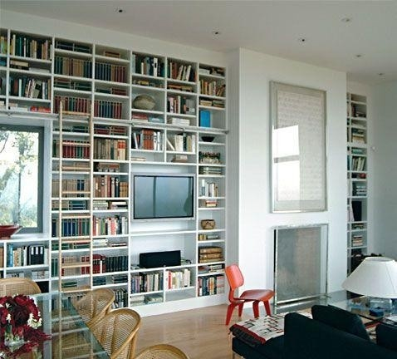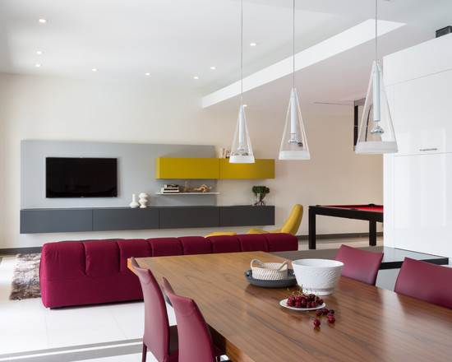

______________________________ Name: Gehan Aly Youssef
Student no.: 1092
Assessment no.: Module 14
Page no.: 3

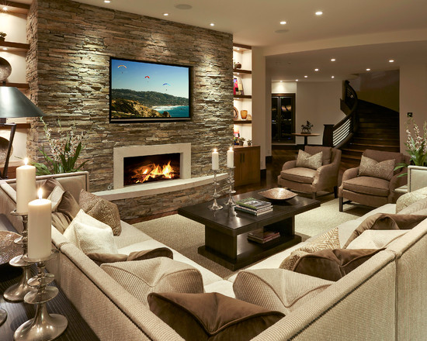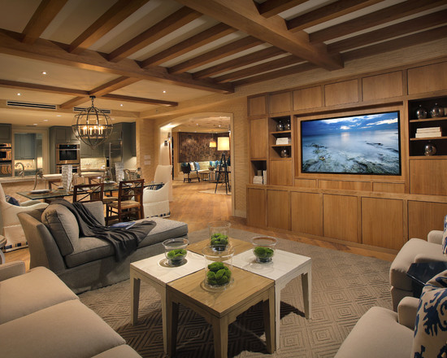

- Apart from carpeting what other options do you think are available for practical flooring for a family living room?

The carpet is the main flooring for a cozy, warm living room and it’s very practical but the others options that are also practical and have a good looking are first wood treatments like parquet, wood panels or strips, HDF they are very useful to give warm atmosphere and they are good in winter or cold countries. And there are many designs can be made with it to give good looking. Also tiles can be used with small rugs on or a centered carpet, there are also slate flooring, marble flooring they are hard and durable and good in summer weather and hot countries.
Wood, Tiles, Marble, Slate flooring are easy to clean this is another point of view.

Name: Gehan Aly Youssef
Student no.: 1092
Assessment no.: Module 14
Page no.: 4
Examples for wood Flooring:

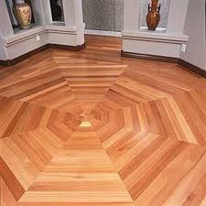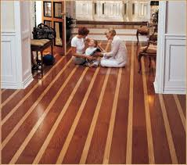

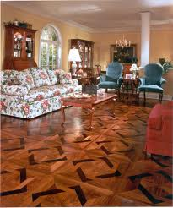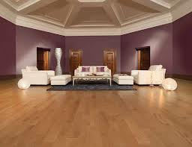

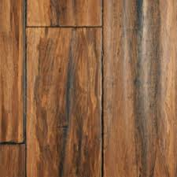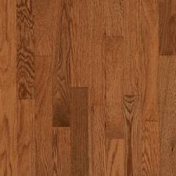

Name: Gehan Aly Youssef
Student no.: 1092
Assessment no.: Module 14
Page no.: 5

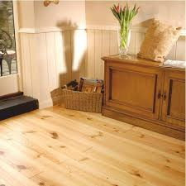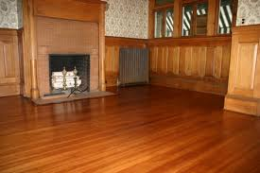

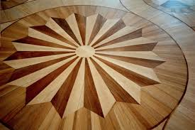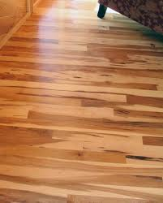

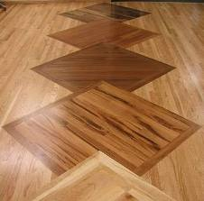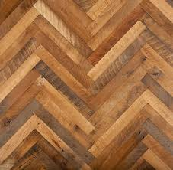

Name: Gehan Aly Youssef
Student no.: 1092
Assessment no.: Module14
Page no.: 6

Examples for Marble Flooring:

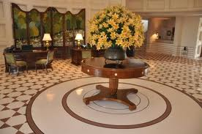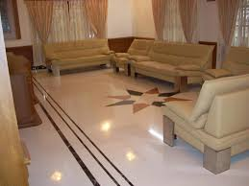

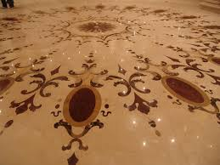

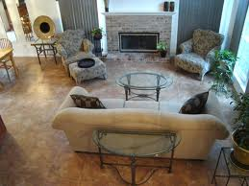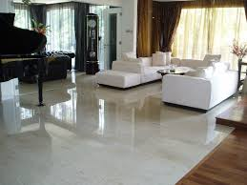

Name: Gehan Aly Youssef
Student no.: 1092
Assessment no.: Module 14
Page no.:7
Examples for Tiles Flooring:
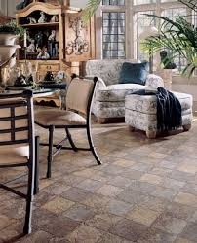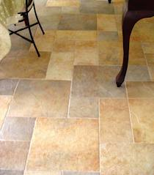
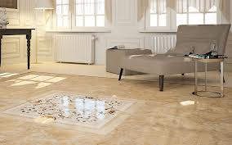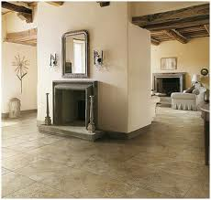
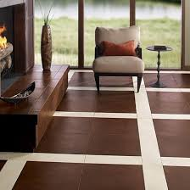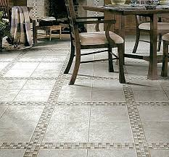
Name: Gehan Aly Youssef
Student no.: 1092
Assessment no.: Module 14
Page no.:8
- How far a well planned lighting scheme is important for a fully functional kitchen?

For a fully functional Kitchen a well planned lighting scheme is very important as the kitchen is the place where the food is prepared so it needs a good lighting that it carefully set as it must be strong lighting without shadows especially above the places that food is cooked and prepared in. like cooker , tables or counters that food is cut and prepared on , light must be above it or coming from a side that make the place well lighted and clear and it mustn’t be behind the person whose preparing the food as not to make his shadow on the table.
Also the natural light amount is very important in the morning so it’s preferable to have in the kitchen an appropriate window or door that enter sunlight if not so the lamps must be more as they will work day and night.
There can be additional indirect light or spotlights that can give the place a warm feeling after finishing preparing the food to light on or in dining time can be used. We can use led lights under the wooden cabinets of the kitchen to give indirect light or also spots in the top of the wood cabinets.

Direct and Indirect Light
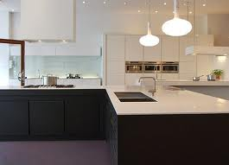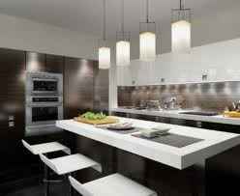

Name: Gehan Aly Youssef
Student no.: 1092
Assessment no.: Module 14
Page no.:9

Spot Lights
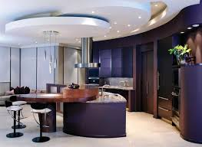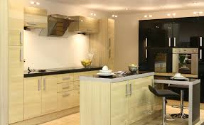

Candilier Lights
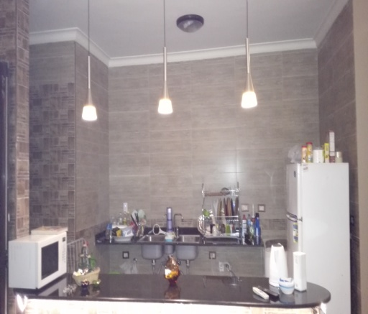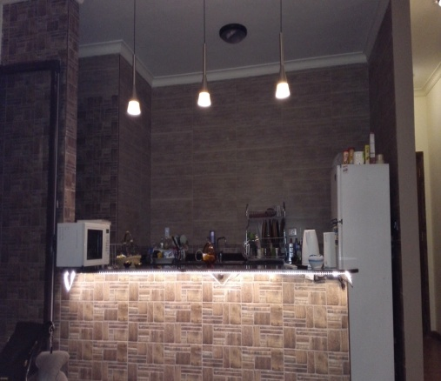

Daylight lighting
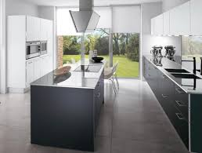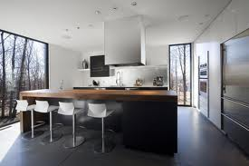

Name: Gehan Aly Youssef
Student no.: 1092
Assessment no.: Module 14
Page no.:10

- Which type of flooring is most suitable for the connecting spaces?

The connecting spaces are very critical place in the home so for choosing most suitable flooring type it’s not easy as we must take in consideration that this place is the most one that feet step on daily so any floor type must be durable, tough, hard, easy to clean, not slippery one as to work good in this place and live longer. So we can put carpet or ceramic tiles, vinyl, rubber surfaces could be suitable slate tiles , traditional flooring like in Victorian houses also linoleum can be used and sometimes we can use wood panels it can act well .
The main thing here is that the floor under foot is not to be noisy or rough and be practical especially when home has elder people or children.

WOOD FLOOR

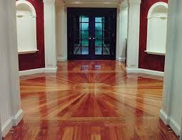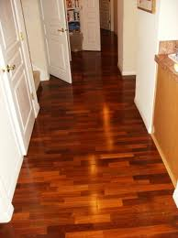

Name: Gehan Aly Youssef
Student no.: 1092
Assessment no.: Module 14
Page no.:11

CERAMIC, SLATE TILES FLOORING

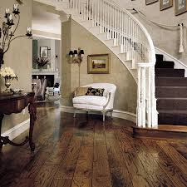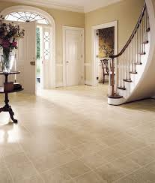

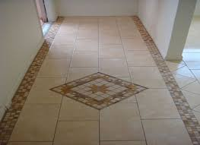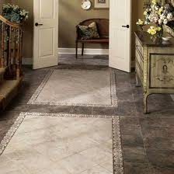

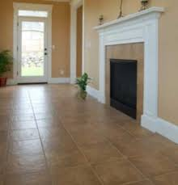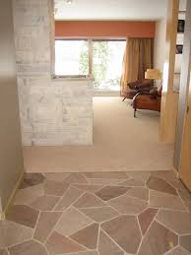
Name: Gehan Aly Youssef
Student no.: 1092
Assessment no.: Module 14
Page no.:12

MARBLE FLOORING

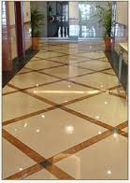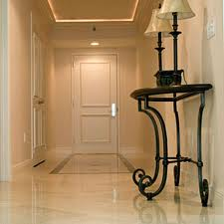

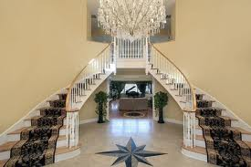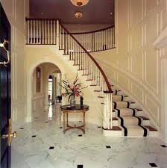

Name: Gehan Aly Youssef
Student no.: 1092
Assessment no.: Module 14
Page no.:13

- How important it is to establish the visual link between the overall scheme and the hall ways?

As we are talking about same place so it must have the same atmosphere and harmony so the corridors and connecting places, hallways are a part of the home they complete the scene or the decor of the place so they must have same colors or matching colors and patterns of the same as the whole house, also the floor should be the same or to separate flooring using matching colors and materials also walls must have same style we should put some arts or hangs that give space some life as not to be boring and dull, Lighting is an important issue that must been take in consideration to make them attractive and welcoming. As they continue the whole scheme so as to establish a visual link between the whole house and the hallways.
In other hand the entrance area is very important part as it’s the first place to ever see in the house and it give the impression how is the whole house style is.

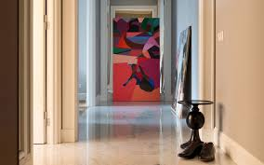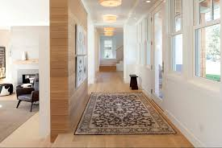

Name: Gehan Aly Youssef
Student no.: 1092
Assessment no.: Module 14
Page no.:14

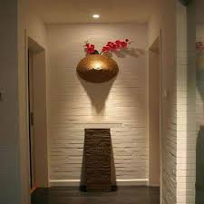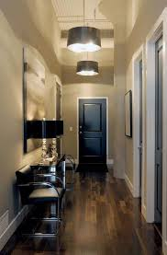

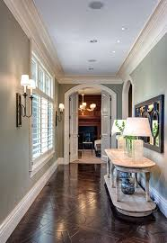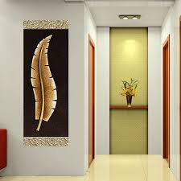

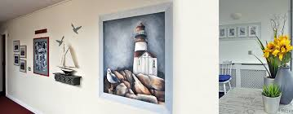

Name: Gehan Aly Youssef
Student no.: 1092
Assessment no.: Module 14
Page no.:15
- Why is it important to draw a floor plan for a room before buying furniture for it?

It’s very important to draw a floor plan for a room before buying furniture to it as the floor is the dominant thing that will be set in the room and changing it is very difficult so it must be the first thing to plan or set in the room, also the furniture choosing or design is according to the floor design and empty spaces . So we can make a draw in the floor or border that must appear so we put the furniture apart from it.
Also according to the purpose of the room the floor will be set and because it’s a hard surface durable or not easy to change and not willing to change it except after a long period so it’s the first thing to choose whether wood or ceramic tiles or Marble or vinyl or slate so choosing depend on the room if it bedroom, living room, kitchen, bathroom, dining room or children room or reception, terrace here we first know the room purpose then choose the appropriate floor then choose the furniture to put on it.

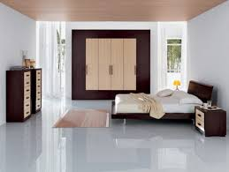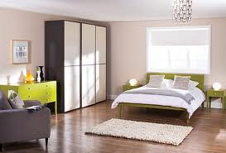

Name: Gehan Aly Youssef
Student no.: 1092
Assessment no.: Module 14
Page no.:16

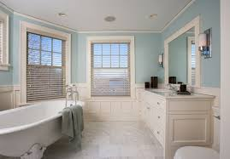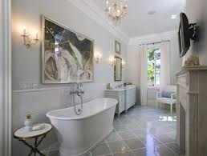

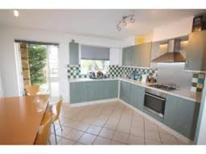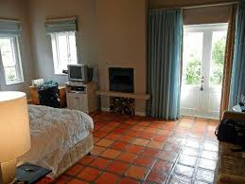

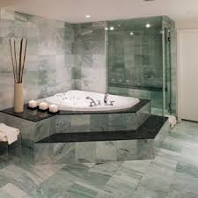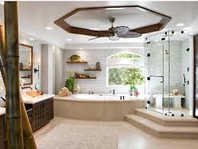

Name: Gehan Aly Youssef
Student no.: 1092
Assessment no.: Module 14
Page no.:17

- Which safety measures would you take when designing a room scheme for an elderly person?

There are some safety measures must be taken when designing a room for an elderly persons, first thing if the house contain more than one level the elder person must be in the ground floor also he must has space not only for sleeping but also to make his activities like cooking, reading, relaxing, bathing so the place must contain all the facilities to the elderly person so he must stay in a suit not just a small room or a large room containing all the facilities with connected bathroom .
These measures could be:
- Warmer room atmosphere.
- Don’t make floor levels and if there is they must be highlighted.
- A comfortable easy access to get out a chair.
- Storage must be in easy appropriate level to elder people.
- Lighting must be good and strong and reachable may make diverter buttons also there must be light everywhere and also warm light for sleeping and reading. Also at morning there must be good openings for sunlight access and good ventilation.
- Smoke alarm should be set , a ring bell also can be set.
- Curtains must be easy used open and closed.
- Any sharp corners must be covered or removed.
- Bathroom must be comfortable and easy to use shower must be in shower cabinet easy to enter and get out , also water mixer must be good controlled for temperature.

Name: Gehan Aly Youssef
Student no.: 1092
Assessment no.: Module 14
Page no.:18

- When two people have to share a room and they both have totally different tastes how will you solve the problems relating to color, pattern etc.

When two people have to share a room and they both have totally different tastes so this is a big problem it can be solved by choosing a neutral color in the mid also the pattern must be something between 2 tastes or make something for the first and other for the other person one as a combination between 2 tastes also we can use more than one style in same room the important thing is that the room looks comfortable and relaxing and to match things or tastes together neutrals are the best choice for this situation and picking charming , attractive accessories and stylish furniture to make the place admirable.

- How far it is important that the ensuit bathroom scheme should relate to the adjoining room’s scheme?

Because the ensuit bathroom is related to a room so logically the décor of the bathroom will be related to the décor of the room at least colors will match together sometimes we can continue the rugs or pictures in the bathroom may be wallpaper also take same pattern or color even the ceramic tiles or the marble will match with the overall scheme of the related room.
But in the same time they must have their own character. The best way is to have both of them same color tones and also pattern.

Name: Gehan Aly Youssef
Student no.: 1092
Assessment no.: Module 14
Page no.:19
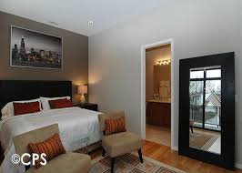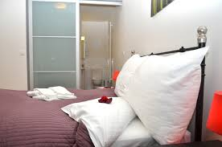
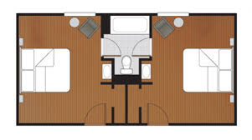

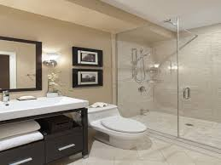

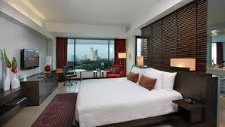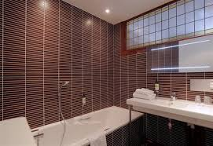

Name: Gehan Aly Youssef
Student no.: 1092
Assessment no.: Module 14
Page no.:20

- Which basic equipment is usually required in a home office?

Basic items of equipment that is usually required in a home
office can be:
A desk, an office chair, shelves, cabinets, storage equipments, filing place, lamp, computer, telephone, fax machine, side office chairs or sofa, also there may be a library in it to contain books.
Kettle or coffee machines should be included, also separate bathroom could be included if there is place for that.

The style of the home office or working place will be decorated according to the type of work and place of the working area whether it is inside the home in living area or in a separate room or in a whole separate building in the garden also if it has separate entrance or not and it should has its own decoration and style , it should has neutral dark colors with deep hard flooring it should be soft simple furnished , light should be strong , also daylight must take place.

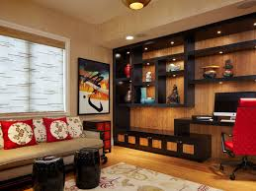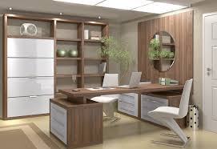

Name: Gehan Aly Youssef
Student no.: 1092
Assessment no.: Module 14
Page no.:21

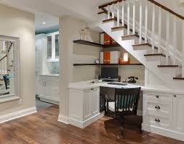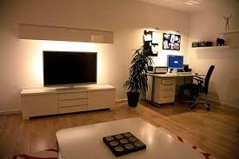

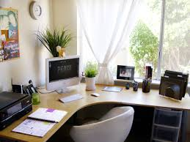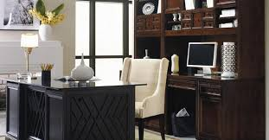

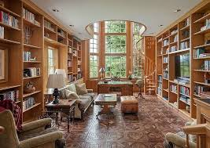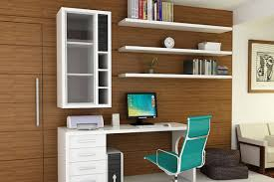

Name: Gehan Aly Youssef
Student no.: 1092
Assessment no.: Module 14
Page no.:22
Activity

- List things that you have in your bedroom and also list things that you want to have?

The Things that I have in my bedroom are a king size bed, a large cupboard, a chair, a chest drawer, T.V. this is now.
Previous there was a sofa instead of the chair and there wasn’t a T.v.
Things I want to have a dressing room or closet another chair and a small tee table or instead a calzone and a dressing table.

- Measure your bedroom and convert these measurements to scale.
My bed room is (4 m X 5 m) the scale will be (1:100) as it will be (400 cm X 500 cm).

- Do you have enough storage space in your bedroom?

Storage space is fair but not enough, so I need more storage space.

- If you are asked to create some more storage space how would you manage to do this?

If I’m asked to create more storage space I can manage it either by 2 options.
First one is to add some extra shelves beside the bedroom or continue a cupboard above the chest drawer.
Second one I have a connected bathroom in my room so I can take apart from the bathroom and apart from the room and make it a large dressing room and keep the drawer chest and small part from the cupboard.

Name: Gehan Aly Youssef
Student no.: 1092
Assessment no.: Module 14
Page no.:23
