
Assignment Cover Sheet

Student Name: | Saleema Choudrey
Student Number: | 1240
Course: | Fashion Designing
Assignment NO: | Unit 7

Assessment 7
Question 1.
- Which type of materials should be chosen for the dress of a thin person? And when choosing a stripy print which type of stripes would you recommend for the dress of a thin person?

Materials for a thin person to be chosen should be wide/loose fabric, stiff fabric to design according the figure fitting to create curved lines and Shiny fabric also enlarge a thin person’s size. Thick Stripes which are horizontal makes a thin person stouter.

- How would you design a dress for a person with a large waist and hips? Which designing technique would you apply?

The dress design for a large waist and hips should be focused on shoulders to create the balance for the figure. The technique to be used for a large waist and hips would be to create big hats to get the balance for this figure.

- A person with stout figure must never try wearing a dress which is too tight for him/her. Discuss.

A person with a stout figure should never wear tight dresses because that would emphasis his/her body. And that doesn’t look very attractive to others. The person should wear appropriately to his or her figure.

Suitable tips for a stout figure to enhance the figure:

- One material or color
- Soft fabric
- Fabric with dull surfaces
- Dull colours in large areas
- Black or very dark colours
- Unbroken silhouette
- Semi fitted. With some fullness below. A-line
- Transitional lines
- Vertical movements
- The emphasis on the top of the dress.
- A long diagonal line on the dress
- Panels, pleats that start from the widest part of the body
- Flared skirts, circle skirt, skater dress
- A normal waist line
- Sleeves vertically slit
- Short jackets
- Dark furs
- Hats of moderate sizes with upward movement
- Hair dressed high

- How would you design a dress for a person with round shoulders so this problem is least noticeable?

To reduce the problem for a person with round shoulders are to set in sleeves, place shoulder about one inch back of the normal shoulder line. Wear collars that will appear to straight the curve of the back. Boleros, ponchos are a good coverage for a person with round shoulders

Activity
Make a collage of the pictures from a magazine, people wearing dresses unsuitable for their figures. For each picture explain how this could have been designed correctly for that person’s figure.
1 2 3 4 5
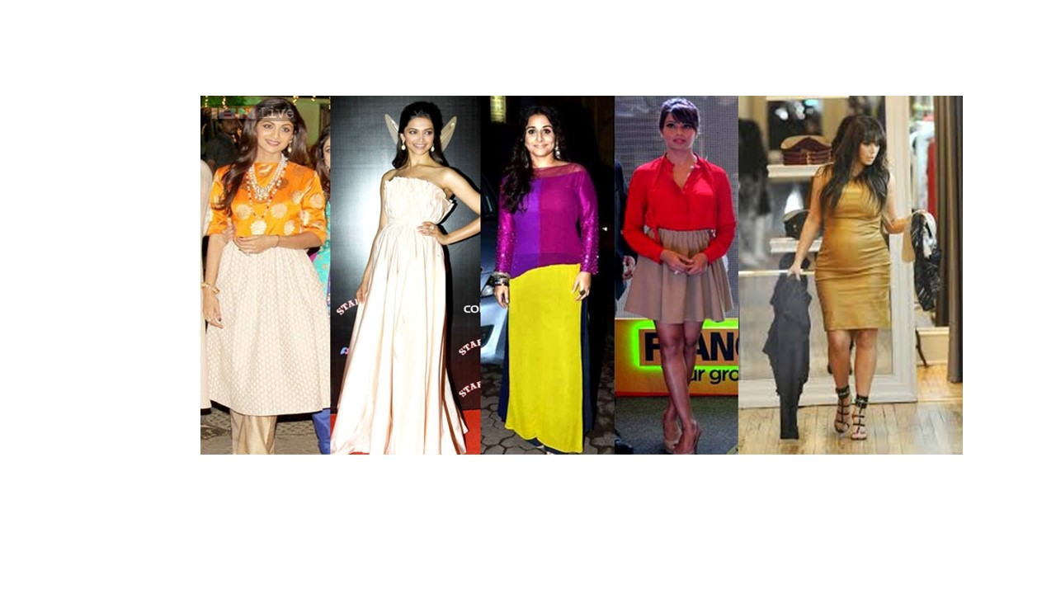
(Source: images from google)
Dress 1. This dress should have be worn without a trouser. The person is tall it would give a more elegant look to the figure. Wearing the dress with a trouser makes it too much fabric at once.
Dress 2. According to this persons thin figure the dress is too plain. It makes the dress unattractive. A little bit more fitting in the waist and bust would stand the dress more out. Drapes in the waist line would make a difference too.
Dress 3. The colors are too bright for the persons figure. It makes the figure look larger instead of thinner. If used in dark/dull colors this design would be perfect as it is already in 2 parts. Neckline in v shape would make the wearer look thin.
Dress 4. Perfect dress for the figure. Just the pleats should have started from the biggest part of the hips. The skirt is too short for the design. To make it more elegant knee length would be perfect.
Dress 5. This dress should be draped in the waist to make it a perfect maternity dress for the wearer. The color is too light as well, darker color would have shown less of the body shape.
Reference
http://www.google.co.uk/imgres?imgurl=http://www.adorethelife.com/wp-content/uploads/2015/09/jwala-gutta-hot-and-spicy-stills-very-tight-skinny-dress.jpg&imgrefurl=http://www.adorethelife.com/index.php/2015/09/11/fashion-crimes-you-always-commit/&h=1130&w=750&tbnid=F5dinxaDpjbEvM:&docid=rGHPJxKg03GjlM&ei=pVQhVuGDLoSBU9TLpfAG&tbm=isch&ved=0CDkQMyg2MDY4ZGoVChMIoer4ruHHyAIVhMAUCh3UZQlu

www.h&m.co.uk

www.google.co.uk

www.pinterest.com

Student Statement:

By submitting this assignment, I confirm that this is my own work.

Student Signature | Saleema choudre | Date | 17-10-2015

For Tutor / Assessor Use Only
Total Marks
Marks Obtained
Percentage / Grade

