Student Name: Saleema Soendas Choudrey

Student number: 1240
Course Fashion Designing
Level 4
Unit 1

Assessment 1
1.
I. How did the First World War influence fashion? Which types of changes were brought about by it?
A woman’s role in the westerns society changed after the First World War, along with that modern fashion changed. The materials that were used in old garments were changed to more expensive fabrics such as wool. Due to the jobs, women wore straight dresses that would hide their feminine features and wore short skirts so they would be easy to do labour work. A military look crept into fashionable designs as well with military style tunic, jackets, belts and epaulets (Monet). The clothing became more relaxed and the colours worn became darker and subtler.
An ample cape with high collar was the latest fashion in 1914 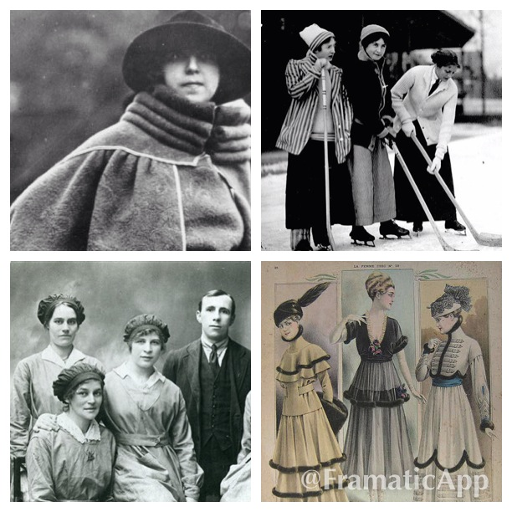
Source: Photos taken from Google.

II. Describe the characteristic features of the twentieth century’s fashion.

1900-1910
News of the times was the changing roles of woman, they joined the politic, work, clubs, joined school, sports etc. there was mass production for clothes. Henry Ford was the 1st model in 1908.
The fashions of the times were delicate and still impractical for the changing role of woman. Tight waist line, exaggerated tight corset one piece dress chiffon lace mitten sleeves, high neckline. Hats embellished with accessories. Shoes were not important, feminine handbags, gloves.
Gibson girl look was in at that time they wore Long skirts and shirt waist blouses.
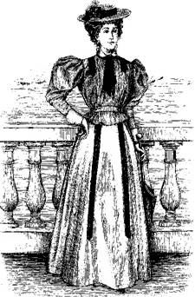Gibson girl look

Influential designers of that time were……
The designers who influenced fashion were Paul Poiret established his own house in 1903. He freed women from corset and designed loose fitting clothes and became famous with controversial kimono.
Mme Paquin she never used to make 2 dresses alike. She designed glamorous event dresses and Jeanne Lanvin wedding gowns were one of the Lanvin’s speciality.

1911-1920
Women started to work and attend universities in greater numbers. Domestic work that was done by men was that women took over.
The fashion at that time was a mix of fashionable and functional. Hobble skirt, slit front, designed by Poirets. He revealed women legs for the 1st time back in the days. Parasols were popular, daytime tailored suits; side button shoes small handbags shoes and hosiery were important fashion elements.
Influential designer of the times were………
Nina Ricci designed graceful and elegant fashion. Madeleine Vionnets fashion included bias cut. She opened her own couture house in Paris in 1912.Closed it in World War 1 then opened it again in 1918. Fortuneys designs were only worn by wealthy women.
1920s
Fashions at the times were different from previous decade. Skirt became shorter. It was an advance decade. Crochets, beading, fringes decorated dresses silky dresses were in fashion. Sportswear was introduced to women as well.
In 1925 the flapper dress created a sensation with shorter shirts, dropped waistlines and uneven hems. Jean Patou was a master of change; he was the first to bring the waistline back to its normal position.
Influential designers of the times were………
Coco Chanel, most important couturier in the 20th century. Her fashion images were simplicity and elegance. She started designing hats for her own use as people started to admire them, she began to produce and sell hats from home. The business expanded so she started to include dresses to her line. Her clothing was casual, smart and practical.

1930’s
Great depression effected fashion industry. 1930’s clothes were sombre and modest. Formal romantic styles, backless evening gowns and soft, slim-fitting dresses became popular.
Fashion reflected the different situations of the decade. Colours that were worn the most were black, grey, green, brown, and soft fabrics, jersey, satin were used the most.

Influential designers of that time were….
The American designer Vera Maxwell designed a weekend wardrobe in 1935 which included collarless tweed, flannel jacket, flannel tennis skirt, longer pleated skirts and cuffed flannel trousers. She introduced plain, simple outfits and men’s work clothes.
Elsa Schiaparelli changed the shape to enhance her designs. She designed sweaters with unusual motifs and broad shouldered silhouette were often seen in the fashion industry.

1940s
The World War 2 forced women to work again in factories because men went off to war. At the beginning of the decade World War 2 had a negative effect on fashion industry. Many fashion houses closed on the other hand some were still open .Due to the difficult times that were going on there were strict rules for the fashion industry. During this time materials that were thrown away were recycled for fashion accessories. American designers Bonnie Cashin and Claire Mccardell designed sportswear which could be mixed and matched. Swimsuit took a new direction the bikini was a new trend. Jeans were slowly accepted too.
Influential designers of the time were….
Christian Dior, designed the A-line and Y-line silhouettes. The creations of Dior were accepted by the fashion industry and they took the world’s attention. Balenciaga was the master of cut and fit he mastered each and every garment perfectly on the body. Adrian designed for films, ready to wear collection from 1941-1952. Typical of Adrian’s designs were a tailored suit with large –square shoulder pads.

1950s
Acrylic and polyester fibres became available. The fashion at the times was extremely diverse. The first decade was elegance. Tailored clothing was important for day-time wear. Full skirted strapless evening dresses were appropriate for special occasions. Mixed and matched became extremely popular. Unisex fashions became in men and women shared the same styles. Outfits worn by film stars were copied. Materials such as sequins, chiffon and fur were demanded.
Influential designers of the times were…..
Hubert Givenchy was noted for masterly cut he had learned the skills from Balenciaga. The peasant blouse was admired by people so has his elegant evening wear. Mary quant and Yves Saint Laurens were one of the first designers who designed for the house of Dior in the 1950s.

1960s
In 1960 there was a variety of fashion no one was dictated by a few designers anymore. The MOD style was in. it was revealed by rockers who wore leather dresses and crash helmets.
In the middle of 1960 the skirt length was around the knee length. Until the shortest mini skirt was introduced by Mary Quant. Boots were important under a mini skirt.
The first lady Jacqueline Kennedy became an important fashion role model. The Chanel pill box hat became popular as well as the Chanel suit. Popular Design by Yves Saint Lauren was the A-line or straight cut, Shapes that were loose from shoulders and wide from the hems.

1970s
Peoples got choices of what to wear the fashions were more individual instead of dictated fashions. The midi skirt was disliked because jeans were more comfortable for women. Fashion had a variety of unisex clothes that was carried from the 1960s fashion. Men en boys wore new, relaxed clothes and comfortable leisure suits.
The layered look became popular in women’s fashion. They would buy different items and wear them in which ever order they would like to. Clothing became functional as well as stylish.
Influential designers of the times were…

Sonya riekels designed 1st pullover with reversed seams. She had individual range of clothes. She was a true successor of Coco Chanel.
Ralph Lauren the one who invented the polo shirt that became very popular and still is. Around 1971 he started to design a whole new collection line for men as well as for women.

1980s
Men and women took care of their body appearances. Woman started to work and wanted to be a size 10 to fit in the famous brands like Calvin Klein jeans, Armani etc. the pouf skirt started in the Paris couture shows. The film Flashdance had a great impact on the fashion. Warmup suits, torn sweaters, sneakers that were worn for sports activities was a hit on street wear.
Influential designers of the times were…..
Donna Karan, she started under the tutelage of Anne Klein and was responsible along with Louis Dell’Ollio for maintaining sportswear. In 1984 she opened her own company. Her sportswear was characterized by blazers and pants that were inspired by men’s fashion.
Tommy Hilfiger designed men’s fashion that was comfortable for both mature and younger consumers.

1990s
The grunge looks for the youth market and Jean Paul Gaultier’s designs were attention-getting highlights in the nineties. Baggy pants and t-shirt influenced by movies were in. In the middle of the decade the look became more retro. Peplum-suits, pointed pumps, wrap dress, vintage dresses all inspired by diverse decades was in.
Influential designers of the time were… Those who made it in previous decades such as Lagerfeld, Karan ,Blass, Gaultiers and Lauren. New fashion designer for the youngsters was Anna sui who designed imaginative and adventurous clothing. Marc Jacobs presented his first collection line to Louis Vuitton.

2000s
The new millennium began. The fashion industry was poised for a great number of innovation designs. But at the time little changed from the previous decade.
Desigers followed their own preferences to satisfy customers. Some trends were taken from movies. Skirt length and designs silhouettes reflected many different styles.
Influential desiners of the times were… the industry leaders from 1990s. New designers at the time but they had not big impact like previous designers that would capture the headlines of 2000s.

2. Write brief note on the works of main fashion designers of 1970s.
Sonya Rykiels: A successful fashion designer of Chanel. She designed individual garments which could be worn at any time. Her designs’ were mostly made out of fluid knitted fabric garments, blacks, rhinestones, boa scarfs and little crochet hats.
Laura ashley: started a small business in wales in 1960 until 1985 till the death of the owner. Her style of clothing was long skirts with floral print blouses.
Bill blass had his range in 1962. He used to travel a lot over the U.S for his customers to hear what their desires were. He was very good in fulfilling others wishes.
Georgia Armani & Nino cerutti became very popular at the same time with ready –to-wear industry in Italy in the city Milan that became the second Paris.

3. How the 19th century influenced fashion industry. What major changes came about in fashion industry in the early 19th century and why?

In 1857 the fashion industry changed radically. Dressmakers would go to customer’s house to create garments for them. But then things changed totally Charles Frederick worth was one of the first fashion designer who created garments annually and run a fashion show in his fashion house that was set up in Paris to have a view of his collection. He also had his own label sewn on garments that he used to create. Since sketching the whole designs was introduced by Charles Fredericks Worth it became easier for customers to have a view of the designs before they would buy it.

Report
1990’s fashion
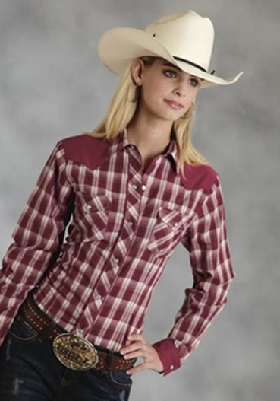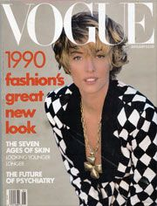
Cowboy’s shirt Printed blazer
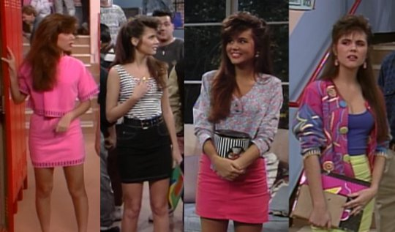
Neon skirts, neon jackets, floral blouse,striped tanktop,
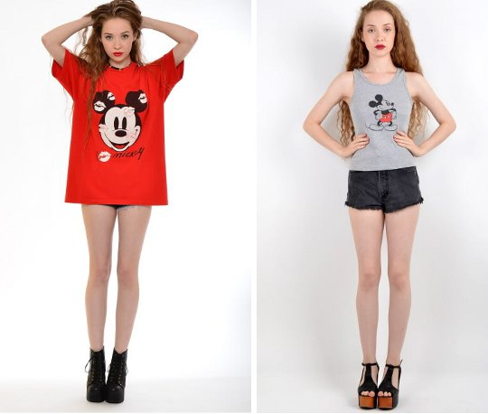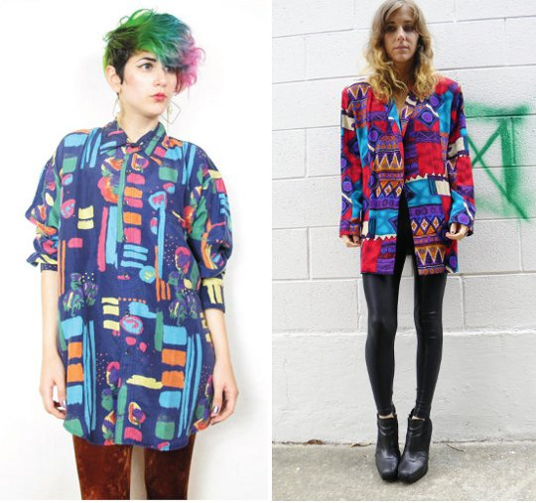
Mickey Mouse oversize/tank top Abstract colours shirts
2000’s fashion
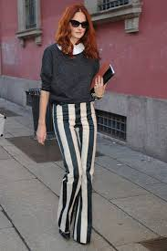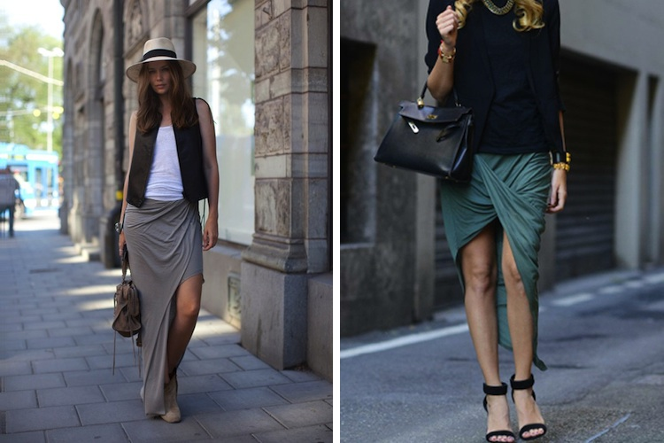
Vertical striped wide trouser asymmetric skirts
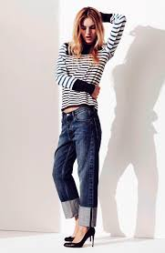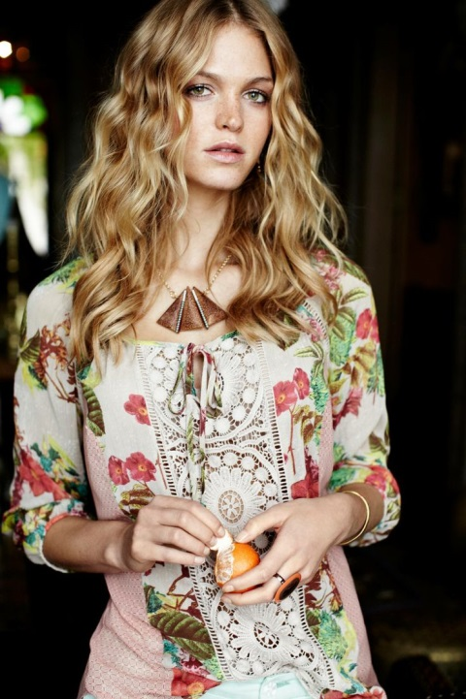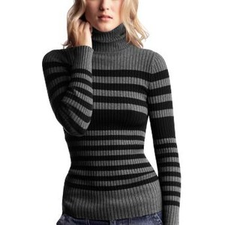
Cuffed jeans with high Peasant Blouse Turtle neck striped jumper
heels

2014’s fashion
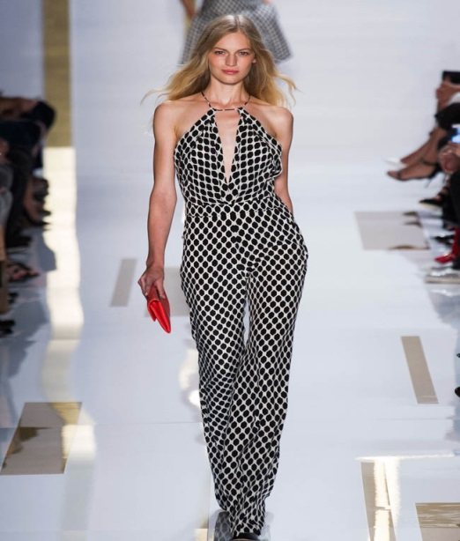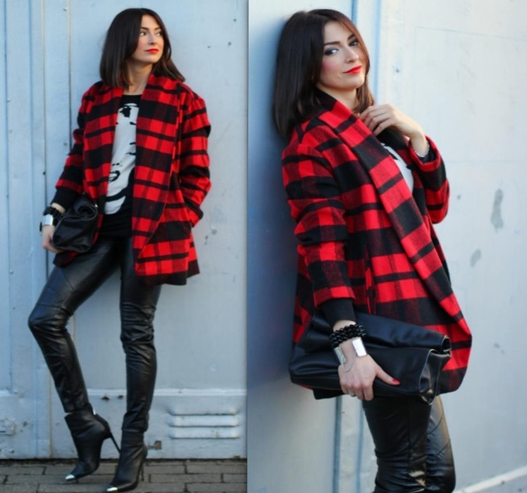
Jumpsuits leather leggings
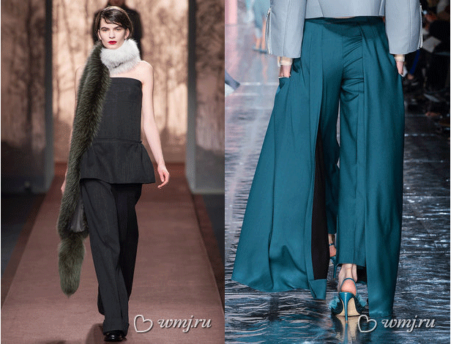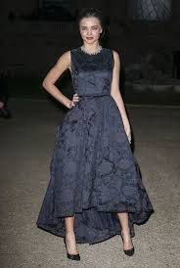
Wide trousers tail frock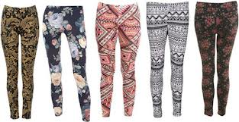
Leggings in all different prints
Fashion years | Fashion trends | Discussion
1990 | Cowboy’s shirt Printed blazer, Neon skirts, neon jackets, floral blouse, striped tank top, Mickey Mouse oversize/tank top, Abstract colours shirts | Fashion in the 90s was very colourful. Abstract prints were used a lot. In 2000 fabric were plain and darker in colours. Current fashion almost everything is worn from previous decades.  From retro to vintage.  Leggings and jumpsuits, wide trousers are a hit. Neon colours are back in fashion like the 90s.
2000 | Vertical striped, wide trousers, asymmetric skirts, Cuffed jeans with high heels, Peasant Blouse, Turtle neck striped jumper.
2014 | Jumpsuits, leather leggings, wide trousers, tail frocks, printed leggings.

References:
www.google.com
wwww.wikipedia.com
www.ralphlauren.co.uk
The World of fashion (Third edition)

