
Assignment Cover Sheet

Student Name: | Arun Christy Fernando
Student Number: | 1306
Course: | Diploma in Logistics & Supply Chain Management
Assignment NO: | 10

Q.1. Give short answers for the following questions:

- What are the aims and functions of warehouses?

The basic aim of a warehouse is to provide space for materials, components, finished goods and work in process goods which are required in the process of manufacturing goods or to satisfy the needs of end consumers.

There are several other aims a warehouse can have and they are;

- Providing security to the goods to avoid damages, theft.
- Providing suitable conditioned storage to avoid exposure to direct sunlight and spoilage.
- To store inventory in order to satisfy customer demands in a timely manner.
- Controlling the flow and movement of materials in and out the production area.
- Carry logistic activities in an efficient manner with lower cost.
- Sorting inbound materials and goods and transferring to storage area
- Control human errors.
- Allowing rotation of stock and avoid aging stock and minimize obsolete stock.
- Giving a safe working environment for warehouse employees.

Functions of a warehouse are;

- Receiving of materials and merchandise from suppliers, sellers, manufacturers, wholesalers, etc.
- Prepackaging- packaging bulk quantities into merchandisable quantities
- Putaway- placing the goods in storage
- Storage- storing the goods until it is required for production or required by a customer.
- Picking- removing the required items from a shelf in order to complete a customer’s order
- Packaging and labeling- Packing the goods to secure the goods to avoid damage and identify the goods externally from the labels.
- Shipping- loading of goods to the customer.

- What is the difference between public and private warehouses?

Private warehouses are warehouses owned and operated by a supply chain as one of the core logistic activity of the company. Private warehouses have higher fixed costs while maintaining lower unit operating costs. For example- DHL have their own warehouses and they operate their warehouse on their own. They invest on the land and infrastructure and warehouse management systems. Their operations cost can be minimized through efficient warehouse management techniques.

Public warehouses are run by governing authorities where the public can store their goods by paying a rental fees. Public warehouses have lower fixed costs and higher operational costs. For example- A small scale company which does not own a warehouse has to store its goods in a public warehouse does not have to invest on the buildings, management systems, etc. But have to face higher operational costs.

- Explain the advantages of public warehouses.

There are several advantages of public warehouses and they are;

- They have highly skilled and experienced workforce that a company has not to operate the warehouse.
- A company does not have to invest on capital expenses such as building, infrastructure and warehouse management systems which are costly.
- A company does not have to pay taxes, regulatory charges, etc.
- Public warehouses are accessible in many locations and the service is flexible and reliable.
- Learning about new technology and innovations what a company cannot have on its own.
- Lesser fixed warehouse costs by using a public warehouse.

- What are the manual warehouses?

Manual warehouses are warehouses where materials are stored in a manner it is very easily accessible. Items are stored in shelves and bins from where it can be picked with less physical movement. In manual warehouses items are stored very close to and avoid much muscle work. For example- a supermarket store where goods are available on shelf and it can be picked with less physical movement.

- What are the automated warehouses?

Automated warehouses are built with high technology and modern infrastructure to improve warehouse productivity and eliminate human errors. These warehouses are built with storage areas accessible by mechanical equipment. These warehouse uses automated guided vehicles for material handling activities. Automated guided vehicles operate without an operator and by pre- installed computer software and guide path. Automated warehouses are installed with high technology warehouse management systems to eliminate human errors and it aims for a paperless environment. Automated warehouses have automated storage and retrieval systems.

- What are the main materials used for packaging?

There are five main materials used in packaging. They are;

- Cardboard- is well known for its wide spread usage in different industries. It is cheap and recyclable. It is cheap and light weight. It is widely used to pack anything due to its flexibility.

- Plastic- is mostly used in different industries and along with cardboard. It is light weight and very expensive. It is very hard to recycle as it is hard to deteriorate.

- Wood-s is widely used and is heavier than cardboard and plastic. It is reusable. It comes in the shape of pallets, crates and boxes. Heavy machineries are packed using wooden crates.

- Glass- is a fragile packaging material. It is mostly used to exhibit the material inside. It is expensive and reusable. It is very hard to handle due to its fragile characteristics.
- Metal- is the heaviest packaging material. It is expensive and to be handled with more caution.

Q.2. Outline the activities that take place in a warehouse.

There are several activities take place in a warehouse and some of them are common in the business. They are the basic activities to take place in a warehouse operation.

Receiving and unloading- This is the primary activity that takes place in a warehouse. A warehouse is an area which supports all the other logistics activities and primarily store materials, components, finished goods, semi- finished goods required by a company to make its product or to satisfy a customer’s need. Receiving is an activity through what the materials or goods come inside the warehouse. Warehouses have receiving dock through materials and goods arrive inside the warehouse by trucks, containers, etc. This is a very critical activity. There should be proper inspection of the goods being received against delivery notes, invoices and purchase orders. Any discrepancy in the quantity or quality should be informed to the warehouse in-charge. Large scale companies employ receiving clerks for this job and some companies and quality department involves in this activity to inspect the condition of the goods received and approves or rejects the materials depends on its condition.

Pre-packaging- This is performed when goods are received in bulk quantity which required de-packaging and convert into smaller merchandisable quantities. Some companies sort the bulk into smaller quantities and add promotions to increase sales. For example bath soap received in bulk is de-packaged and a tooth brush is added and packed with the bath soap as a sales promotion activity.

Cross docking- Cross docking is a shipment received in a warehouse is directly loaded into outbound trucks to be delivered to the customers. This step avoids extra handling such as put away, storage and picking. This requires lesser handling of material and minimize handling damages.

Putaway- This is the action of placing the received goods in warehouse storage. This activity involves material handling and storing the product in the selected bin, shelf or rack.

Storage- This is the core activity among warehouse activities. Storage activity takes places until the product is moved out from its location to satisfy a customer’s need. There are several storage methods depends on the characteristics of the goods and quantity. In modern days, goods are palletized on wooden pallets and use racking systems to store the goods. Some companies spend on high tech systems such as automated storage and retrieval system which is costly and require high technological computer systems.

Picking- This is the action to select or choose a product from its storage to complete a customer’s orders. There are several new methods used to pick a product such as RFID which uses barcodes to pick the product. A preprinted barcode sticker on the product which sends all the required information to the system to complete the order picking. There are also latest such as voice picking which uses human voice to pick the product and complete the order entry and invoicing.

Packaging- This is an action to purposefully done to identify the product and to give protection to the products required by a customer.

Shipping and loading- This is the final stage of disposition of a customer’s order. Once the order is picked and packed it is shipped using trucks. There are loading bays or docks where trucks are available to ship the goods. Warehouse use manual hand pallets, forklift trucks and conveyors to ship the item out of the warehouse to the destination. Shipping involves checking and inspecting the goods, preparation of shipping documents, bills, delivery notes, invoices, etc.

Q.3. Describe in details the general layout of a warehouse. Using examples and illustrations.

The general layout of a warehouse includes a receiving area, storage area, dispatching area and systems and controls.

We will look into it elaborately. Every warehouse has an entry point for its goods coming inside which is called in many names such arrival bay, receiving bay, receiving area, unloading area, etc. Secondly there is a storage area where goods can be stored until it is picked to complete a customer’s order. Finally there is an exit point for the goods to go out which can be called as departure bay, loading bay, dispatch area, loading are, etc.

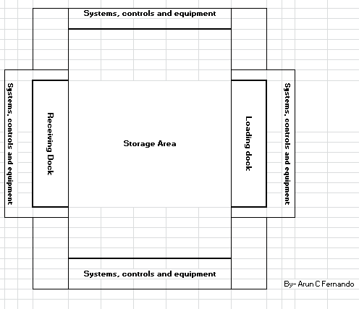

The above figure shows a general layout of a warehouse.
The below figure shows an elaborated layout (plan view) of a warehouse.

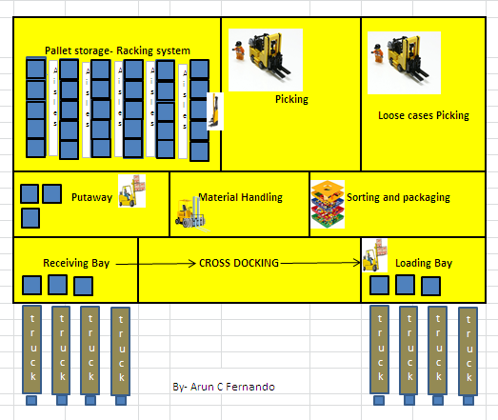

The above figure which shows the layout of a warehouse reflecting all the activities take place in a warehouse from receiving to shipping. Trucks with shipments are received in the receiving bay and materials are unloaded and putaway for storing in racking type storages. There are aisles in between the bays where VNAs can move to retrieve the pallets. VNAs are used in racking systems called selective racking systems where assorted type of product is stored. Forklifts can be used in drive in and drive through racking systems.

Materials are handled using different handling equipment such as forklift trucks, hand pallet trucks, reach trucks and VNAs.

Warehouseman does the order picking and the materials are ready for packing and inspection and labeling etc. There are times loose cases are picked for shipment as shown in the figure above. Goods are packed and labeled and billing is done using warehouse management systems which connect the picking device to the inventory and record the information flow in the system.

Finally goods are loaded using loading bays and trucks are dispatched to the customers.

Student Statement:

By submitting this assignment, I confirm that this is my own work.

Student Signature | Arun Christy Fernando | Date | 10-July-2015

For Tutor / Assessor Use Only
Total Marks
Marks Obtained
Percentage / Grade

