
Assignment Cover Sheet

Student Name: | Raymond Harrison
Student Number: | 1582
Course: | Diploma in project management level 4
Assignment NO: | 3

Marking Criteria:
We expect the learners to write minimum one well expressed point in three lines against each allocated mark. This means one needs to write 15 lines with 5 well expressed points to get high grades for a 5 marks question.
For high grades use examples and illustrations where appropriate.
Please insert your completed assignment ( in word format) here:

1. Give brief answers for the following questions:
- Where is project plan used? Which type of information does it contain?
A Project plan is used to guide project execution and control.
A good project plan should contain the following information;
- An overview of the reasons for your project
- A detailed description of intended results
- A list of constraints the project must address
- A list of assumptions related to the project
- A list of all required work (WBS)
- A breakdown of the roles you and your team members will play
- A detailed project schedule
- Needs for personnel, fund, non-person resources (such as equipment, facilities, and information
- A description of how you plan to manage and significant risks and uncertainties
- Plans for project communications
- Plans for ensuring project quality
- Briefly describe the type of information that is contained in a stakeholder analysis document?
A list of the stake holders with the following information;
- There contact details
- There organization
- The role on the project
- There level of interest in the project
- There level of influence on the project
- Any unique facts about them
- Suggestions of managing a relationship with them

- Outline the main objectives of integrated change control process.
- To manage each request for change, in order to keep the scope of the project under control with full traceability
- To allow the impact of all changed to be understood, documented and managed
- To make sure each change request is assessed by key project stakeholders
- To make sure each assessed change request is accepted, rejected, or deferred by the appropriate authority
- To enable the orderly implementation of each accepted change

- What are the major tools and techniques that help managing integrated change control process?
Expert Judgment – Stakeholders with expertise may be asked to sit on the change control board (CCB)
Meetings – Meetings of the change control board are referred to as change control meetings
Change Control Tools – Manual or automated tools may be used for change or configuration management

- Briefly describe the outputs of integrated change control process.
Approved Change Requests – Only those change requests which are approved by the appropriate authority (such as the CCB) are put into action
Change Log – All Change requests, whether approved or rejected, get recorded in the change log
Project Management Plan Updates - The project management plans scope, budget or anything else effected by the changes are updated
Project Document Updates – All documents that are considered part of the formal change control process are updated

- What is ‘work break down structure (WBS)?
A work breakdown structure breaks down the project into individual parts. each of these parts essentially become mini projects in themselves.
It makes the project seem more manageable and can be used to give different members of the project team responsibility for different parts of the project.
The Project Management Body of Knowledge (PMBOK) defines the work break down structure as a “deliverable oriented hierarchical decomposition of the work to be executed by the project team”

- What are the out puts of project plan development?
- A comprehensive description of the project strategy and methodology – how the project will be implemented
- Cost estimate
- Performance benchmarks
- Key staff required for successful implementation
- A clear and precise statement of scope
- A preliminary work breakdown schedule
- A schedule of events including milestones
- Assignment of responsibilities
- A comprehensive risk assessment and statement
- Scope change processes
- Communication protocol
- Stated limitations and “off limit” issues
- A list of open decisions and pending decisions
- Monitoring process
- Applicable standards and specifications of outputs

- “Project integration management means tying together all of the other aspects involved in a project to make it a success.” Discuss
Project integration management is a collection of processes that are required to ensure all the project components are coordinated correctly in order to achieve the project goals.
It involves making trade-offs among competing objectives and alternatives to meet or exceed stakeholder needs or expectations.
Project integration management is comprised of:
Project Plan Development – integrating and coordinating all project plans to create a consistent, coherent document
Project Plan Execution – carrying out the project plan, according to the strategy, plan and activities as per the plan
Integrated Change Control – coordinating changes across the project

- Describe the processes involved in project integration management.
There are seven process, these are:

Develop Project Charter – The Project charter initiates the project. The derived project charter approves and sanctions the project and gives the project manager the authority to act and apply organizational resources to the project.

Develop Preliminary Project Scope Statement – The preliminary project scope statement is an initial, high-level definition of the project scope. This document defines the project’s product or service, methods of approval, and tactical strategies for the change control process.

Develop the Project Management Plan – Developing the Project Management Plan includes all activities needed to create and integrate all subsidiary plans into the Project Management Plan. This plan will be how the project is executed, managed, and monitored.

Direct and Manage Project Execution - Directing and Managing Project execution is orchestrating how the project team performs the actions to implement the Project Management Plan and complete the work detailed in the Project Scope Statement.

Monitor and Control Project Work – Monitoring and Controlling Project work measures and balance the projects progress and any corrective or preventative actions needed to assure all project objectives are met.

Integrated Change Control – Integrated Change Control is the change control process for the project which includes evaluating all change requests, authorizing changes, and managing changes to project plans and deliverables. The key benefit to this process is that only validated approved changes are implemented.

Close Project – Closing the project equates to completing all project activities, delivering the final project, turning over continual support to operations, and obtaining the client approval to formally close the project.

Activity
Identify a project that you would like to carry out in your particular field. It could be either a consultation project or a change project.
Factors to consider in selecting an appropriate project:
- What problems and opportunities are you facing at work?
- What processes in your work area are creating barriers or impeding the quality of the services or products you and your department provide to others?
- What aspects of your work are you particularly interested in?
Scenario:
I work in an electrical contracting company and we have been given the opportunity to take on 3 different project. The problem is that we are very busy and our funds and man power are already stretched at the moment on servicing contracts and project that are already under way. We are going to have to identify one particular project out of the 3 that we would like to carry out and turn down the other 2.
The Projects:
- Project A – A mechanical services project involving a lot of electrical controls for Heating, Ventilation and Air Conditioning in an office building. All materials are free issue by the client.
- Project B – A new build house. It’s a large house but the owners have spent most of there budget on the fact that the house is so large so they wish to install the cheapest lights and fittings possible which they plan on upgrading in a few years time once they have saved some more money
- Project C – Another new build house. Again it’s a large house but this time the owners are very wealthy and have opted for the most expensive lights and fittings

Identifying the project we would like to carry out:
To identify which project we would like to carry out we have to identify a pro’s and cons list for each project, decide which project carry’s the most risk and which project is most likely to succeed, as well as taking into account which project will make the company the most money.

Project | Pros | Cons
A | This would be an interesting project for some of our staff on the job – however this doesn’t benefit the company financially | Staff on the job have to specialize in electrical controls which means we need expert electricians or mistakes could be made costing extra time and money.  Because we need expert electricians we cant utilize apprentices on the job which means we will be paying more for fully qualified staff.  Materials are free issue so we wont make any money on a materials mark up
B | Houses are relatively easy so we can utilize apprentices to do a portion of the work which saves money and frees our more experienced staff for other projects.  Houses are usually finished and signed of within 14 weeks which means we will get our full pay out for the project quickly and not have to wait | The owners are strapped for cash so if there are any variations on the project that incur additional charges the owners may be difficult to claim money from or pay late  They have used the cheapest fittings so our 10% mark up isn’t going to make us a great deal of money
C | Houses are relatively easy so we can utilize apprentices to do a portion of the work which saves money and frees our more experienced staff for other projects.  Houses are usually finished and signed of within 14 weeks which means we will get our full pay out for the project quickly and not have to wait  The owners want the most expensive fittings meaning out 10% mark up on materials will be very profitable | The fittings and lights are all very expensive so if something was to get damaged whilst installing it we would have to replace it at our own cost which could end up being very expensive.

We can now take all this information and plot the projects on a priority quadrant to visually aid us in deciding which project would be best to choose. After looking at all our pros and cons our priorty quadrant would look like this
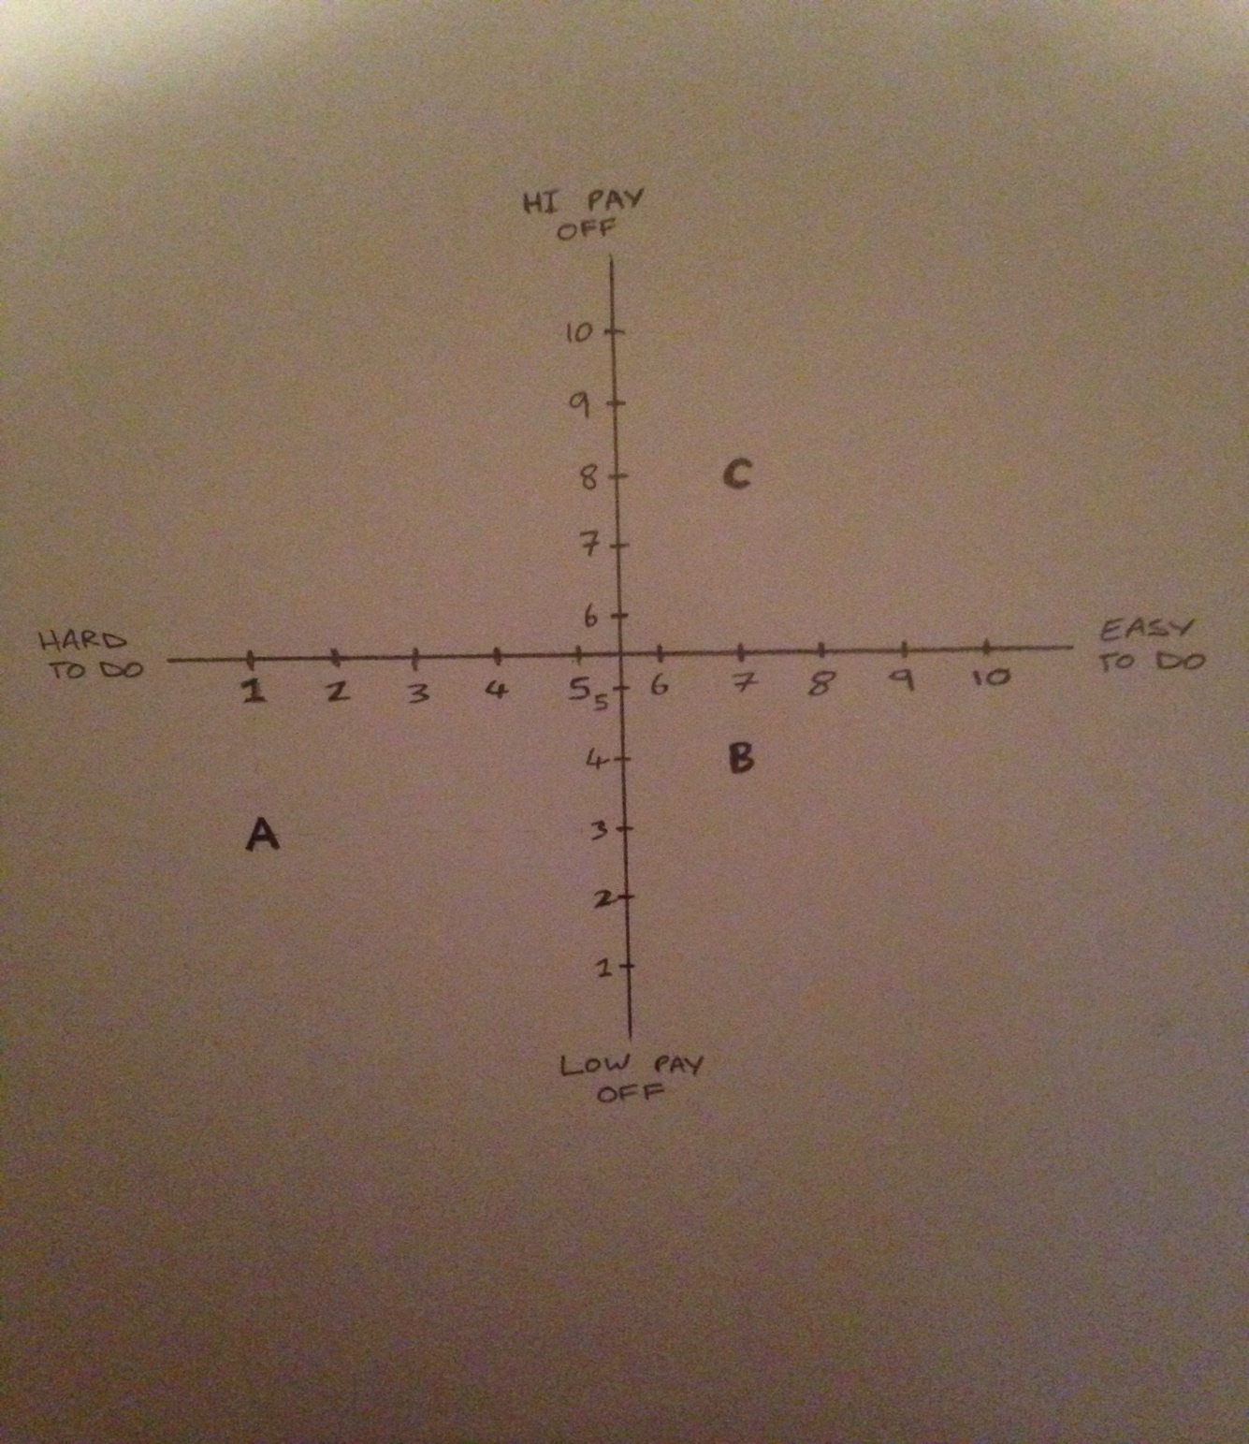

We can clearly identify from looking at our priority quadrant and our pros and cons list that Project C is the best project for us to choose and we should turn down projects A and B.

Our only downfall with project C is if something gets damaged it could potentially cost us quite a lot of money to replace however we are confident that our project manager has good risk management skills and good control measures to see the project through to completion without any problems.

Student Statement:

By submitting this assignment, I confirm that this is my own work.

Student Signature | Raymond Harrison | Date | 12/11/15

For Tutor / Assessor Use Only
Total Marks
Marks Obtained
Percentage / Grade

