
Assignment Cover Sheet

Student Name: | Justyna Singh
Student Number: | 1690
Course: | Fashion Design
Assignment NO: | #1

Marking Criteria:
We expect the learners to write minimum one well expressed point in three lines against each allocated mark. This means one needs to write 15 lines with 5 well expressed points to get high grades for a 5 marks question.
For high grades use examples and illustrations where appropriate.
1. i. How did the First World War influence fashion? Which types of changes were brought about by it?
Before the First World War women were still wearing long dresses, they’ve been not allowed to smoke in public or go out alone, as the belief was that women’s place is at home.
The WWI made a large impact on women. They had to start working as all the men were at war fighting. Women to gain money had to wear uniforms and more practical and economical clothing which will be comfortable for every day house duties or for work.
First of all the length of the skirt had shortened till calf length – approximately 8 inches above the ground. Next women removed tide corsets and started wearing more loose clothes. Shoulders sloped and collars widened. Also as there was a shortage of fabric women had to improvise and make clothes from what was available on that time.
Men’s fashion didn’t change radically as women’s.
1. ii. Describe the characteristic features of the Twentieth Century’s fashion scheme.
First of the changes were influenced but the First and Second World Wars, where the clothing became more simple but still feminine. During the WWI skirts were moderately wide; around 8 inches above the ground and women did wear hip-length jackets.
In twenties the length of the skirt even shortened. Women started wearing skirts hardly covering knee. Fashion was influenced by discovery of the grave of Tutankhamen. Dresses were decorated by Egyptian ornaments. If women could not afford it they just wear loose-hanging dresses. The waist was dropped, and men’s collar was very popular for the dresses. Also for this period of time long chains of pearls were very characteristic.
In this period Chanel created “Little Black Dress” – evening dress in black colour.
Men’s suit was moderate also – trousers widened and jacket had a slightly tapered waist.
In thirties waist level came back to the natural place. There were introduced shoulder pads and wide lapels and belts. All of these tricks were used to create the view of slimmer waist. For the evening women were wearing long gowns with small “mermaid” train. Women clothing were influenced by ‘bias cut’ discovered by Madeleine Vionnet.
For men this time was very innovative. There were introduced patterned shirts with grey fennel suits, wider cravattes and double-breasted suits with four buttons instead of six.
In forties fashion was pushed again into practical and simple clothes due to shortage of fabrics. Skirts and coats became shorter, suits had uniform’s character. Hats and shoes usually were handmade and silk was replaced by wool. By the end of forties pencil skirt was introduced by Dior.
Men’s clothing was mostly dominated by uniforms.
In fifties dominated narrow line with strong body –consciousness and also strong notice drawn to the hip line by a gathered waistband and petticoat. This period was full of new synthetic materials like nylon, perlon, elastic and imitation of leather material.
For teenager there were introduced jeans, capri pants, and ballerina shoes.
Men’s fashion was conservative – pure white shirts. Here very popular for leisure became Hawaiian shirt. In England popular was to wear very narrow pants and frock-coat like jackets.
In sixties the teenage style favoured wide-swinging petticoats while mature women preferred to wear narrow sheath dresses and cocktail dresses for the evening. In this time mini skirt was introduced to fashion. Also “no bra” brassiere was invented. There were introduced to fashion strong colours like pink or orange, and pop-art images on clothing. Popular were jeans and mini-skirt trousers in many lengths.
In seventies the fashion belonged to hippies. Many items were handmade, popular knitted shawls, flowers and other colourful patterns stitched or sewed on trousers. Fashion had to be very easy but original and individual and sizes did vary from mini to maxi according to the mood.
In eighties was created by over-sized large sleeves and wide padded shoulders. The evening wear was also defined by low cut necklines and narrow waists. Mini-dresses were worn by teenagers. The skirt length extended from mini size to the calf-length. Fashion was a sign of prestige and symbol of status. Gold coloured accessories were popular.
In nineties the styles extremely varied. For every day fashion leggings with large variety of patterns and colours became popular. They were worn under skirts. At the end of the eighties popular became the look of inside out. Also popular became the sports look and the trademarks like Diesel, Burton, Nike, Adidas or Levis. Fir male part of young adults or teenagers the popular look was created by wearing oversized shirts and baggy pants.
2. Write brief note on the works of main fashion designers in the 1970s.
In the seventies there were many fashion designers who influenced the fashion across the globe.
In 1974 Diane Von Furstenberg introduces “The Wrap Dress” – the dress which will suit every woman’s body size. It was known as symbol of “female power”.
Vivienne Westwood connected music with fashion – her trademarks are bondage trousers and platform shoes and punk.
Yves St Laurent was famous for creating trousers which could be worn to work and dress. He introduced trouser suit like safari suit.
Roy Halston Frowick was famous for creation of draped jersey dresses, also lean trousers suits and the use of ulta-suede fabric.
Next one is Missoni who is known for knitwear and their bold, bright space dyed wave patterns. The most popular was the zig zag pattern.
Thea Porter was famous for creating caftans, maxi dresses which were stylish and accessible.
Bob Gibbs was popular for the “hippie” style where he was widely using colour and pattern and design.
Claude Montana in 1978 brought the military and punk look into the world.
3. How did the Nineteenth Century influence the fashion industry? What major changes came about in fashion industry in the early Nineteenth Century and why?

Clothes of nineteen century changed a lot. This was influenced by introducing sewing machines, power looms, steam power, machines for constructing the clothes and electricity. During the nineteenth century clothes were made on measure by tailor. As there was so many new inventions which pushed bulk production it started to be more popular to wear ready-to-wear clothes by men, but also for women.

The mass production of clothes became more popular in the middle of nineteenth century. Some of producers began creating clothes which did not require fitting, and been standardised.

Especially in America, where migration was large, manufacturers took advantage of it, creating manufacturing factories, where they could hire seeking jobs migrants.

4. ACTIVITY
Clothes in 90’s
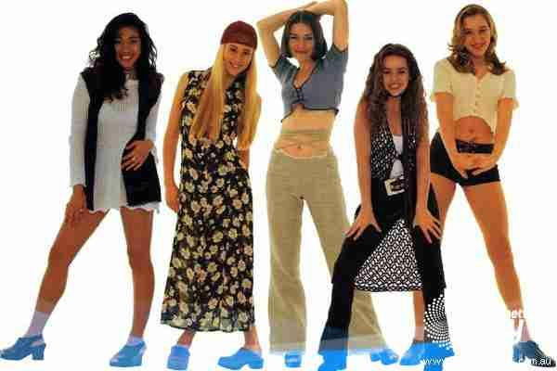

Clothes in 2002
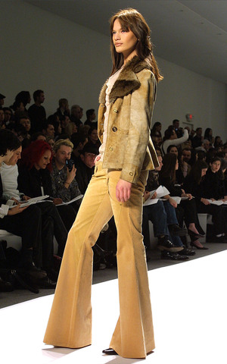
Clothes in 2005

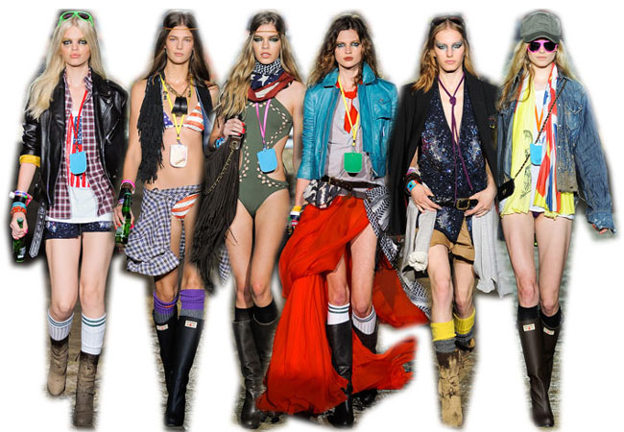
2008
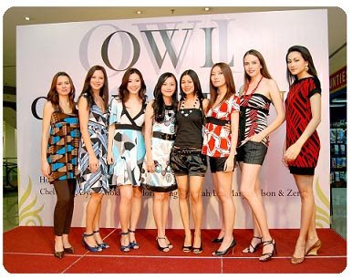
2015
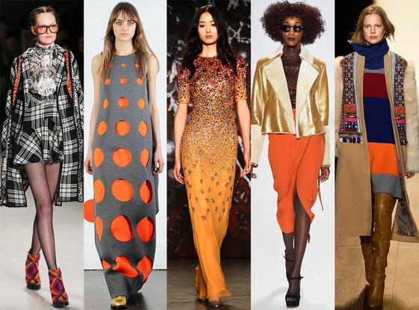
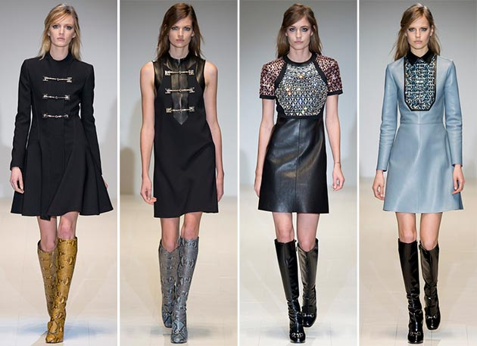
2016
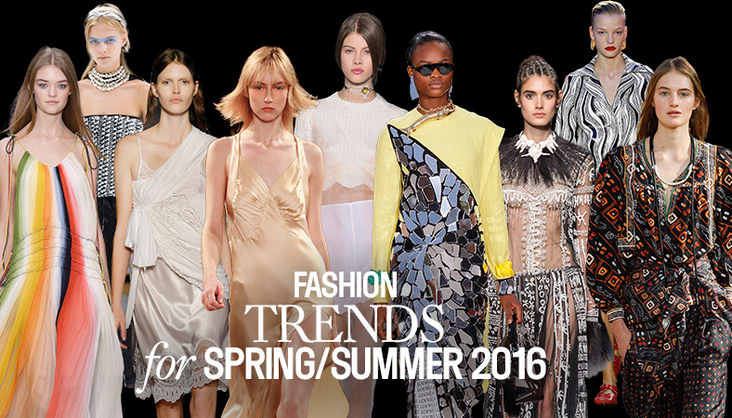
Trends in the fashion are change all the time. In ’90 very popular style was to wear short tops which will show belly, very wide blouses with printouts. The most popular were those with printed music bands. Jackets were having little cushions to widen the shoulders. Also popular were leggings with many different printouts and colours, also animal prints on clothes and handbags or earrings. Very popular was to wear jeans and blouses in grunge style, it means with partially ripped holes and cuts. Shoes were with large platforms.

In the beginning of 21st century it can be seen that the clothes became rather freely chosen, sometimes very radical. Very popular was to connect two or more different style together, for example Emo style (fashion from eighties) with punk. For people it was important rather to be seen, therefore they try to outstand from fashion by wearing something different, more colourful or with different shapes.

Currently fashion goes further. People want to be seen and look different. But they want to wear stylish clothes and simple, Currently comes back the trend of oversized clothes mixed with simplicity but still feminine.

Student Statement:

By submitting this assignment, I confirm that this is my own work.

Student Signature |  | Date

For Tutor / Assessor Use Only
Total Marks
Marks Obtained
Percentage / Grade

