
Assignment Cover Sheet

Student Name: | Omnia Rafiq
Student Number: | 1343
Course: | Diploma in interior Design
Assignment NO: | 10

Student Statement:

By submitting this assignment, I confirm that this is my own work.

Student Signature | Omnia Rafiq | Date | 9-4-2015

For Tutor / Assessor Use Only
Total Marks
Marks Obtained
Percentage / Grade

Q.1.i. Which element should be considered when deciding upon the floor for a room?
Deciding on the right floor for a particular room is not about the taste alone. We should consider the shape and size of the room, its architecture, furnishings, style, the amount and quality of natural light, and the room’s purpose. Once all these elements have been carefully weighed, you can consider the different materials that might work in the room. The first step in flooring process is to plan and determine a room’s overall use, appearance and personality.
Q.1.ii. What should be considered when choosing floor for a kitchen?
Kitchen floors need to be durable, easy to clean, so choose surfaces like, tiles, stones, varnished wood, or good quality vinyl.
Tiles Varnished wood
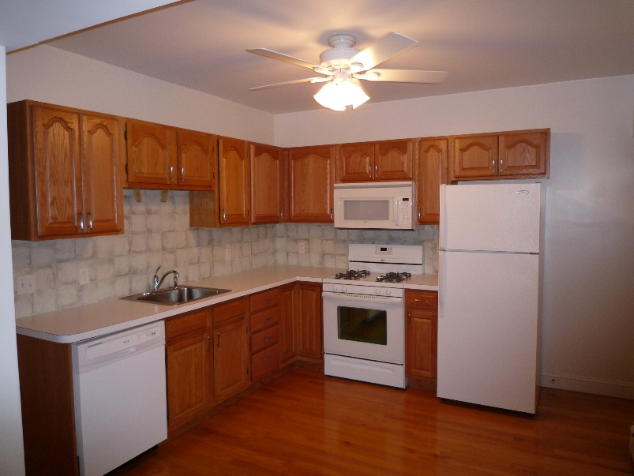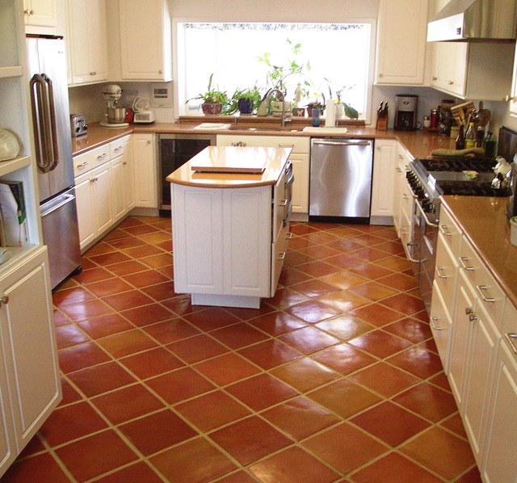
Stones Good quality vinyl
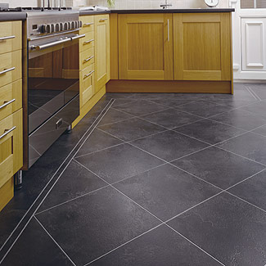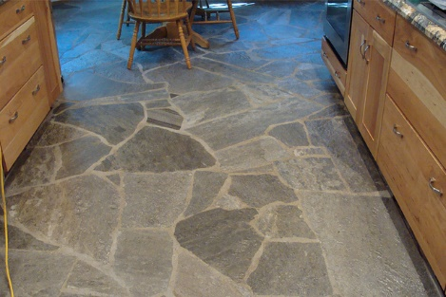
Q.1.iii. If a feeling of warmth is required in a room which type of flooring would you choose?
If something warm and soft is required, consider good quality vinyl or a natural floor bamboo or sea grass. For living room a wall to wall carpet is another option, since it’s luxurious, warm and quiet, but it may not be the most practical one.
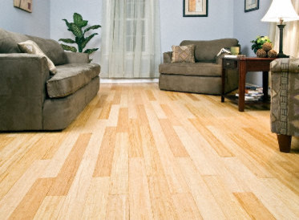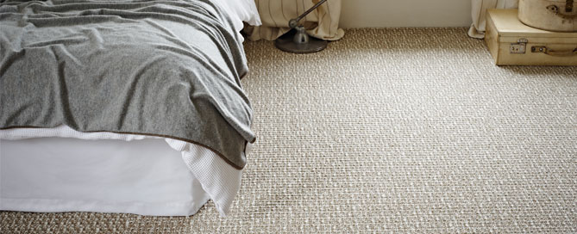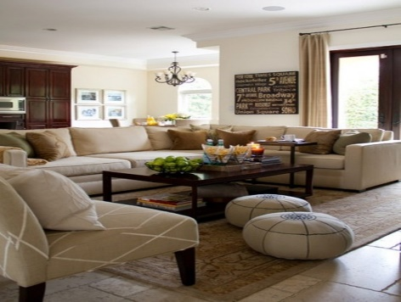

Q.1.iv. What does Terrazzo flooring consist of?
It consists of a marble chips set in a cement base and polished to high Sheen. Terrazzo is non-slip and durable. It is also laid on concrete subfloor.
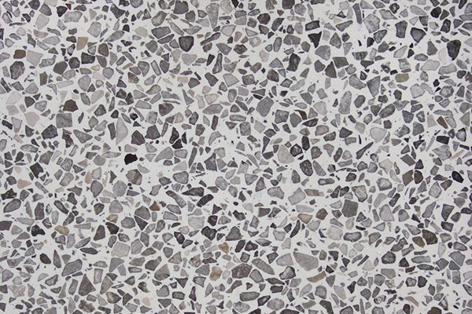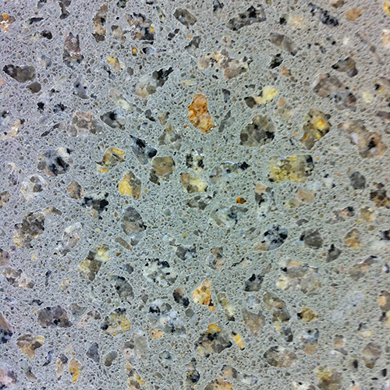

Q.1.v. What is meant by ‘cut pile carpet’? Which is it made of?
There are two main types of carpet - cut pile and loop pile.As the name suggest the fibers of the carpet are sheared off creating soft Tufts above the carpet backing. This type of carpet is usually made of Wool, nylon, polyester, acrylic or a combination of these materials. Cut pile carpet is a form of carpet pile that involves a strategic cut of the loops that are created during the weaving process. The loops are cut to the same height and allowed to tuft slightly. This approach gives the pile the appearance of softness and can be employed with various levels of thickness in the pile. As a result, the carpet often appears to be very dense and provides a cushion for the foot.
While cut pile carpet can be constructed using natural fibers, many carpets today are made with a blend of man-made fibers. It is not usual to find this type composed of a combination of polyester, olefin, and polyester fiber. Often, it is the ability of these blends to hold up well under a lot of traffic that make them ideal for carpeting both homes and offices.
There are essentially three different designs for a cut pile carpet, and each of them varies slightly in the twist to the individual yarns, along with the choice of fibers used for the finished piece. With proper care, all of them can to last for years before they begin to show their age.
How a carpet will wear depends on the various factors not just the
Material it is made of. Twist and density of the fiber are very important. Higher numbers are better on these scales. Very closely tufted or woven carpet means that it will wear more. Carpet tufts that are not dense will have the tendency to mash down over time.
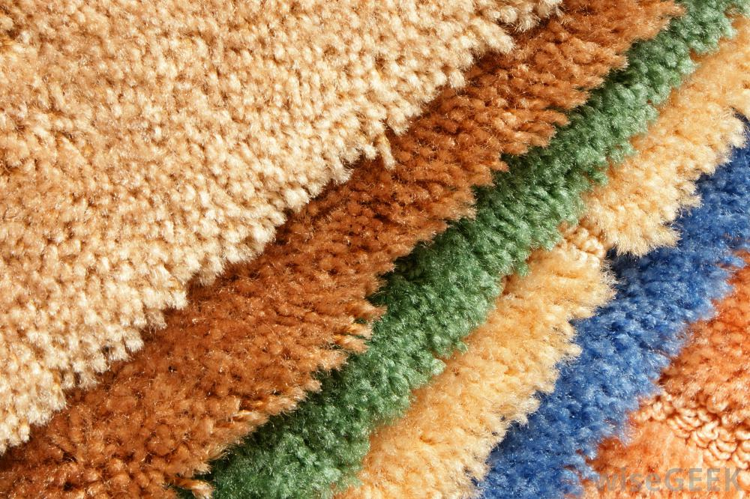

Q.1.vi.Which material is often used to make loop carpet?
Loop pile carpeting tends to be more resilient and hard wearing because of its construction. However it is not as soft to the touch as cut pile carpet Therefore it is not as comfortable underfoot as cut pile carpet.
Looped carpeting is often made of olefin fibers which are naturally stain Resistant. There is a degree of variation in style within the looped carpet category. The loops can either be uniform in length or sometimes varied to create interesting patterns.
In shopping for loop pile products, three distinct categories will be encountered: level loop, textured loop, and multi-level loop.
- Level Loop: Primarily found in commercial environments, some residential Berbers are now offered in this style. This type consists of loops constructed at the same height. While patterns may be printed on the surface of this style type or may be tufted into pile, this type offers a relatively smooth, homogenous surface. Lower density construction may allow the loops to be dispersed farther apart providing the illusion of texture, but this style offers no apparent texture.
- Textured Loop: Textured products offer slightly different variations in loop height creating a texture or pattern. Fiber color variations may increase or complement the visibility of the pattern. Loops may vary in size to increase the visibility of texture. Textured loops represent a sizeable portion of residential loop pile products. Textured products offer slightly different variations in loop height creating a texture or pattern. Fiber color variations may increase or complement the visibility of the pattern. Loops may vary in size to increase the visibility of texture. Textured loops represent a sizeable portion of residential loop pile products and can provide beautiful carpet installations
- Multilevel Loop: Similar to the textured loop, except that height variations are far more dramatic providing deep, easily visible patterns with or without color enhancements.

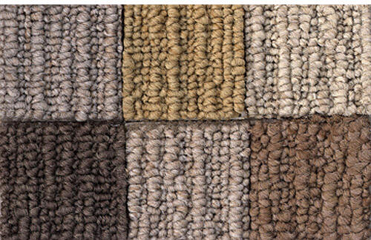

Q.1.vii. Describe main characteristics of Persian rugs?
These are considered the finest of all oriental rugs. Most of the oriental rugs generally are made from 5 basic materials. Wool, cotton, silk, jute and animal hair. There are also some kind of variations of these materials. Wool woven onto cotton is most often used in a rug, especially in stores you can find easily. Persian rugs are generally woven in wool, using special sinner Knot.
Persian rugs are almost always rectangular or elongated rather than Square. Their coloring is usually rich. Indigo or crimson is usually the main Color. Other colors usually include yellows, greens and brown. The Persians were the only Muslim people to represent the men and
Animals (in hunting carpets).The designs are usually based on floral motifs, showing flower beds,
Pools and streams.
Vase rugs are more formal motifs i.e. vases holding flowers.
Persian rugs made before the eighteenth century can be classified according to their design: garden, vase, animal etc.
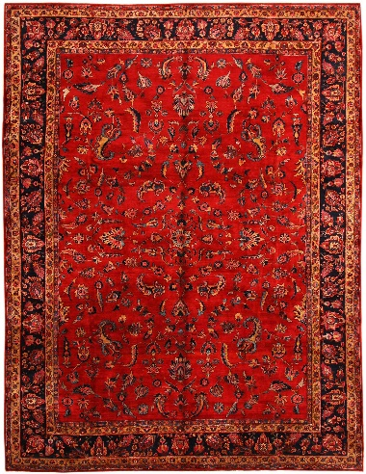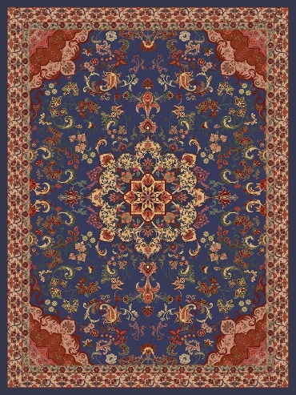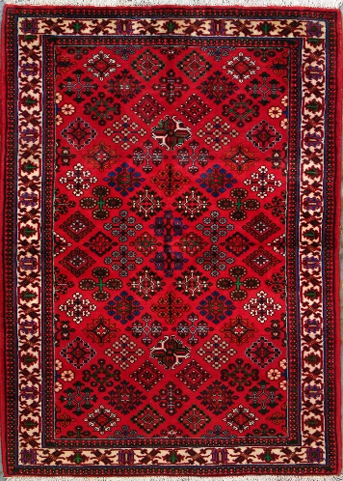

Q.1.viii.What is linoleum flooring made of and how is it laid?
Linoleum is a material that is comprised largely of linseed oil (a naturally occurring substance that is extracted from flax seed). This is mixed with other natural and renewable materials such as cork dust, wood flour, pine resins, and pigment Pressed onto a jute backing. It comes in sheets and tiles. It is non-slip, Reasonably priced and burn resistant. These come in a wide variety of Colors, the material can be inlaid to make handsome designs. Linoleum is glued to a spotless, level surface preferably plywood. The floor is easy To clean.Very similar to the installation of vinyl
Linoleum is susceptible to moisture damage, and has to be treated with a surface sealer after installation. When installing tile it is also important to ensure that the seams between tiles are as thin as possible, and are properly protected against water penetration.
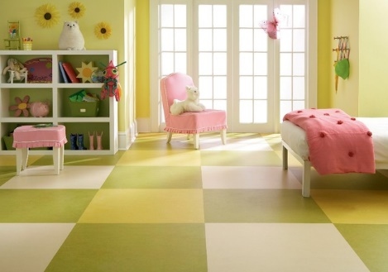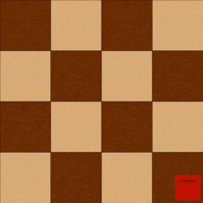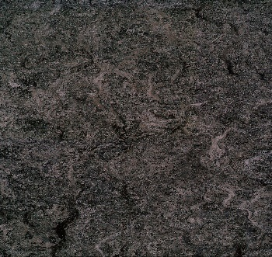

Case Study

Linda’s house is in bad need of re-decoration. The flooring is also damaged at some areas of
The house. Few tiles are cracked on hallways flooring. Living room has parquet flooring and
Linda wants to retain it as her budget does not allow her to replace the flooring altogether.
If you are assigned the project.

- What would you suggest for the living room flooring?
If parquet floor is in reasonably good condition- without any gaps, splits, frayed, or splintered ends; this can just be polished and Can then be covered with either rugs or left bare. If a floor is worn, the First task is sanding it. It can then be either stained a different color – say, much darker, or maybe even a dark green or bronze- or bleached, or Whitened. An alternative is to paint it with either floor paint or with
Acrylic, emulsion paint. Another option can be a plain floor with a Stenciled border or design. Whichever treatment is chosen – plain, stained, bleached or painted- the
Floor will need to be sealed with two or three coats of protective varnish Afterwards.
Polished Parquet floor Parquet sanding Parquet Painting
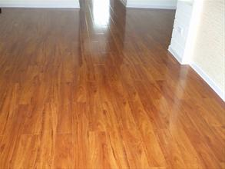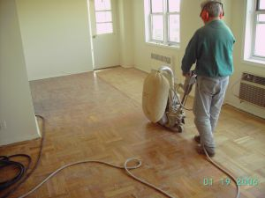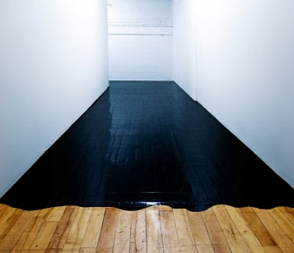

- Do you think that the hall way floor should be repaid altogether or there is any other cheaper alternative available?
Existing tiled floor with cracked or unsightly grout can be cleaned and re-laid With new grout. While damaged tile replacement is always the option for the professionals broken tiles, But this isn’t necessary with a hairline crack, for which epoxy filling provides an effective way to seal and hide the crack. Patching hairline cracks is preferable to replacement because attempting to remove a tile can result in damage to the adjacent tiles.
For cracked grout
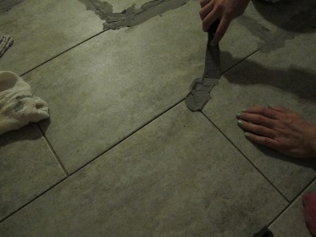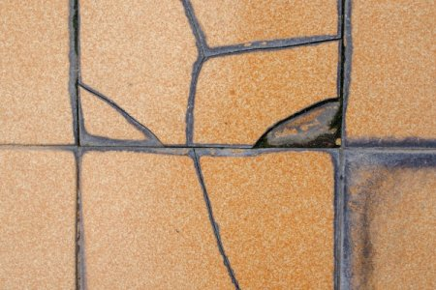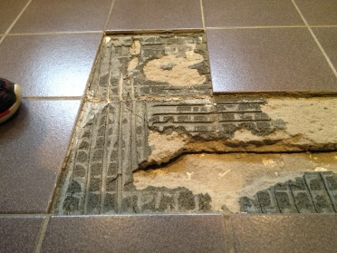
Crack filling
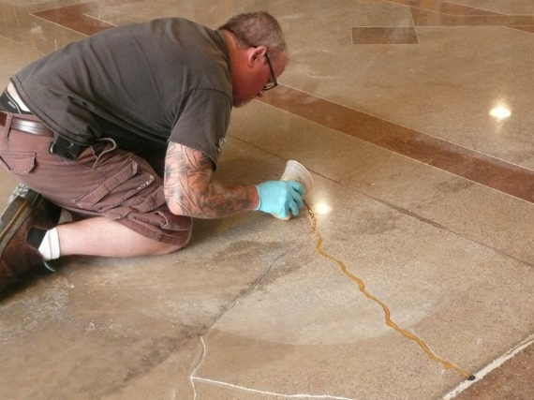
For tile replacement
