
Assignment Cover Sheet

Student Name: | Sukhwinder kaur
Student Number: | 1282
Course: | Fashion design
Assignment NO: | 9

Answer 1.
- The engraved roller printing in this technique, a separate roller engraving is used for each colour in the pattern. The design is rolled onto the fabric as it passes through the printing machine.
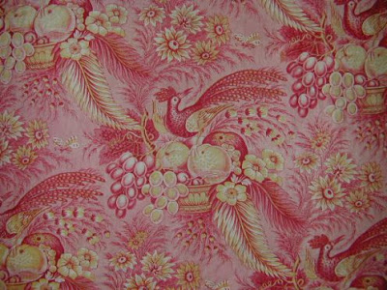
- The screen printing flat-bed screen printing this technique uses a screen spread over a frame. The portions of the design to be printed are made of porous nylon that allows the colour to pass through the screen. The areas that are not to be printed are covered or coated with enamel. Colour is poured in to the frame shell and is forced through the nylon by means of a squeegee worked back and forth. Flat-bed screen printing is versatile but expensive.

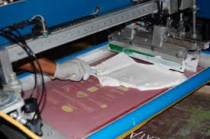
- Rotary screen printing this is a mechanized version of flat-bed screen printing. In this method, the roller itself is porous in the areas to be printed. Dye is forced into the roller cylinder and through its porous screen as it rolls over the cloth. This method is faster than flat-bed screen printing and ic continuous, leaving no breaks between screens.in engraved-roller printing and screen printing, dyestuffs are applied wet for optimum colour penetration. In pigment printing, another method of wet printing, the pigment is attached to the fabric surface with a resin. Other wet prints use dyestuffs that have a chemical affinity to the cloth fibre and do not require resin. With wet printing it is possible to achieve a soft, drapable hand( the feel, body, and afall of a fabric) as well as crisp finish.
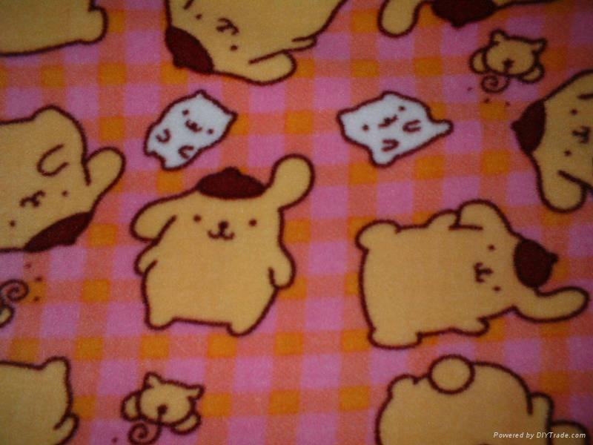

Answer 2.
The knitte fabric are made from one continuous yarm or combination of yarms formed into a series of interlocking loops to make cloth. There are two way s of knitting fabrics. The process is called weft or circular knitting. This is the least expensive method of converting yarm into fabric. Weft knits are made in a wide variety of single and double knits and generally have more stretch than warp knits.
Warp knitting multiple yarns are used and the loops run vertically. Warp knits include tricot and Rachel. In addition, novelty or patterned knits may be prouduced on special machinery. In comparing one weft-or warp-knit fabric with another, people in the trade refer to the cut or gauge the number of needles per inch. The more needles there are the finer and closer the knit loops are on modern electronic knitting machine automatically.
Answer activity 1.
The terms `natural; fibres-the last two being grouped together as man-made-refer to the origin of the polymer. Natural fibres are obtained directly from a plant or animals and, apart from cleaning processes, are used largely as they occur naturally. Regenerated fibres are those made from a natural polymer. the most important natural fibres are flax, wool, cotton, and silk. Others are ramineles. Used for, jute, sisal, and hemp. All of these are derved from either animals or vegetables. For beauty, nothing can compare with natural fibres. Cotton has long been the world`s major textile fibre. A vegitable fiber, it grows best in tropical and subtropical climates. Most cotton is grown in the united ststes, Russia, china, and india. Smaller but still important cotton producers are brazil, Egyp , mexico, Pakistan, peru, turkey, and the sudan. The total world production is about 14 million tons. Cotton is washable and durable, holding up well after many launderings. But because it has little elasticity or resilience, it wrinkles easily. Cotton absorbs dyestuffs easily to produce a wide range of vivid colours.
All textile fibres are complex long-chain polymers. The difference between them is in the chemical nature of the polymer and in the physical structure. A number are made of the same polymer, cellulose, but while they are similar in many ways, there also considerable differences caused by the way in wich the chemical cellulose is physically arranged to produce the fibre. Examples are cotton, linen, viscose and modal.
activity 2.
The weaving crosswise-called weft in England and in hand weaving at right angles. Weaving begins with a process called warping yarms are wound onto a beam and hung lengthwise on the loom. There may be many as 15,000 warp threads on one loom in the conventional method of weaving, fillng yams are fed into the loom by a shuttle carrying yam wound on the bobbin. The warp yams separate warp shed.these looms operate at three times the speed of shuttle looms and produce seven to eight times the fabric because they weave wide widths.
There are three basic weaves plain, twill, and satin. A plain weave is the simplest, most common weave. The warp and filling yarns alternately. Pass over and under each other.

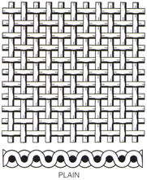

In twill weave, the filling yarm passes over a number of warp before going under one. The same pattern is repeated row after row, but each time the repletion begins on the next warp yarm, creating a diagonal weave. The resulting fabric is very durable.

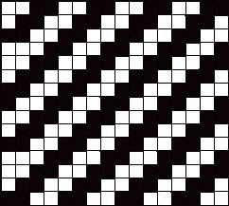
A satin weave is achieved by one warp yarn crossing over several filling yarn, creating floats on the face side of the fabric. The floats give the fabric luster and smoothness.
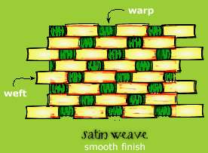
But because they are caught into the fabric only at comparatively wide intervals, a satin weave does not wear as well as others. The many variations of basic weaves used to create designs or patterns in fabrics are called novelty weaves.

Student Statement:

By submitting this assignment, I confirm that this is my own work.

Student Signature | Sukhwinder kaur | Date

For Tutor / Assessor Use Only
Total Marks
Marks Obtained
Percentage / Grade

