
Assignment Cover Sheet

Student Name: | Coenrad Adolph Groenewald
Student Number: | 1382
Course: | Hotel Management Dip
Assignment NO: | Assessment 7 – Marketing and Advertising

Marketing and Advertising

Assessment 7 Total Marks: 30

1. Give short answers to the following questions: (8)

I. What is hotel product? Which components are included in it?

Hotel product components consists of
- accommodation,
- food and beverage,
- recreation and health,
- shops,
- car rental service,
From the above list it can be said that the accommodation and food and beverage components are the primary hotel products.

II. Outline the factors that affect Hotel Pricing.

Factors affecting hotel pricing

- Hotel pricing could be influenced by flexibility,
- The depreciated valuation of the hotel property,
- Its financial management efficiencies,
- The hotels credit policies
- Other factors could include the cost of empty room-nights and fixed overheads

III. What is franchising?

- Def: “Franchising involves making available to the franchisee (the beneficiary) of a service or system that is designed and controlled the quality and standards set by the franchiser.”

IV. What are the benefits of franchising in hotel industry?

How it works

- The franchisee gets the advantage of being part of a reservation and sales system which ensures a certain level of business which may not be available otherwise. This is also known as market segmentation.

- The franchisee also benefits from the image of the franchiser, professional advice and training provided by the franchiser. This is also known as market imaging or branding.

- In the process, he improves his own operational image and efficiency.

- The franchiser also benefits as his investment is not required in the franchisee’s properties.

- At the same time, the franchiser’s distribution system is expanded and the franchisee is well motivated to succeed in his/her own business

2. Compare a product mix of a city hotel with a resort hotel. Also identify those services which may create a competitive difference between both types of hotel. (10)

Introduction

Before comparing the product mix, I would like to explain what a product mix is by defining product mix and then explaining the service which may create a competitive advantage between both types of hotels

Product mix defined

Product mix can be defined as “A bundle of goods and services offered by and organization” (Robert D Reid & David C Bojonis, 2009:8)

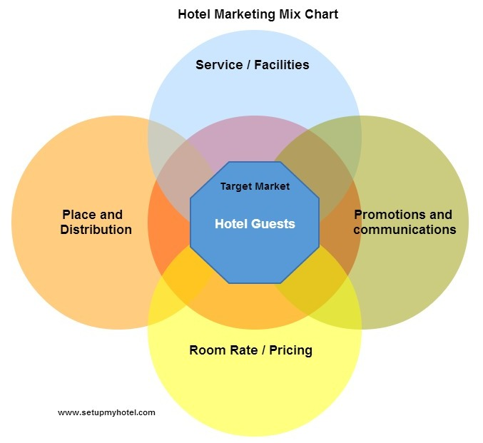

The product mix of a city hotel

A city hotel would concentrate on offering products that is aimed mostly at the corporate market or a one night stop over. Therefore they would offer facilities like conferencing, corporate rates, early morning breakfast and check outs(i.e. 04H30), airport pickups and drop offs, WIFI, Gym and Fitness facilities, LAN cables in the rooms, break away meeting rooms for a short meeting, complimentary transfer to the closest shopping mall and other destinations within a certain radius. The marketing mix would also consider how to advertise the room rate or pricing and what method of communication will be used. City hotels would communicate these rates through methods of corporate rate contracts.

The product mix of a resort hotel

A resort hotel would cover a more of a holiday feel as this is the target market that they try to attract. A resort hotel would include offers of facilities like couples massages, cocktail evenings, dinner for two in the garden or on the beach, offers to go on excursions to local attractions, swimming pool, late check outs, etc. Communication for resort hotels is made on platforms like Booking.com, Agoda, Hotelbeds.com, Expedia, etc.

3. Identify how important it is for a hotel located at a hill station to use “promotions” during off season. Also identify the possible sales promotion schemes it can offer. (12)

Sales promotion is aimed at generating immediate response in terms of a buying decision.
As it is off season it is important to push sales in rooms and F&B. This can be done by keeping an eye on important events in the area and run special discounted rates on room or full board with i.e. complimentary transfers to the final destination. As was pointed out in the prescribed work, the Hill Side hotel would benefit of a big winter sports events when they offer special discounted rates. Other options that they would have available are national and international conferencing or workshops and can attract the delegates by offering relaxation options after a long day’s conference. This option would allow guest to visit the Hill Station that would not normally do so.
Sales promotions that could be used by Hill Station could include
1. Price-off Promotion
Price-off Promotion could assist the Hill Station as it offers special terms for specific clients at specific time; e.g., off-peak or off season periods. This would cover a discount for specific departure/hotel stay dates or times, etc

2. Loyalty Schemes
The Hill Station could offer a sum of money off the guest next booking if the booking is done within a certain period of time; “Give away” to loyal customers

3. Cooperative advertising
The Hill Station could offer allowance or financial assistance given to a tour operator or travel retailer advertising in an effort to increase future bookings during the off-season
4. Welcome cocktail
The Hill Station could offer a first drink free or cheapest drink comp on the final bill to generate more demand for “Food and Beverage.

6. Honeymooners Return Trip
The Hill Station could offer a special coupon to honeymooners to come and celebrate their first or subsequent wedding anniversary. This gives an aura and finesse to the hotel. It also ensures permanent customer and future business.

7. Discount for Agent and Airlines Crew
The Hill Station could offer discount to Agents and Airline Crews in an effort to increase travel sales promotional and developing good relations with the travel trade. This may help in getting favorable publicity.

Student Statement:

By submitting this assignment, I confirm that this is my own work.

Student Signature | Coenrad Adolph Groenewald | Date | 16 March 2015

For Tutor / Assessor Use Only
Total Marks
Marks Obtained
Percentage / Grade

