
Assignment Cover Sheet

Student Name: | Ray Wilson
Student Number: | 1336
Course: | Project Management
Assignment No: | 5

Assessment 5 Total Marks: 30

1. Give short answers for the following questions: (18)

- What are the inputs for creating activity list?
Activity Definition is the process of decomposing a project into a number of tasks which are needed to complete the deliverables. The inputs to the Activity Definition process numerous and include the following;
- Enterprise Environmental Factors are all of the organizational influences that may impact the project’s success. Within the process of activity definition it is useful to review all enterprise environmental factors. Afterwards the Project Manager should determine which factors are important to the project and plan accordingly.
- Organizational process assets are the historical information from current or previous projects. The process information can be obtained from various sources such as plans, operating policies and procedures and lessons learned from other projects.
- The project scope statement provides a description of the project scope, major deliverables, objectives, assumptions, constraints, and the statement of work.
- The work breakdown structure is the hierarchical decomposition of the work to be completed to deliver the project. The WBS comprises the scope of the project at a work package level. This document can be in outline and/or graphical format.
- The WBS dictionary provides additional information about each component in the WBS. Normally this covers a statement of the work, the deliverables, associated activities, responsible parties, resources needed, cost estimate, quality requirements, and technical reference materials needed among other items.

- Expert conclusions from professional engineers and similar that will guide decisions with regards to the needed work packages for the project.
- Assumptions need to be identified for the project work. Examples such as the availability of skilled resources, time allocations to complete the project and prevailing weather conditions all need consideration.
- Constraints are restrictions which are forced on the project manager and his team. These clearly include the project schedule, specified quality metrics and normally a fixed budget to name a few.
- The Project Management Plan describes how the project scope will be defined, developed, verified, and controlled. This is a useful checkpoint to assure only activities which are within scope are defined.
- The Schedule Management provides how the schedule will be tracked, how changes to the schedule will be managed and how the work will be monitored.

II. What is Arrow Diagramming method and how does it work?

The Arrow diagramming method (ADM) is a network diagramming technique in which activities are represented by arrows. It is also sometimes known as the activity-on-arrow (AOA) method.
ADM is used for scheduling activities in a project plan. Significance relationships between activities are represented by circles connected by one or more arrows. The length of the arrow represents the duration of the relevant activity and only the finish-to-start relationships, meaning that each activity is completed before the successor activity starts, are shown.
Sometimes a "dummy task" is added, to represent a dependency between tasks, which does not represent any actual activity. The dummy task is added to indicate precedence that can't be expressed using only the actual activities. Such a dummy task often has a completion time of 0.
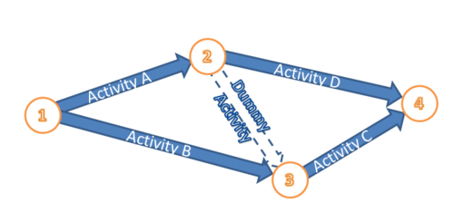
As shown above the ADM network drawing technique shows the start and end of each node or event which is connected to an arrow. The start of the arrow comes out of a node while the tip of the arrow goes into a node. Between the two nodes lies an arrow that represents the activity.
The event represented by the circular node consumes neither time nor resources.
- A node is a specific, definable achievement in the project.
- It has zero duration and consumes nil resources.
- All activities that lead into a node must be completed before the activity lines following this node can start.
The use of ADM has declined over recent years with the adoption of computer-based scheduling tools. In addition, the precedence diagram method (PDM), or activity-on-node, is often favored over ADM and this will be described later.

III. How does Project Network Diagram help in creating flow of project work?

The flow of the project work, as illustrated below, can help the project team imagine what needs to be carried out once activities have been put into a chronological order. This project network diagram (PND) helps explain the relationship between the work packages and the flow of the project work.

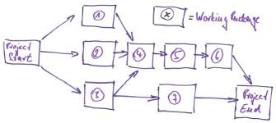

The network diagram lets you do the following which helps create a flow;
- Define the project's path and determine the sequence of tasks to be completed
- Look at the relationship between activities and define the dependencies
- Set up simultaneous tasks and make adjustments as tasks are completed
- Monitor your project by establishing benchmarks, milestones, or deliverables — these are markers to determine whether your project is on, ahead of, or behind schedule
- Take a broad look at the project path and clearly see the relationships and dependencies between tasks
There are both complicated network diagrams and simple ones and the ease with which you can follow the network diagram depends on how complex the project is and how well you have defined everything that appears on it. You can use either one color to indicate the tasks that can be completed simultaneously or another color to highlight tasks that are dependencies, or dependent on the completion of a previous task.

The network diagram will have a critical path that runs from start to finish. This is the backbone, or what drives the network diagram. The activities that need to be completed along the critical path and other paths that connect to the critical path are typically connected with lines and arrows. Activities are then labeled and as they are completed, each one should be highlighted or clearly marked by an established means. Each activity should include the number of days it will take to complete the task.

IV. What is meant by the term ‘decomposition’? Why the project activities are decomposed?

Literally Decomposition is the process by which organic substances are broken down into a much simpler form of matter. However in relation to a Construction Project this involves dividing project deliverables, which are derived from the project activity list, into smaller lots, such as work packages, until there is enough detail to support the schedule, estimation of cost and project controls.

A template, often developed and used on previous projects, can be used by the project manager and this can include several elements as detailed below to make his/her life easier and the new project with more chance of success;

Required resources and skills
Required actions to complete the project scope
Known risks
Outputs of the work
Required hours of duration for activities
Supporting details
Descriptions of the work packages

Compiling the activity list normally follows but as discussed can be carried out in parallel. The activity list also ensures that there is no extra work included in the project. Extra work costs time and money and setbacks the project scope. The activities list is comprised of all of the work required to create the components within the WBS.

This results in a work breakdown structure being developed which are a group of deliverable components work packs that are then fragmented down into further activities and manageable work elements as required. It’s worth noting that the WBS and the activity list can be developed at the same time.

In summary this project activity decomposition allows the project manager to;

- More accurately and specifically define and organize the scope of the total project (the most common way this is done is by using a hierarchical tree structure) so that each level of this structure breaks the project deliverables or objectives down to more specific and measurable chunks.
- Secondly by using a WBS on his project the project manager can assign responsibilities, resource allocation, monitor the project, and control the project. The WBS makes the deliverables more precise and concrete and also allows for better estimating of cost, risk, and time because you can work from the smaller tasks back up to the level of the entire project.
- Finally, it allows you double check all the deliverables' specifics with the stakeholders and make sure there is nothing missing or overlapping.

V. How does a project manager decompose project components?
The first step is to create your WBS by getting all the relevant project team, and possibly key stakeholders, together in one room. This team possesses all the expertise, experience, and creative thinking that will be needed to get down to the specifics of each deliverable and is an invaluable asset. The resulting review will create the first two levels setup, the first level is the project title, and the second level is made up of all the deliverables for the project. At this stage it is important to collect all of the deliverables for the project including internal, external, and interim.
Once the first two levels are completed and established, it is time to launch into the decomposition level stage. This level of breakdown and detail is called the work package. Work packages are the lowest level of the WBS and are pieces of work that are specifically assigned to one person or one team of people to be completed. Activities and tasks are not included in the WBS. They will be planned from the work packages once they are assigned.
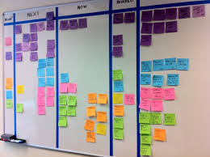
The team can now start on the decomposition process. Normally the project manager and his team, or organization will have completed like this one in the past, although occasionally a project type may be new to most involved. That means that there should be a WBS available from a previous project that can be used as a model. This can save a lot time and effort. Another great technique to make your life easier is the Post-It Note Technique, as illustrated above, and although there are numerous modern software packages available that can satisfy this need, this age old system actually works very well. In this technique you simply write each deliverable on a post-it note and stick them at the top of a wall. Then you and your team start to break down each deliverable into components and write each component on its own post-it note. This way, as you place them on the wall and start to create your tree structure, everyone can easily see what has been accomplished and where you are headed. Also this technique allows for easy movement of components around within the WBS.
Many larger projects will also find it necessary to create a WBS Dictionary to accompany their WBS. The WBS Dictionary is simply a document that describes each component in the WBS. This helps clarify any specifics later on when team members completing the work or stakeholders viewing the deliverables have questions.

VI. Outline the factors that can affect a project’s length

There are numerous factors that can affect the length of time a project needs for completing. The list below is indicative of some of those reasons;

- Poor supervision and management
- Finance and payments
- Unpredictable site conditions
- Poor handling of the contract
- Slow decisions and responses to queries
- Shortages of materials and equipment
- Variations by the client
- Inaccurate estimations of the work
- Variations of work
- Fluctuations in prices (commodities and wages)
- Project schedules
- Resources (lack of or imbalanced skill sets)
- Activity durations
- Vendors or suppliers defective products or delays in delivery
- Incorrect activity sequencing.
- Government or local authority regulation changes
- Incompetent contractors

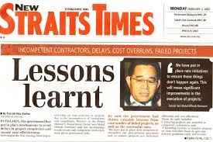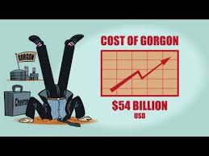

All of these, either individually or a combination of, can cause serious delays to a project as well as the impact on cost, quality of product and harm to a company’s credibility and reputation as can be illustrated in the captions above.

VII. Define the term ‘activity sequencing’. What are the inputs to activity sequencing?

Activity Sequencing is the process for identifying and documenting dependencies among schedule activities which are also known as "logical relationships". Having the list of all the activities which together constitute all or some of the work packages it logically leads to which tasks have to be started and/or finished before or after other tasks.

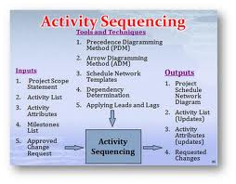

The sequence activities process takes all the activities defined in the Define Activities process and orders them by precedence. This in fact then creates a map or diagram that illustrates the relationship between these activities and identifying the order in which they need to be done. It is important to note at this stage the project schedule is not being made, and therefore start or finish dates to these activities is not required.
The inputs for this process include: project scope statement, activity list, activity attributes, milestone list, and approved change requests as illustrated above.

The project scope statement helps you ensure nothing is missed, and often influences the activity performance order.

The project activity list contains a schedule activities and needs to be arranged into the order they should be performed for the diagram presentation.

Activity attributes provides additional insight into which activities need to be performed before others.

A milestone list provides all the key milestones that might influence the order of the project activities.

The approved change request is a document containing a call for an adjustment of a system and is of great importance within change management process. A change request is declarative, i.e. it states what needs to be accomplished, but leaves out how the change should be carried out.

VIII. Apart from the duration of activities, which other factors can effect a project’s time

Within a project there can be many factors that affect the project duration such as but not limited too;

Preparation and Planning;
- It is important to establish, by doing the preliminary studies, that the project is feasible, profitable and necessary. Feasibility studies, plans, supplies, staff, costs and time frame all need to be established before a project can begin.

Organization;
- The project must be organized by putting a schedule in place with a beginning and proposed ending date and provide a budget so the moneys assigned to the project stay within cost perimeters. Staff should know how much time is allotted for the project, so they can plan accordingly. Distribute duties so team members know what is expected of them.


Leadership;
- Every project needs a leader to take charge and keep things moving, even when the going gets rough. Without a quality leader in place, confusion rules and controversies ensue. A good leader delegates, recognizes the strengths of each team member by empowering them and places people in the most effective positions.

Knowledge;
- Everyone involved needs to understand the basic principles and the desired outcome of the project, so it can move forward with the least amount of interruption. It is the responsibility of the project manager to ensure that everyone understands the goals they are working toward.

Teamwork;
A large project needs a team of the best workers to be the best. Everyone must pull together toward a common objective to make it to the finish line -- there is no room for grandstanders or solo performers. Staff members must work together with the best interests of the project as a whole in place for the entire duration. If the project team is weak or has no experience on similar projects, then the project manager must account for that in his project schedule and must cushion his estimates.
Timeliness;
- A project manager needs to be careful that work in progress stays on course as the project nears its end. Some employees have a tendency to drop the ball or let things slide as the conclusion approaches. Costs may exceed budget. The project manager must remain alert all the way to the finish line.
Project complexity;

If the project has complex and never undertaken tasks, then surely the project manager must accommodate that fact in his project schedule or secure specialist services with known track records of the tasks that need to be carried out.
Deadlines;

Quite often, the stakeholders impose a specific deadline. A "hard" deadline will greatly affect the project schedule, as the project manager will probably over-allocate resources and will also probably make them work on weekends and holidays in order to meet the deadline.

Resource availability;

The less resources allocated to the project, the lengthier the project schedule is.
Task dependencies;

There are many tasks that cannot be started before others are finished, there are also some tasks that have to start together. Tasks dependencies will dictate the sequence of tasks and will also dictate the project's need for resources at any one point.
Project priority;

If the project has low priority within the company, then the project manager will not be able to claim the resources he really needs to finish the project in a reduced timeframe, he will only get a fraction of his needs, as most resources will be assigned to high priority projects.
Material availability:

For example, in a construction project, you need GRE pipe for underground services, but the pipe is not available until the third month of the project, so the project manager needs to create the project schedule accordingly and ensure that there are no idle resources waiting for the pipe to arrive in these first 3 months.
IX. What time related risks could be involved in a project?

There are numerous time related risks such as;

- Tight project schedule
- Design variations

- 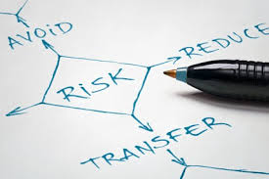

- Excessive approval procedures in administrative government departments
- Variations by the client
- Incomplete approval and other documents
- Unsuitable construction program planning
- Inadequate program scheduling
- Bureaucracy of government
- High performance or quality expectations
- Variations of construction programs

As the illustration above indicates however these risks could be avoided, reduced or transferred by employing mitigating measures wherever practical.

2. You are the project manager for a large construction project. The project objective is to construct a set of outbuildings to house the Olympic support team that will be arriving in your city 15 months from the project start date. You’ve been given a budget of $18 million to complete this project. Resources are easily attained. Which of the triple constraints is the primary constraint for this project? (4)

  - Time, because the date cannot be moved
- 
In this case the client has a completion date that they cannot miss under any circumstances as the event date is fixed. In these circumstances it is very clear that the primary constraint that will judge whether a project is a success or failure will be based on whether or not you are able to meet the deadline.

3. Explain Precedence Diagramming methods of arranging project work. (8)

A precedence diagram is a graphical method of depicting the sequence of activities in a project. It is represented as a network of arrows and nodes where the nodes represent activities and the arrows indicate dependencies between activities.

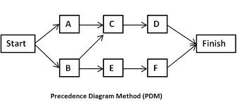
The main benefit of Precedence Diagramming Method (PDM) is that it shows the activity dependencies, and it also an important communication tool for the stakeholders

- Precedence Diagrams help project managers to;
  - Communicate: The visual representation, as illustrated above, makes it easier for you to communicate the flow of project execution or the project activity flow.
  - Identify missing activities: When an activity is not identified, it will more than likely never be done. By visually representing the activities, there is a greater chance for your team to identify missing activities.
  - Identify dependencies: Each activity is dependent on some other activity. When a dependency is not identified, the project will be delayed until such a time that identification occurs.
  - Identify critical activities: Certain activities have a greater impact on project schedule than others. By using PDMs, you can determine the activities critical to the project schedule. This is known as the Critical Path Method (CPM).
  - Create a project schedule: The final goal of PDM is to create a practical and robust project schedule.
Other key elements of PD include determining predecessors and defining attributes such as
- early start date..
- late start date
- early finish date
- late finish date
- duration
- WBS reference

Student Statement:

By submitting this assignment, I confirm that this is my own work.

Student Signature | Raymond Wilson | Date | 27th Nov 2014

For Tutor / Assessor Use Only
Total Marks
Marks Obtained
Percentage / Grade

