
Assignment Cover Sheet

Student Name: | Maria Magdalena Barragan Zermeno
Student Number: | ID 1619
Course: | Management Level 3
Assignment NO: | 2

Marking Criteria:
We expect the learners to write minimum one well expressed point in three lines against each allocated mark. This means one needs to write 15 lines with 5 well expressed points to get high grades for a 5 marks question.
For high grades use examples and illustrations where appropriate.
Please insert your completed assignment ( in word format) here:

Question 1

The “Five Learning Disciplines”

Peter Senge identified five learning disciplines that he believes are at the core of leadership in any learning organization. Organizations can become learning organizations for two main reasons. First, as human nature drives people to seek ways to overcome problems, these organizations successfully “tap people’s commitment and capacity to learn.” Second, for employees work is more than just means to an end; they want to gain intrinsic satisfaction from their undertakings.

A learning organization that can provide this kind of satisfaction consists of five key disciplines, “five learning disciplines”; they are listed separately, but, in fact, they operate together:

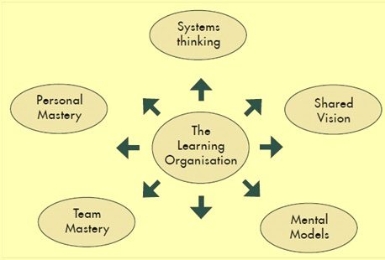
- 1.- Personal Mastery
- 2.- Mental Models
- 3.- Shared Vision
- 4.- Team Learning
- 5.- Systems thinking

1. - Personal Mastery
“No man is free who is not a master of himself.”
(Epictetus)

As leaders within living systems that are highly complex and ever changing, it is important that we constantly condition and maintain our mind, body and spirit to meet the challenges before us. This leads us to talk about Personal Mastery or a dedication to continuous focus, learning and growth.

According to Peter M. Senge and The Fifth Discipline: The Art and Practice of the Learning Organization, “personal mastery is the discipline of continually clarifying and deepening our personal vision, of focusing our energies, of developing patience, and of seeing reality objectively," (Senge, 7).

Personal mastery is an ‘art’, the art of managing our mind and a desire to understand and learn for its own sake; it recognizes that organizations advance only through individuals who learn. This personal mastery is based around that part of learning in the learning organization that belongs to the individual, allowing us to clarify and go further into our personal vision; it is the skill of continually clarifying and deepening our personal way of looking at the world around us, and within us. It can help us understand what we do well, what we can do better, and what things about our personalities are fixed and have to be accepted as is.

Personal Mastery revolves around the idea that leadership starts with ‘you’ – that no matter what our leadership level, roles or goals, the critical factor to begin with is inside us.

We can’t be experts at everything. Yet we have gifts to sharpen, use and share. We also have weaknesses and shortcoming that we need to address or, ask the help of others who have those strengths or expertise we lack. Personal mastery means knowing ourselves fully and accepting ourselves deeply so that we think, feel and act from a grounded, integrated centre in all we do. We have the commitment, motivation and persistence to gain knowledge and skills in any given situation. We maintain a focus on our calling and keep important goals in sight vs. get distracted and lost in busyness. We focus on developing personal mastery as a real, conscious and integrated foundation for great leadership. This is because effective leadership comes from ‘who we are’, not just ‘what we do’. It requires patience, perseverance and humility. Complex problems do not get solved overnight. Personal mastery is a life-long pursuit of learning and growth and is not something to possess or a destination to arrive at.

Learning and growth need to take place on multiple levels including spiritual, mental, emotional, social, and physical. And it means being able to incorporate “reason and instinct,” two abilities that help you see things in a holistic way. With personal mastery, we dedicate ourselves to looking for and welcoming opportunities to be refined and stretched, because they equip us to be better leaders in a complex world.

Personal mastery is about approaching life from a different perspective and it is guided by key principles like vision, personal purpose, creative tension, commitment to truth and understanding the subconscious mind. This is not something you can accomplish overnight.

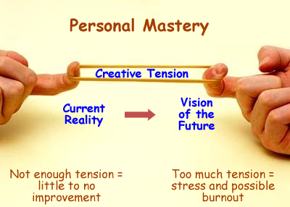
One of the most important and fundamental aspects of personal mastery is personal vision. Personal mastery combined with personal vision can create a guiding philosophy on how you can operate and live your life. Some people would say that personal vision serves as a guide that would keep you on track. Learning to cultivate the tension between vision and reality can expand our capacity to make better choices, and to achieve more of the results that we have chosen.

Followers of personal mastery see that there are great opportunities to improve their growth, there are many avenues for growth and opportunities like books, tapes, lectures and courses. People also benefit from organizations during their quest for personal mastery. Through the discipline of personal mastery the individuals take responsibility for their own learning and the methods they will use to achieve it.

Personal mastery is self-discipline. It is about taking responsibility for the direction that your life is going to take. You would slowly realize that you can do anything with the aid of your skills and talents. Discipline would clarify and deepen your perspective in life. Those who quest for personal mastery would develop patience and see life objectively. You can say that you have developed personal mastery if you are starting to fully understand your strengths, talents and your purpose in life.

Personal mastery is about loving yourself and expressing your gift to its fullest. Some would think that personal mastery is controlling and limiting oneself, but actually it is about understanding your personality. To control or overcome some habits, it would be important to identify how and why those habits arise. The more you suppress things, the more you would have difficulty in conquering and overcoming them.

It is also important for a person who is in a quest for personal mastery to develop integrity, humility, justice and industry. Actually, these are "rules" on how we could conduct ourselves professionally, socially and spiritually. Personal mastery guides you to develop being aware of your beliefs, attitudes and behavior impacts. It also enables you to accept yourself and be responsible of your own actions, attitudes, and thoughts.

Personal mastery is how you understand and direct your life. For an organization to succeed, each member of the organization has to be a part of the organizations purpose and make it their own personal purpose. When each member of the organization adapts the organizations purpose as his/her own, personal and organization growth increases because personal mastery is the power of an organization whose members believe and are committed to one idea; this is the deepest commitment an organization could ever have. Followers of personal mastery are capable of accepting the harsh realities and learn to adapt with the changes happening in their surroundings. Those who have a high level of personal mastery are able to commit into their lives and see themselves as part of the whole.

These people when combined with the members of the group or an organization can influence others to have the same thought. They can influence but not control. They are grounded to reality, they can see objectively. A learning organization depends on individual learning; consequently, personal mastery is critical. Achieving it also means having an individual vision that gives you direction and purpose, including a commitment to your organization and to its vision and goals.

Personal mastery is a journey we are on, rather than reaching a destination, since we don’t stop learning or pursuing once we reach our goals. As part of the lifelong learning process, we set new goals and keep going. It is journey to which we neither finish nor arrive.

Personal mastery builds integrity, authenticity and confidence in leaders. It opens them up to clearer vision and more decisive action. It is experienced as personal power - charisma - which leads others to trust and be inspired to follow. Personal mastery is very important if you are responsible for leading people or groups; it is important to model your own commitment, to demonstrate your commitment to learning and to setting goals and achieving them. It motivates those around you to produce their best, and can also help you to support your staff in identifying their own vision, overcoming gaps in knowledge and performance, and finding a way to achieve their objectives. What starts on the inside, produces outstanding results in the real world.

Examples:
These examples help us understand why personal mastery is so important:

1. - If you are a ‘sports person’ but you stop doing sports for a while and one day you decide start doing it again, you will find it hard in the beginning because your body and your muscles struggle and do not respond and recover as quickly as you want because they have not been used for such a demanding purpose recently. This experience is similar to being overwhelmed by leadership. Or maybe you are just consumed by tasks and busyness but are unsure about the “bigger picture,” what it is all for. As you need to keep training, you need to keep ‘learning’.

2. - A person who spends so much time coping with problems and difficulties along her path and her daily life that she even forgets why she is on that path in the first place; she doesn’t even think about the meaning and purpose of her own life. The result is that she only has a dim, or even inaccurate, view of what’s really important to her and her life.

3. - We’ve all known people entangled in counterproductive relationships, who remain stuck because they keep pretending everything is all right. Or people who have been in business meetings where everyone says, “We’re on course relative to our plan,” yet an honest look at current reality would show otherwise. These persons lack personal mastery.
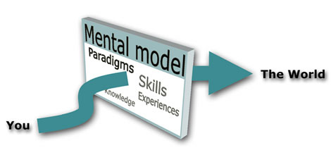
2. - Mental Models

According to Peter Senge Mental Models are ‘deeply ingrained assumptions, generalizations, or even pictures and images that influence how we understand the world and how we take action’.


For example:
At the turn of the 15th century, prevailing wisdom said the earth was flat and, if you sailed too far to the west, you’d fall off the face of the earth. For the average person of the era, there was nothing wrong with this assumption. Most people never journeyed more than 20 miles from their homes, so whether the earth was flat or round didn’t matter. This assumption is a classic example of a mental model as described by Senge.

The discipline of Mental Models is the ability to unearth our internal pictures, assumptions and generalizations that influence how we understand and interpret, the world, to scrutinize them and to make them open to the influence of others. These models shape what we see and therefore how we react to events. Our mental models include our assumptions, values, beliefs and worldview. If we have false convictions and don’t correct them, we will end up making mistakes when we act. If we take steps to modify our beliefs, then we can make better choices.

For example, when a school teacher assumes that “Andrew” is careless and that he doesn’t have the capacity to study, she will not be willing to help him, perhaps not realizing that the little boy is going through some difficulties at home which hampers his concentration in class and affects him in the way he behaves in class.

With ‘Mental Models’ we explore the concept that we are what we think; that how we manage our project and how we approach people and problems is a logical extension of our deeply held views of the world.

Mental models help us to develop the capacity to reflect on our internal images of the world to see how they shape our thinking and actions. By continually reflecting upon, talking about, and reconsidering these internal pictures of the world, we can gain more capability in governing our actions and decisions, we can make some adjustments resulting in living with more meaning, purpose, and satisfaction. Very often we are not aware of their impact on our behaviour, so it is very important to develop the ability to reflect carefully on what we do and the whys recognizing and scrutinizing our assumptions and prejudices about how the world works, since these affect the actions we take. We may not even know that these mental models exist or are affecting us because they exist somewhere below our awareness.

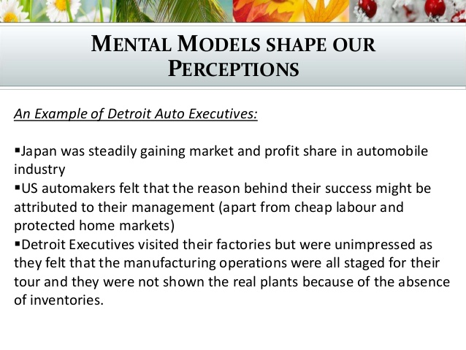

Another example, of the
automobile industry:

It’s important to remember that no human being will ever have completely reconciled mental models. We all have our dark corners and our blind spots, and it’s nothing but arrogance to assume that we’ll completely eliminate them. On the other hand, we can’t lose by attempting to practice what we preach.

Mental models present some significant obstacles to learning and innovation. According to Senge, mental models often limit the ways in which we think and act. If our mental models are incorrect, we will make the wrong decisions. The discipline of mental models involves “discernment” of the facts or information that supports (or doesn’t) the many generalizations we hold about the world. If our mental models are not based on real data, then those assumptions limit our ability to read the environment accurately.

For example, a common mental model for a production manager may be that low-level employees are lazy and that's why production goals are not being met. This mental model consists of an untested assumption and prompts the manager to ignore other possible causes of the problem.
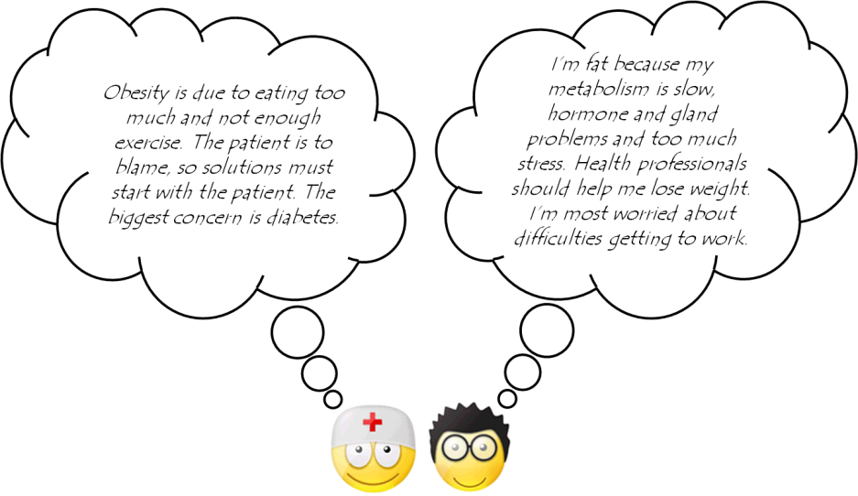

Other examples of
“Mental Models”

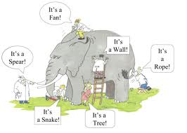

We can overcome erroneous mental models by managing them appropriately. That means we need to discover our mental models, test each model's validity, and improve them based upon information learned

For example, Royal Dutch/Shell’s managers did this when they changed their stance on global geopolitics and the oil industry during the OPEC embargo in the early 1970s. They gave their local operating companies more power at a time when other oil companies continued to rely on centralized control. This strategy enabled Royal Dutch to respond to the turbulence of the period more effectively, because it gave up the traditional command structure and control dogma.

Mental models are by nature conservative, even for the most nimble of us. In fact, this phenomenon is so strongly a part of us that we have jokes about it:
"When the only tool you have is a hammer, every problem looks like a nail"

The Ladder of Inference:

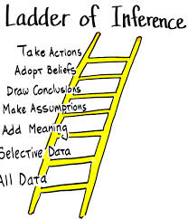
It was first proposed by Chris Argyris, in 1970, and it is a way of describing how you move from a piece of data (a comment made to you, or something that you have observed to happen), through a series of mental processes to a conclusion. You start by selecting from the data, translate it into your own terms, explain it to yourself, and then draw conclusions. It’s dangerous, because it all happens extremely quickly in your head, and you are probably unaware that you are only selecting some of the data. Nobody else sees your thought processes, or knows what stages you have gone through to reach your conclusions. All that they see is the action you take as a result.

Sometimes you find yourself perplexed at the way someone else interprets something you say or do, and put a meaning on it that you never intended; other times perhaps you find yourself enraged by someone’s comment or action, and conclude that they must be acting against you for some reason. You are climbing the ‘Ladder of Inference’.
Your beliefs tend to reinforce the data that you select, and how you interpret it, which means that it becomes a positive feedback loop; in this sense, ‘positive’ is not necessarily ‘good’. Instead, it means that the feedback drives the process onwards instead of stopping it, and therefore confirms what you already believe.

Example of a few moves up the ladder:
- Jane arranges to meet Mary for coffee at 10.30am.
- Mary is late and does not explain why. In fact, she doesn’t seem to have noticed that she’s late at all.
- Jane decides that Mary simply couldn’t be bothered to turn up on time, and that Mary values her own time more highly than Jane’s.
- Jane concludes that it’s not worth bothering to meet up in future, because Mary obviously doesn’t want to see her.
- When Mary suggests meeting the next week, Jane makes an excuse to avoid it.
At the end of this, all Mary sees is that Jane does not want to meet up again. She may have no idea why. There could be any number of reasons why Mary was late, and hasn’t explained: a doctor’s appointment, perhaps, or it could be as simple as her watch being slow, so that she has no idea that she is late. Meanwhile, Jane has decided the friendship is not worth pursuing.

A lot of the time, you won’t even be aware of the beliefs and assumptions underlying your data selection and the inferences that you draw. They may go right back to childhood, and a chance comment, even one overheard and only half-understood.

What we can do to avoid climbing the ladder of inference, or help others to avoid it is to accept that we are always going to draw meaning and inferences from what others say and do, based on our past experience. It’s how people work. The issue is to draw on experience, but in a way that does not make assumptions about others’ behaviour, or which allows us to check back on those assumptions.
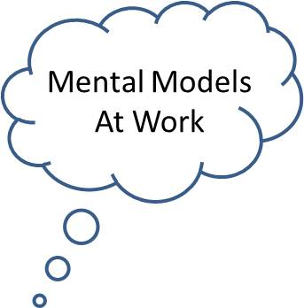
Reflecting is the process of paraphrasing and restating both the feelings and words of the other person, or your own words or actions. To help us understand better the way we and others see the world (mental models) apart of good listening skills, we need to develop the ability to reflect words and feelings and to clarify that we have understood them correctly.

3. - Shared Vision

Shared vision is the ability of a group of individuals to hold a shared picture of a mutually desirable future. It is working together to create the vision and then working to incorporate that vision into each unit or part of the organization.

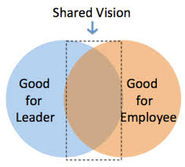
All members of the organization must understand and contribute to the vision. It has to be meaningful and something that relates to their individual visions of the organization. It creates a focus for the organization that will guide all parts of the organization. It encourages collaboration and team learning.

When there is a genuine vision people excel and learn, not because they are told to, but because they want to. Here what matters most is the visible behaviour of people in leadership positions in sharing their own personal visions and demonstrating their commitment to the truth.

Shared vision requires that members of an organization share a commitment to its overall “goals, values and missions.” Having a shared vision helps to build commitment within the group; promoting a common vision among staff members involves more than just a bland mission statement.

Leaders cultivate a shared vision among people throughout the organization, as well as with stakeholders. Shared vision is a discipline for bringing into alignment the vision and efforts of people organization-wide. The principle of shared vision leverages the most productive usage of capital, technology, and human capital since resources are coordinated toward the same ends. Processes, job functions, system-wide problem solving, and so forth, flow in a common direction.

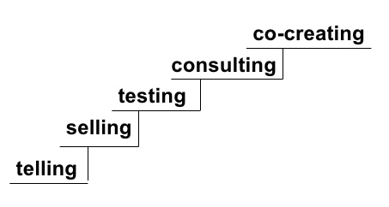
In articulating a vision, leaders can proceed in various ways, and it could be something like the following steps, because these vision strategies should be developmental as if going up a ladder:

Telling: this is the vision of what the organization is going to look like two years from now…We’ve got to do this. It’s our vision. It is the vision set by the leaders (he tells you).

Selling: The leader attempts to enroll people in the vision, enlisting as much commitment as possible…We think we have a very good option, let’s see if we are able to convince you and you accept it (you buy it).

Testing: The leader lays out the vision for testing, not just to find out whether the group supports the vision, but to see how enthusiastic they are about it and accept it, and what aspects of it matter to them. How are they going to react?

Consulting: This is a preferred stage for a leader who recognizes that he or she cannot have all the answers, and who wants to make the vision stronger by inviting the group to be his or her consultant….What vision do members recommend that we adopt?; leaders get input and ideas from others.

Co-Creating: They work together for what they want to build rather than to please a leader…the leader and the group collaborate and build a shared vision together, and create the future they individually and collectively want.

After the vision is in place it needs to be maintained in the consciousness of people and passed along to new members. We look for informal actions and formal policies which express the shared vision in such a way that people feel a sense of partnership, cohesion, and direction company-wide and look for the processes and practices that could help create community and a sense of what’s important, finding out how can regular, open and honest feedback become a valued contribution to building shared meaning and helping people to grow.

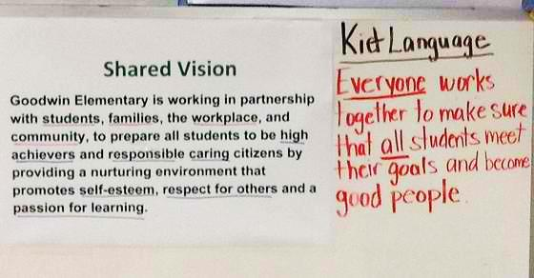

An example of Shared Vision in an elementary school:

4. - Team Learning


“The discipline of team learning starts with ‘dialogue’, the capacity of members of a team to suspend assumptions and enter into a genuine ‘thinking together’. To the Greeks dia-logos meant a free-flowing of meaning through a group, allowing the group to discover insights not attainable individually…. It also involves learning how to recognize the patterns of interaction in teams that undermine learning. (Senge 1990: 10) It is the process of aligning and developing the capacity of a team to create the results its members truly desire. (Senge 1990, p.236)

Team learning is the ability of group of individuals to suspend assumptions about each other and engage in dialogue and discussion. It empowers people toward a collective vision; it is all about how dialogue and skillful discussion transforms teams to swarm and combine their energies and ability greater than the sum of individual members’ talents. It is a developing capacity for collective intelligence and productive conversation. It is a skill developed for group problem solving and learning. Team learning is also defined as learning done in groups where people teach each other and work together to acquire knowledge; it is wisdom that incorporates different viewpoints, allows business people to deal with a changing world and encourages innovation and renewal.

Team learning is the discipline that focuses on the abilities of a group working together. It involves the interaction of people learning from each other as well as from the task at hand. The learning takes place through the transfer of skills by observing others in action, collective problem-solving and experimentation, questioning mental models and reviewing outcomes as a group. Team learning helps to share prior skills, knowledge and experience enhancing the learning experience for the team. It requires participants to present, promote and negotiate their views leading to better retention, and it develops open, effective communications within the organization as individuals learn the value of sharing information with colleagues; it creates co-operative working practices and builds better links within organizations; reveals new insight about colleagues, builds trust and create a supportive environment allowing participants the confidence to explore beyond their perceived limitations. It generates competition between teams, which motivates individuals to work harder and learn more. Allows team members direct the learning within the group making the training more enjoyable, relevant and effective

Team learning means that members of a group progress together; great teams aren’t born, they must grow in unison and learn how to achieve extraordinary results. Team learning leads to more effective learning since the group’s combined intelligence is greater than the intelligence of any single individual. It stresses empowering groups to explore all the ramifications of a problem and to come to actionable solutions that will help both their projects and the organization as a whole, so that it can adapt and transform itself to achieve its goals in a dynamic and competitive world.

The tools of the team learning are dialogue and conversation; it is an open and honest talk and each one in the team grows more and more aware of their own assumptions, and the assumptions of the others.

When team learning exists there is an ongoing process of reflection and action in which a team engages in asking questions, learning behaviours such as feedback freely given, accepted and valued, error discussions, information sharing and experimentation, reflection on results and, or unexpected outcomes of action, and innovative problem solving that will help team members to adapt and improve. There is a flow of information as well. Working in a team helps participants to present, promote and negotiate their views. This is a process that requests the learner to think critically. People learn to ask questions that help learning and not to make experts points. Becoming comfortable with feedback builds trust, care, listening skills and integrity in how people talk with one another. Senge believes this is the most difficult discipline and takes the longest to develop. It is getting to know how to create a space where people are able to relax, work hard, have fun, and creatively produce.

It forces restructuring of existing knowledge and the formation of new mental schema to organize the knowledge. This deep processing ensures assimilation of learning. Thus working in a team helps embed the learning and develops coaching skills

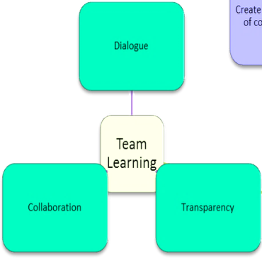
It is essential for groups within organizations to have dialogue and discussions among them in order to facilitate learning from each other as a team; it is vital to overcome barriers and come to mutual sharing. Learning is enhanced when it is more like a team effort than a solo race. Working with others often increases involvement in learning. Sharing one's own ideas and responding to other's reactions improves thinking and deepens understanding. A typical group of business people on a business course will have different prior learning, knowledge and experience and working in a team of four or five provides a means of sharing this.

There are three factors which play a critical role in fostering team learning:
- Less aggressive performance goals
- A minimum level of psychological safety (supportive environment, reward systems, adequate resources)
- A high level of team self-confidence

There is an important interrelationship with team learning and the other four disciplines. In order for you to engage in team learning, you should have developed a commitment to the truth that is found in personal mastery. You should also understand and be able to apply system thinking, which is the ability to see patterns and interrelationships - the big picture.

Additionally, you must be able to effectively recognize, test the validity, and improve upon your mental models, the generalized way you view the world. You will also need an understanding of the organization’s shared vision so that solutions presented are in harmony with the vision. These skills are necessary to effectively help your team in discussions, dialogues and in finding creative solutions to problems facing your organization.

Senge defines three dimensions of team learning:
- The ability to think insightfully about complex issues: someone who can see four levels operating simultaneously: events, patterns of behavior, systems, and mental models. A willingness to deeply explore a problem. According to Senge, a group's collective IQ is much higher than the IQ in an individual if the group can coalesce and begin to use each other as a springboard for understanding and resolving the problem at hand.
- The ability to take innovative, coordinated action: Any difficulty in taking action seems to occur when teams solve what they think are bigger problems that might run counter to “the way things have always been done. A team will implement the innovation on a trial basis and then sell it outward, if they can prove to themselves that it works. In some cultures, all action on something that is truly innovative will be deferred pending official written approval from some committee to go forward.
- The ability to create a network that will allow other teams to take action as well: the ability of the team to sell its learning outward to other teams.

An example of team learning is when students are assembled into groups to study a subject together or to compete with other student groups to practice their newly-gained knowledge.

Another example is a meeting where everyone is engaged and excited, and the ideas just seem to build seamlessly on one another. It means that the solution the group has developed is far better than a solution an individual alone could have developed.

Another example of team learning is: The QA manager at one company had developed a practice of bringing in bagels every Monday morning for the development group. The rule was that you had to answer the question-of-the-day (usually about problems you’d confronted in the past) for the edification of everyone in the room, in exchange for your bagel. These Monday morning exchanges were remarkable for revealing people's more obvious mental models, their personal visions, and often skills and interests none of us knew they had.

5. - Systems Thinking

This is the fifth discipline that integrates the other four into a coherent body of theory and practice.

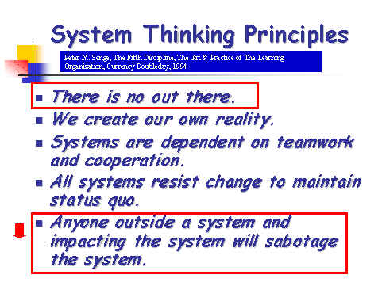
Organizations are made up of complex systems that consist of various inter-relationships, and it is essential to learn how to identify the patterns in those relationships and recognize the problems within.

Systems thinking is the ability to see the consequences of my own actions; to see the connections in any situation and to understand better how things unfold over time. Something happens and we react but we don’t see how that situation may have in fact been influenced by things we did or contributed doing in the past, so, to see more clearly how things unfold over time and to see whether they’ve been connected we use systems thinking.

Systems thinking is the ability to see the whole, perceive long-term patterns, understand interdependencies, and better recognize the consequences of our actions.

For example: a car. A car is made up of parts (engine, wheels…); all these parts are put together and organized in a specific way so as to make them function as a vehicle Transport.

Systems thinking is a unique perspective on reality, a perspective that sharpens our awareness of wholes and how the parts within those wholes interrelate. A systems thinker knows how systems fit into the larger context of day-to-day life, how they behave, and how to manage them.

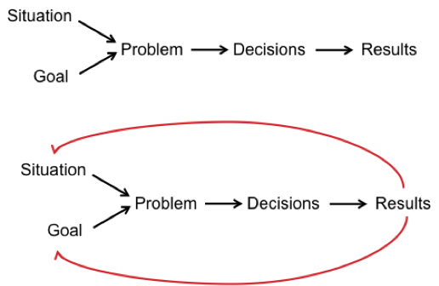
Systems thinking recognizes circular causation, where a variable is both the cause and the effect of another and recognizes the primacy of interrelationships and non-linear and organic thinking, a way of thinking where the primacy of the whole is acknowledged.

Systems thinking promotes the understanding that business and human life are systems, where single components affect the other elements of the set. Many people focus on isolated parts and, in effect, don’t see the forest for the trees. Systems thinking integrates all five disciplines into an organized structure.

Systems thinking is a way of seeing the connections, links, or relationships between things. Instead of seeing parts and pieces of how things happen, it allows the interdependent whole to be appreciated. It is a process for understanding the interrelationships among key components of a system, such as: hierarchical relations, process flow, attitudes and perceptions, product quality, sales, production, just in time delivery, cash flow, customer service, delivery, research and development, how decisions are made, and hundreds of other factors. This discipline draws on perceptions and experiences of people from different levels and functions in the organization, providing diverse perspectives for improving the quality of systems thinking.

Observing at a systems level will enable self-corrections, a balancing of forces, regained stability, self-regulation, and generative adaptations. Systems thinking helps to uncover the living connections between things large and small. After a while, what emerges is recognition of underlying structures to a complex situation. Mapping and analyzing at the systems level allow a careful tracking of factors affecting input, processes, output and outcomes that might otherwise have remained invisible or misunderstood.

Systems thinking engages us into a shift of mind: we need to continually discover how we contribute to creating our reality and how we can change it.

‘Systems thinking’ can be a difficult concept to grasp entirely, as it challenges our traditional thinking which most of us have grown accustomed to. But, once understood, the concept of 'systems thinking' can become an effective approach for problem solving and decision-making.

It is considered to be a way of looking at the world as a hierarchy of systems that all connect in some way. Through this interconnecting world-view approach, a different process for problem solving emerges. Rather than isolating a problem and then fixing it, which is a common practice using traditional thinking, the ‘systems thinking’ approach widens the view to observe the area surrounding a problem. It reviews an entire system when all its parts are functioning and considers how each part interacts with each other. Through this approach, ‘causal effects’ are identified and a ‘problem space’ is mapped-out. With this in-mind, ‘systems thinking’ is more defined through three particular characteristics:

1 – Emergent Properties
All systems are comprised of components that contribute to a complete and hooked-up system. When a system is complete, its emergent properties are on display, which are unable to be predicted by merely looking at a system’s components in isolation. Instead, all interacting components of a system contribute to reveal its emergent properties.

For example:
Take a bicycle comprising of a frame, two wheels, handlebars, brakes, pedals, saddle, etc. The main ‘emergent property’ of dynamic balance is only produced when a rider jumps on the bicycle. Together with a road, the bicycle only becomes a means of transport when somebody powers and controls it.

Take any of these components away and the system falls apart. Therefore, the properties of a system cannot be predicted solely by looking at its components. In this case, the system is the bicycle, the person using it, and the environmental factors surrounding them both.

2 – Hierarchal Structure
All systems in the world sit in a hierarchy, and where they sit is determined by their emergent properties.

For example:
In Chicago, there is a local bicycle sharing arrangement known as DIVVY bikes. DIVVY is described as a “bicycle sharing system”, and it works by letting Chicagoans share over 4000 bikes that are situated across 400 docking stations located throughout the city. The hierarchal structure of this DIVVY system sits above each bicycle, which are then observed as sub-systems in relation to DIVVY. Both the DIVVY system and each bicycle’s individual system are connected, but they are not the same system. This is one example of a hierarchal structure that can be observed between two systems.

3 – Control
It appreciates that there is a decision-making process taken to support a system’s purpose and its measures of performance.

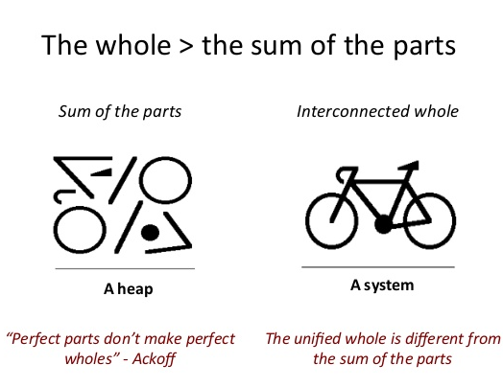
For example:
In DIVVY’s and each bicycle’s system, an element of control is needed to help retain their system identities. This predicates the need for observation, monitoring, and action. In the case of a bicycle’s system, the rider effects decision-making to keep the system’s identity and emergent property alive. Similarly, the DIVVY system requires observation and monitoring of the locations of all bicycles. Action is taken if too many bicycles are in one docking station, and a truck then relocates them to another empty docking station to balance the availability of bikes across the city.

‘Systems thinking’ is a source for discovering and learning about a problem, it’s a process of inquiry that helps to make better-informed decisions. The benefits of this process is that it realizes problems are rarely simple, instead they are rather complex and in need of well-considered solutions.

‘Systems thinking’ as a process looks to achieve three objectives: (1) understand a system’s dynamics—analysis. (2) Understand a system’s hierarchy—synthesis; and (3) develop solutions—decision making. These three elements make it possible to apply ‘systems thinking’ as a function for problem solving.
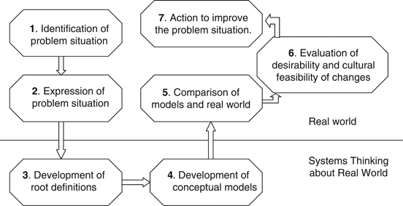

Example:

These five represent the essential “disciplines” of a learning organization. Individuals and companies need to master all five if they want to develop organizations that are capable of learning. The disciplines are also crucial for nurturing the learning individual within an organization.

Question 2


What is a personal vision?
“One day Alice came to a fork in the road and saw a Cheshire cat in a tree.
“Which road do I take?” she asked.
“Where do you want to go?” was his response.
“I don’t know,” Alice answered. “Then,” said the cat, “it doesn’t matter.”
Lewis Carroll

If you come to a fork as Alice does in the above quote, what’s the difference what way you go if you have no clue? A personal vision is what you really want to achieve in your life and your career. While most people wander through their lives without a plan, successful people map out their lives and ultimately achieve much more. As Barbara Geraci said:
‘Our background and circumstances may have influenced who we are,
but we are responsible for who we become.’

Each of us has a unique purpose in life. It’s up to us to uncover our purpose and fulfill it. We all search for significance. We want to know that our life counts. We want to make a difference in this world. Each of us has been given different gifts, talents and skills that we can use for the good of others. If we use our talents to benefit others, and become the persons we were intended to be, we will be blessed, and our lives will take on meaning and significance, and we will be fulfilled.

Peter Senge tells us:
“Personal vision comes from within. We have goals and objectives, but these are not visions. … The ability to focus on ultimate intrinsic desires, not only on secondary goals, is a cornerstone of personal mastery. Real vision cannot be understood in isolation from the idea of purpose, I mean an individual’s sense of why he is alive. Purpose is similar to a direction, a general heading. Vision is a specific destination, a picture of a desired future. Purpose is abstract. Vision is concrete. Purpose is “advancing man’s capability to explore the heavens.” Vision is “a man on the moon by the end of the 1960s.” It can truly be said that nothing happens until there is vision. But it is equally true that a vision with no underlying sense of purpose, no calling, is just a good idea. Vision is something you desire for its intrinsic value; relative visions may be appropriate in the interim, but they will rarely lead to greatness.
It is also clear that it takes courage to hold visions that are not in the social mainstream. But it is exactly that courage to take a stand for one’s vision that distinguishes people with high levels of personal mastery”.

Your personal vision is what you want to create of yourself and the world around you; it guides your life and provides the direction necessary to chart the course of your days and the choices you make about your life, your career, etc. Personal vision is what gives purpose and meaning to your life. It clarifies your values, and provides focus and direction. By defining your life purpose, you can gain clarity, focus, and direction in your life. Personal vision informs the ability to lead the self through uncertainty and anything else put on the path of life-long learning.

A personal vision is what reflects your deepest values and priorities; it encompasses: ‘the person you want to be’, what you want to have, what you want to do, feel, think, own, associate with, and impact by some date in the future. Your personal vision helps you make rational decisions consistently.

A personal vision is what you may want to achieve with your life. Vision, whether personal or organizational, is about purpose, meaning and not goal bound. It is the why not the what. Personal vision is what keeps us on our true course and will be instrumental in us being successful. Successful people don't believe in luck – they create their own success by having a vision and setting out to achieve it.

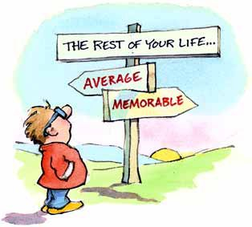

“Destiny is not a matter of chance; it is a matter of choice.
It is not a thing to be waited for; it is a thing to be achieved.”
William Jennings Bryan

Creating a personal vision is a critical step in one’s success and ability to lead, but before doing any organizational visioning, leaders need to articulate their own individual visions. Leaders have a personal vision and use it to guide their decisions and behaviour at work. They may keep it very secret, but make no mistake that they have clear long-term goals. They create a vision and thereby build the organization.

Personal vision totally independent of an organizational vision does not pay in the long run. Such vision should include thoughts on how you can achieve your personal vision within the organization where you work. This will help you set short and long term goals which will influence your daily plans.

A leader manages to live through every day events, attaining desired change and avoiding being manipulated. But in order to avoid being manipulated, he needs to have a vision; because after all, you can’t give directions without a destination, can you?
By creating a vision for your business, you create a destination. You need to know what you want in order to see how to get there.
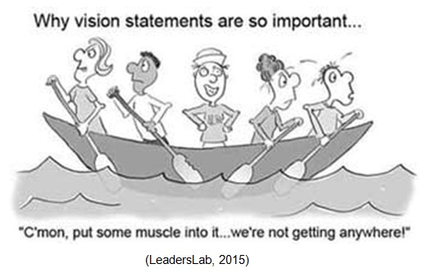

Example:
Here we have a clear example on why ‘vision’ whether it is personal or organizational, is important; especially for a leader:

A vision needs neither be worthy in the eyes of other people nor huge and unwieldy. Your own ‘personal’ vision needs only be important to you. It includes the qualities you’d like to have and what you’d like to contribute to the world. It should inspire and motivate you to be the best that you can be.

To create your personal vision your need to reflect on how well you really know yourself, and bring to awareness the unique talents, gifts, and skills you already have, the desires you crave for and the mastermind to fulfill them. Refection will help you to have a deeper understanding of yourself, to be more aware of who you truly are and what you want. Most of the time we're unconscious! We live on autopilot, stuck in familiar old habits, and we can't see our way out. Self-awareness is a journey towards self-discovery and about understanding different facets of ourselves.

Explore yourself in depth. The more you intimately know yourself, the more you truly know yourself, your character, strengths, weaknesses and potentials, and your deepest desires and aspirations, the better because out of this comes your ‘Personal Vision’, and your short and long term action plans, and the steps to bring change are easier to master focusing your energy and time towards what you really want giving priority to what truly matters to you. But if we don't consciously choose how we spend the precious time of our life, we lose it - to mundane tasks or to meeting other people's expectations.

Having a personal vision is critical to having the life and career that you want. If you don't identify your vision, others will plan and direct your life for you. If you don’t create your vision, it will be determined for you by your circumstances and by other people. Having a defined vision helps you live your life on purpose rather than by chance.

Three Important Steps in Creating a Personal Vision:

1. - Identify your values:

Try not to become a man of success but rather to become a man of value. Albert Einstein

You need to have a clear vision and a concise set of core values; this will help you make the right decisions, the important decisions.

What do you hold most dear to you? What do you value? Our values are deeply held beliefs that govern and guide our behavior. Values are the deep-seated, personal standards that influence every aspect of our lives. This step of identifying our values is defining our identity; including our strengths, weakness, preferences, and long-term ambitions. When we understand who we are and where we are going it is easier to identify the governing principles that will help us reach our destination.
‘A person with nothing to achieve is certain to achieve it’.

Leaders are crystal clear on their values and use their values guide their behaviors and decisions. With a clear and consistent set of values, or guiding principles, leaders demonstrate consistency in their behavior and others understand where they are coming from and why.

Some examples of values are honesty, integrity, faith, family, privacy, harmony, loyalty and love. They are what matter most to us, and are at the core of our being. They’re extremely important, because we make important decisions based upon values. Our behavior, decisions and actions flow from values. In order to uncover our values, we need to ask ourselves, “What is most important to me?”

We start setting aside some quiet time for ourselves, finding a place where we won’t be interrupted or distracted. We try to be open and explore our values and vision. Our mission comes from deep inside us, so ‘we listen to our heart’. Gaining clarity about our personal values is essential to living our life to the full. Clarity about personal values is also important on an organizational level because all organizations are made up of individuals. The degree of success or failure of the organizational unit hinges on whether the values of the individuals are in alignment with those of the organization.

Our personal and organizational values should be an expression of who we are at our ‘core’. If we are not committed to them, no one else will be.


Authenticity Achievement Adventure
Autonomy Balance Beauty
Compassion Challenge Citizenship
Competency Contribution Creativity
Determination Fairness Faith
Friendships Fun Growth
Honesty Humor Influence Inner Harmony
Justice Kindness Knowledge Leadership
Learning Love Loyalty Authority
Openness Optimism Peace Boldness
Poise Popularity Recognition Community
Reputation Respect Responsibility Curiosity
Self-Respect Service Spirituality Fame
Success Status Trustworthiness Happiness
Wisdom Wealth Stability Security
Religion Pleasure Meaningful Work

This is a list of common values. We start by crossing off the values that are not so important to us. Then we go through the list again, marking every value which is important to us, in our daily life and in our work-place. Then we reflect and review them again. We can add any value not written and which is important to us as well. Select 10 out of them all. Then, we narrow down our choice to three or four, so that we do not get lost focusing on too many things at one time; so, by doing this we are focusing on what really matters for us.

2. - Define your values:

In this second step we outline what success for each of the values we chose would look like; writing them down will help us concretize them. Some questions help us to put it all in words: how would you do it? How would you live it in your daily life? How would your life look like if you lived on these values? How would you measure the results? Deadlines? Without a deadline you just dream. How would my life be if …

Having done the preliminary work of choosing your values, then answer the question, “What is my personal vision?” Write whatever comes to mind. This becomes your first draft of your personal vision statement.

We must give meaning to our chosen values by creating clear definitions so that we can understand what behaviours they advocate or forbid.

In this step we start defining our destiny. Our destiny will be determined by the daily choices and the long-term goals we set. We identify first the accomplishments we most want to make, and start mapping a plan that will get us there. How would you demonstrate those three, four values in your day-to-day choices and behaviour?

As Mahatma Gandhi said, "Your beliefs become your thoughts. Your thoughts become your words. Your words become your actions. Your actions become your habits. Your habits become your values. Your values become your destiny"

3. - Put it all together:

Finally, we commit to our goals. Imagine! How great we’ll feel once we achieve our goals. Be sure to write them down. Take your first draft, forming a paragraph bringing your statements together. Research shows that people who write their vision are more likely to achieve it; be as clear, concise, and specific as possible. Better yet, if we share our ‘vision’ and goals with someone close to us, by communicating our vision we’ll be more accountable.

Review your vision and refine it until you feel comfortable with it. The format is up to you. It can be one page, one paragraph, or one sentence. As long as it is meaningful to you, that’s all that matters.

Your personal vision statement is adaptable. It is not meant to be written once and blasted into stone. You should set aside some time on a regular basis to review your personal vision statement

By completing your review and reflection, you’ll feel a sense of accomplishment, learn from your challenges, and continuously improve. Setting a vision and goals for the coming years will provide motivation and focus. This process will help you continually improve yourself and your life.

Having a clearly articulated personal vision statement gives us a template of purpose that can be used to initiate, evaluate, and refine all our activities. Your personal vision, however, does not include the distinctive ways you intend to accomplish your purpose. Many people write an additional personal mission statement and additional goals to help them focus on achieving their vision. These are typically much more robust than a simple personal vision statement

Use your personal vision to guide your day-to-day decisions and actions. By doing so, you’ll find that you’ll move closer and closer to achieving your vision. Then when you reach the end of your life, you can look back with peace and satisfaction, knowing that you have achieved your mission in life!

Question 3

Senge’s Mental Models with reference to effective leadership
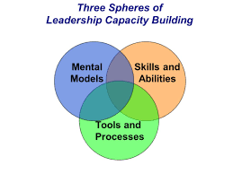

“Insanity is continuing to do the same thing
over and over and expecting different results.”
Albert Einstein

It has been said, and rightly so, that “we become what we think about.” The challenge is for a leader to make sure that he is in fact thinking, that he is thinking about the right things, and that he is thinking critically using solid mental models.

Mental models affect both leadership effectiveness and overall organizational development. They are an important component of Senge's conception of a learning organization. A leader must have a command of mental models in order to effectively build a learning organization; learning organizations are important because they facilitate and encourage learning within all levels of an organization, permitting the organization to adapt and transform in a complex environment. Leaders are responsible for building organizations where people continually expand their capabilities to understand complexity, clarify vision, and improve shared mental models.

According to Senge, mental models often limit the ways in which we think and act. If our mental models are incorrect, we will make the wrong decisions.

For example,
A common mental model for a production manager may be that low-level employees are lazy and that's why production goals are not being met. This mental model consists of an untested assumption and prompts the manager to ignore other possible causes of the problem.

Leaders need to move from the old paradigm and make a shift toward new mental models whenever necessary because they offer more valid and useful ways to effectively deal with the complex challenges in an increasingly competitive business environment.

A leader can overcome erroneous mental models by managing them appropriately. That means he needs to discover his mental models, test each model's validity, and improve them based upon information learned from his analysis and external sources. Leaders have to learn to listen to other people’s vision and to change their own wherever necessary. This way allows others to be involved and to help develop a vision that is both individual and shared.

We are often not aware of the impact of our assumptions etc. on our behaviour and, thus, a fundamental part of a leader’s task is to develop the ability to reflect-in- and –on-action. Leaders need to know that developing effective mental models is the key to their success.

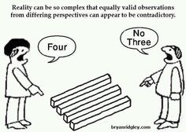
What separate successful leaders from unsuccessful ones is their mental models, the way they view and deal with their world; they have a more valid and effective way of handling the complex issues they face. So what separate them are their mental models and not their knowledge, information, training, or experience per se. Thus the development of effective leaders should focus on acquisition, enhancing or changing mental models that offer more valid and useful ways for effectively dealing with the complex challenges of leadership, rather than relying on learning new information.

For example, in a study conducted at the Center for Creative Leadership (McCall, Lombardo, & Morrison, 1998) successful executives were asked to list their most significant learning experiences. The two highest-ranking categories of learning experience were “hardships” and “challenging experiences.”
The examples of ‘hardships’ included business failure, failure to obtain an expected promotion, and being fired.
The examples of ‘challenging experiences’ consisted of building an operation from scratch, managing a turnaround operation, being part of a task force, being given increased responsibility in terms of people or functions, and so on.

In contrast, executives gave low rankings to those types of experience that were specifically designed to assist people in becoming better leaders like conferences, workshops, in-house training programs, and graduate degree programs. No workshop or behavioral intervention can simulate the urgency and complexity of managing a turnaround operation or the launch of a new product. New mental models are needed, and old models need to change in depth and complexity.

Thus a major key in leader development, and the development of mental models, is challenging opportunities of increased scope and responsibility, opportunities that challenge current mental models in a leader.

For example, the action learning approach developed by Revans (1980), and more recently described in Marquardt (2004), incorporates working on projects of major consequence, teaming with personnel from other functions, receiving continuous feedback on performance and behavior, reflecting on assumptions of current mental models, and having an opportunity to attempt new approaches.

The beneficial effects of leadership mental models depend as well on the accuracy of the mental models. Only shared and accurate leadership mental models enhance organization’s performance and each mental model may be influential in predicting that organization’s performance. The accuracy of a leader’s mental model(s) may influence the quality of his decision making and performance.

Mental models represent a relevant management issue because they affect both our reasoning and our behavior; great leadership requires that leaders challenge their own mental models, and that is the assumptions, beliefs, values and perceptions because both, their decision making and actions are determined and guided by their mental models. Also, great leaders understand that their mental models have much more influence over the outcomes than their actions or decisions being made.

When new conditions arise, such as highly complex challenge of globalization or global financial crisis, leaders can easily fail because they fail to adapt to the rapidly changing and complex external environment. Due to commonly rooted ways of viewing the world, organizations frequently see solutions to their problems limited only by resources, whether time, personnel, or money.

In his dialogue The Republic, Greek philosopher Plato tells a Parable of the Cave in which he concludes that we are all misguided cave dwellers, operating under incomplete or distorted perceptions of reality. The point of the story is that humans are very resistant to challenge and change their own perceptions of reality. In other words, Plato is pointing out that due to our mental models, we refuse to change.

Individuals generally have a tendency to reject data that does not support an already existing assumption. In other words, the trouble begins when we begin to comprehend everything through categories that worked for us in the past. For this reason, mental models are often the greatest barriers to implementing new ideas in organizations, but they are also the area of organizational learning where organizations can make the most significant impact. For the same reason, many good ideas in organizations never go through because they simply do not match prevailing ideology or assumptions and beliefs.

The examples of successful companies are those that are not afraid to introduce new models of thinking.
Examples are:
Apple’s innovation strategy and design thinking.
Dell Computer that completely changed the idea of computer selling and distribution.

Managers often get locked into a mindset due to which they tend to filter out information that does not fit their current paradigm. In order to avoid this, managers have to break the old paradigm and step outside their preconceived mental models to keep pace with an ever changing reality. Management of the 21st century is about change and learning in order to remain competitive and answer the challenges in the contemporary fast-changing business environment.

In order to face this complex system, leaders and organizations must have the capacity to identify and examine their assumptions or mental models. Only when these assumptions are identified and tested, organizations can continuously adapt and improve. Once the mind closes, assumptions grow hard and immobile, and a changing context will pass them by. Affecting both, decision making and implementing strategic orientation, mental models can damage overall organizational development.

Chris Argyris explains how based on prevailing type of mental model, organizations are managing either valid or invalid knowledge. The importance of a mental model here is that it is reflected in the organization’s ability to perform and compete. Many implementation barriers grow out of managers’ assumptions or mental models.

For example, if people believe that sharing bad news at a meeting is going to get them in trouble, they will refrain to do so. As a result, suggests Argyris, the organization receives so-called "invalid" knowledge about its status and overall reality.

Another example is that what many organizations call “planning” is simply a projection of their current mental models into the future. In this case, planning becomes projecting the status quo with a new date.

The underlying reason is mental models which limit us to familiar ways of thinking and acting. For this reason, our projections of the future suffer from basic assumptions that are not generally valid.

In order to avoid these limitations, every planning procedure must, to some extent, expose and challenge the organization’s mental models. This does not mean that all mental models should be changed in a planning procedure, but some of our mental models will have to change in order to prepare the ground floor for changing our future.
The most common reason that many innovative ideas fail to be translated into meaningful strategic organizational actions is simply because such ideas do not match dominant mental models.

The current socio-political and economic climate requires a new approach that necessitate leaders thinking differently about how change occurs and how professionals develop themselves and work with each other’ (Meehan and Reinelt, 2010).

For example, how can a manager deal effectively with an interpersonal problem in his unit if he has certain opinions about an individual? To be an effective leader requires the discipline of mental models which means being able to modify assumptions in order to show the true causes of problems.

The fact is that leaders today frequently face challenges and opportunities that cannot be adequately addressed by reflecting on the past. Leaders must be able to overcome the limitations of their own mental models to develop a new understanding that will ensure the development of innovative, but feasible strategies to deal with an unfolding reality.

Question 4

The five elements of skillful discussion as pointed out by Peter Senge


The term "skillful discussion" is different from the simple term ‘discussion’; it promotes a different experience – one that moves beyond debate and advocacy to a collaborative process and to understand the dynamics of the people involved. Skillful discussion is similar to dialogue, in that the team is attempting to build shared meaning, but the key difference involves ‘intention’.

In The Fifth Discipline Fieldbook, Peter Senge writes:
‘In skillful discussion, the team intends to come to some sort of closure - either to make a decision, reach agreement, or identify priorities. Along the way the team may explore new issues and build some deeper meaning among the members; but their intent involves convergent thinking. In dialogue, the intention is exploration, discovery, and insight. Along that path, the group may in fact sometimes come to a meeting of the minds and reach some agreement - but that isn't their primary purpose in coming together.’

This difference makes skillful discussion practical for work teams, and other people trying to gather diverse opinion and chart a course of action.

Skillful discussion incorporates some of the techniques of action learning and dialogue, but it is always focused on a real task at hand. It helps a team learn to make their thought processes transparent, to bring to the surface and challenge assumptions, and to look more closely at sources of disagreement. The most important part of skillful discussion is the commitment team members make to follow the five protocols recommended for skillful discussion.


During a recent meeting of about 15 people, including two other VPs, I lost my cool. I was not happy with the direction of the discussion and instead of calmly exploring the impasse I let my emotions get the best of me and became angry and upset. I lost my balance.
This meeting could have gone very differently. At the moment I felt my frustration rising, I could have asked myself what I needed to do to find balance. If I had used the fifth protocol (using self-awareness as a resource) and explained my position, asking for feedback in an open and calm manner, I’m sure I could have achieved the skillful discussion needed to achieve the objective at hand. (Roger Hoffmann)

The five elements of skillful discussion as pointed out by Peter Senge:

1. - I will pay attention to my intention

What do you want from this conversation? Be clear of what you want. Notice how this affects your thinking and speaking. Be clear about what your personal intentions are and do not mislead others as to your intentions.

Make sure you know and understand what you hope to accomplish in the discussion, become very self-aware and clarify it to yourself. Ask yourself: “What is my intention?” This has to be more than ‘I want to get my own way’ or ‘persuade everyone to take up my idea’.

Are you willing to be influenced? If you are not, why have the conversation? What is the purpose of it all? Good conversations are rarely about getting it all your own way. Can you be flexible? Entrenched views lead to unproductive, win-lose debate. Think about what would a mutually acceptable outcome look like? Listen to ideas as if for the first time. Work at being open to new ideas and seek understanding of other’s assumptions, values, and aspirations for the topic and team evolution. What observable data (facts, not opinions) can you bring to the group’s skillful discussion?

Don’t withdraw mentally from the conversation. If you say you are going to be open-minded, make sure you are.

2. - I need to balance advocacy with thoughtful inquiry

The focus of inquiry is discovery, exploration, asking lots of questions in an attempt to understand others points of view. The focus of advocacy is making assertions, stating opinions and reasoning, declaring your point of view in an attempt to get others to understand you. Skillful discussion requires a balance of both. When inquiry and advocacy are understood and employed in the pursuit of productive communication they are very powerful. In balancing inquiry and advocacy, it is important that we lay out our reasoning and thinking, and then encourage others to challenge us.

Examples of statements (advocacy) and questions (inquiry) that facilitate this balance:
“Here’s my view and here is how I arrived at it. How does it sound to you?” “What makes sense to you and what doesn’t? Do you see any ways I can improve it?”

While hard on people’s cherished opinions, more creative and insightful realizations occur when people combine multiple perspectives. We need to ensure that the pendulum of advocacy and inquiry remains balanced and does not swing too far to either side. As with dialogue, there is a need to inquire deeper into opinions and comments to surface and challenge hidden assumptions with honesty and integrity and clarify what's being said and avoid a lack of balance which causes misunderstanding, miscommunication and poor decisions. Meaningful challenging is surfacing assumptions and analyzing our thinking.

Make your views and positions known – but also be genuinely open to finding out about other’s views, positions, assumptions and mental models too. Don’t force your view as the only right one. It isn’t. Driving home your own while diminishing someone else’s view strengthens opposition and condones unproductive debate. Ask others about their assumptions without being critical or accusing. Explore others’ points of view and the reasons behind them. Watch the conversation flow, and make comments which pertain to the group process, but not to content.

Examples of questions to ask or statements to make:
“Here’s what I say, and here’s why I say it. What do you think of it?” “What is the question we are trying to answer?”

If this is not done, the team will just sit and listen to each other’s position statements. People’s assumptions will not even surface, much less be challenged. In this case what people are really thinking will surface in the hallway after the meeting.

When advocating, how often do you:
- State opinions and ideas clearly as to paint a picture in others’ minds
- Offer assumptions on which ideas were built
- Provide observable data to support / illuminate reasoning
- Invite others to add to your ideas
- Refrain from defensiveness when questioned

When inquiring, how often do you:
- Ask questions about others assumptions and data without evoking defensiveness
- Ask questions which increased group’s understanding of someone’s opinions
- Listen without judgment

3. - I will try to build shared meaning

Build shared meaning. What do you mean by certain terms? Is something that is "understood by all" really understood? All words are symbols, and as such are abstractions. They often have different meanings for different people, and people interpret them differently. In many meetings, the discussion moves at such a pace and people use words so loosely, that it becomes very hard to build shared meaning. People walk away with vague ambiguous understandings. Decisions made in such an environment won’t work. It is important to use language with great precision, taking care to make the meaning evident.

If people understood that words are symbols and have different meanings to different people, then everyone would routinely check what others mean and there would be far less miscommunication. If you want to create shared meaning it is very important to use language with precision and to question what is really meant 'what is the meaning behind the words?’ As you talk around the meaning, you will get closer to a precise definition, which everyone can agree on.

Be precise. Do not make assumptions that everyone understands what you are saying. Consider each person’s “mental model” as a piece of a larger puzzle. Look at the issues from the other person’s perspective. If people assumed that they did not understand what an individual meant by a particular word unless they inquired about it - then everyone would routinely check the meanings behind the words being spoken more often and there would be far less miscommunication. People walk away with vague ambiguous understandings, even gross misunderstandings of who meant what and who will do what. Thus it is important to use language with great precision, taking care to make evident the meaning-or lack of meaning-in a word. Avoid having phrases in your team lexicon where you assume everyone agrees on the definition, but nobody actually has any idea what it is.

This practice is most important with the simplest phrases:
"You said 'Get it done.' But what's 'done'?" "Well, finish the marketing plan." "Oh. So you're not including shipping." "I hadn't intended to. But what leads you to suggest that our definition of 'done' should include shipping?"
When talking about definitions, particularly for abstract concepts like 'inferences' and 'mental models,' it helps to start out with some sloppiness-so that everyone gets a chance to "feel around" for the right meaning of the word you are using together.
"I just want to exaggerate for a minute," you might say, "so take this with a grain of salt, but I think when we say 'empowerment,' we're actually talking about. . ."
As you talk around the issue, you may get closer to a precise definition which you can all agree on. If the word is important to you, then converge on the meaning with as much precision as possible.

Don’t walk away from meetings with misunderstandings or ambiguities about who meant what and who will do what. Decisions made in such an environment won’t work. Explore the differences; don’t let yourself get defensive about them. Genuinely explore why there are differences of opinion in the group and invite other ideas – instead of debating one over the other.

4. - I will increase my self-awareness as a resource

Use self-awareness as a reference and as a resource. Ask yourself, at moments when you are feeling confused, angry, frustrated, concerned, or troubled, ask, “What am I doing right now? What am I feeling right now? What am I thinking right now? What is happening right now?

Avoid speaking all the time from your own thinking. Allow some inner-space to critically reflect on your thoughts and reactions. Then ask yourself a second primary question: “What do I want right now?” In other words, ask yourself what you are trying to achieve in the conversation. Then choose your response accordingly; you may uncover insights that help the group as a whole. You will often end up with insights into the others’ assumptions or into your own concerns, which you can then raise in the discussion with the team without casting blame.
For example: "You know, this action implies an assumption about our ...” "When you say _____ I find myself disagreeing because _____" The "because" part is very important; or 'When you say such-and-such, I find myself disagreeing because. . ." or simply, "I notice that I'm feeling uncomfortable, and I'm not sure why."

Often simply asking yourself this question will provoke a change, without your making a deliberate decision to change. This can lead to another primary question: “What am I doing right now to prevent myself from getting what I want?” Then change the focus of your attention. Don’t remain stuck trying to push at the same stuck situation.

5. - I will explore impasses or roadblocks to look for ways to move forward

First of all try to determine what you agree on; then pinpoint the sources of disagreement. Simply agreeing on the source of the disagreement often allows people to learn more about the situation, clarify assumptions that previously were below awareness, to learn enough more information to move forward.

Three things might help the team when this happens.
a. Listen to ideas as if for the first time. Work at being open to new ideas.
b. Consider each person’s “mental model” as a piece of a larger puzzle. Look at the issues from the other person’s perspective.
c. Ask yourself (and everyone else): ‘What do we need to do to move forward?’

Ask yourself: What do we agree on and what do we disagree on? What is the impasse? Can we pinpoint the source of the disagreement or impasse? Often sources of disagreement fall into one of four categories.

- Facts – what exactly has happened? What is the data?
- Methods – how should we do what we need to do? Is there only one right way?
- Goals – what is our objective? Is it consistent with our vision?
- Values – why do we think it must be done in a particular way? What do we believe in?

Remember: Listen. Be open to new ideas. Be willing to see the other's perspective. Ask out loud what is needed to move forward.

References & Background Reading
- Achieving Skillful Discussion by Balancing Inquiry and Advocacy. By Cedricj and Roger Hoffmann. June 30, 2015
- Adopt Systems Thinking Strategy to Boost Project Success. By Donna Fitzgerald. April 22, 2003
- A Team Learning Model. By Jeremy J. S. B. Hall 2002
- Creating or revising your personal vision. By Dr. Linda Phillips-Jones. The Mentoring Group. 2002
- Create your personal vision statement. By Susan M. Heathfield. Human resources expert.
- Creating a personal vision. By Rob Yeung. May 3, 2007
- Develop Personal Mastery for Effective Project Management. By Donna Fitzgerald. March 3, 2003
- Decision Making: Risk Management, Systems Thinking and Situation Awareness. A. Mc Lucas. Argos Press, Canberra. 2003
- Focusing on your personal vision. By Kathleen Barton. Jan 4, 2012
- How to Aim High: 3 steps to Create Your Personal Vision. By Jinny Ditzler. May 19, 2013
- How to understand the bias of mental models. By Donna Fitzgerald. April 2, 2003
- Identifying Personal Core Values. By C. Carpenter
- Leadership. Mountain State University. The Learning Organization. Worksheet Seminar 4
- Mental Models and Transformative Learning: The Key to Leadership Development. By Homer H. Johnson. Spring 2008
- Overcoming Organizational Defenses. By Chris Argyris. Prentice Hall 1990
- Shared Vision: A key to project success. By Donna Fitzgerald. April 29, 2003
- Skillful Discussion. “Gracious Space”. Center for Ethical Leadership.
- Skillful Discussion. Protocols for Reaching Decision – Mindfully. By Rick Ross
- Systems Thinking Applied. By R. Edson. 2008. Analytic Services Inc. Maryland. Systems Thinking: A Better Way of Problem-Solving. By Dan Milberg. Jan 15, 2016
- Teaming: How organizations learn, innovate and compete in the knowledge economy. By Amy C. Edmonson. London 1996
- Team Learning: more than group thinking. By Donna Fitzgerald. May 5, 2003
- The Fifth Discipline: The Art and practice of the Learning Organization. By Peter Senge. 1990
- Three Steps to creating your vision. By Craig Ballantyne
- Understanding your mental models can help sharpen PM skills. By Donna Fitzgerald. April 14, 2003
- Values Clarification exercise. By Dan McCarthy. Management and Leadership expert.
- Writing a Personal Vision Statement. By Dr. Linda Phillips-Jones. The Mentoring Group. 2002

Student Statement:

By submitting this assignment, I confirm that this is my own work.

Student Signature | Maria Magdalena Barragan Zermeno | Date | February 29, 2016

For Tutor / Assessor Use Only
Total Marks
Marks Obtained
Percentage / Grade

