#
Assignment Cover Sheet

Student Name: | Asabi Beckles
Student Number: | 1217
Course: | Diploma in Event Management
Assignment NO: | 6

Assessment 6 \Total marks = 30

Q1. Short Questions: (15)
i. What are the main benefits of conducting events in the hotels?
There are many benefits of conducting events within a hotel:

- They are accessible to all budgets
- The venues can vary in size, location and suitability
- Many come with various recognised ratings and awards from bodies such as AA (star ratings), and local tourist boards like Visit England (rose ratings).
- They can accommodate for various client types, from executive meetings, high profile lunches to staff celebrations.
- Facilities and amenities are mostly on-site, including catering, WiFi access, parking and PA systems
- Staff are knowledgeable and able to assist during emergencies or when technical issues arise

ii. Outline the basic steps in developing a site plan.
When choosing an appropriate site/venue it is important to complete the following to ensure all components are in place when finalising the event prior to the opening/launch date:

  - Determine the event’s site requirements – size, location, capacity, accessibility, ability to facilitate internal/external decoration/displays, if appropriate.
  - Investigate a range of sites/venues and cross reference them against the event’s site requirements.
  - Decide on the most suitable site/venue ensuring it closely matches the event’s requirements in terms of budget and compulsory facilities, etc.
  - Ensure a site plan is obtained or prepared to scale - detail is key for preparation, for example the number and location of exits.
  - Decisions must be made regarding the placement of event activities and facilities
  - Refine the site plan accounting for stakeholders needs, for example the location of sponsor’s displays.
  - Record all activities as the site plan is essential when planning and communicating with staff and stakeholders.

iii. Describe the main factors which need to be considered when selecting a venue.

A number of factors need to be taken into account when selecting the right venue it is important the following steps are completed as they significantly reduce the likelihood of emergencies or undue complications:

- Capacity – in terms of size and availability of specified dates
- Location and distance from transport systems/parking
- Disabled access
- Venue reputation and customer feedback
- Technical Equipment – dedicated set-up/rehearsals areas, staging facilities or dressing rooms
- Catering availability
- Cost of additional add-ons
- Any venue restrictions – use of specific areas, parking bays, adapting/removal of current displays etc
- Immediate venue decor and atmosphere
- Availability of facilities and amenities such as Power, water and Waste management arrangements, including number of toilets
- Arrangements and procedures for deliveries/emergencies
- Safety and Security considerations/arrangements
- Other events at the venue at the same time
- Weather contingency

Q.2. An award dinner for employees to share company’s growth is going to be held on the weekend. It is an informal party containing some entertainment for the attendees. Maximum number excepted to attend this dinner is 50. The company is a private legal firm and enjoys very good repute at national level. (7)

a) Select an appropriate venue for the party
Location: Alexandra Palace in North London – Palm Court Suite

b) Which type of arrangements would be required?
- View venue website or speak to bookings staff
- Investigate room sizes and décor within budget range
- Accessibility via public transport with onsite customer parking and disabled facilities
- View seating plans
- Optimum capacity: 50+ people
- Options for either on-site or self-arranged catering
- Access to bar area/range of drinks

Alexandra Palace offers:
- Transport arrangements:
- London Underground stations: East Finchley, Hornsey and Wood Green
- London Overground stations: Crouch End
- National (London) Rail stations: Alexandra Palace
- Bus: W3 or Shuttle bus service
- Sat Nav: N22 7AY (via North Circular)b
- Disabled Parking
- Venue Capacity: 5000 people maximum
- Site/Room Capacity: 80 – 300 people
- On-site Catering
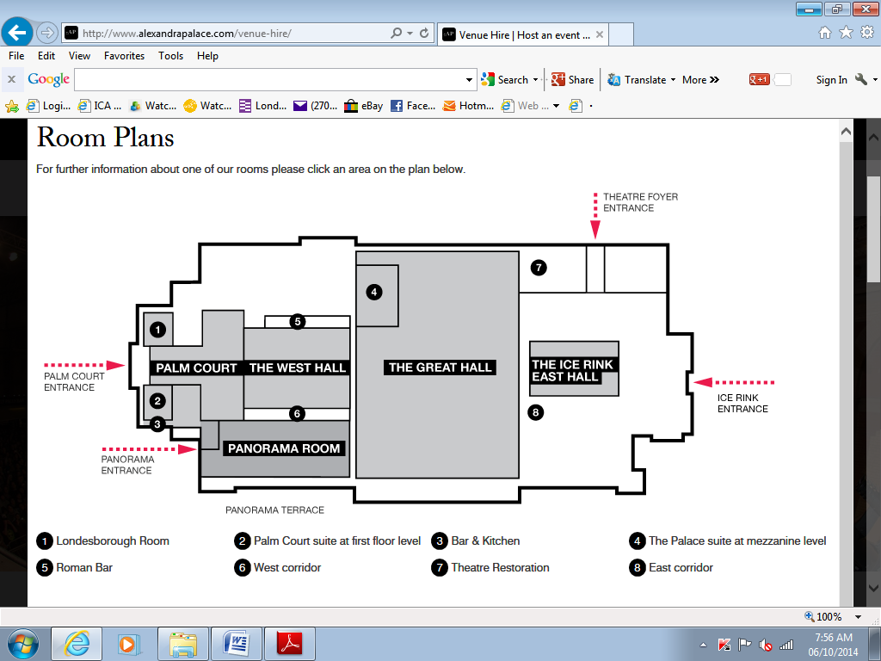
http://www.alexandrapalace.com/venue-hire/

c) Which type of facilities would be required?
Facilities Required:
- Disabled Parking
- Toilet
- PA systems
- Stage Area
- Power supply points
- Tables and Chairs
- Large screen display

Alexandra Palace Offers:
- Side bars or extra rooms fully serviced by our dedicated in-house catering team
- 3 phased power
- WiFi
- Organiser’s offices
- In-house security
- In-house catering and work with an experienced and approved catering team
- 3 course meal
- Tea, coffee and mints
- Drinks reception
- Side bars and breakout rooms - Facilities for a cash or account bar
- Production packages available bespoke to your needs.

d) How best the attendees can be entertained?
- Comedy performances
- Cabaret selection

Q.3. ‘Global Soft Tech’ is an IT company looking to launch its new product – easy to use and cost effective software for managing personal finances. It is expected that the product with its immaculate features will bring a revolution in the software industry. 500 people have been formally invited to attend this product launch event. Representatives of some companies will be coming from other cities and may arrive a night before. The event timelines will be as follows: (8)

Guests Arrival: 5 pm
Speech from the Chairman: 5:30 pm
Speech from the voice president: 6:00-7.00 pm (He will introduce the product and will present its demo)
Entertainments: 7:00- 8:00pm
Dinner: 8:00 pm
Based on the above case:

a) Which type of a venue would best suit for such an event?
Conference centre – as hotel accommodation is normally nearby for those arriving the night before.

b) Which facilities should be available at the venue?
- Display screens
- Staging area
- PA and sound system
- Seating for 500+
- Access to on-site technology: i.e. WiFi, possibly laptops, projectors, smart boards, etc
- Catering options
- On-sight security and staff assistance
- Toilet and waste management facilities
- Provision for disabled guests – i.e. parking, access ramps, etc

c) Which types of seating arrangement would be fine for this event?
Theatre style seating

d) Any special considerations for dinner?
- Food allergies, i.e. shellfish, nuts, lactose, etc
- Special health requirements i.e. Vegetarian, Celiac,
- Medical conditions – Diabetic, those on special medications, etc

e) How much time would you allow for the dinner?
20-mins per course

Student Statement:

By submitting this assignment, I confirm that this is my own work.

Student Signature | Asabi Beckles | Date | 7/10/2014

For Tutor / Assessor Use Only
Total Marks
Marks Obtained
Percentage / Grade

