
Assignment Cover Sheet

Student Name: | Drew Wilkins
Student Number: | 1318
Course: | Diploma in Fashion Design
Assignment NO: | 2

Marking Criteria:
We expect the learners to write minimum one well expressed point in three lines against each allocated mark. This means one needs to write 15 lines with 5 well expressed points to get high grades for a 5 marks question.
For high grades use examples and illustrations where appropriate.
Please insert your completed assignment ( in word format) here:
Principles of fashion.

What is fad?
A Fad is short lived fashion, it stays for a very short period, because they are very costly and every one cannot afford to buy it, like a craze as such.

Define the term ‘fashion forecasting’.

Fashion forecasting is a world-wide career that focuses on upcoming trends. A fashion forecaster predicts the colours, fabrics and styles that will be existing on the runway and in the stores for the upcoming seasons.

How would you differentiate fashion forecasting from trend forecasting?

Fashion forecasting find the upcoming trends down to colour, fabrics and style whereas the trend may appear in a fabrication, a silhouette, or another design element that appears in several collections.

What is meant by fashion trends?

A trend is any form of behavior that develops among a large population and is collectively followed with enthusiasm for some period. Fashion trends are something that appears in numerous collections.

Outline the basic practical considerations that a customer takes into account when selecting fashion garments or accessories?

What a customer will take into account when selecting a fashion garment or accessories is the colour and texture, the colour because it may not suit the customers colouring and they relate to texture because of its sumptuous appeal, also what they take into consideration is the style price and fitting.

What is the difference between fashion and style?

Fashion is concerned with what’s out there, such as, fashion items in stores, run ways and add campaigns. Therefore, fashion is more focused with what’s on trend and who’s wearing it. Kendall Jenner is a huge fashion icon at the moment for young women around the world. She is very simple and elegant with what she wears. She’s seen on runways, magazine covers and also on the TV daily.

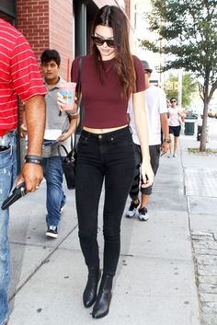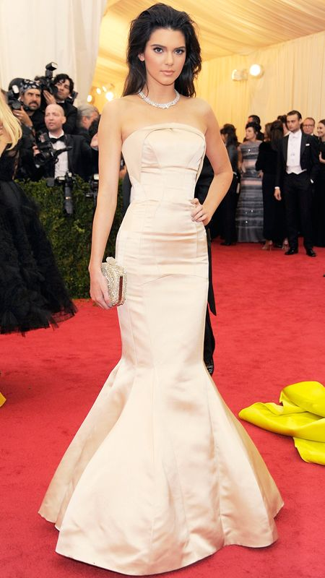

Style, on the other hand is what makes the fashion industry so exciting and unpredictable. Where style is on the person it’s what makes them unique, how they express their individuality and creativity a way to express your personality. You may feel in the mood for a certain style depending on how they feel when they wake up in the morning, or going to a certain event and want to match there outfit with the atmosphere of that event. For example if you’ve been invited to a wedding or black tie event you will dress for the occasion with a twist of your own personal style.
Many fashion designers build their empires on their own style such as Rihanna,

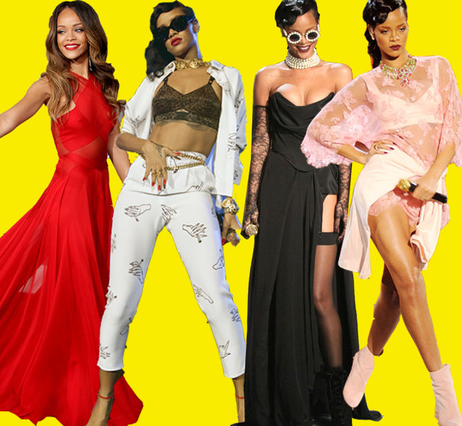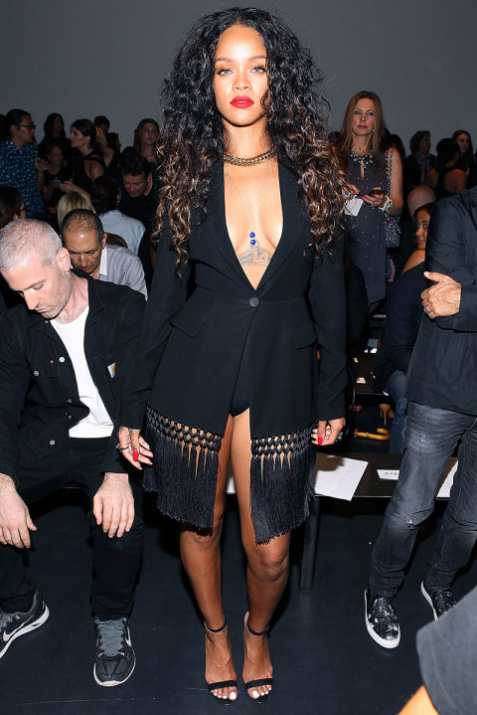

Although she’s a huge fashion icon she also designs her own label in her own distinctive way as you can see her own style in her clothing line in the pictures below.

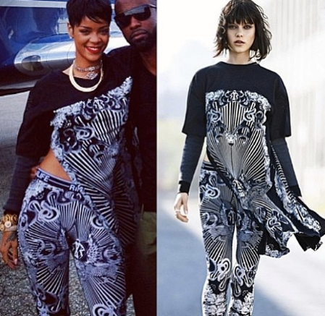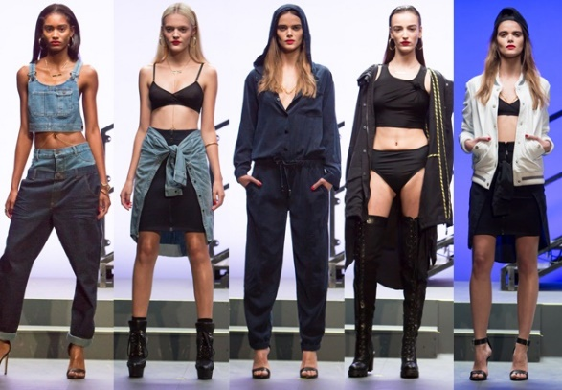

A designer may envision their muse as someone just like them. This is how fashion is created and then evolves into a cycle that is recreated throughout the years.

Student Statement:

By submitting this assignment, I confirm that this is my own work.

Student Signature | Drew Wilkins | Date | 16/05/15

For Tutor / Assessor Use Only
Total Marks
Marks Obtained
Percentage / Grade

