
Assignment Cover Sheet

Student Name: | Sumbal Jamil
Student Number: | 1149
Course: | Fashion Design
Assignment NO: | 1

Student Statement:

By submitting this assignment, I confirm that this is my own work.

Student Signature | Sumbal Jamil | Date | 10-10-2013

For Tutor / Assessor Use Only
Total Marks
Marks Obtained
Percentage / Grade

Name: Sumbal Jamil
Student No: 1149
Assessment No: 1
Course: Fashion design
Sumbal.jamil94@yahoo.com

1. Objective Answers.
a.1960
b.1908
c.The Maison Redfern
Answer no: 2
2. First World War had great and pronounced effect on women’s fashion in the western world. As women’s role in western society changed, modern fashion changed along with it. Several trends that had great importance were rapidly changed by wartime conditions. Many of the changes came about because women took over jobs previously done by men. Women became more visible in the world of work. They were seen to be doing important jobs. Women adapted men’s clothing for comfort .Women’s dresses completely hid their female features and they looked like men in society.
Changes due to First World War:
a. The great change happened to women’s hemlines. Hems which had risen to ankle length rose to the mid-calf length by 1916 and had stayed higher ever since.
b. The flapper style became popular and new icon of all that was young and fashionable.
c. The bell shaped hat and sportswear became popular with both men and women.
d. Several fashion like women trousers and short hair were promoted as practical fashion.
e. Women borrowed their clothes from men’s wardrobe and chose to dress like boys.
f. Most women did not suddenly cut their hairs but once it became acceptable to do so gradually more and more women did it in next decades.

Answer no: 4
Work of main fashion designers of 1970s: Following are the main fashion designers of 1970s.
- Work of Sonia Rykiel: She was the designer of 1974.she designed sweater with reversed seams. She created a range of clothes that could be worn almost everywhere. She was dominated by fluid knitted garments, dark black rhinestones, boa like scarves and crocheted hats. She was considered as the true successor of Chanel.
- Work of Laura Ashley: She was popularized for countrified style of clothing which consisted of long flounced skirts and high necked blouses in traditional floral prints worn with crocheted shawls. She started a business in mid 1960s and the company continued until the death of its owner in 1985.
- Work of Bill Bass: He launched his own range in 1962.He had the habit of travelling all over the United States so he could hear his customers and he was almost successful in fulfilling his customers wants. His style and workmanship was favored by businesswomen and wives of senior executives.
- Work of Milian: He was second famous designer in Paris as Paris was the center of international fashion.
- Two most influential designers of 1970: Giorgio Armani and Nino Cerrito.

Answer no: 3
Characteristic features of 20th century: following are the characteristic features of 20th century:
- Paris as centre in fashion industry: All high fashion originated from Paris in early 20th century. Fashion magazines from other countries sent editors to the Paris fashion shows.
- First real fashion show: were originated during this time period by first female designer Jeanne.
- 1st world war: It had great effect on women’s fashion in western world. Women had to take part with men in work force so women adapted men’s clothing for comfort. After world war, the great changed happened to women’s hemlines. It rose to the mid-calf length and had stayed higher ever since.
- Great depression: In 1929, great depression set in, hemlines returned to more conservative length (below the knee or lower).

- Art Deco movement: It began to emerge during this time and its influence was evident in the designs of many fashion designers of that time.
- Coco Chanel (designer): She was major figure in fashion at that time. She went on to revolutionize women’s clothing preserving, comfort and elegance.
- Lanvin’s name in fashion yearbook: Her name appears in fashion yearbook from about 1901 onwards. In 1920s, she reached the peak of her popularity and success.
- Second World War: During 2nd world war, luxurious fabrics like wool, silk and nylon were highly regulated and women’s shirts and dresses were often made of viscose and rayon.
- Simple looks or trends due to war: The fashion trend during this time was simple due to war because shops had been closing down. Hats were key items in this time. Skirts were lengthened and widened to give women a simpler look.
- Hourglass shape: In 1950s, hourglass shape became popular in this era to show off a women’s figure. Short skirts, wide shoulder and strapless were popular fashion.
- Hippie fashion: In late 60s and 70s, hippie fashion took over and loose fitting maxi skirts and dresses became dominant. Disco dresses, denim dresses, high waist jeans, jumpers and glitzy dresses were also popular.
- Trends in 80s: It was all about colors and wild prints. A popular look of 80s was miniskirts; legging and leg warmer fashion became highly influenced by music stars and movies. Oversized tops were also popular in 80s.
- Casual look of 90s: Skirts and dresses were not as prominent and more casual looks became acceptable with hip-hop and alternative music setting the scene for fashion early in the decades.
- T-shirts a way to express individuality: T-shirts have become more a way to express individuality and person’s taste.
- Commercialization: The 1990s saw a lot more commercialization of fashion to promote status and trends.
- Influential designers: Jacques Doucet, Mariano Fortuny, Elsa Schiaparelli, Edith Head, Orry-Kelly, WilliamTravilla, Gilbert Adrian,Emilio Pucci, Pacco Rabanne,Giorgio Armani, Nino Cerruti , Michael Kors, Calvin Klein etc.
Answer no: 5
Influence of19th century on fashion industry: Fashion industry changed radically as the 19th century began simpler and lighter. The first fashion designer who was not merely a dressmaker was Worth. Before the former draper set up his fashion house in Paris, clothing design and creation was handled by largely anonymous tailors and high fashion descended from styles worn at royal court. Worth’s success was such that he was able to dictate to his customers what they should wear.

Changes in fashion in 19th century:
- The use of tiny piping to finish seams began in this century.
- Dresses became slightly more structured with padded hems and firmer fabric.
- Soft colors returned to fashion after 10 years absence.
- Skirts hems widened ever so slightly.
- Fabric trimming was used extensively.
- As romantic era arrived, clothing becomes more complex and increasingly structured.
- The previous design simplicity was replaced with decorative excess.
- First cross cut mutton sleeves appeared.
- Ankle length skirts became quite full and needed several petticoat beneath for support.
- Short capes with longer front ends called pelerines become quite popular. The focus was clearly on femininity. Aprons were popular accessories.
- The gothic era arrived on the scene and fashion lines wilted dropping ringlets and dragging skirts.
- The hoop was worn almost universally and could be seen on ladies, maid, middle class and shop girl.
Reason: The reason of changes in fashion industry is the first fashion house set up in 19th century. Before this time, clothing was custom made and hand made for individuals either as home production or an order from dressmaker or tailor but the first fashion designer Worth changed the fashion industry by set up 1st fashion house in Paris.

Activity
Difference between modern fashion dresses and past dresses: Fashion is an art that recycles itself. We would also notice that mostly each year there are new trends and new fashion. The biggest difference between fashion then and now is simply technology in textiles and just in general. Textile as a science has evolved in ways that were unimaginable during the past. This changes how fabrics can be used and shaped. Fashion changes very quickly and is not limited with one group or area of the world but is spread throughout the world where people can communicate easily with each other. The greatest difference would be society .Women as well as men are more casual in dress today than they ever were. Most people took comfort in every aspect of their clothing. People just wear what they feel more comfortable with. There was a time when women and men would not leave the house without wearing a hat and a pair of day gloves but today most people want effortless fashion that is comfortable and timeless.

Comparison of last two decades fashion with today’s fashion:
- The grunge look: It was famous during past two decades; it was influenced by rock music which was popular during this time period. The clothing was influenced by hit music group. The grunge look was big during past time, now it is not really popular. We only see certain people who probably have that kind of look.
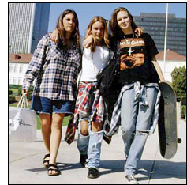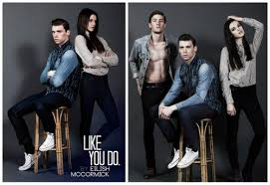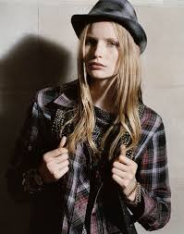
Grunge fashion during last two decade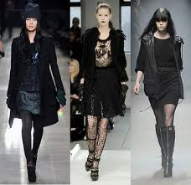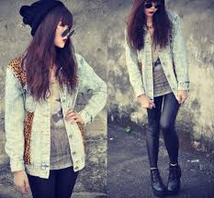
Latest Grunge fashion

- Trousers: It was the famous fashion of past decades but it is not a big part of today’s fashion. We only see some/few people wearing trousers.

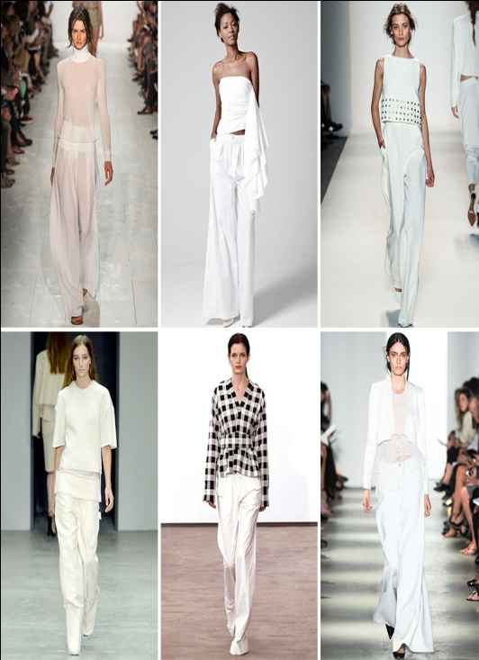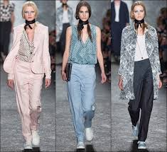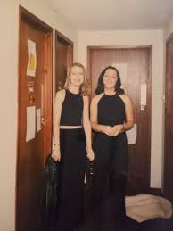
Trouser Fashion during last two decades
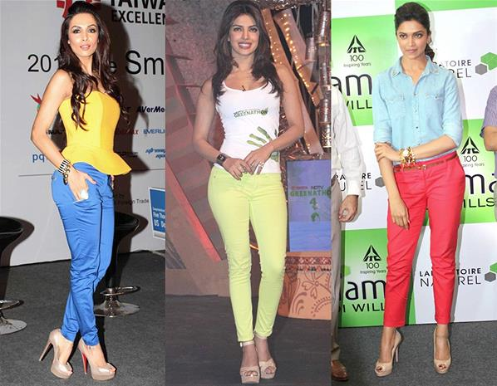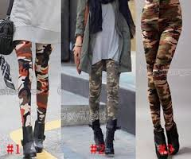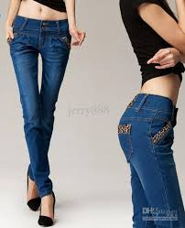
Latest Trouser Fashion

- Capri pants: It came very popular in past time. People now still wear Capri pants .In past decades people wore their pants higher now people wear them lower.

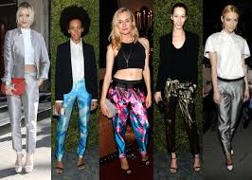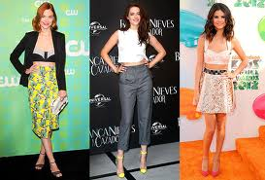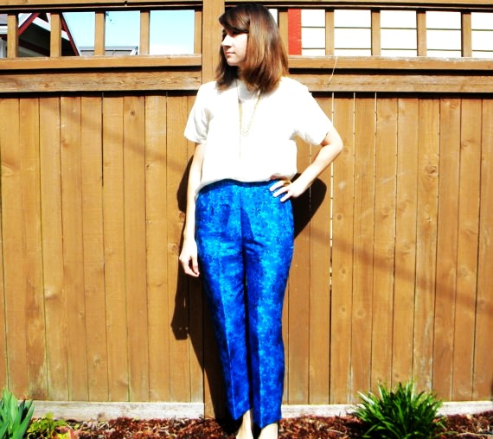
Capri Fashion during last two decade
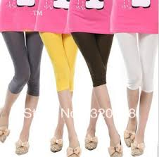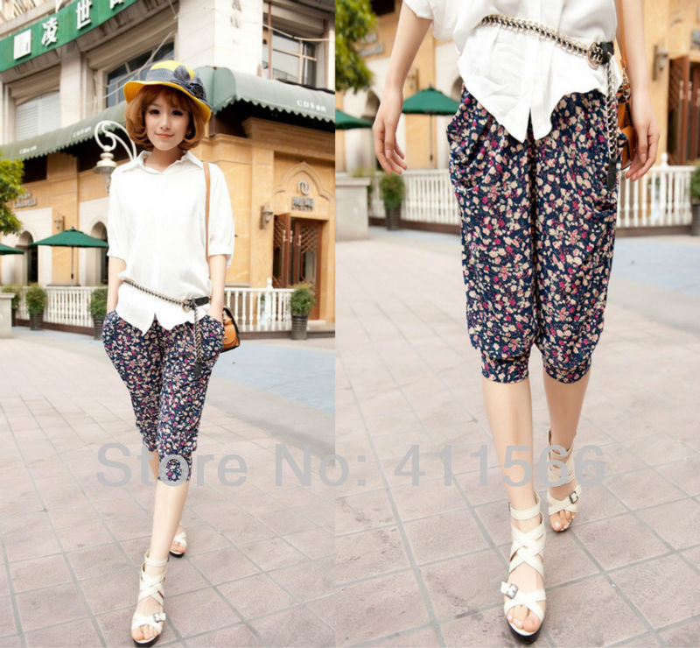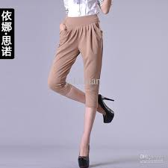
Latest Capri Fashion

- Petticoat dresses: These dresses were famous in past decades. These dresses were made out of soft material; it had cowl neck and was womanlike in their overall look. We only see a few women wearing it.
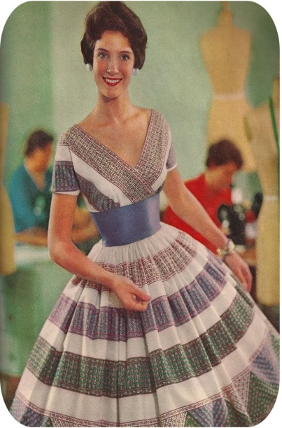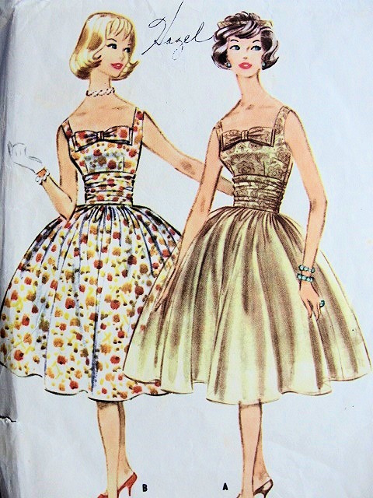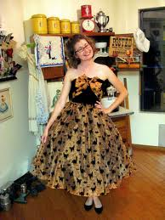
Petticoat dresses during last two decades

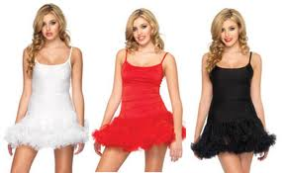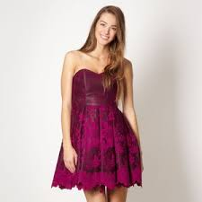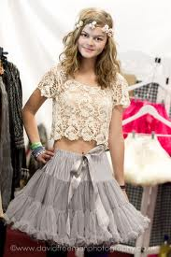
Latest Petticoat dresses

Peace symbols: These were seen on shirts in past decades but now peace symbols are not only on shirts but on accessories, handbags, or any type of clothing, wallets, phone cases etc.
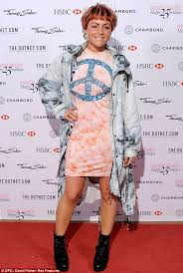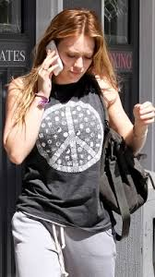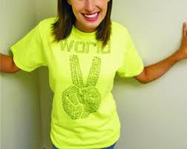
Peace Symbols during last two decades
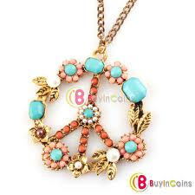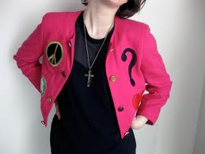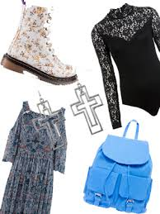
Latest Peace Symbols Fashion

- Leather jackets: was worn in past decades but it was not really popular but people still wear leather jackets. If we go to the mall or any other store, we would probably see some jackets.
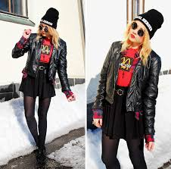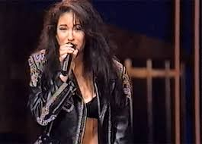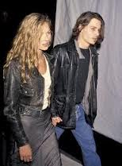
Leather jackets fashion during last two decades
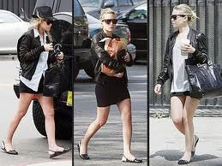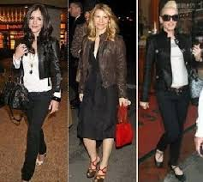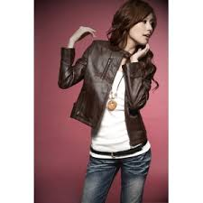

Latest leather jacket fashion

- Over-sized or baggy dresses: It was famous during past decades. Now there are guys that still wear baggy clothing just like past time or ever bigger. It depends what style we have.

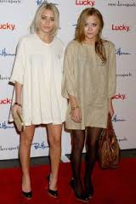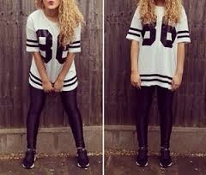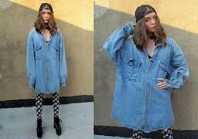
Oversized dresses during last two decades
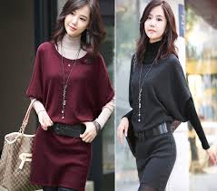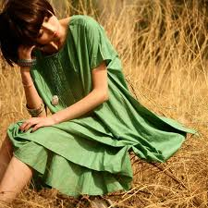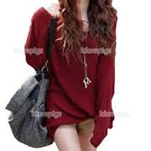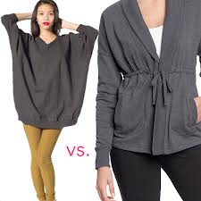

Latest oversized dresses

