
Assignment Cover Sheet

Student Name: | MAJALIWA FREDRICK
Student Number: | 1506
Course: | DIPLOMA IN ACCOUNTING AND FINANCE
Assignment NO: | 1

Marking Criteria:
We expect the learners to write minimum one well expressed point in three lines against each allocated mark. This means one needs to write 15 lines with 5 well expressed points to get high grades for a 5 marks question.
For high grades use examples and illustrations where appropriate.
Introduction to Accounting & Finance
Assessment 1 Total Marks: 30
1. Give short answers for the following questions: (18)
I. Define ‘Accounting’.
Answer:
Accounting - a process of identifying, recording, summarizing, and reporting economic information to decision makers in the form of financial statements. Financial accounting - focuses on the specific needs of decision makers external to the organization, such as stockholders, suppliers, banks, and government agencies. The accounting system is a series of steps performed to analyze, record, quantify, accumulate, summarize, classify, report, and interpret economic events and their effects on an organization and to prepare the financial statements.
Accounting can be defined as an information system that provides reports to stakeholders about the economic activities and condition of a business.

"Accounting is the science of recording and classifying business transactions and events, primarily of a financial character, and the art of making significant summaries, analysis and interpretations of those transactions and events and communicating the results to persons who must make decisions or form judgment." by -Smith and Ashburne.

"Accounting is a service activity. Its function is to provide qualitative information, primarily financial in nature, about economic entities that is intended to be useful in making economic decisions." Source:--Accounting Principles Board

II. Explain the primary objectives of accounting.
Answer
The objectives of accounting are:
- To maintain Systematic Records of Financial Transactions an Events
- To ascertain Profit or Loss
- To ascertain Financial Position
- To assist the Management
- To communicate accounting Information to Users

III. Discuss the limitations of accounting.
Answer:
Followings are the limitations of accounting
- Accounting is not Fully Exact
- Accounting does not Indicate the Realisable Value
- Accounting Ignores the Qualitative Elements
- Accounting Ignores the Effect of Price Level Changes
- Accounting may Lead to Window Dressing

IV. Explain the term “recordative”.
Answer:
What is recordation? It is a voluntary system permitting transfers of copyright ownership to be recorded with the Copyright Office. Recording a transfer is done by You file EITHER the original transfer OR (more often) a copy that is accompanied by a sworn certification that it is a true copy of the original transfer

Recordation operates as constructive notice (so long 2 conditions are met: work is specifically identified and there is a registration of copyright for the work)

V. Which types of activities are included in data evaluation?
Answer:
Data evaluation activities includes but not limited to controlling the business activities through preparation of budgets and standard costs, evaluating the performance of the business, analyzing financial statements, analyzing cash flows and choosing alternative courses of action for decision-making process. Evaluation of data is one of the most important business activities.

VI. Outline the main functions of accounting.
Answer:
The functions of accounting are:
- Maintaining Systematic Records
- Communicating the Financial Results
- Meeting Legal Requirements
- Protecting Business Assets
- Assistance to Management
- Stewardship

VII. Considering the following groups;
Lenders
Employees
Customers
Please suggest information that each one is likely to need from accounting statements and reports.
Answer:
In Brief statement, the following outlines describes briefly information from financial accounting reports to each section/group of people:-
- Lenders
  - Lenders need information about the profitability and solvency of the business in order to determine the risk and interest rate of loans

- Customers
  - Customers are interested in long-tem stability of the business and continuance of the supply of particular products
- Employees
  - Employees are interested in the stability of the business to provide employment, fringe benefits and promotion opportunities

VIII. Distinguish management accounting from financial accounting.
Answer:
Managerial accounting uses both financial accounting and estimated data to aid management in running day-to-day operations and in planning future operations. Management Accounting is the most recently developed branch of accounting. It is concerned with generating accounting information relating to funds, costs, profits, etc., as it enables the management in decision-making. We may say that Management Accounting addresses the needs of a single user group, i.e., the management

While Financial accounting is primarily concerned with the recording & reporting of economic data and activities for a business to external parties. Financial Accounting is that branch of accounting, which records financial transactions and events, summarises and interprets them and communicates the results to the users

IX. How does the accountant help in planning and control process of a large commercial organization?
Answer:
Management’s activities and responsibilities can be classified into the following three broad functions: Planning, Directing and Controlling
With Planning, it means accountant Manager has to:-
- Look ahead and establish objectives such as –
    - Maximize short-term profit
    - Commit to environmental protection
- Note key Objective that Add value to the business. Value measured by trading price of stock and by potential selling price of the company

While with Controlling, management accountant has
- Keep activities on track
- Determine whether goals are met
- Decide changes needed to get back on track
- May use an informal or formal system of evaluations
Good decision making is the outcome of good judgment in planning, directing, and controlling.
The diagram below summarizes Planning and controlling function of Management accountants
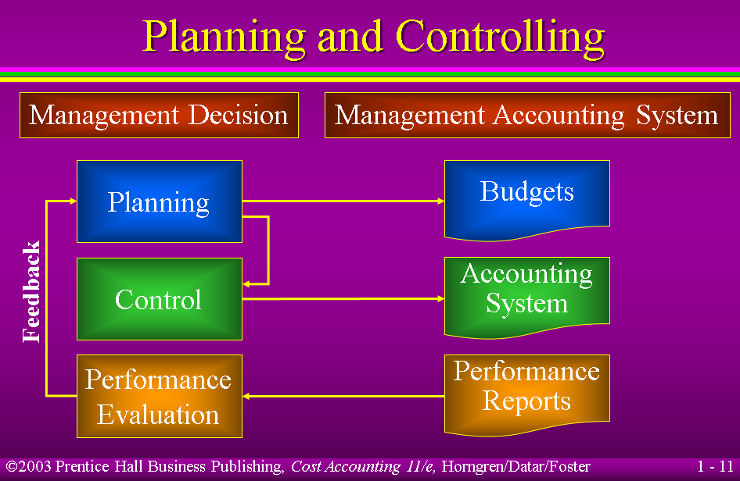

2. Discuss the role of accountants in modern business organizations. (4)
Answer:
Understanding the Role of Accountant, must first answer such questions as :-
- Who really is our client: the company, the management, current shareholders, future shareholders, and the public?
- Do I owe primary loyalty to my employer, client, boss, profession, myself, or the public?
- Am I a professional accountant bound by professional standards, or just an employee?
- Is professional accounting a profession or a business - can it be both?
- When should I not offer a service?
- Can I serve two clients with competing interests?
- Is there any occasion when breaking the profession's guideline against revealing confidences is warranted?

The following outline describes the Public expectations of Accounting Profession
- Essential Features: (Bayles)
  - Extensive training
  - Provision of important services to society
  - Training and skills largely intellectual in character
- Typical Features:
  - Generally licensed or certified
  - Represented by organizations, associations, institutes
  - Autonomy
- Foundation of Ethical Values: (Behrman)
  - Significantly delineated by and founded on ethical considerations rather than techniques or tools
Features and duties of accounting profession are:-
Features:
- Provision of important fiduciary services to society
- Extensive knowledge and skill are required
- Training and skills required are largely intellectual
- Overseen by self-regulating membership organisations
- Accountable to governmental authority

Duties essential to a fiduciary relationship:
- Continuing attention to the needs of clients and other stakeholders
- Development & maintenance of required knowledge & skills
- Maintenance of the trust inherent in a fiduciary relationship by behaviour exhibiting responsible values
- Maintenance of an acceptable personal reputation
- Maintenance of a credible reputation as a profession

The following are rights permitted and values necessary to discharge duties and maintain rights for accounting profession are outlines below:-

Rights permitted in most jurisdictions:
- Ability to hold oneself out as a designated professional to render important fiduciary services
- Ability to set entrance standards and examine candidates
- Self-regulation and discipline based on codes of conduct**
- Participation in the development of accounting & audit practice
- Access to some or all fields of accounting & audit endeavour
Values necessary to discharge duties & maintain rights:
- Honesty & Integrity (i.e. truth & the whole truth)
- Objectivity - based on independent judgement
- Desire to exercise due care
- Competence
- Confidentiality
- Commitment to place the needs of the public, the client, the profession, and the employer or firm before the professional's own self-interest

3. What is accounting cycle? Outline the basic steps included in accounting cycle. (4)
Answer:
The process of identifying and measuring economic events that leads to communication and decision making. There are ten steps explained below:-

- Obtain information about external transactions from source documents.
  - Check stubs
  - Invoices
  - Receipts
  - Remittance advices
- Analyze transactions.
  - Accounts affected?
  - Increase or decrease?
  - Account type?
  - Debit or credit?
  - Debits equal credits?
- Record transactions in a journal.
  - General journal is the most common
  - Sometimes referred to as the “book of original entry”
  - Transactions recorded chronologically
- Post transactions to ledger.
  - Reorganizes information by account
  - Often handled with information technology today
- Prepare an unadjusted trial balance.
  - Verifies the equality of debits and credits in the ledger
  - Does not indicate an error-free AIS
- Record and post adjusting entries.
  - Account for timing differences between cash and accrual
  - Six types
    - Accrued expenses & revenue
    - Prepaid expenses & deferred revenue
    - Bad debts & depreciation
- Prepare an adjusted trial balance.
  - Same purpose as unadjusted trial balance
  - Only difference is in the timing
- Prepare financial statements.
  - Income statement
  - Statement of changes in equity
  - Balance sheet
  - Statement of cash flows
- Close temporary accounts to retained earnings.
  - Year-end only
  - Also called “nominal” accounts
  - Revenues, expenses, gains & losses
- Prepare post-closing trial balance.
  - Same purpose as other trial balances
  - Difference, once again, is timing
  - Contains only balance sheet accounts

The diagram below summarizes the accounting cycle
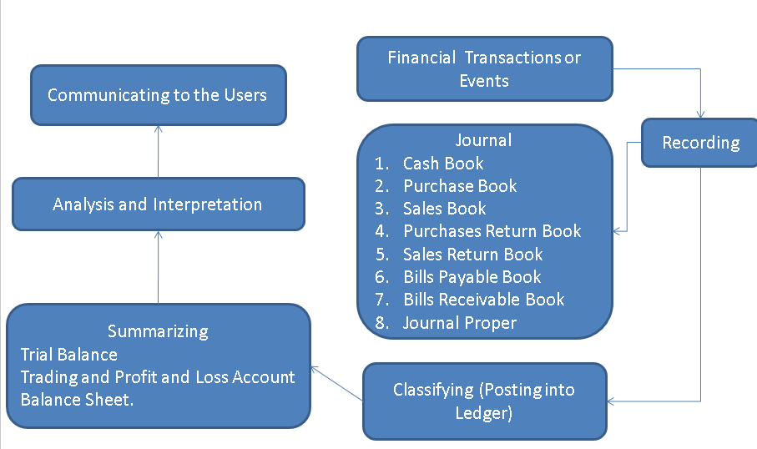

Activity (4)
List the various accounting activities that an organization under takes and give reasons for each as to why that particular activity is performed in the organizations.
Answer:
Accounting activities can be summarized in broader terms by the following points below:-
- Explain manufacturing and nonmanufacturing costs and how they are reported
- Compute cost of providing a service or manufacturing a product.
- Determine behavior of costs and expenses as activity changes
- Assist management in profit planning and formalizing these plans in the form of budgets.
- Help to control costs by comparing actual results with planned objectives and standard costs.
- Accumulate and present data for making decisions.

Student Statement:

By submitting this assignment, I confirm that this is my own work.

Student Signature |  | Date | 15th Sept, 2015

For Tutor / Assessor Use Only
Total Marks
Marks Obtained
Percentage / Grade

