
Assignment Cover Sheet

Student Name: | Ray Wilson
Student Number: | 1390
Course: | Environmental Management
Assignment No: | 11

Assignment 11 Total Marks 30

1. Write short notes on the followings: 10

a) Emission Standards (dust/nongaseous pollutants)

Emission standards are legal requirements governing air pollutants released into the atmosphere. These Emission standards set quantitative limits on the permissible amount of specific air pollutants that may be released from precise sources over exact timeframes. They are generally designed to achieve air quality standards and to primarily protect human health.

A number of ambient air quality and emission standards exist, based on the maximum impact allowed before harm is likely or nuisance is perceived. There can however, be conflict between these two strategies as an emission standard may allow for a particular level of dust emission that exceeds an air quality standard. An air quality standard will allow for all source contribution, both natural and anthropogenic. Therefore, a mineral extraction process will add to the existing "background" dust levels and requires assessment as to what the level of contribution is. This will require the forecast of the dust emission prior to development approval, and monitoring (and discriminating between) both the "background" and actual dust emissions during site operations.

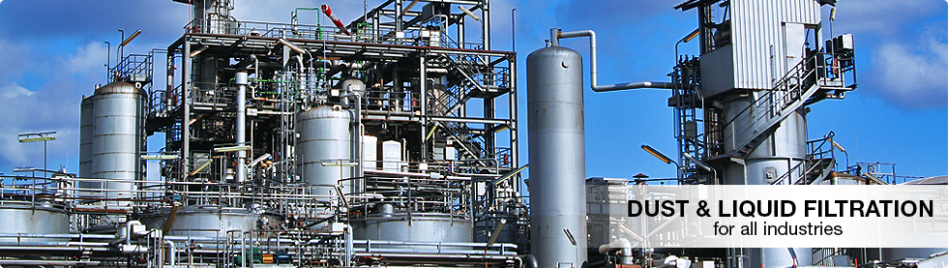

The maximum permissible level of dust in the form of suspended particular matter (SPM) is 150 mg/ Nm3 (read as milligram per normal cubic meter). Dust particles are released from chimneys and stacks of thermal power plants, iron/steel plants, fertilizer plants, small industry boilers and stone quarrying activities. Of course emissions can be controlled and there is technology available to ensure discharges are measured and limited accordingly as illustrated above. There are other pollutants emitted into the atmosphere in addition to dust particles and these normally consist of droplets of dissolved gases suspended in air, sometimes referred to as acid mist or rain. These droplets consist mainly of aqueous solution of varying proportions of gases like SO2, oxides of nitrogen (NO,), CS₂, CO₂ and H₂S. The total permissible level of acid mist in the stack exhaust should not exceed 50 mg/Nm³.

b) Emission Standards (gaseous pollutants)

As detailed in a) above, all the pollutants released from the stacks of various industries are ultimately deposited in the air surrounding these plants or units, that is, into the ambient air. There needs to be a control and limits to this discharge and more specifically the amount of individual pollutants that can be allowed to accumulate in the zone surrounding a factory, kiln or unit. The ambient air quality or emission air standards define the maximum permissible level/concentration of individual pollutants which can be allowed to prevail the surrounding air.

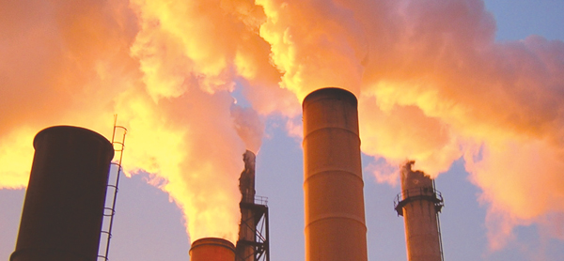

The 2008 ambient air quality directive (2008/50/EC) sets legally binding limits for concentrations of major air pollutants. It merges and replaces nearly all the previous EU air quality legislation and incorporates the 4th daughter directive. It was transposed into law across the UK through the Air Quality Standards Regulations 2010.
Generally this directive protects human health but considers nature and wildlife by default. It sets limit values for lead (Pb), nitrogen dioxide (NO₂), particulate matter (PM10 and PM2.5), Sulphur dioxide (SO₂), benzene, carbon monoxide (CO), certain toxic heavy metals (arsenic, cadmium, nickel and benzo-pyrene) and polycyclic aromatic hydrocarbons (PaH) and ozone (O₃). The long-term objective for ozone protection is intended to provide safeguards for vegetation.
There are limit values for nitrogen dioxide and Sulphur dioxide to protect vegetation but these do not need to be applied near major roads, built up areas or industrial processes, so in practice in the UK they provide little protection for ecosystems. However the industrial regulatory bodies have agreed with the countryside agencies that they will use these as standards against which to judge harm for sensitive wildlife sites.
A number of member states (including the UK) have experienced difficulties in meeting some of the limit values set out in the directive. The directive includes the option of applying for time extensions from limit values in zones where limits are being exceeded, provided plans and appropriate measures are put in place to ensure compliance within five years. The UK was successful in applying for a time extension (to 11 June 2011) for PM10 in all the zones it applied for. For NO₂, the UK was successful in requesting time extensions (to 2015) for 9 zones, 15 zones were rejected and exceedances in 19 zones weren’t applied for.
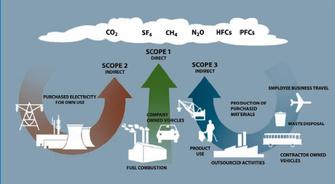

Regardless of the source of emissions (as illustrated above) or extensions in time to be able to meet legislative emission limits it is vitally important to mankind to make concerted efforts to limit and control the discharges into the atmosphere because uncontrolled the face of the world as we currently know it, mainly through ozone depletion, will change forever and no doubt for the worse.

2. What is water quality measurement? And how it is performed? 10

Water Quality
Water quality testing is an important part of environmental measurement and monitoring. When water quality is poor, it affects not only aquatic life but the surrounding ecosystem as well.
The properties that affect water quality can be physical, chemical or biological factors. Physical properties of water quality include temperature and turbidity. Chemical characteristics involve parameters such as pH and dissolved oxygen. Biological indicators of water quality include algae and phytoplankton. These parameters are relevant not only to surface water studies of the ocean, lakes and rivers, but to groundwater and industrial processes as well.
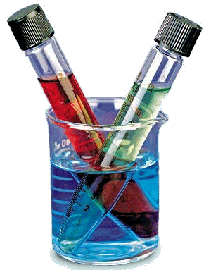Water quality measurement (and monitoring) can help researchers predict and learn from natural processes in the environment and determine human impacts on an ecosystem. These measurement efforts can also assist in restoration projects or ensure environmental standards are being met. The following types of fresh water physiques and quality criteria are of significant importance for humans so as to determine standards are being met;
- Drinking water source without conventional treatment but after disinfection.
- Drinking water source with conventional treatment followed by disinfection
- Propagation of wildlife and fisheries,
- Organized outdoor bathing.
- Irrigation, industrial cooling and controlled waste disposal
Scientists use many different instruments to measure and determine the quality of water, as listed above or from other sources, and including Sec chi disks (measure water clarity), probes, nets, gauges and meters. Water quality is not just measured by direct sampling. Information can also be derived from aerial and satellite photographs by observing the surrounding environment and by collecting organisms that live in the body of water.
Both measurable and qualitative measurements are essential to understand and control the processes affecting the fresh surface water pollution. Depending upon the objectives, the water quality measurement programs are normally divided into the following;
- Monitoring: Continuous, standardized measurement-to define the characteristics of the water resources, the nature of existing inputs and their potential pollutants.
- Survey: Series of intensive programs of finite duration, designed to carry out measurements in detail, ideal for a specific purpose and to determine the self-purification capacity of the receiving media under the conditions of the survey.
- Surveillance: For practical reasons related to both economic and human resources, continuous specific observations and measurements are carried out for specific pollution control or management purposes.
The following segments will discourse each water quality parameter specifically. Each paragraph defines what the parameter is, where it comes from and why it is important to measure. Although not everyone might not have access to the resources of a scientist, there are some simple tests that can be performed to get an idea of the quality of a particular water body;

Temperature
The temperature of water can affect it in many different ways. Some organisms prefer cool water, while some like it warm. Most aquatic organisms are cold-blooded. This means that the temperature of their bodies match the temperature of their surroundings. Reactions that take place in their bodies, like photosynthesis and digestion, can be affected by temperature. It is also important to know that when the temperature goes up, water will hold more dissolved solids (like salt or sugar) but fewer dissolved gases (like oxygen). The opposite is true for colder water.
Plants and algae that use photosynthesis prefer to live in warm water, where there is less dissolved oxygen.
Generally, bacteria tend to grow more rapidly in warm waters. Colder water contains more oxygen, which is better for animals like fish and insect larvae. A typical deep water monitor is shown below.
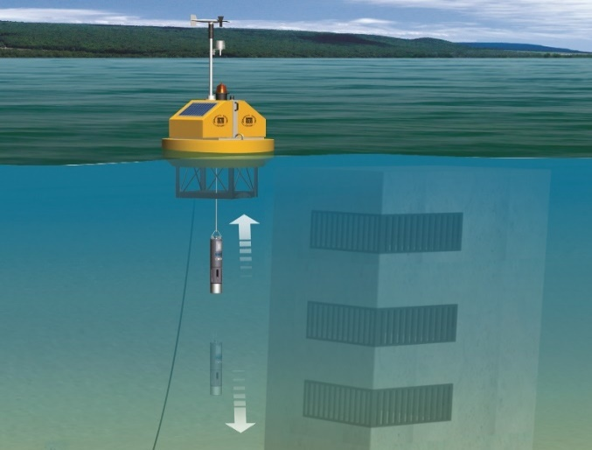

Dissolved Oxygen (DO)
Oxygen is necessary for many aquatic species to survive. This test tells you how much oxygen is dissolved in water for fish and other organisms to breathe. Most healthy water bodies have high levels of DO. Certain water bodies, like swamps, naturally have low levels of DO in the water. Lots of organic debris (fallen leaves, sewage leak) can cause a decrease in DO concentration. Microorganisms, in the process of decomposing the organic material, use all the oxygen in water. How does oxygen get in water in the first place? Much of the oxygen in water comes from plants during photosynthesis and also from air as wind blows across the water’s surface.

PH (acidity)
The potential of Hydrogen, also known as PH, is a measure of acidity and ranges from 0 (extremely acidic) to 14 (extremely basic) with 7 being neutral. Most of the world’s water is in the range of 6.5–8.5. Some examples to compare PH values are as follows;
- Lemon juice has a PH of 3 — this makes it an acid. We all know how it feels to accidentally get lemon juice on a cut finger. Stronger acids have the ability to eat through solid objects if spilled.
- Liquid bleach has a PH of 11 — this makes it a base. Strong bases, just like acids, can burn your skin. Let’s think about why. Our bodies are made mostly of water.
- Water has a PH of 7. Things that are close to PH 7 work well with our bodies. The same holds true for aquatic organisms. If the water becomes too acidic or basic, it can kill them. Not all acids and bases are bad. Aspirin and tomatoes are acidic, while milk of magnesia and baking soda are both bases.

Turbidity
Turbidity refers to the clarity of water, or how clear it is (as illustrated below). This determines how much light gets into the water and how deep it goes. Excess soil erosion, dissolved solids or excess growth of microorganisms can cause turbidity. All of these can block light. Without light, plants die. Fewer plants mean less dissolved oxygen. Dead plants also increase the organic debris, which microorganisms feed on. This will further reduce the dissolved oxygen. No dissolved oxygen means other aquatic life forms cannot live in the water.
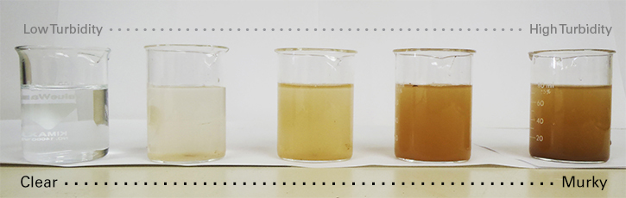
After testing the above parameters, statistics such as the time of year, current weather conditions, cloud cover, air temperature and any other environmental observations that may affect the tests must recorded.

3. What is social forestry? 10

Social forestry is forestry by the people and for the people, whose main purpose is to fulfill the needs of forestry which are - manure, food, fruit, fiber and productive capacity. As a whole social forestry's main objective is to reconstruct the ecosystem and conserve the environment.
The National Commission for Farmers, in the UK for instance, has determined the following objectives for social forestry;
(i) To cooperate soil conservation and to prevent spoiling the productive capacity of soil.
(ii) To increase fuel availability and to increase the food modification by increasing fruit production.
(iii) To encourage plantation of large and beautiful trees which provide shadow to enhance the natural beauty and to plant all around the cultivation field to increase production.
(iv) To encourage environment conservation by plantation and to create general consciousness regarding environment conservation.
(v) To enhance the natural beauty of the villages and cities by plantation.
Of course social forestry is a concept relating to worldwide audiences and in fact many countries, not just the UK, are involved in programs that are designed to protect or reinstate lost forest regions as the photo below shows.

Reforestation of severely degraded landmass in Khammam District of Andhra Pradesh, India under ITC Social Forestry Project'
Social forestry programs have primarily three modules whereas they aim to;
a) Encouraging farmers to plant trees on their own farms, by distributing free or subsidized seedlings. This is fine as long as the farmers can be persuaded to allocate land and time. This element is known as farm forestry.
b) Plant woodlots. These are normally carried out by regional forestry departments for the needs of the community, especially along roadside, canal banks and other such public lands
c) Persuade communities themselves to plant community woodlots on otherwise useless lands
The whole notion of social forestry is to grow woodlands/forests on any available land which is not being used for other purposes such as grazing or agricultural purposes. This strategy will enable natural forests to be saved from degradation while allowing barren lands to be utilized purposefully. Social forestry programs however face a number of problems and some of these are detailed below;
(1) The lack of information among people and ignorance regarding social forestry program.
(2) Illegal tree-cutting.
(3) In many states or counties there are unsatisfactory activities regarding social forestry.
(4) Social forestry has not been implemented extensively.
(5) Corruption and misuse of the fund which is for the purpose of social forestry.
And of course there is the finances required to support such programs and more importantly who wants to get involved with careers, such as Forestry, when there are more lucrative careers around. The down side of attracting people into environmental careers are as follows as well as what could be done to encourage recruitment;
- Unpopular – the environmental sector is unpopular among younger generations as science, engineering and technology (SET), finance, medicine, law and social care attract more attention
- Unaware – there are wide range of roles on offer within the Forestry Commission, including those connected with finance and SET, but this is not recognized
- Attractive offer – people found certain aspects of working for the Forestry Commission attractive: civil service terms and conditions; the provision of training; possibilities for flexible working; and diversity in the roles on offer
- Understanding – for individuals to respond to job adverts, they need first to recognize, know and understand the Forestry Commission as an organization and the values it stands for
- Outreach – recruitment should use ‘community outreach’ methods to increase knowledge of the Forest Commission and what it does for younger populations
- Advertising – the Forestry Commission should place adverts for job vacancies in the mainstream media used by younger individuals
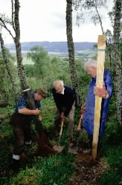

It shouldn’t be left to retired or older people, as portrayed above, to get this done we need to encourage all ages, especially the young, to change mindsets and look at careers such as this to save our planet.

Student Statement:

By submitting this assignment, I confirm that this is my own work.

Student Signature | Raymond Wilson | Date | 15th June 2015

For Tutor / Assessor Use Only
Total Marks
Marks Obtained
Percentage / Grade

