
Assignment Cover Sheet

Student Name: | Kyle Pentland
Student Number: | 1605
Course: | Diploma in Environmental Management – Level 4
Assignment NO: | Assignment 9

Marking Criteria:
We expect the learners to write minimum one well expressed point in three lines against each allocated mark. This means one needs to write 15 lines with 5 well expressed points to get high grades for a 5 marks question.
For high grades use examples and illustrations where appropriate.

Page 1
Q1:
Energy Management covers an expansive range of procedures, activities and expertise in the most efficient use of energy. This includes the areas of measurement and control; the development of management strategies, programmes and plans; and the expert implementation of techniques, technology and tools to improve the efficiency, productivity and sustainable use of energy.
Energy Management can be useful to humans in such ways as:
- By conserving energy, it is being used a much slower rate. As a commodity becomes less and less, its price will continue to rise. Energy conservation leaves people with more money in their pockets.
- By managing energy now and trying to find alternatives to fossil fuels. Humans are trying to find a sustainable alternate to finite energy sources (which ultimately run out) for future generations.
Short-term benfits to Energy Management would be:
- boosting growth and creating jobs in our economy
- saving households and businesses money on fuel bills
- creating a more sustainable and secure energy system
- delivering cost effectively against our climate change goals
- reducing energy imports.
With system development comes productivity. You can continuously improve your energy performance at a faster pace. And energy awareness becomes embedded in the culture of your organisation. You reap great strategic benefits by:
- Energy reduction use over the long term
- Cost reduction through being more efficient year on year
- Meeting your carbon reduction obligations
- Influencing the knock on energy requirements of the entire energy chain.

Page 2
As well, by maintaining a certified energy-management system, you demonstrate to the public your businesses social responsibility.
Q2:
Energy management is important to organisations in that it:
Reduces costs. In a world were companies, for a large part, still rely on fossil fuel consumption this inevitably leads to a rise in resource cost as they become harder to find. With energy management policies in place, finite resource consumption slows and the impact of cost is a lot slower and more manageable. An example of this would be Installing motion detectors that automatically shut off the lights in lesser-used areas of your business.
Reduces carbon emissions. It is imperative to reduce carbon emissions because of the environmental damage that they inflict. Another feature of increased carbon emissions is cost-related implications of carbon taxes. Organisations anticipate maintaining a minimal carbon footprint in order to promote a green, sustainable image, which would help that organisation achieve better social acceptance. An example of this would be companies trying to use the most energy-efficient vehicles possible, converting cars, vans and trucks to be low-emission.
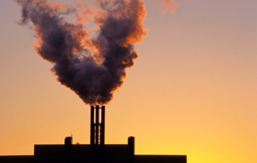
Reduces risk: Energy usage is directly proportional to risk or price rises and inversely proportional to supply. If there is risk of increase of energy price or shortage of supply, it could have an adverse impact on profitability. It may even put the future of the organisation in peril.

Page 3
With energy management, you can reduce this risk by reducing your demand for energy and by controlling it in order to make it more predictable.
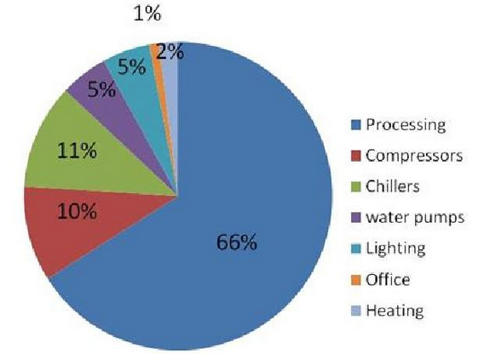
Typical Energy Expenditure for a plastic processing company
Q3:
Reduce is lowering you consumption of physical objects and natural resources. Reduce means to lower the use of or to end the use from the start. Some ways you can reduce driving is carpooling, walking, biking, or taking public transportation to your destination. You can take shorter showers or replace your appliances with Energy Star appliances. An example would be, reducing the rate of deforestation. Using better, more sustainable practices of agricultural land use.
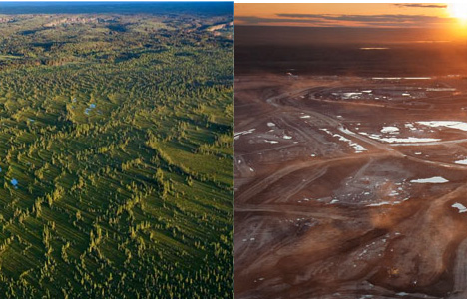
Amazon, before and After Picture
Page 4
Reuse means using a product again for the originally intended purpose. Reusing reduces the need to purchase a newer version of an item or product. An example of this is bottles. Beverage companies produce, sell, return, clean and refill the bottles for sale. It is estimated that the average glass beverage bottle can make about 15 round-trips between the manufacturer and the consumer before it must be recycled due to damage.
Recycling extracts valuable materials from items that might otherwise be considered rubbish and converts them into new products. In converting them into new products less raw materials were needed and and a more sustainable, efficient process was produced. An example of this is Compost, which is an organic material that adds nutrients to soil. People can use kitchen scraps and lawn detritus, such as grass clippings. Homeowners can use mulching lawn mowers to reduce the size of grass clippings, which are a good source of nitrogen, and spread them back over the yard.
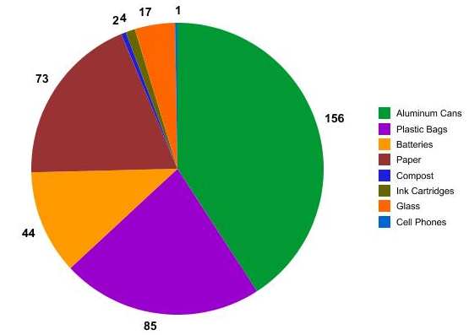
Recycled items from a Primary School
Q4:
Advantages of fossil fuels are:
Easily Available: Since these fossil fuels have been of such a great source of energy, more and more extractions are going on every day.
Page 5
The pressure is even more as the population is increasing. With the advancement in science and technology, the refineries and the extraction procedures have also improved a lot. This makes the availability even smoother.
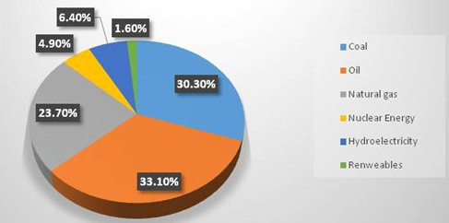
2011 World Energy Consumption by Fuel Type
Produce Large Amount of Energy: Fossil fuels are easily combustible. Most combustion engines need to be powered with little amount of fuel to and they can produce large amount of energy. All machines, devices, vehicles depend on the fossil fuels, may it be coal, petroleum or natural gas. Sustainable fuel sources like solar, wind or geothermal have complex process to harness energy from them.
Low Cost: Fossil fuels are available all over the planet and the methods to extract energy from them are also not that expensive. In obtaining the fossil fuels, the resource is already prepared to be broken down and used as an energy source. This does not need a wide set up and is economical, unlike wind turbines, for example.

Page 6
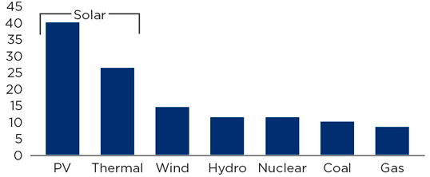
Costs of Power Plants entering Sector (cents/kw/hour)
Disadvantages of fossil fuels are:
Non-Renewable: Fossil fuels are being extracted at an exorbitant rate and it is estimated that they will be finished in next 30-40 years. Since they are non-renewable, it is more likely that fuel expenses will face a steep hike in near future. It would take millions of years to replace coal, and oil, and this means that we will not be able drive cars anymore, produce goods that are provided from fossil fuelled companies and supply our homes with heat and electricity.
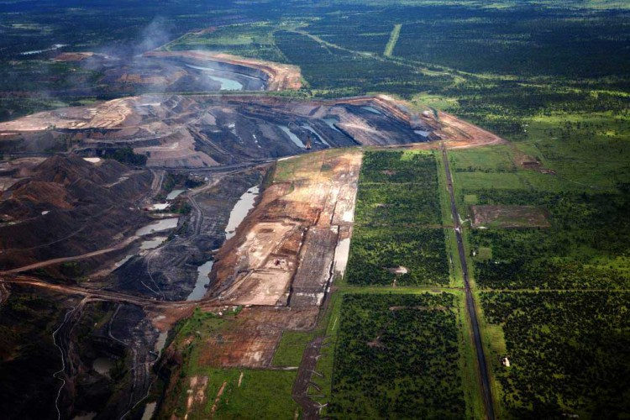
Carmicheal Coal Mine, Quennsland, Australia
Effect on Human Health: Pollution from vehicles and coal powered power plants can cause serious environmental hazards. Pollution related diseases range from mild to severe and can significantly affect one’s quality of life. Air pollution can result in asthma and lung cancer.
Page 7
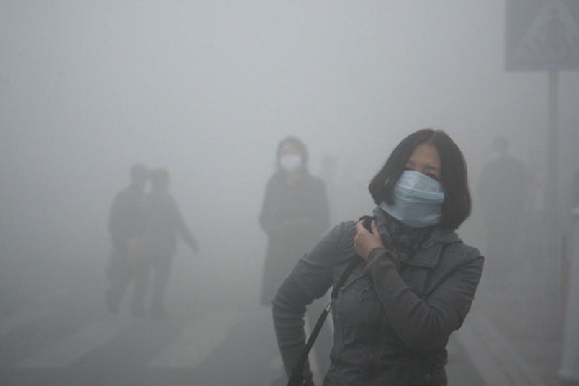
Air Pollution Beijing, China
Habitat destruction: Fossil fuels like wood from forests makes up the habitat of entire ecosystems. If the resource isn’t directly taken from the habitat itself, many resources like iron and gold, involve the removal of habitats in order to access them.
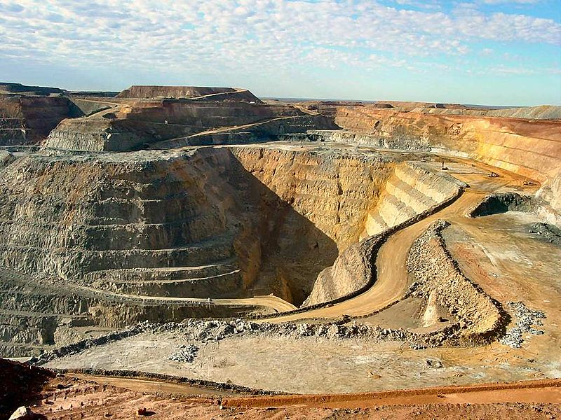
Gold Mine, Western Australia

Student Statement:

By submitting this assignment, I confirm that this is my own work.

Student Signature | Kyle Pentland | Date | 15/03/2016

For Tutor / Assessor Use Only
Total Marks
Marks Obtained
Percentage / Grade

