
Brent
Assignment Cover Sheet

Student Name: | Mery Ann Alaba
Student Number: | 1406
Course: | Fashion Design
Assignment NO: | Assessment 8

Marking Criteria:
We expect the learners to write minimum one well expressed point in three lines against each allocated mark. This means one needs to write 15 lines with 5 well expressed points to get high grades for a 5 marks question.
For high grades use examples and illustrations where appropriate.
Assessment 8

Question

- I. Binary color is created by mixing two primary colors also called secondary
- color .

For example: Orange is a secondary color which is created when the
Subtractive primary colors red and yellow are mixed together.

- Both warm or cool color is stand for hue, name of the color.

Achromatic means absence of color. This scheme has white and black at the two extremes with tones of gray in between.

Color or hue is one of the first things people notice about clothing. The use of color can create illusions of the figure size in the same way as line does.

By mixing this color into other color it gives attractive color scheme

- Actually for me both can used. Light or dark color clothes people look thin but it defends for the style and how to express your fashion.

Wear dark colors on place that you don’t want people to focus and lighter colors where you want to draw attention.

The best with stout person is clothes with thin vertical lines will make you look the same way, vertical lines it gives you make taller and slimmer.

- Color is one of the first things people notice about clothing. The use of color can create illusions of the figure size in the same way as line does. Color should be selected on the basis of complexion-hair, skin and eyes-as well as the figure’s size.

Colors should complement the complexion that tends to be sallow(yellow tones) should wear colors that bring out the pink/red tones of the skin. A complexion that is florid (red/blue tones) should avoid colors that emphasis of the redness of the skin.

Colors are classified as warm-reds, yellow, and oranges-or cool-blues, and greens. Warm color tend to create an illusion of greater size. Cool colors tend to create an illusion of reduced size.

The brightness or dullness and the lightness and darkness of colors also affect the illusion created. Dull and dark colors seem to recede and make figure appear smaller. Bright and light colors have the opposite effect.

Contracting colors in tops and bottoms create a horizontal line where they meet and tend to shorten the figure. A single color outfit gives a vertical feeling and creates an illusion of height and slimness.

- When the grey-haired lady wearing black looks well, but she must not forget that a touch of white in the form of a yoke or collar to relieve and black near the face is most necessary. White of course , being a neutral colors is very good for this type. Some of the dull warm shades may also be pleasing, if the color of the eyes and features warrant their use.

- Red, shades of rose and pink, because for a person with sallow complexion great care must be taken in the choice of colors in fact it is better to select those which will reflect color in the cheeks.

Shades of blue green, navy and blue will help to bring out the color in the cheeks helping the skin look less yellow.

- Some of the very darkest shades of green may be suitable.
Navy or midnight blue and the soft, silent tones should be very pleasing. The deep shades of brown, also black and the cream and ivory hues, will be found to be very good.

Activity

Blue and orange, Red and Green, Yellow and Orange Blue and violet
Scheme of two hues can be extended by using tint, tones or shades of the selected hues.

Red-violet and blue-violet – Scheme would be yellow.

Red, blue, or orange, purple and green – Scheme and yellow.

Achromatic –absence of color – Scheme has white and black at the two extremes with tones of grey in between

Light pink, rose, maroon and watermelon, value and chroma gradations are to close together; the effect may be unpleasing because of ambiguity of colors, giving the impression of a mismatch. Scheme requires noticeable differences to avoid a fatiguing and monotonous effect.

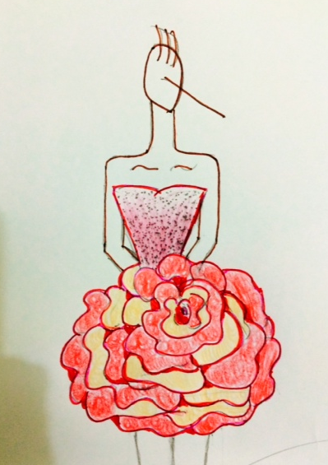

Student Statement:

By submitting this assignment, I confirm that this is my own work.

Student Signature | Mery Ann P. Alaba | Date | 29 Oct 2015

For Tutor / Assessor Use Only
Total Marks
Marks Obtained
Percentage / Grade

