
Assignment Cover Sheet

Student Name: | MAJALIWA FREDRICK
Student Number: | 1506
Course: | DIPLOMA IN ACCOUNTING AND FINANCE
Assignment NO: | 3

Marking Criteria:
We expect the learners to write minimum one well expressed point in three lines against each allocated mark. This means one needs to write 15 lines with 5 well expressed points to get high grades for a 5 marks question.
For high grades use examples and illustrations where appropriate.
Accounting Concepts & Standards
Assignment 3 Total Marks: 30
Q: 1: Give short answers to the following questions: (15)
- What is a dual aspect concept?
Answer:
Dual Concept in accounting refers to the basic principle of accounting which is considered as the foundation of accounting. According to this concept, every transaction has two-fold effect, namely receiving and giving. There are two aspects of every business transaction apart from this, the dual aspect concept is called the double entry system of bookkeeping which implies total assets and total Liabilities of a business entity or organizations should be equal.

b) What do you understand by the term 'convention of materiality'?
Answer:

c) What is accounting equation?
Answer:
Accounting Equation is represented as:-
Assets = Liabilities + Owner’s Equity (Capital), that is to say, Capital is the excess of assets over liabilities of the enterprise. It is the difference between the total assets and total liabilities of the enterprise. E.g. if on a particular date the assets of the business amounts to Us $ 100,000 and Liabilities to Us $ 30,000, then the capital on that date would be Us$ 70,000

d) What does GAAP stand for?
Answer:
GAAP stand for Generally Accepted Accounting Principles, which is a set of nationally (United States) recognized accounting standards. Using GAAP accounting standards, costs and benefits arte accounted for in a recognized way to assure consistency with other firms accounting principles for comparing various projects and investments with one another. Generally accepted accounting principles not only include broad guidelines for accounting practices, they also outline specific and detailed rules and procedures. Basically, they comprise all conventions and rules of accounting practice that have been agreed upon at a particular time. – Last definition borrowed from reading materials

e) What you understand by the following terms?
- Assets
Answer:
An Asset is any item of value owned by a business. A firm’s assets are listed on its balance sheet, where they are set off against its liabilities. Assets may Include factories, land, equipment, inventories, machinery, vehicles, and other items. Some assets are short –term assets such as cash, are easy to value and liquidate, whereas others are long-term assets such as buildings and farmland, are difficult to value and taker longer time to liquidate. These kinds of assets are collectively called tangible assets. Intangible assets, like a valued brand, trademarks, and copyrights don’t show up on balance sheets.
- Liabilities
Answer:
Liabilities are the opposite of assets. These are obligations of one company to another. Accounts payables are liabilities and represent a company’s future duty to pay a vendor. So is the loan you took from a bank. A business organizes liabilities into short-term liabilities and long-term liabilities. Long-term liabilities or debts( claims due in more than one year and short-term liabilities ( claims due within one year)
- Revenue
Answer:
A revenue is a monetary value of the products or services sold to customers during the period. It results from sales, services and sources like interest, dividend, income from sales of assets, and commission.

Q: 2: Explain the various types of accounting concept (7)
Answer:
Financial operating guidelines are classified as assumptions, principles, and constraints. On the other hand, financial assumptions provide a foundation for the accounting process. Principles indicate how transactions and other economic events should be recorded while constraints on the accounting process allow for a relaxation of the principles under certain circumstances.
Here below is a brief explanation of each concept
- Monetary unit assumption or concept:
This concept assumes only transaction data expressed in terms of money can be included in the accounting records. Example: employee satisfaction and percent of international employees are not transactions that should be included in the financial records.
- Economic Entity Concept/Business Entity
According to Business Entity concept, business is treated as separate unit or entity which is distinct from its owners, creditors, managers, and its stakeholders. In otherworld’s, Economic unit concepts assumes only activities of the entity are kept separate and distinct from the activities of the owner and all other economic entities.
Example: BMW activities can be distinguished from those of other car manufacturers such as Mercedes
This concept can expressed in mathematical expression as follows:
Assets= Liability + Owner’s Equity ( Capital)

- Time Period Assumption/ Accounting Period Concept
Accounting period concept refers to the period for an organization evaluate its financial position. That is to say the economic life of a business is divided into artificial time periods. It covers the profits earned or losses the business has realised in the particular financial period.
Consider the diagram below to illustrate the concept above in (c)
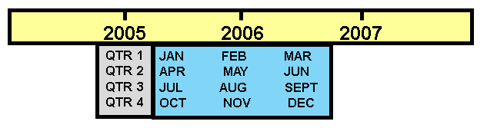

- Going Concern Concept/Assumption
Enterprise will continue in operation long enough to carry out its existing objectives. This assumption is sometimes referred to as Continuity concept where it refers to the existence of business in long period of time. It assumes that the business will be in operation till unforeseeable future. There is no intention of liquidating the company in the near future unless the company declares bankrupt according to the guidance of existing laws.
Implications: depreciation and amortization are used, plant assets recorded at cost instead of liquidation value, items are labeled as fixed or long-term.

- Principle of Revenue recognition
Revenue recognition principle dictates that revenue should be recognized in the accounting period in which it is earned. When a sale is involved, revenue is recognized at the point of sale
- Percentage of Completion method of Revenue recognition
In long-term construction contracts, revenue recognition is usually required before the contract is completed. The percentage-of-completion method recognizes revenue on the basis of reasonable estimates of progress toward completion. A project’s progress toward completion is measured by comparing the costs incurred in a year to total estimated costs of the entire project
The figure below tries to summarize the concept of period
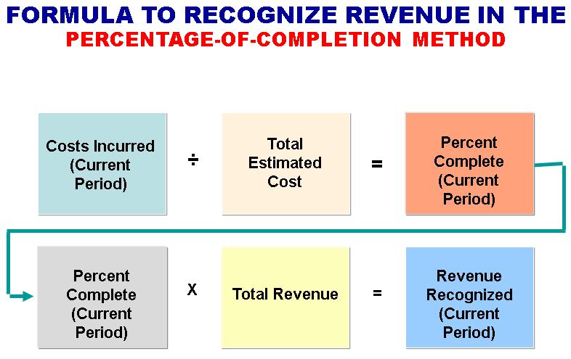

- Matching( Expense Recognition concept
Expense recognition is traditionally tied to revenue recognition. It is referred to as the matching principle dictates that expenses be matched with revenues in the period in which efforts are made to generate revenues.

With this concept, here in real life experience unexpired costs become expenses in two ways:
Cost of goods merchandise inventory becomes expensed when the inventory is sold
2) Operating expenses other unexpired costs through use or consumption or through the passage of time
NB: Operating expenses contribute to the revenues of the period but their association with revenues is less direct than for cost of goods sold

- Full Disclosure Principle
Requires that circumstances and events that make a difference to financial statement users be disclosed.
According to disclosure concept, accounts must be prepared honestly and all the facts associated must be fully disclosed. i.e., compliance with the full disclosure principle to ensure that data in the financial statements and notes that accompanying the statements are dully disclosed to stakeholders of the financial reports.
Summary of significant accounting policies usually the first note to the financial statements
- Realization concept
According to realization concept, an organization should determine the time when the revenues are earned or expenses are incurred. Revenue f4om accounting books should be recorded when it is received.

- Cost Concept/Principle
The cost principle dictates that assets be recorded at their cost. According to cost concept, the assets are measured as per price paid (cost incurred) to acquire them.
Cost is relevant in that it represents the price paid, the assets sacrificed, or the commitment made at the date of acquisition and secondly, cost is reliable because it is objectively measurable, factual, and verifiable.

In a nutshell the following figure gives a snapshot of how these concepts are grouped
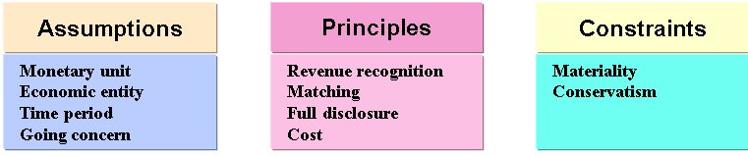

Q: 3: 'Why do we need accounting standards'? Discuss (8)
Answer:
Financial Accounting standard as developed by Financial Accounting Standards Board (FASB) and Securities and Exchange Commission (SEC). The conceptual framework developed by the FASB serves as the basis for resolving accounting and reporting problems. The conceptual framework consists of:
1) objectives of financial reporting;
2) qualitative characteristics of accounting information;
3) elements of financial statements; and
4) Operating guidelines (assumptions, principles, and constraints).
FASB objectives of financial reporting are to provide information that is:
- useful to those making investment and credit decisions
- helps in assessing future cash flows
- identifies the economic resources (assets), the claims to those resources (liabilities), and the changes in those resources and claims
In order for financial information to be useful, information should possess the following qualitative characteristics:
1 relevance
2 reliability
3 comparability
4 consistency
Where by Accounting information has relevance if it makes a difference in a decision. Relevant information helps users forecast future events (predictive value), or it confirms or corrects prior expectations (feedback value).Information must be available to decision makers before it loses its capacity to influence their decisions (timeliness). While when we mention reliability of information means that the information is free of error and bias, in short, it can be depended on. To be reliable, accounting information must be verifiable

Again by financial information ccomparability means that the information should be comparable with accounting information about other enterprises. While by consistency means that the same accounting principles and methods should be used from year to year within a company.

The following are a summary of the importance of having accounting stands in brief points:
- Improve credibility and reliability of financial statements of company business reporting
- Determining the managerial accountability to preparing business financial reports
- Helping the Accountants and Auditors to prepare and Audit financial statements

The above reasons shows why financial accounting standards needs to be established and maintained from time to time and ensuring that all business entities complies to these standards and rules to produce fair reports to the business shareholders

Student Statement:
By submitting this assignment, I confirm that this is my own work.

Student Signature |  | Date | 24 Sept., 2015

For Tutor / Assessor Use Only
Total Marks
Marks Obtained
Percentage / Grade

