
Assignment Cover Sheet

Student Name: | Sumbal Jamil
Student Number: | 1149
Course: | Fashion design
Assignment NO: | 4

Student Statement:

By submitting this assignment, I confirm that this is my own work.

Student Signature | Sumbal jamil | Date | 15-11-2013

For Tutor / Assessor Use Only
Total Marks
Marks Obtained
Percentage / Grade

Q-1.Short Answers:
(a). What is meant by market segmentation?
Answer: Market segmentation is a technique used to enable a business to better target it products at the right consumers. It is about identifying the specific needs and wants of customer groups and then using those insights into providing products and services which meet customer needs. Segments are usually measured in terms of sales value.
Need to segment the market: It is because customer differ in the
- Benefits they want.
- Amount they are able to or willing to pay.
- Media they see quantities to buy.
- Time and place that they buy.
Significance: market segmentation takes on great significance in today’s cluttered market place with thousands of products, media proliferation, ad-fatigue and general economic problems around the world markets. Rightly segmenting the market place can make the difference between successes and shut down for a company. It allows a seller to closely tailor his products to the needs, desires, uses and paying ability of customers. It allow sellers to concentrate on their resources, money, time and effort on a profitable market which will grow in numbers, usage and value.

(b). Design is a visual thinking, perhaps of a higher order than verbal thinking. Explain
Answer. Visual thinking also called visual or spatial learning and picture thinking. It is the phenomenon of thinking through visual processing. It uses the parts of brain that is emotional and creative to organize information in a intuitive and simultaneous way. Concepts related to visual thinking have played an important role in art and design education over the past several decades. Two of the most influential aspects of visual composition are patterns and color. There are now studied approaches to how color should be used in design where “the functional aesthetics of color can be reduced to a small number of guidelines and lists the main properties needed to make design decisions leading to visual clarity”.
At the same time, techniques in arts and design open up pathway to stimulate the thought process. Sketches offer an unrestrained way to get thoughts down on paper through “abstract representations of ideas and idea structure.”It is a difficult skill to master. Those who can are well versed in visual analysis.
“When you make your thinking visual, you start to think like a designer” (Jam)
Some things are hard to describe in words. In fact many things are hard to describe in words. Words may be a start but they often lack the precision and clarity required to describe a new idea to someone else. Photos, sketches and data visualization can make complex ideas easier to understand and share. That’s why young designers are still encouraged to carry a sketchbook.
“Design is thinking made visual.”(Saul Bass)

(d). What is a CAD system and how it has revolutionized the fashion industry?
Answer. Fashion CAD is innovative approach to pattern making ensures that you can create patterns for your own unique designs that will fit your shape or each of your individual customers size and shape. It is a stable and mature product.
The world of fashion and the computers have one thing very much in common. They both changes keeping up with fashion trends as well as new developments in software for the fashion designers. Today, all has changed .The designer is finding a more predominant role in all the decision making within the garment industry in term of what software best feels like a creative tools in order to design clothes. Today all large garment manufacturing companies have developed CAD system to do the process of garment manufacturing. In CAD the designer designs the garments by using any suitable software numerically controls the machine that generates the production.
Advantages of CAD over manual methods of designing and production of garments:
- The expense and time is reduced a considerable manner when compared to the laborious manual work of designing.
- Designing can be done from anywhere as the designers are able to control the process from remote location as well.
- The data can be easily stored transmitted and transported through computer files.
- Digital swatches can be saved on floppy disks, zip disks, CD-ROM or hard drive thus saving space. Moreover they can be easily organized for fast and easy retrieval.
- The designs can be easily customized and personalized as corrections and editing can be done at any time without significant delays or cost increases.
- The designer don’t need to produce swatches all the time as they can now see how a particular fabric or garment looks in different colors and shape on computer screen itself.
(c_. Explain briefly the developing of a sample garment.
Developing of a sample garment:
SL No. | Operation | Job
01 | Design/Sketch | It is given by buyers to manufacturers containing sketches including measurements of particular styles
02 | Basic Block | Basic block is an individual component of garments without any style of design (without Allowance, Style, Design)
03 | Working Pattern | When a pattern is made for a particular style with net dimension regarding the basic block along with allowance then it is called working pattern.
04 | Sample Garments | To make a sample, this will be approved by buyer. After making a sample, it is sent to buyer for approval to rectify the faults
05 | Approved Sample | After rectify the faults, sample is again sent to buyers. If it is ok then , then it is called approved sample
06 | Costing | - Fabric Costing  - Making Charged  - Trimmings  - Profit
07 | Production Pattern | Making allowance with net dimension for bulk production
08 | Grading | If the buyer requires different sizes, so should be grade as S, M, L, XL, XXL
09 | Marker Making | Marker is a thin paper which contains all the components for different sizes for a particular style of garments
10 | Fabric Spreading | To spread the fabrics on table properly for cutting
11 | Cutting | To cut fabric according to marker dimension
12 | Sorting & Bundling | Sort out the fabric according to size and for each size make in individual bundles
13 | Sewing | To assemble a full garments
14 | Ironing & Finishing | After sewing we will get a complete garment which is treated with steam ironing & also several finishing processes are done for example extra loose thread cutting
15 | Inspection | Should be approved as initial sample
16 | Packing | Treated by Polyethylene bag
17 | Cartooning | After packing, it should be placed In cartooning for export
18 | Dispatching | Ready for export

Activity:
b. In a local department store, compare contemporary and junior departments.
Comparison of contemporary and junior department:
- Dresses:
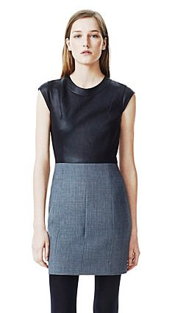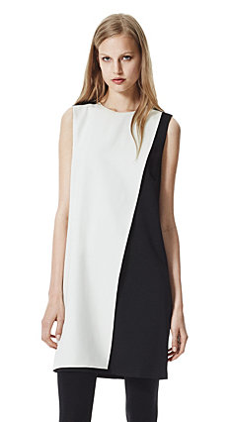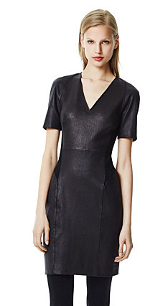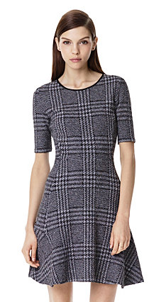
Dresses in contemporary department
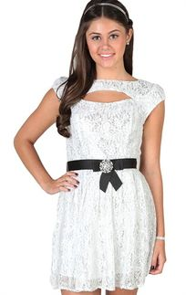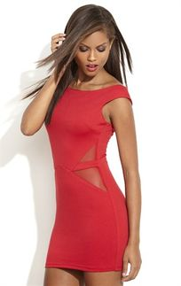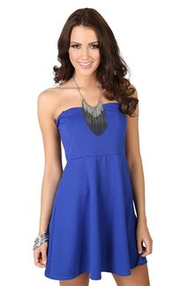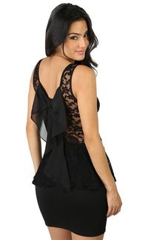
Dresses in junior department

- Tops:
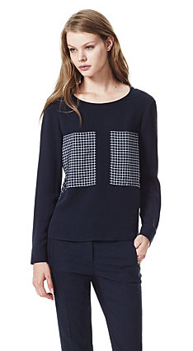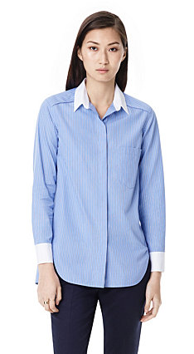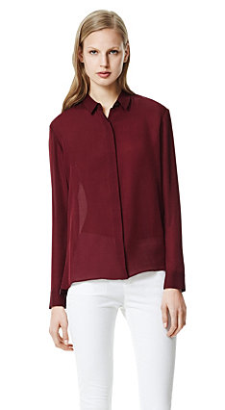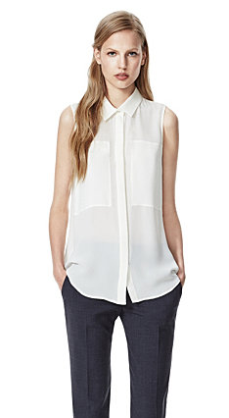
Tops in contemporary department
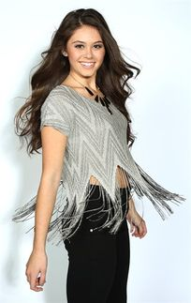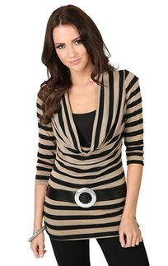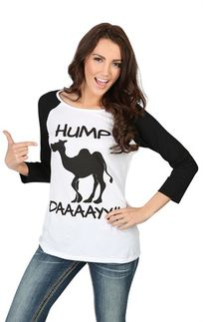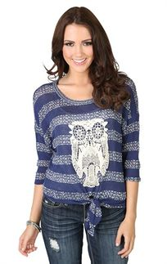
Tops in junior department

- Pants:
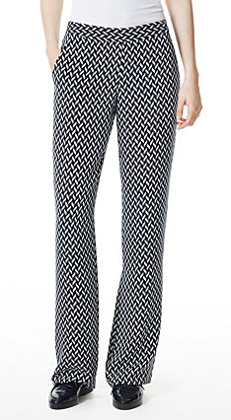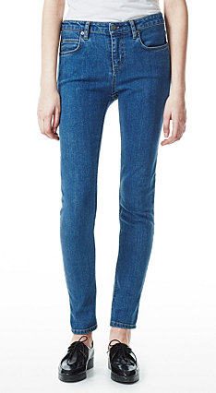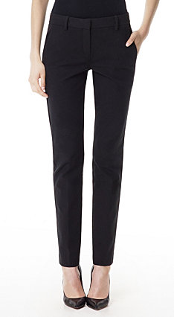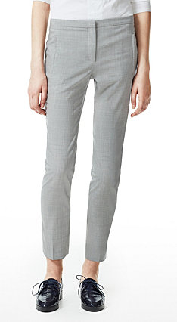
Pants in contemporary department
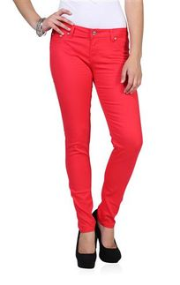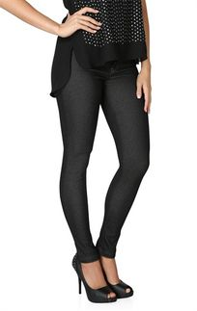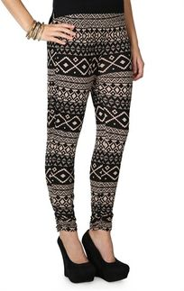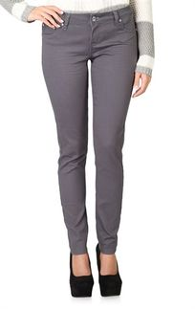
Pants in junior department

- Jackets:
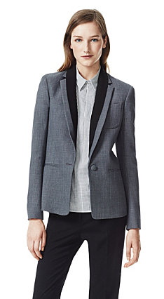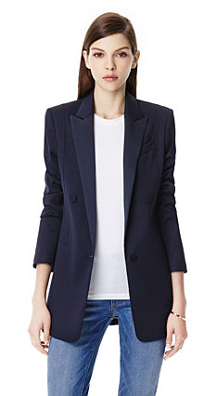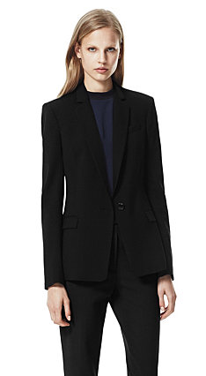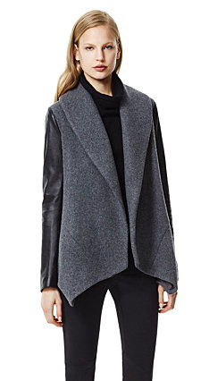
Jackets in contemporary department
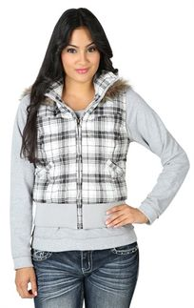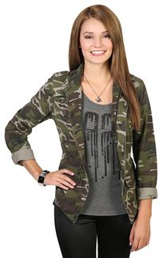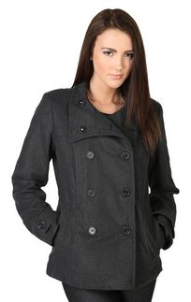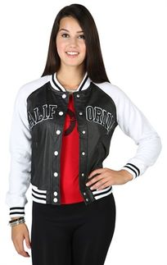
Jackets in junior department

- Skirts:
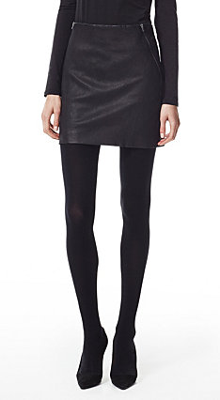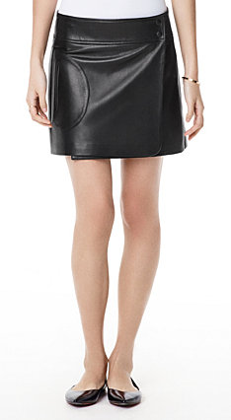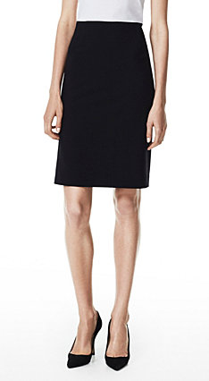
Skirts in contemporary department
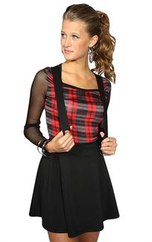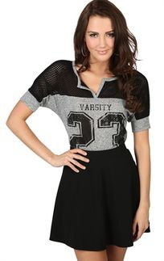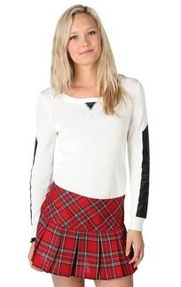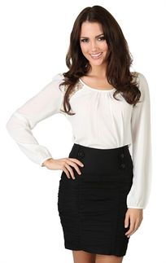
Skirts in junior department

a. Compare two dresses of similar prices by two different designers’ .Which one has best fit? Compare fabric choices in term of quality and suitability to the design. Compare styling which is more innovative? Which dress is the best buy?

Comparison of two dresses of similar prices:
Dress (a):
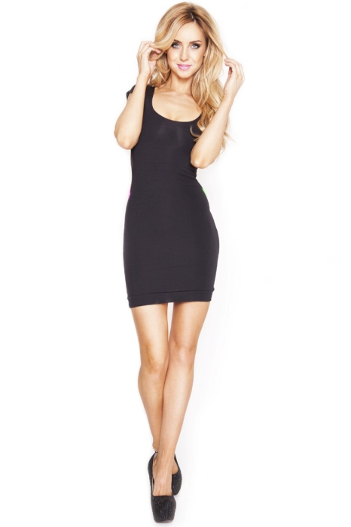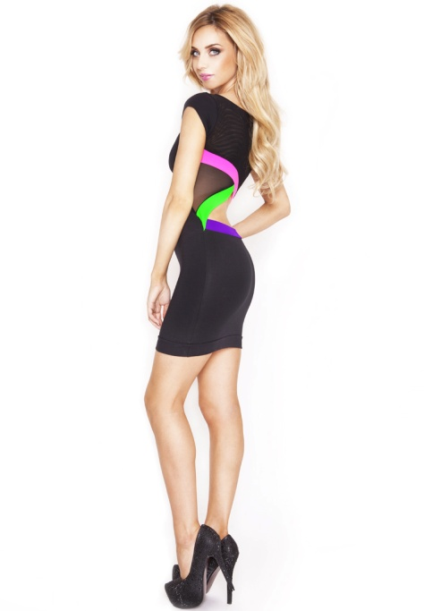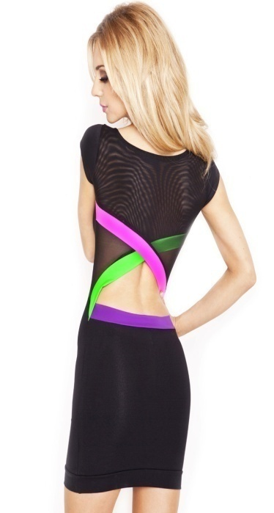
Dress (b):

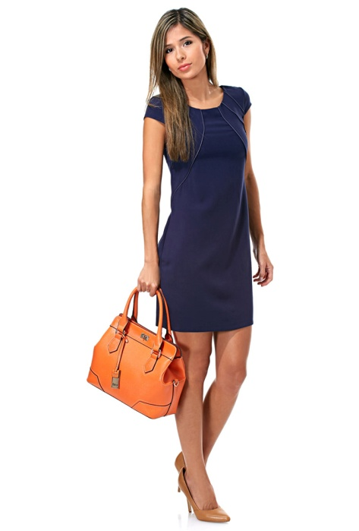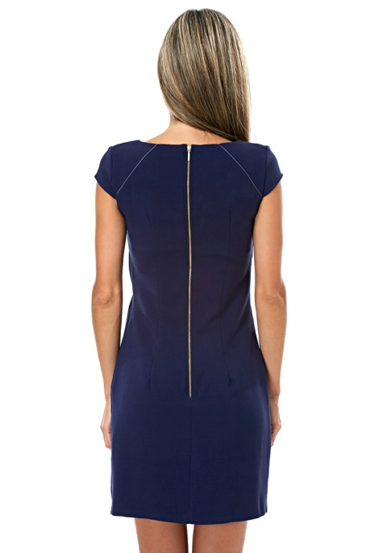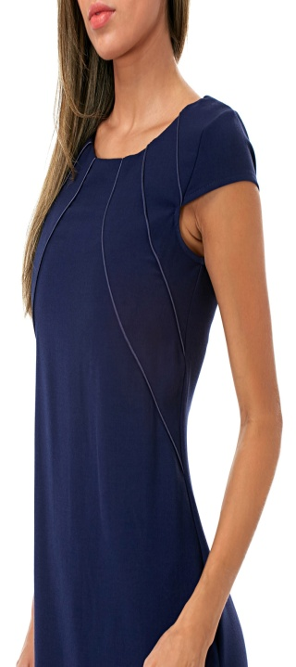

Comparison of dress (a) and (b):
Dress (a) | Dress (b)
- It is a party dress.  - This dress is from Quontum.  - Price: 215 SAR.  - Quality of fabric: 92% Cotton, 8% Elastane.  - Color: Black.  - Neck type: Deep-U.  - Apparel type: Dress  - Washing instructions:  Hands wash only. Do not iron on contrast. Wash separately to avoid dye run from other garments and in bleach free detergent to avoid fading.  - Size: Small.  - This is step out looking dress like a diva. Featuring neon trims along a cut-out black and a super sexy fit, this bold dress is sure to turn heads wherever we go. Perfect for our night out! | - It is a capped sleeve dress.  - This dress is from Closet.  - Price: 215 SAR.  - Quality of fabric: 97% Cotton, 3% Elastane.  - Color: Navy.  - Neck type: Round.  - Apparel type: Dress  - Washing Instructions:  Machine washes cold 30C.Low iron. Dry Clean, any solvent except Trichloroethylene. Do not tumble dry. Do not bleach.  - Size: Small.  - This is sophisticated dress for our formal look. Flare pattern with chic cap sleeves make it a classic choice for work and formal event.
Dress (a) is the best buy.

