
Assignment Cover Sheet

Student Name: | Ray Wilson
Student Number: | 1250
Course: | Construction Management
Assignment No: | 10

Student Statement:

By submitting this assignment, I confirm that this is my own work.

Student Signature | Raymond Wilson | Date | 17th Sept 2014

For Tutor / Assessor Use Only
Total Marks
Marks Obtained
Percentage / Grade

Assessment 10 Total Marks: 30

1. Give Short answers for the following questions: (20)

- What is vendor management? Describe its essential components.
Vendor management is not just negotiating the lowest price possible it consists of constantly working with your vendors to come to agreements that will mutually benefit both companies.

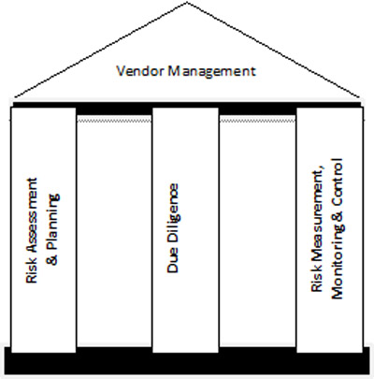

Vendor management is a major element in the procurement process and also allows you to build a relationship with your suppliers and service providers that will strengthen both businesses.
As the diagram indicates above there are a number of key elements needed to ensure a sound foundation to manage vendors
Risk assessment and planning should confirm the contract is managed so that each potential vendor is assessed to ensure they can supply a service or product at a competitive price with a “right first time” approach, meets expectations and can react to unscheduled emergencies or difficult times whilst continually looking to improve services. It should be planned that there at least two of these vendors who are selected as the “right source” that can provide provision of such services.
The due diligence component should continuously review a vendor to confirm its performance expectations and upkeep of its allotted classification. Part of this strategy should include the development of such vendors so that he clearly understands the intent and scope of the development programme for both parties and this is input into a vendor database for tracking and analysing purposes.
Risk measurement, control and monitoring of a vendor should be carried out by the governance of key performance indicators that provide statistics on quality of service/product, quantity, prices, and deliveries and hence providing a vendor oversight to provide the company with assurance the right source is being optimised.

II. Outline the various factors considered for the identification of right source of supply at micro and macro level.
Once a suitable Vendor has been identified the purchaser should develop and nurture the relationship to establish if this is the right source but there are a number of functional factors that need to be considered first and addressed accordingly such as;
- How can they (the vendor) be developed to the required standards and what alternatives are there should the required standards not be achieved?
- How do we (the company) best balance our risks by capitalizing on our strengths in minimizing the risks arising out of the monopoly supply situation that may be encountered?
- Have we really searched and exhausted all sources of supply for the required items - both nationally and internationally?
- What are the major elements of the cost components of items and what are the anticipated cost trends of key component supply in the foreseeable future of these vendors and how will these vendors be affected?
- Will the entry/exit of the major suppliers to these vendors affect the pricing structure in the market and if yes, how will this affect the manufacturing-cost?
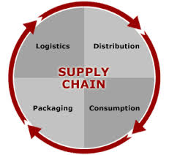

At the micro-level, the right source of vendor should have the following points as a minimum clarified and addressed if deficient:
- Any historic record that the supplier has with the company.
- The financial wellbeing of the supplier i.e. their credit worthiness.
- Current order books, available capacity and growth plans need to be established as evidence that size/volume of envisaged orders can be handled by the vendor.
- Willingness to accept the buyer's specifications and other contract conditions on warrantee and replacements as required from time to time.
- Ability to respond to unusual and emergency requests from buyers.
- The technical, financial and production capacity in terms of capability of its personnel and the reliability of owned machinery.
- The vendor’s ability to embrace new ideas and technology and morale of staff and workers employed by them.
- KPI’s indicating minimum lead time and delays.

III. What is vendor rating? What are its advantages and disadvantages?
Once feedback from the vendors is obtained, either by facility visits or questionnaires (or both), registration is carried and the vendors are then rated.
This ensures each vendor gets receives different development support and whilst this criteria may vary between vendors some basic foundations assist in this process as follow;
- Does the vendor have an adequate and documented quality control system and/or is he IS0 9000 accredited?
- Has the vendor developed and applied the use of specifications and inspection procedures in his processes?
- How would you rate the delivery and service of the vendor?
- What are the current rejection levels of the vendor and his recent trends?
- Is the vendor's price within plus or minus 10% of the average market price for his products?
- Does the vendor have a good shop floor planning system and does he operate up to date systems and software to support the production line?
- Is the vendor's labor relations record above average?
- What is the vendor's reputation in the marketplace and which other reputable clients can he claim to provide for?

The aim of vendor rating is to establish a procedure by which procurement, quality control and other interested parties can satisfy the company’s corporate objective of obtaining quality products at a low or “right” cost whilst covering technical, financial, managerial and service factors.

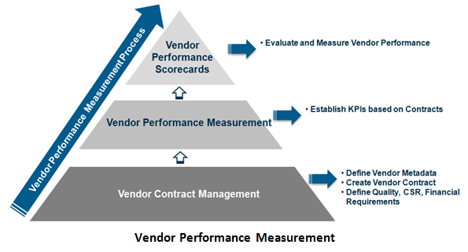
The advantages of such a rating system can save time and money, brings clarity to the procurement process thus side stepping any potential accusations with regards to favouring etc., brings the company recognition of being a “fair player” image in the industry, helps improve relations with vendors by giving them due recognition when warranted, encourages a competitive spirit environment among vendors who will stride to improve and many more advantages too numerous to mention.
Disadvantages of a rating system for vendors are the time and resources cost needed in carrying out measurement activities and by assessing only objective or only subjective criteria this could lead to skewed results. It is necessary therefore to take account of both.
The weightings and the actual scores given to suppliers can also be influenced by a biased buyer or company and misused accordingly.

IV. How an IS0 9000 company is different from others?
An ISO 9000 accredited company will guarantee that processes and procedures are well documented and prepared to provide a reliable, self-correcting and continually improving service in the field on supply

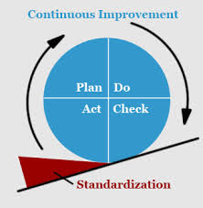

ISO 9000 certification brings about many benefits to an organization such as;
- Improved product and/or service quality,
- Reduction in incidents, rejections and complaints,
- Increased productivity and/or efficiency accompanied with reduced internal costs,
- Increased workforce motivation and becoming more quality aware,
- Improved processes and procedures,
- Elimination of redundancy or unnecessary work,
- Better customer service and increased customer satisfaction
- Greater competitive advantage in the market place,
- Effective promotional and/or marketing tool,
- Organization’s image in the market improved
- Coding and classification of items of supply

V. Why it is necessary for the stores in charge to know the legal aspects involved in purchasing and procurement of materials?
A purchase or procurement manager may be involved in disputes, law suits or back charge claims and therefore should have a general awareness of the law with regards to any purchase of materials or services which is a contract in the legal manner of speaking.
Each contract will have the following legal aspects.
1. Two parties i.e. Buyer and seller.
2. There should be a “subject matter”.
3. There must be consensus and understanding of the subject.
4. It must be lawful and legal.
5. There must be communication.
6. There must be consideration (not free).
7. There must be an offer from one party.
8. There must be an acceptance from the other party.
9. Competency to the parties.
10. Subject must be possible to be executed.


There is also the legal aspects of purchasing and payments as well as breach of contract, discharge of contract, liquidated damages and other subjects that the responsible person in charge of procurement needs to be aware of.

2. 'Training is the best method to shorten the learning curve." Discuss (10)
A learning curve is a graphical representation of progress in learning:
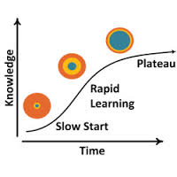
The standard graph illustrated above shows some measure of something learned against the time spent learning and is a psychology graph which normally slopes upward whereas the manufacturing ones normally slope downward but they are both usually steep to start with and then level out.
As in all activities and actions in life the duration taken for “the first time” is always high, and this especially true when applying this principle to manufacturing and supplying specialist products, however the more the equipment and tools are used the increase in familiarity increases thus reducing the time need on components and eventually all problems will disappear and a constant flow will be achieved.
To reduce a learning curve duration associated with vendor management, and avoid its potential pitfalls, training should be used so that a materials/procurement manager can obtain the best from his new team members, and sometimes existing ones, and a training program (which needs budgeting for) should be developed. The case of individuals however, as a factor in training, should not be underestimated as personality traits can affect the duration of the learning process which is applied to situations, problems and negotiations.
Training is the best method to shorten the learning curve and with this, the material manager can provided induction training to all new personnel where the company objectives and department objectives are clearly explained, explain the organisation and departmental rules, regulations and procedures to personnel and provide functional and relevant training.
Some facets need considering when developing a training program to reduce the learning curve period and give the manger the desired results such as,
- Define your program objectives ― what you want to accomplish has to be tangible, measurable, and as specific as possible with the aim of labor and product cost reduction and giving you a position to get better deals from suppliers.
- Talk to someone who is doing what you want your team to do ― One of the biggest timesavers (and confidence boosters) when setting out to learn something new is to talk to someone who has already mastered what you want to do.
- Give yourself a deadline and break down what you want to achieve into tasks ― not giving yourself a deadline could add weeks, even months, to your learning curve. Once you’ve established a training program deadline, map out what you plan to achieve on a daily, weekly, and monthly basis. The whole purpose of this training is to shorten the learning curve and get your new employees, or existing workers, to carry out unmanaged activities.

Methods of training can vary from classroom lectures to on-the-job training. Other modes like plant visits, seminars, exhibition visits, audio-visual presentations etc. may be used and refresher training should be carried out from time to time which complies with ISO 9000 governance.

