
Assignment Cover Sheet

Student Name: | Sumbal jamil
Student Number: | 1149
Course: | Fashion design
Assignment NO: | 11

Student Statement:

By submitting this assignment, I confirm that this is my own work.

Student Signature | Sumbal jamil | Date | 13-8-2014

For Tutor / Assessor Use Only
Total Marks
Marks Obtained
Percentage / Grade

1.Discuss in details how the designers work?
Answer. Fashion designer study trends and sketch the initial clothing or accessory design. They attend trade shows on visit manufacturers to select fabrics and trims. Designers conduct fitting and adjustments on prototypes of their designs and the end products is then marketed to clothing retailers. They oversee the entire garment production from their initial sketch to final manufacturing. The responsibilities of designer may include:
- Producing concepts
- Making sketches by hand or on computer
- Developing patterns
- Overseeing production
- Analyzing trends in fabric, color and shapes
Fashion designer need:
- To be creative
- An eye for color, texture and pattern
- The ability to visualize things in three dimensions
- Technical skills in areas such as pattern cutting, grading and garment construction
There are three main sectors:
- Haute couture: Designers work on exclusive one-off creation that can cost thousands of pounds. They work directly with the clients, organizing fittings and making alternations, and the work takes a high level of skill and large amount of time. Many couture designers also produce ready-to-wear collections that are produced in relatively small numbers,
- Ready-to-wear: designers work on garments that are sold in small numbers but often at a high price. These garments bear the designer’s name.
Designing for high street stores: Designer develop cheaper ranges for the mass market. These garments are manufactured in large numbers and are quite often produced overseas. There is generally much less scope for creative input, as garment are made in line with strict budgets and need to be easy to produce efficiently. Designers usually work two seasons ahead, liaising with buyers and forecasters to predict the coming fashions. They draw initial sketches by hand or using computer software. Designers have to consider who might buy and wear their designs, how much they will cost to produce and how much people will be prepared to pay. designers usually discuss their initial ideas with the design and marketing team before the best are selected and made up as sample garments. When the clothes go into production, the fashion designer has to be available to give advice and sort out any problem with cutting or stitching.
2.”A fashion storyboard is a summary of your collection’s inspiration and theme. It is a design tool that will help you remain focused and consistent as your line develops". Discuss.
Answer. A fashion storyboard is a summary of our collection’s inspiration and theme. It’s a design tool that will help us remain focused and consistent of our line develops. It’s a great communication aid when explaining our vision to others. Magazine tears, fabric swatches, old photos, buttons, ribbons: basically any visual reference we desire are mounted onto a hard board. A fashion story board will usually consist of a full colour illustration of a fashion figures wearing the garments that are being showcased. This storyboard tutorial will show us how to correctly format and create a fashion storyboard for assignments or professional. A clearly labelled, sizeable swatch of our chosen fabric should also be included on the board. The storyboard should be thought of as a pictorial representation of our proposed clothing design in full color,along with technical rendering of each garment individually. Just the sketches individually can look dull , lifeless and very uninteresting. We need a well-planned layout and a strong theme-our ideas much seem commercially successful.
Planning presentation: The design brief will dictate the storyboard’s objective-trend forecasting, fashion design, a thematic board, and so on. Depending on the target market, the brief and the purpose of the presentation, our storyboard should include the following:
1.A fashion figure, clothed in our designs on a flat working figure.
2.Swatches of our fabric(all the fabric used).
3.Color palettes(all the colour that are used in our designed).
4.Any trims used.
5.Photographs of the garments.
Presentation Techniques: The fashion storyboard must have a strong theme running throughout which captures the mood.Additionally,the presentation must have a title, even if it is a working title at that stage. The theme and title can be determined by the fabrics(natural linens),the season(summer blues),or the merchandise (metamorphosis),for example
Stance: We should choose the correct and appropriate pose for storyboard templates when we start drawing:classic,sophisticated,funky,moody or sporty are all appropriate moods for a board.
Positioning: fashion figure should not look like it’s is floating on the page, we should use shadowing and shading to create the illusion of structure. If we feel competent enough, then we should draw our character in a scene where the clothes enhance the situation.
Figures: When using more than one fashion figure on the fashion storyboard, we may vary the size of each figure. This creates perspective on the board and looks visually appealing. One large scale figure in the foreground and the rest on the background points out the importance of the clothing as well as giving the viewer a visual treat.
Fabrics: Cutting the fabric with pinking shears(zigzag cut on edges)looks professional and will give the storyboard an interesting feature. We can also crumple the fabric into little roughed balls and stick them down with double sided tape to create a different texture and layering effect for the fashion storyboard. Sometimes the fabric swatches should be able to be felt with the fingers, so we should try to leave the storyboard open.
Labels: Whenever necessary, print labels for any specific objects that we need to draw attention to(for example:”Extra wide jeans” or “long coat”).
Collages: Anything we find in magazines, on our computer, in craft stores, fabric shops or our garage in fair games. Use anything that will add to overall theme of our storyboard, but to not go overboard. Too much additional material on a fashion storyboard can look messy and unprofessional.
Borders: To give our fashion storyboard a sense of finality and perspective, We should surround our storyboard with a contrasting cardboard frame.
Fashion storyboard are most often coupled with a mood board, an inspiration board containing a collection of pictures or colors,card and fabric that evoke their feelings, as the mood board enables us to see a theme that runs throughout our selection. We can make use of various media to create interest on the mood board:buttons,ribbons,wool,sand,corrugated board etc.
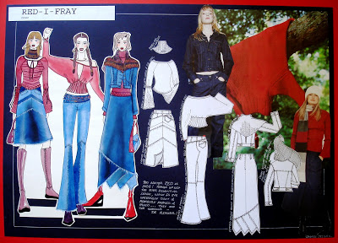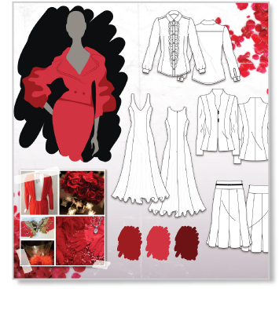
Q3. What is the difference between a story board and a colour Board?
Answer: Story Board : A fashion story board is when someone already has a feel for what we are showing and we just organize the board in manner we want to present it.
Story board tell the story of the designer's idea. A fashion story board includes original illustrations and flat, as well as original materials(such as photos from the internet or magazines, paper, fabric swatches, patterns)that influenced the unique design.
The purpose of the story board is to give an opportunity to create a storyboard of their original designs. It also provides the members am opportunity to gain knowledge of career responsibilities of a fashion design an illustrator enhance creativity and originality, and develop visual communication skills.
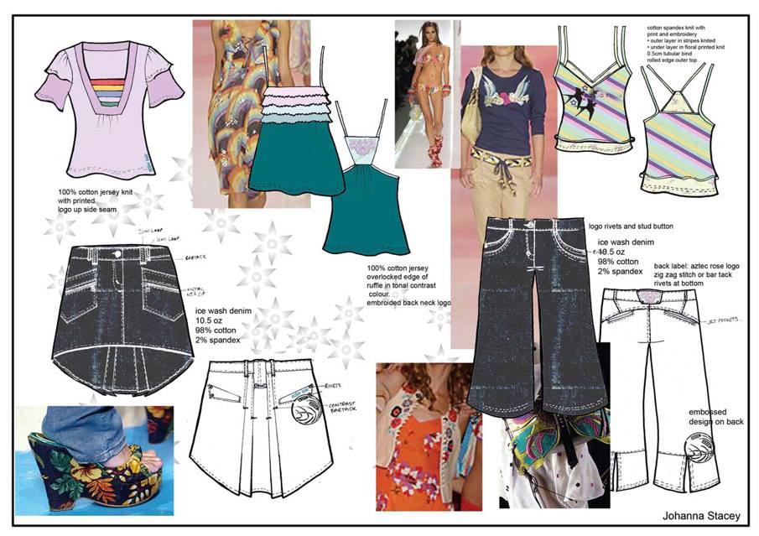
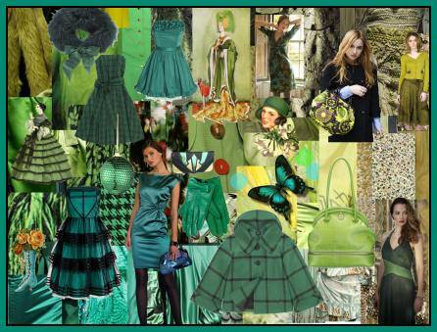
Colour Board: After the story board has formulated, a visual presentation of colour in the form of swatches, write up(addictives of colours may be used),pantone contains the standard colors,which renumbered .This number is indicated along with the colour for accuracy in colour shade and tone.
