
Catherine Richardson
1427
Diploma in Public Relations
Public Relations as Planned Communication
Assessment 4
Page 1
Assignment Cover Sheet

Student Name: | Catherine Jane Richardson
Student Number: | 1427
Course: | Diploma in Public Relations
Assignment NO: | Public Relations as Planned Communication - Assessment 4

Marking Criteria:
We expect the learners to write minimum one well expressed point in three lines against each allocated mark. This means one needs to write 15 lines with 5 well expressed points to get high grades for a 5 marks question.
For high grades use examples and illustrations where appropriate.
Please insert your completed assignment (in word format) here:
- Give short answers to the following questions.
I. Why planning is important for Public Relations Activities?
Planning allows the planner to envisage a structure to a Public Relations programme or activity. Structured programmes or schedules allow for solutions focus, creativity, as well as guidance to remain dedicated to the aims and objectives or purpose of the programme.
Specifically with public relations programmes, planning focuses on the tasks in hand and where the priorities lie. As a result, the planning allows the planner to focus on the effort required to achieve these tasks and thus the overall objective of an event or purpose. Planning also foresees the effectiveness of the tasks and whether the initial objectives are achieved (Edmund, 2003).
Positive consequences of planning are of a forward thinking visionary nature whereby one can keep in mind the organisation's future needs and the preparation for eventual change (Oliver, 2001). Furthermore, planning also permits the planner to assess and visualise future risks, and, therefore, minimize these risks.
Planning encourages proactivity (Wilcox et.al, 2000) by setting agendas and keeping to milestones. This provides measurable guidelines for those tasked to ensure that the expectations are met with the noted guidelines while keeping to the objectives. If at any point the milestones at not achieved within a given timeframe, planning allows for contingency planning to ensure that challenging tasks are re-prioritised and managed in a realistic manner. This means that the planner can plan for potential difficulties and conflicts and address these at the planning stage to limit mishaps while creating contingency plans should they arise (Johnston & Zawawi, 2000).
Most organisations would also consider planning crucial in terms of efficiency (Tyma, 2008) of those tasked by managing and organising objectives to meet the overall objective of an event or purpose. Efficiency leads to financial concepts within planning. Planning budgets manages the financial gains from planning all eventualities. Therefore, planning, in general, demonstrates value for money by adhering, if possible to financial budgets set and foreseeing future resourcing and requirements.
Catherine Richardson
1427
Diploma in Public Relations
Public Relations as Planned Communication
Assessment 4
Page 2

- Why do Public Relations Professionals sometimes feel reluctant to plan Public Relations activities?
Planning requires a multitude of factors and resources to ensure that the result is effective according to the aims and objectives set. There are a few factors where planning can be perceived as a hindrance. Planning requires time and effort to ensure that the overall plan can be obtainable (Sheldon, 1993). In modernized organisations, time is always considered as something that we do not have a lot of and, therefore, to commit more time away from daily tasks for planning purposes poses a hindrance. Taking into consideration the latter point, from an immediate point of view, planning could be perceived as time-consuming to the here and now. Taking time away from the daily tasks means that time is wasted in future planning that would result in a lack in the return of investment. As an example, a small organization selling cars need their individuals to process the sales. Seeing that they also have a sales exhibition event to plan, would they take the time to plan the event or continue with the immediate sale of cars?
Plans more often than not are interchangeable. Plans rarely ever stay the same to what was initially planned and so, as they are interchangeable some may consider plans as inadequate and, therefore, become outdated rather quickly.
Plans can also be considered as rigid and inflexible to change. Of some individuals perceive plans as concrete strategies with no room for movement so that objectives are met ("no matter what, because the plan says so!") As a result this would also hinder creativity (Adams, 2005) and opportunity to deliver an effective event or idea.
Catherine Richardson
1427
Diploma in Public Relations
Public Relations as Planned Communication
Assessment 4
Page 3
Once plans are in place, this raises high expectations of whether the plans are met, especially from managerial spectators (Authentic Enterprise, 2007). These high expectations form ideal scenarios and rarely meet the real expectations of the aims and objectives of the planned event.
For some, plans require some rigidity by setting achievable boundaries while allowing flexibility for creativity and opportunity.

- What is SWOT analysis? And what does it consist of?
The SWOT analysis is a tool used for businesses and organisations to aid the decision-making process. The SWOT acronym means ‘strengths', ‘weaknesses', ‘opportunities', and ‘threats' to an organisation and the planning for projects (Defren, 2008). The SWOT analysis titles provide a good framework for reviewing strategies, current position and directional values an organisation and how they wish to address proposed ideas.
The four categories can be identified as either internal or external to an organization. The strengths and weaknesses are aspects internal to the organization while the opportunities and threats are external to the organization (Stanford Research Institute, 1960 – 1970).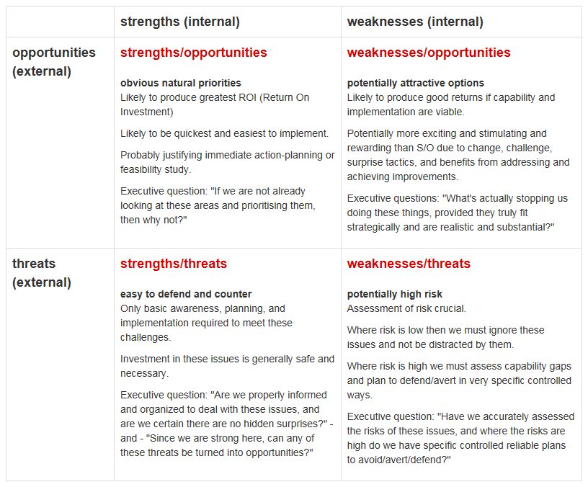
Catherine Richardson
1427
Diploma in Public Relations
Public Relations as Planned Communication
Assessment 4
Page 5
The above shows an example of the SWOT matrix highlighting the four categories with internal and external factors.
Catherine Richardson
1427
Diploma in Public Relations
Public Relations as Planned Communication
Assessment 4
Page 4
When considering strengths, an organisation's communication is of importance. The advantages a company has may be reputation, customer loyalty, positive perceptions, good corporate social responsibility (CSR) programmes (Golob & Bartlett, 2007), strong brands, good media and internet presence (Gombita, 2011) and so on. Public relations focus on developing relationships that lead to positive, public declarations by influencers and consumers (Wood 2013). Public relations focus on synthesizing a big message in a way that is both brief and of distinct value to every individual it reaches.
Weaknesses focus on what constraints and possible limitations a business faces, now or in the future. These factors may also relate to the identified strengths as mentioned earlier. For example, a company with strong brands may have a potential weakness if it lacks the resources to invest in their proper development (Waters, 2014).
The PESTLE (Political, Economic, Social, Technology, Legal & Environmental; Philip & Armstrong, 2006) analysis observes the opportunities in a way that
is likely to detect issues that may have an impact on the business.
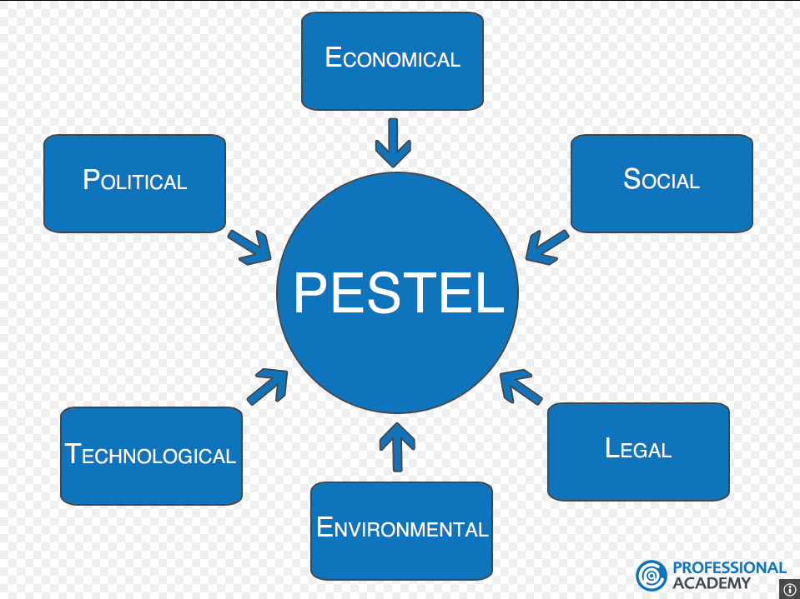
These issues could be indicators promoting opportunities either deriving from subtle factors or prominent ones. The key issue is identifying the positive and negative consequences ensuring that with some creativity these factors are turned into positive advantages. Public relations not only have a unique opportunity to step into the light and interact directly with its publics but in so doing is gaining the authority to guide the overall corporate communications approach.
Tactically, public relations have an unprecedented chance to lead on the content creation side, through social media platforms.
Catherine Richardson
1427
Diploma in Public Relations
Public Relations as Planned Communication
Assessment 4
Page 5
Crisis Communications require rapid response. With the use of social media, the response strategy can be issued within minutes of identifying the challenge.
Competition is a key threat for any business and corporate organisation. Key performance indicators (KPI's) if applied to one's competitors can provide insight in the organisations products, messages, reputation, etc. and how it compares with others within the same market. Those organisations that continue to operate behind closed doors are closed-off to opportunities in adapting to the competitive changes with other organisations within the same market.
SWOT analysis takes into consideration aspects of internal and external issues that are prevalent to an organisation as a result of adapting and planning for positive changes while meeting the requirements of all publics within a specific market group. SWOT enhances planning by focusing on continuous improvement (Kaizen) taking into consideration both internal and external factors affecting an organisation.
- What is ‘environmental scanning’? Explain with reference to Public Relations.
An organizational environment consists of both external and internal entities. An organisations' environment must be scanned so as to determine the development and forecasts the factors that will influence organizational success (Gruning et.al 2002).
Environmental scanning refers to an organisation applying acquired information about occasions, patterns, trends, and relationships within an organization's internal and external environment. This concept assists managers and leaders to decide the future path of the organization (Calderon et.al, 2003). Scanning must identify the threats and intercept opportunities existing in the environment allowing an organisation to develop. Therefore, strategy formulation lets an organization take advantage of the opportunities and minimize the threats. Even within the same market, a threat for one organization may be an opportunity for another (Kayton, 2012).
Internal analysis of the environment is the first process of environment scanning. Organizations should note the internal organizational environment. This includes employee interaction with other employees, management, shareholders and suppliers. An organization also needs to be aware of their branding as well as products and services. The analysis of the internal environment helps in identifying strengths and weaknesses of an organization. One example is the use of employee engagement (Saks, 2006) by identifying and analyzing “employee engagement levels which in turn drives organisational success”.
Businesses become more competitive, and consequently there are rapid changes in the external environment. Information from the external environment adds crucial elements to the effectiveness of long-term plans (Bradford, 2012). As the environment is a dynamic entity, it becomes essential to identify competitors' moves and actions. Organisations also have to update their core capabilities and their internal environment as per external environment. Furthermore, ensuring that change is embedded in the organisational culture so that the workforce remains focused and aligned to the business strategy and objectives (Holbeche & Springett, 2003).
Catherine Richardson
1427
Diploma in Public Relations
Public Relations as Planned Communication
Assessment 4
Page 6
Environmental factors are endless, and, therefore, an organisation should be flexible to accept and adjust to the environmental changes. Forecasting and analysing external environmental factors allow for a holistic review of all factors having an impact on an organization. By identifying these resources, some areas may be no more credible than other resources and, therefore, could imply the requirement for more focused scanning to create a more trustworthy prediction about such resources. In a similar fashion, there can be changes in factors such as competitor's activities, technology, market tastes and preferences.
Organisations need to analyse and identify three correlated environments; immediate or industry environment, national environment and a broader socio-economic environment / macro-environment (Gupta, 2009).
According to Kokmuller (2004) organisations need to evaluate the competitive structure within that particular market. Attention is required to assess and evaluate its rivals and competitors that could prove a threat. On a grander scale organisations also need to review and assess how the effect of globalization has an impact on competition within the marketplace (Root, 1995). Analysing the national environment needs consideration of whether the national framework helps in achieving competitive advantage in the globalized environment (Ashe-Edmunds, 2015). Analysis of macro-environment includes exploring macro-economic, social, government, legal, technological and international factors that may influence the environment. Therefore, analysis of organization's external environment reveals opportunities and threats for an organization (Hill & Westbrook, 1997).
Within the strategic public relations domain, an organisation must not only appreciate the present state of the holistic environment and their industry but also be able to predict its future positions.
Catherine Richardson
1427
Diploma in Public Relations
Public Relations as Planned Communication
Assessment 4
Page 7

- Discuss the various approaches used for Public Relations Planning.
Planning public relations activities, events and programmes ensure a multitude of positive factors that are of benefit for an organisation. The main focus will be examining the various approaches within a corporate organisation and how these approaches have a differing impact on strategy and the overall goal and corporate objectives. The various approaches will discuss the following approaches: Open, Closed planning and Systems theory, Systematic Planning, Management by objectives and SMART theory.
Within an Open System, this concept views the environment as important to the survival of an organisation. Open systems continuously exchange productivities with the environment through absorbent boundaries (Cutlip, Centre & Broom 2006, Morgan, 1998).

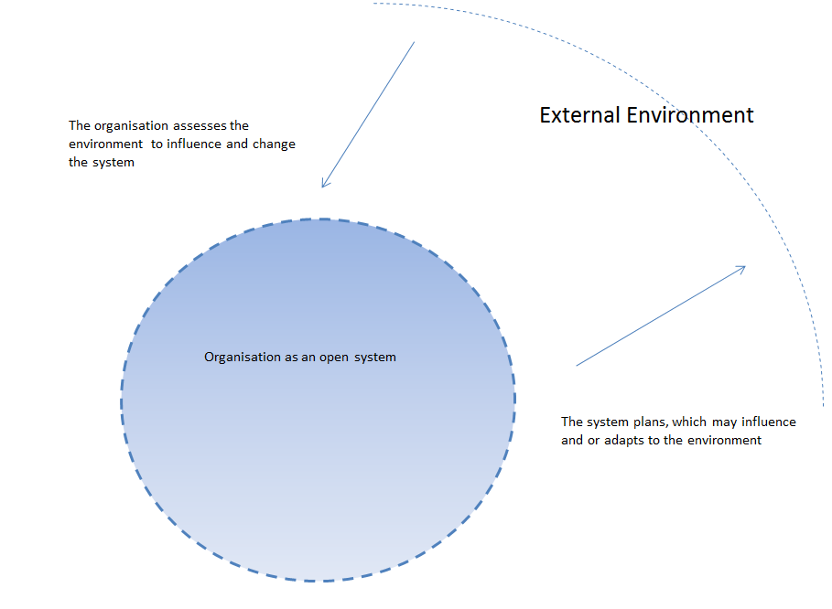

Open systems continuously exchange feedback with their environments. Feedback is analysed and internal systems are adjusted as required to achieve the goals set. Once these goals are set this information is then transmitted back out to the environment. These open organizations regularly try to understand their environments through the use of environmental scanning, market research and evaluations (Long & Hazelton, 1987). They often try to influence their external environment, as well, for example, through the use of public relations, marketing strategies, advocacy and lobbying, as well as through educating systems. The general flow of activities in the system is in a large loop or cycle (Authenticity Consulting, 1998). Each phase exchanges feedback (for evaluation and learning) with other phases and, as a result, some phases are changed and/or repeated in the overall cycle.
Catherine Richardson
1427
Diploma in Public Relations
Public Relations as Planned Communication
Assessment 4
Page 8
In contrast, a closed system is isolated from the environment and other systems. Its boundaries are considered resistant, which deters the exchange of information with the environment (Cutlip, Center & Broom, 2006). This result is a closed system that is rarely persuaded by their environment. In closed organisations, managers operate as if they are autonomous or unconstrained by environmental dynamics (Grunig, Grunig & Dozier, 2002; Witmer 2006). Closed systems are likely to encounter the system state of disorder or deterioration (Morgan, 1998). In closed systems, the public relations function has a low regard for the environment. Although public relations managers may acknowledge their environment and follow regulatory procedures, they are unlikely to interact with other publics. Instead, public relations departments will adopt a one-way communication perspective without considering environmental feedback. This type of approach is a functionary one, implemented to preserve the organisation's image (Skinner & Shanklin, 1978). Because the organisation is closed to its environment, it is unable to make best us of opportunities or move quickly to address and highlight potential problems. As a result, public relations professionals respond to crises in a manner whereby executives and managers cover-up the crisis as well as denying that a crisis ever occurred. (Seeger, Sellnow &Ulmer, 1998).
Systems theory describes organisations as a set of subsystems that affect each other and simultaneously interact with the external environment. The external environment is always changing; in turn the organisation must adapt and evolve to develop further (Stichweh, 2011). Organisations consist part of a social system that consists of publics. Organisations exist by accepting contributions from these publics, and transforming them into creations. It then receives feedback on those creations and adjusts accordingly, thus developing a positive feedback loop (L'Etang, 2012).
Public relations within a systems theory approach undertake this role of strengthening relations between an organisation and its subsystems, whether internal or external. The public relations practitioner is the link between the organization and its publics. By publics, we refer to both the internal and external publics of the organization. By considering these publics as separate groups or units, the PR professional can better address the individual needs of that particular audience (Meghan, 2010).
Catherine Richardson
1427
Diploma in Public Relations
Public Relations as Planned Communication
Assessment 4
Page 9
Systematic planning approach is simply using a methodical, or ordered, approach to planning. Some organisations use systematic planning to plan projects and link corporate goals, financial costs and timely schedules, resulting quality-based criteria with the desired final outcomes (Surtherland & Reynolds, 2012). Systematic planning ensures that all participants understand the needs and expectations of the outcome, bearing in mind the product or service provided and their publics. It also results in a project's logical development, efficient use of resources, transparency of intent and direction, the defensibility of project results, and appropriate documentation. Walters (1985) argues that systematic planning reduces creativity and innovation and restricting autonomy for partakers in the campaign or task (Miller & Osburn, 2008).
Management by objectives (Gregory, 2000) uses SMART goals method—setting objectives that are specific, measurable, achievable, realistic, and time-based.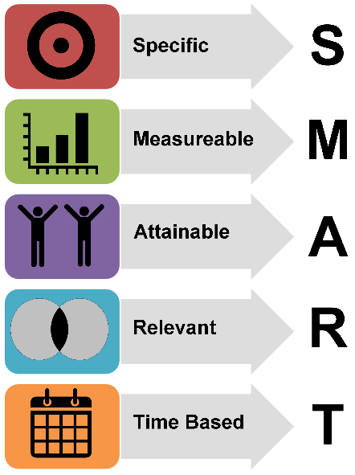
A management system in which the objectives of an organization are agreed upon so that management and employees understand a consensus of future development. Windahl et.al (1992) suggests that those partaking in a campaign or project are collaborative by working together reaching the common goals. Thus, communication is reflective an open irrespective of the hierarchical position within the organisation.
Management by objectives aims to serve as a basis for greater employee motivation and commitment through participation in the planning process and planning for results instead of planning just for work. In management by objectives practice, specific objectives are determined jointly by managers and their subordinates, progress toward agreed-upon objectives is periodically reviewed, end results are evaluated, and rewards are allocated on the basis of the progress (Drucker, 1909-2005).
Catherine Richardson
1427
Diploma in Public Relations
Public Relations as Planned Communication
Assessment 4
Page 10
Fundamental issues with planning are the issues facing analysis; environmental factors, public analysis and internal analysis. Organisations should aim to work within a system; responding and adapting to environmental changes to meet their publics' needs. However, when referring to a social system, no system is completely open or closed. In terms of public relations, the degree of openness or closeness determines an organisation's sensitivity to its environment and relevant publics. Internal transparency and systematic approaches lead others to the organisations goals and objectivities of the planned outcome. Needless to say, creativity and innovation also influences planning by viewing different perspectives that may be considered as vibrant tactics to engage publics in expanding markets.

Student Statement:

By submitting this assignment, I confirm that this is my own work.

Student Signature | Catherine Jane Richardson | Date | 1st Oct 2015

For Tutor / Assessor Use Only
Total Marks
Marks Obtained
Percentage / Grade

