
Assignment Cover Sheet

Student Name: | Annur Zara Liyana Othman
Student Number: | 1227
Course: | Diploma of fashion design
Assignment NO: | 3

Student Statement:

By submitting this assignment, I confirm that this is my own work.

Student Signature |  | Date | 21ST May 2014

For Tutor / Assessor Use Only
Total Marks
Marks Obtained
Percentage / Grade

Fashion Forecasting

Assessment 3

1. Give short answers for the following questions:

How the income groups influence fashion?
Answer:
Fashion consumers are free to choose clothing and accessorize that they like. However, their income group qualifies fashion consumers. Income group can be qualified by few factors; geography location and job type. Based on this few factors, consumer will be place in certain income group, which is affecting the fashion industry. For example, if a consumer working and live in a big city or fashion city such as Milan, New York, or London, they tend to receive the fashion trend first. They also can attend designer’s fashion show and get know the latest style. Because of there is no problem about the cost, they tend to buy designer’s new collection according to their taste and will. Celebrity and VIP are some of people who qualified in this group.

For the average income group, they tend to see what the high-income group’s people wear. Since they earn a less amount than the first group, they will visit small retail boutiques and will buy the clothes that the prices match their income. Normally it takes some time to small boutique sell a clothes that inspired by famous brand or famous people. Some of consumer try to copy how people from first group dress themselves and will buy the similar looking clothes for a cheaper prize. Some of them just don’t care and just buy what they prefer to wear.
Overall, income group really affect fashion. This can be summarized like this because is a consumer earn a lot so he/she can buy the designers clothes, which is he/she will make certain style become a fashion.

II. Why is awareness of fashion forecasting important for the designer and the buyer?
Answer:
Fashion Forecasting is a global career that predict for upcoming trends. The prediction includes the colours, fabric, and style. Every seasons, designer try to come out with different style in their collection with hope the style will be accepted by the consumer. This can be done by the fashion forecasting. Fashion forecasters will look for pattern, trend and change in the product preference by consumer. By doing this, designers can know the exactly taste/style that consumer want and they will create new style that can satisfy the consumer.
For the buyers, who work near designers they will predict for months and in some cases years in advance about what accessorize and apparel will sell and at what prices. The buyers need to stay current with the fashion industry; depending upon the items and seasons, buyers will purchase merchandise 6 months before it sold in store. There they must be able to anticipate fashion trends and consumer needs. In order for buyers to anticipate future trends, they familiarize themselves with current merchandise in catalogs and line sheets, travel to seasonal fashion weeks and show to view new style.

Overall, both designers and buyers have to be aware to fashion forecasting in order to make sure they upcoming collection will be accept by consumer.

III. What are the different factors that affect fashion trend?
Answer:
Fashion trend forecasting recourse help predict trends in the fashion industry. Fashion and trends forecasting is the prediction of mood, behaviour and buying habits of the consumer at particular time of seasons. The market is qualified by age, geography location, and also depending on fashion cycle. There are few different factors that affecting fashion trends.

Season
Each season, designers and manufactures worldwide are waiting what’s is trend for upcoming season. They rely heavily on creating a new style based trend forecaster’s service. Trend forecast are based on spring-summer and autumn-winter to connect with certain aspect. For example; colour of earth tone in autumn seasons, jewellery colour for holidays, the pastel colour in early spring and refreshing colour for summer.

Market Intelligent
Many large companies are turning to market intelligent to put in their strategic management system and decision-making. Marketing research is increasingly viewed as being to narrowly focus on tactical and operational issues. The large retailer and export companies around the world also do lots of research work based on the Internet. The marketing intelligent cycle whether is apparel or other business houses typically consist of directing, collecting, compiling, cataloguing, analyzing and form filled up data by consumer. There is no fashion if nobody buys it. Acceptable by large number of people makes market important –Karl Lagerfeld.

Consumer Research
The manufactures may ask consumer directly about their buying preference or look in to their buying habits over a period of time. Consumer reactions are recorded and documented to find preference for certain garments or accessorises, seizes, or colour and so on. Also they find out which product fit consumer taste. Survey by phone, mail or consumer feedback forms and publication and market researcher, manufacturer and retailer conduct informal interview. These surveys include question about lifestyle, fashion preference, income, and shopping habit.
Overall, those factors are very important to make sure all the collection become a fashion trend.

2. Define the following terms;
Classics, fads, interrupted cycles, recurring cycles, fashion adaptation, traditional fashion adoption, reverse adoption, dissemination.
Answer:

Classic
Classic can be refers as repeated styles. This is happen because not all fashions are completely gone. Some of them, which got great acceptance in one time, mostly will be repeat in the future. So, its a fashion forecaster’s job to see and identify which design/style can be bring up again.
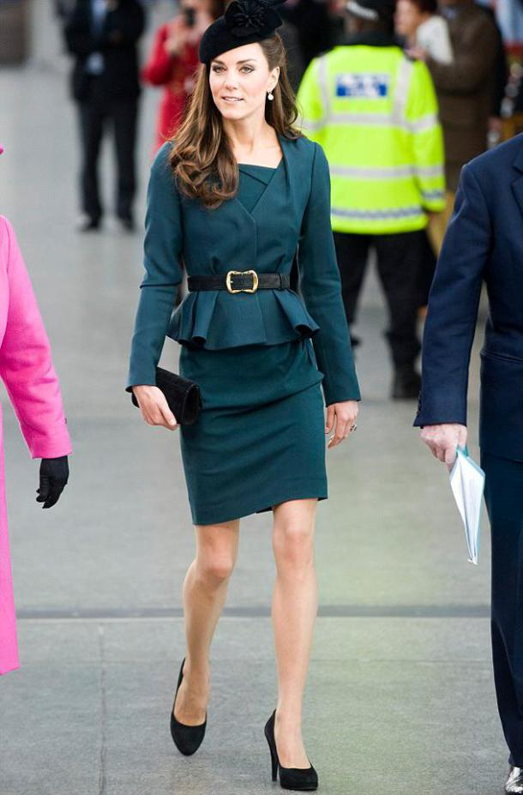
For example, peplum style was very popular in 1940s, been brought up in several times in 2010s.

Fad
Known as short-lived fashion. It’s come on single season and the prize normally very high that is only certain consumer will buy it. Those styles that became fad usually lack the strength to make people keep wearing and buying. Fad design also easy to copy so after sometime its became flood in the market and people lost interest to buy it.
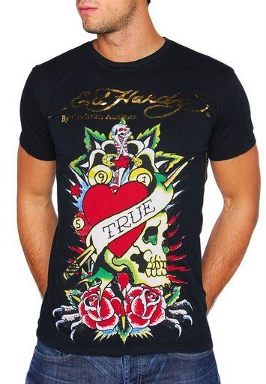

For example, Ed Hardy printed style.

Interrupted Cycles
The interrupted cycles cab be affected by social upheaval, economic depression, or war. The manufactures usually will not stoking merchandise that will soon decline in popularity. When this happen, consumer no longer can buy. So this situation will interrupt the period length in fashion cycles.

Recurring cycles
Designers often borrow ideas from the past. The silhouette or proportion may be recurring, but it’s normally different in fabric and detail. Nothing is ever exactly the same yet nothing is totally new. Fashion forecaster will see which design can be accept by consumer by the previous record.

Fashion adaptation
Fashion adaptation means the work to understand how new fashion ideas are disseminated, or spread, and how they are adapted to the taste, lifestyle and budget of various consumers.

Traditional Fashion Adaptation
The high fashion is always expensive and only affordable to a few people. The fashion leader will normally start wearing certain designer’s collection and soon become a fashion trend. However, for average consumer, they want to look like the fashion leader, but that can’t be happen because those collections cost too high to them. So, manufacturers produce a less expensive version or adaptation of high fashion. They copied again and again for a lower prize. Until they see that style been accepted well by the average consumer. Later then, consumer will be tired of the look and it’s popularity fades.

Reverse Adoption
Fashion sometimes begins with the consumer. There are few times consumer wear certain style of clothes and it’s become a huge fashion. Later then, designers and retailer start creating similar look or style and this can be refers as reverse adoption.

Dissemination
Fashion dissemination is the spread of fashion information that integral to the fashion acceptance and adoption process. As methods of fashion dissemination have evolved over the past 100 years in respond to social, economic, cultural and technology development, the scope and nature of their influence.

Activity
Look into some old and new fashion magazines, read fashion columns in the daily newspaper. Compare contents with fashion looks six months ago. From the information you find, try to analyse the fashion directions for the future. Organise your ideas for few basic trend forecasts for colour, fabric, silhouette and line.

Colour
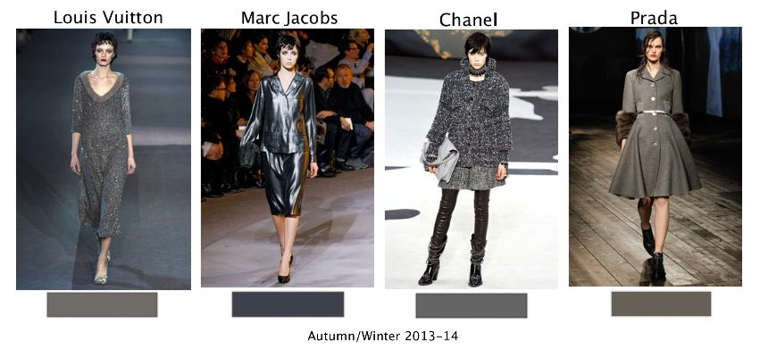
This season, darker colour was widely chosen by designers. Tones like grey, elegant blue and sepia gave a classy look.

Fabric
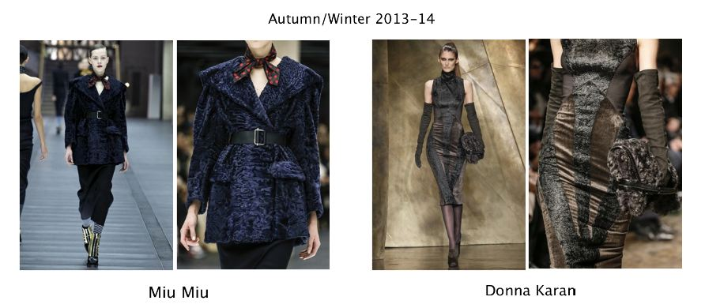
This season the fabric such as velvet and fur are widely chosen. This kind of fabric never fail to catch consumer attention because its look fashionable and at the same time its comfortable to wear.

Silhouette
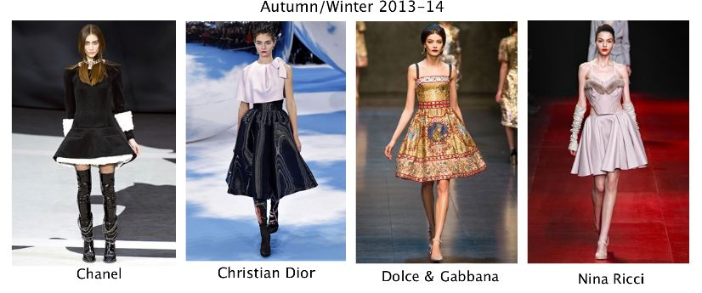
This season, many designers came out with almost similar silhouette look. As shown in the picture, dress style tends to be in short skirt/medium length. This style, will always remain popular.

Line
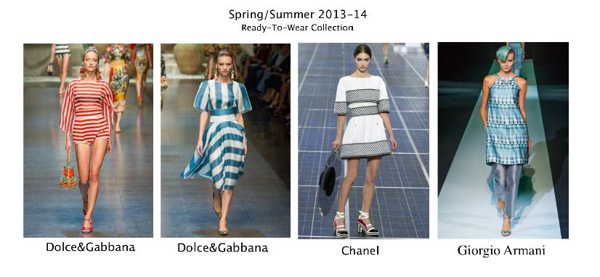
For this season, some designers choose the horizontal line as their main ideas. As the meaning of line; lead the eye in a definite direction, these collection really captured consumer’s heart.

Activity
From current fashion magazines, collect five examples of each of the following types of fashion: (a) high fashion; (b) mass fashion; (c) classic; (d) fad.

High fashion
High fashion refers to the creation of exclusive costume fitted clothing.
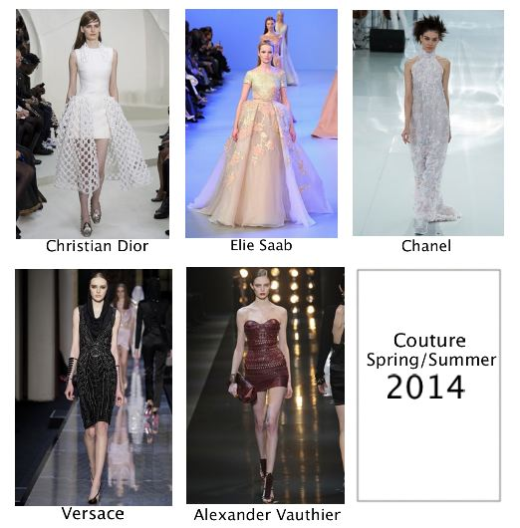

Mass fashion
Mass fashion refers to fashion are worn by large number of people at any one time and continue to be accepted for long period of time.
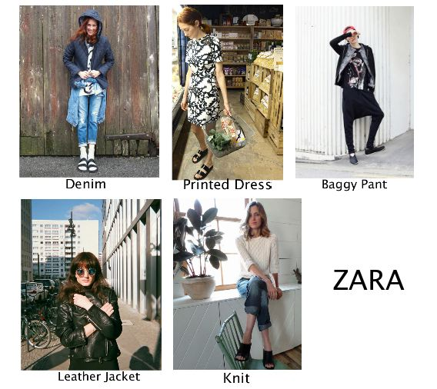

Classic fashion
Classic fashion means the style has been around for a long time or come back in style over and over again.
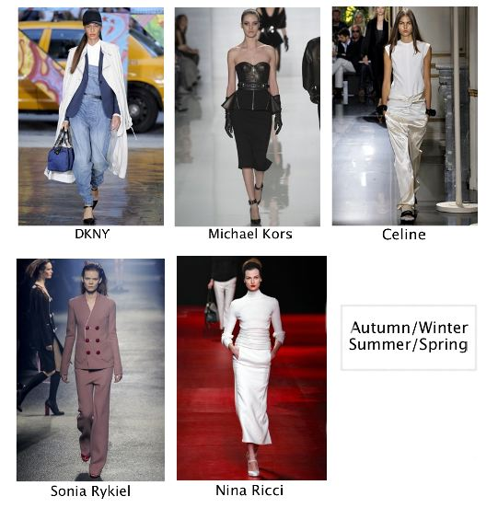

Fad
Fad fashion refers to something that is going to come and go in a certain time.
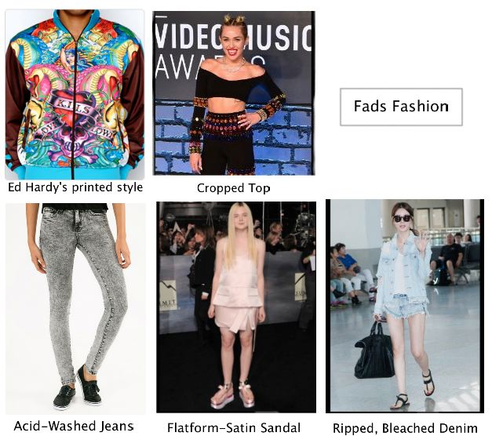

References
Information: Unit 3 Fashion Forecasting (BOLC), Wikipedia, Fashion’s website, Fashion’s blog, Fashion history Books by certain brand, Fashion Magazine
Image: Fashion’s website, Online Fashion’s magazine, Certain Fashion’s brand website, Google images.

