
Assignment Cover Sheet

Student Name: | Christian Blackmore
Student Number: | 1394
Course: | Construction Management
Assignment NO: | 04

Marking Criteria:
We expect the learners to write minimum one well expressed point in three lines against each allocated mark. This means one needs to write 15 lines with 5 well expressed points to get high grades for a 5 marks question.
For high grades use examples and illustrations where appropriate.
Assignment 4

- Give short answers for the following questions:

I. What is environmental impact study or EIS?

An Environmental Impact Study is a complete analysis of a proposed construction project or development plan which is undertaken to determine the impact of that construction or development on the environment in the immediate locality and surrounding area.

The purpose of EIS is to protect the environment and must be implemented by developers from the initial phases of planning. An EIS is to be submitted to the local planning authorities and must include a schedule of possible environmental effects that the new development may have on the surrounding areas.

A screening procedure is used to determine if the project will have any environmental effects on the area and if it is necessary to do an EIS study.

Once this study has been assessed by the local planning authorities the decision will be made to authorise planning permission or not. The planning authority’s decision will be based on the magnitude of the project and the impact it will have on the environment.

If, for example after a field reconnaissance of the site signs of possible contamination are to be found, a ´Desk Study´ is carried out. The purpose of this particular study is to determine if the area has been subjected to processes that would have caused contamination in the past. The relevant information can be obtained from archives which are kept to show past and present uses for the different sites.

Geology and hydrology studies must be undertaken at this phase to test the water and soil. It will be the developer’s responsibility to decontaminate the area to an appropriate level so allowing the site to be used. This; depending on the project, e.g. a site for a planned shopping centre will not need to be cleaned to the same standards as a public garden.

The developer will need to consider many issues as to the impact of the projected development relative to the surrounding area. These issues will include but not be limited to – air quality, noise ratio, energy consumption, water quality, discharge and containment of solid waste, construction traffic, to mention a few of the issues which are often not adequately considered by the developer.

II What is the basic criterion for judging the suitability of the site for construction?

Selecting the appropriate site location can be very complex and should be undertaken with considerable care. The topography and size of the site will determine the approach in terms of design development, which in turn will impact the appearance and configuration of the structure. The size and topography of a site will impose constraints that will affect the overall cost of the development.

The rock and soil below ground level is of primary importance and is not always what it seems from the surface. To establish soil quality borehole samples must be taken to determine load bearing qualities, rock content and depth below surface of stable soil/rock, this will play a critical part in the way the development is focused relative to excavation, below ground drainage, rainwater runoff and the capability to carry the load imposed by the planned structures.

Easy access to and from the site is essential for construction purposes, for instance transporting building material or access for cranes. Also, once the project has come to its completion having good access to motorways and railway facilities will be an advantage for the developers when looking to sell off properties.

Items such as water (portable), telephone lines, sewerage systems and power supplies are essential; these must be close by as this will cause a huge increase in development costs if they are not easily accessible.

An aspect that is crucial in site location is the water table must be low enough so that there will be no flooding in households with basement facilities. Sufficient drainage should be provided for storm water and subsurface water. A site location should never be considered if there has been flooding in the past due to a high ground water table. In the past building sites have been located on flood plains hence flooding occurs regularly, many developers ignore this obvious occurrence resulting in vast damage leaving the society to deal with these negligent acts.

It is equally important for developers to be aware of the hydrological systems at subsurface level (aquifers) if water is to be utilised for residential purposes or industrial use.

Example:
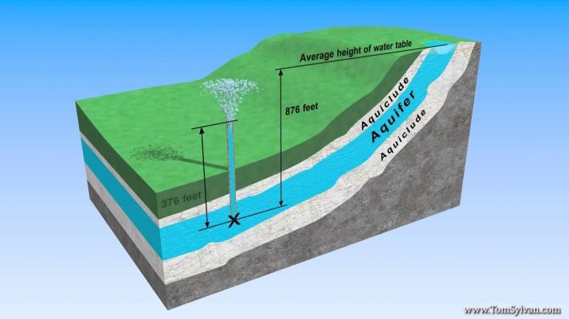

Site orientation for climatic reasons should also be taken into consideration. It is possible to control temperatures of certain buildings by their structural design. By orienting each building so it receives as much solar light as possible during the day will help save energy costs such as heating, and so being environmentally friendly.

III What is topographic data about?

A visual inspection is initially carried out of the site to establish if it will be necessary for detailed maps to be prepared. Topographic data is used for development of residential, commercial and industrial purposes. It also can be used for recreation developments such as golf courses.

When this data is gathered together information will then be available for:-

- Sea level elevation
- Site orientation
- Percentage of slopes
- Surface water- streams & rivers
- Hills and valleys
- Swamps or quick sand

Example:

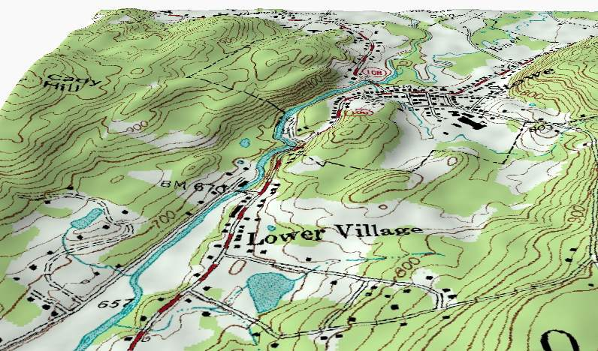

IV Which type of buildings should be constructed on rocky sites?
This type of construction can be very costly and difficult to achieve. Arch dams for example, are good for narrow rocky locations as they are curved and the natural shape of the arch holds back the water in the reservoir. A study should be carried out on the deposition of sediments on the foundation rock, to insure there will be no rock movement in the subsurface.
Geology studies for tunnelling are vital as the feasibility, planning and design depend on it. The most important element of these types of construction is the safety of personnel directly or indirectly involved with the project, all construction sites must have a safety officer.
It is possible to construct a house on a rocky site, but there are many complications one of them being foundations. Some people opt for blasting the rock and pouring the concrete to serve as a block foundation which is very expensive and not really practical. Insulated concrete forms (ICF´s) is an ideal material for this type of build, as they can be easily cut and shaped around the irregular forms of rock and also serve as insulation once they are installed. As they are very light in weight they will require to be anchored to the bed rock before concrete is poured. Although this material wasn’t really designed for this purpose I believe it is a practical and functional option for installing foundations for a house built on rock.
Fault zones should be studied carefully before any of these options are considered for construction.

2. Give the classification under which the following buildings fall:

- Museum – Group D: Assemble Buildings
- Hospital – Group C (C1): Institutional Buildings
- Hotels – Group A (A5): Residential Buildings
- Library (public) Group E: Business Buildings
- Department stores Group F (F2) Mercantile Buildings with areas more than 500m

The purpose of building classification is to divide municipalities into residential, commercial and industrial zones. For fire-resistance characteristics it is necessary to have sub-classifications for all types of buildings.

For environmental reasons it is essential to control which types of buildings can be built in the same zone, for example: inhabited area with an industrial zone, this will cause problems with noise, dust and air pollution and will also affect property values.

Due to development controls imposed by the government selecting a suitable site is becoming more and more difficult, as the demand for locations for different types of buildings are on the increase each day.

Dividing into zones also benefits the planning and location of transportation such as railway lines to evade noise problems near to inhabited areas.

Student Statement:

By submitting this assignment, I confirm that this is my own work.

Student Signature | Christian Blackmore | Date | 12-08-2015

For Tutor / Assessor Use Only
Total Marks
Marks Obtained
Percentage / Grade

